Project Unit Testing

Testing Purpose

Software testing is an important part of the software development process. Its purpose is to identify software defects through various testing activities and ensure that the software meets the functional, performance, and reliability requirements defined in the requirements specification.

Framework Used

Mocha + Chai

Test Results

user_controller_test.js

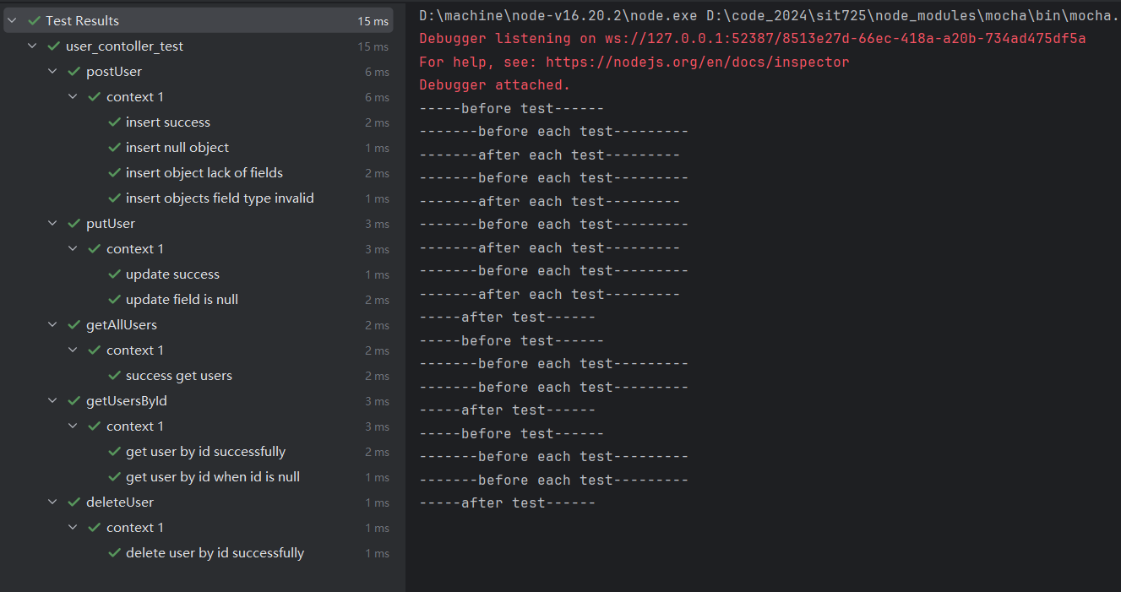

item_controller_test.js

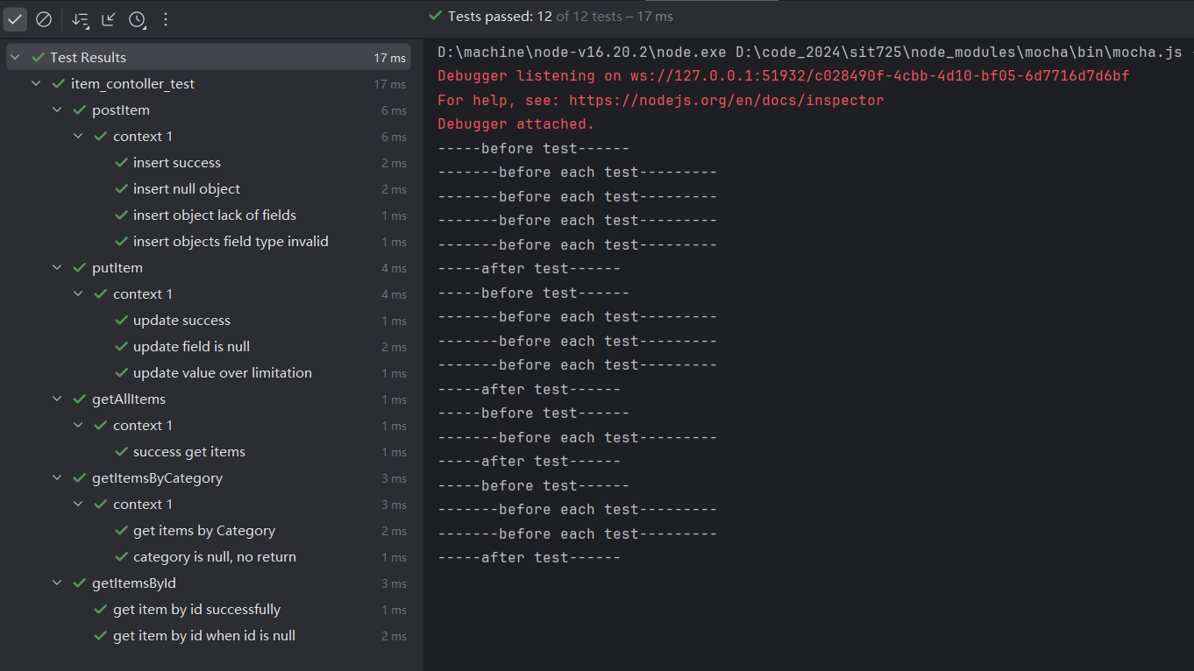

order_controller_test.js

