
CONFIDENTIAL
1

CD/JULY 2025/CSC569

UNIVERSITI TEKNOLOGI MARA
FINAL ASSESSMENT

COURSE | : | PRINCIPLES OF COMPILERS
COURSE CODE | : | CSC569
EXAMINATION | : | JULY 2025
TIME | : | 2 HOURS

INSTRUCTIONS TO CANDIDATES

1. This question paper consists of four (4) questions.

2 Answer ALL questions in this question paper.

3. Answer ALL questions in English.

This examination paper consists of 6 printed pages.
© Hak Cipta Universiti Teknologi MARA CONFIDENTIAL

QUESTION 1 (30 marks)

Based on the following gammar:

- S -> {x} b S B
- S -> a A
- A -> B b {y}
- B -> c
- B -> {z}
- Find the selection set for each rule.
(15 marks)

- Build the extended pushdown translator for the grammar.
  - marks)

- Show the sequences of stacks and the output when parsing this input string: babc↵

  - marks)

QUESTION 2 (20 marks)
Consider the following attributed translation grammar and the table for comparison codes:

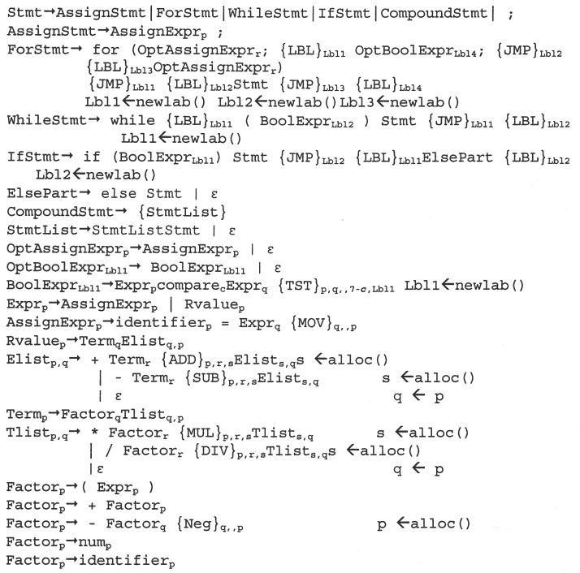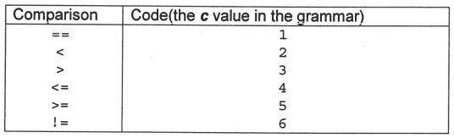

- Show an attributed derivation tree for the following expression:

if (m * 3 != 20) y = y * 5
(15 marks)

- Show the atoms generated by the following statement:
if (n>0)
  - = x + 10;else
while (i>0)
  - = y + 10;
(5 marks)

QUESTION 3 (18 marks)

a) Identify the sequence of stack and input configurations as the string

id + * ; + * ;
is parsed with a shift-reduce parser using the following grammar:

- Prog → Stmt + Seq
- Stmt → id
- Seq → * ;
- Seq → Seq * ;
- Prog → Prog + Seq
(10 marks)

b) Show the sequence of stack and input configurations and the reduce and goto operations for the following expressions using the given action and goto tables below.

var+var
Given:
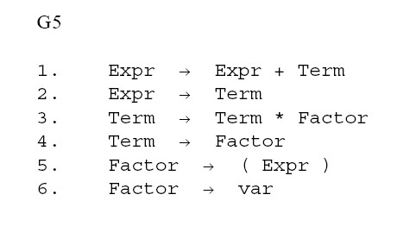
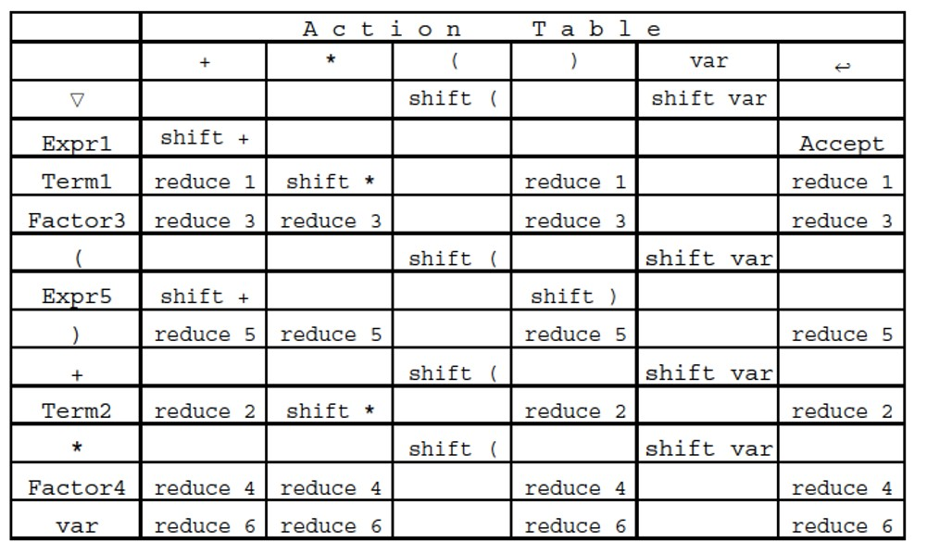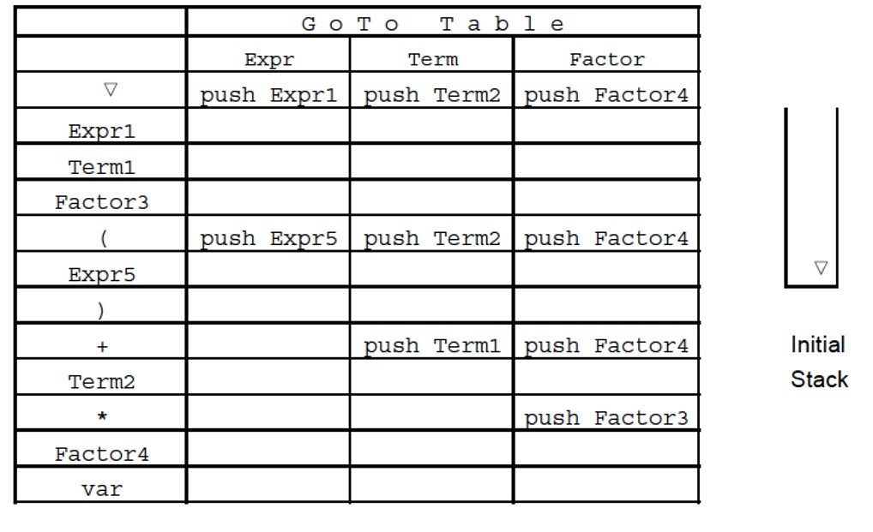
(8 marks)

QUESTION 4 (7 marks)

Consider the following grammar:

- Expr → Expr + Term
- Expr → Term
- Term → Term * Factor
- Term → Factor
- Factor → number
- Factor → ( Expr ) 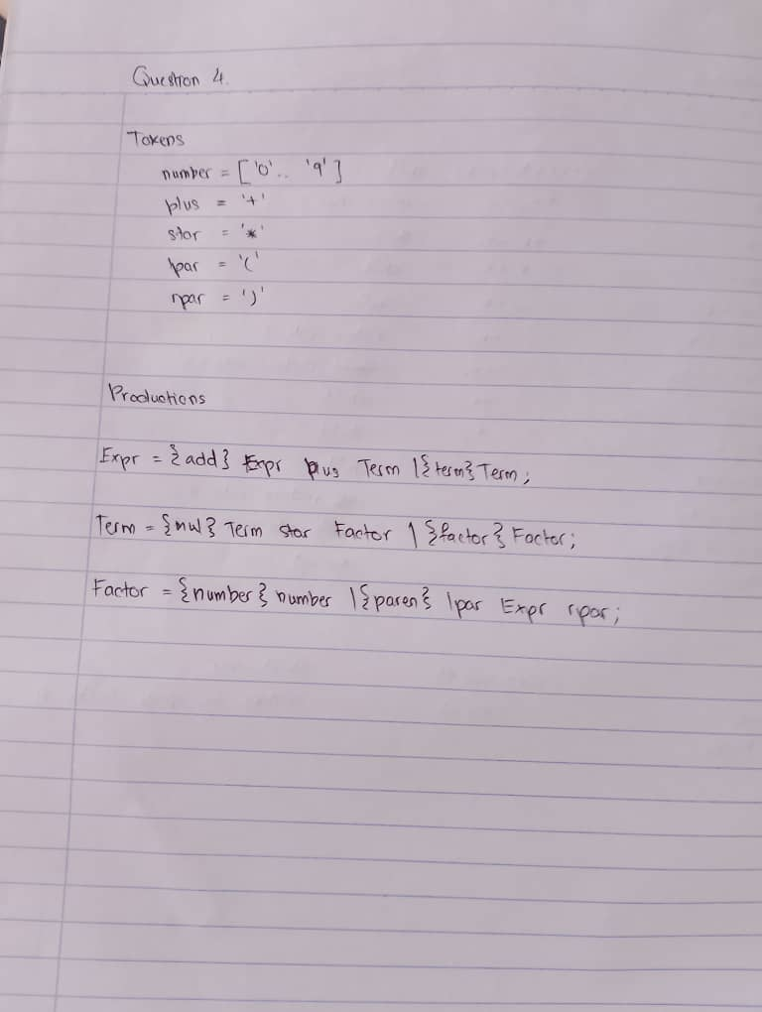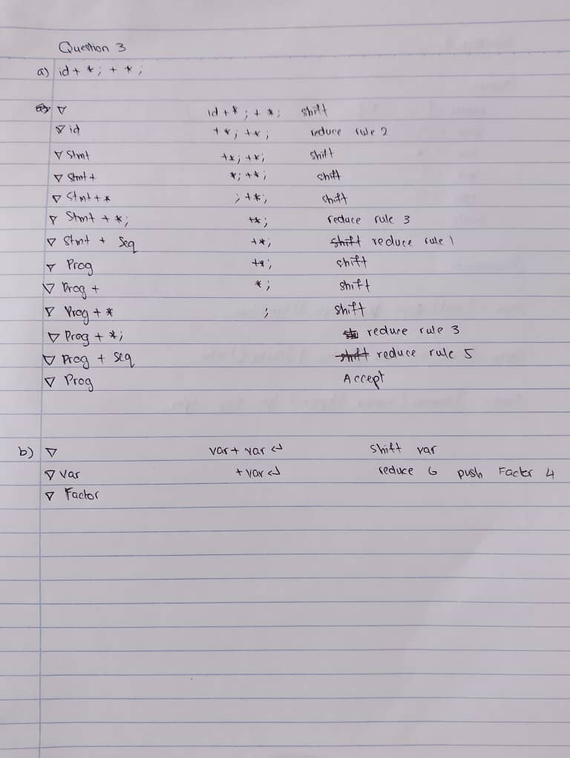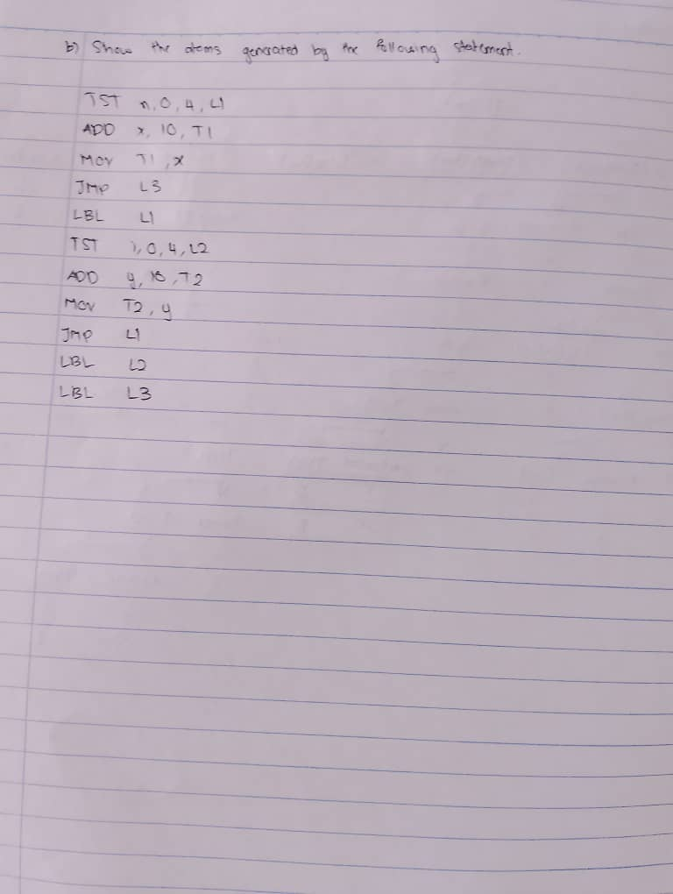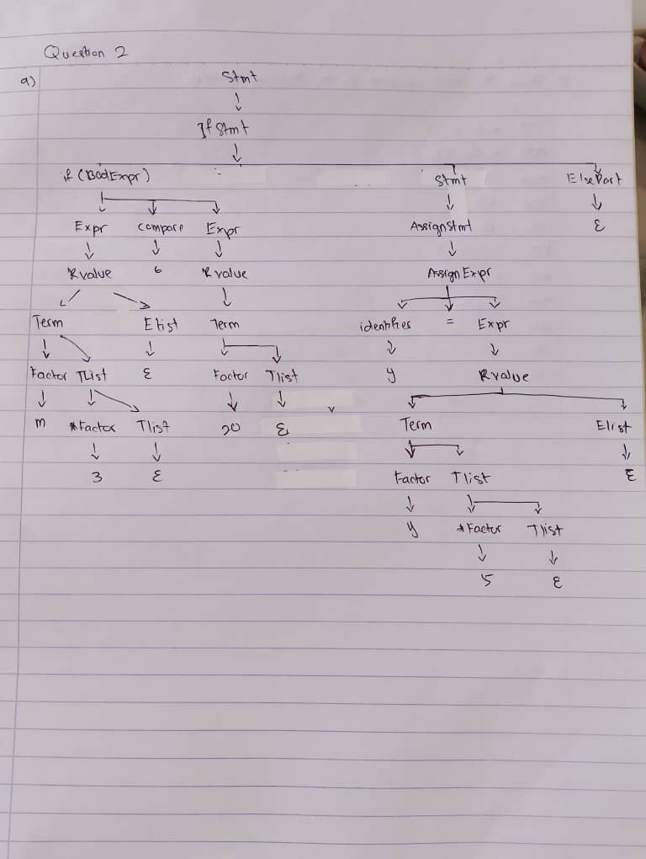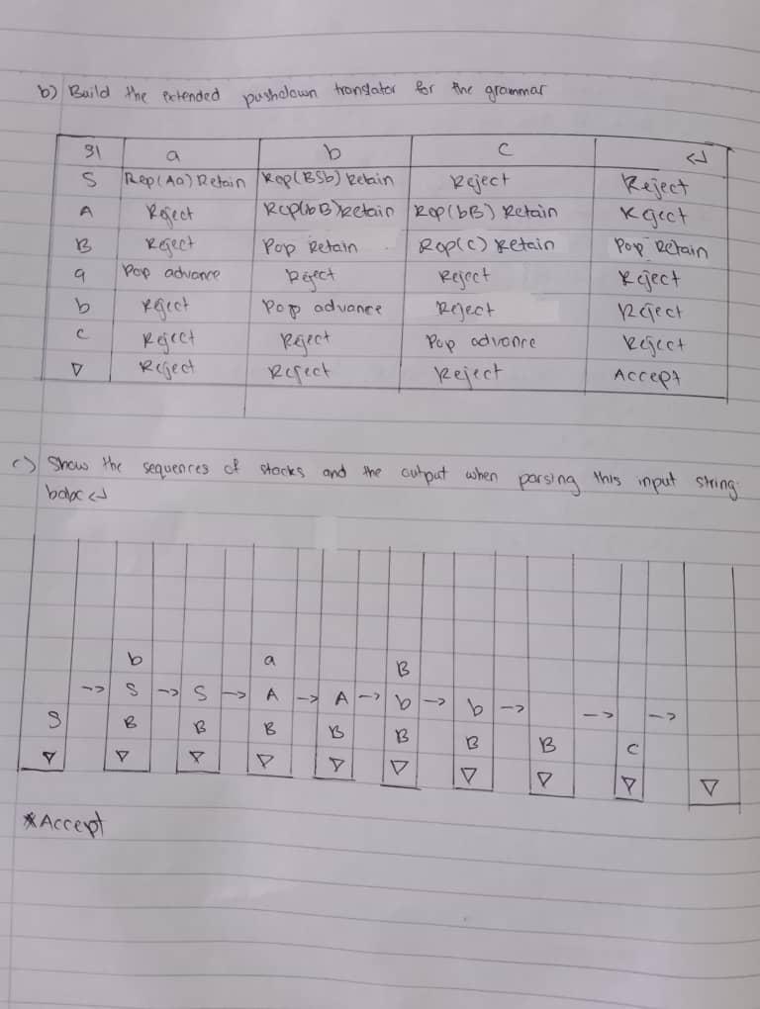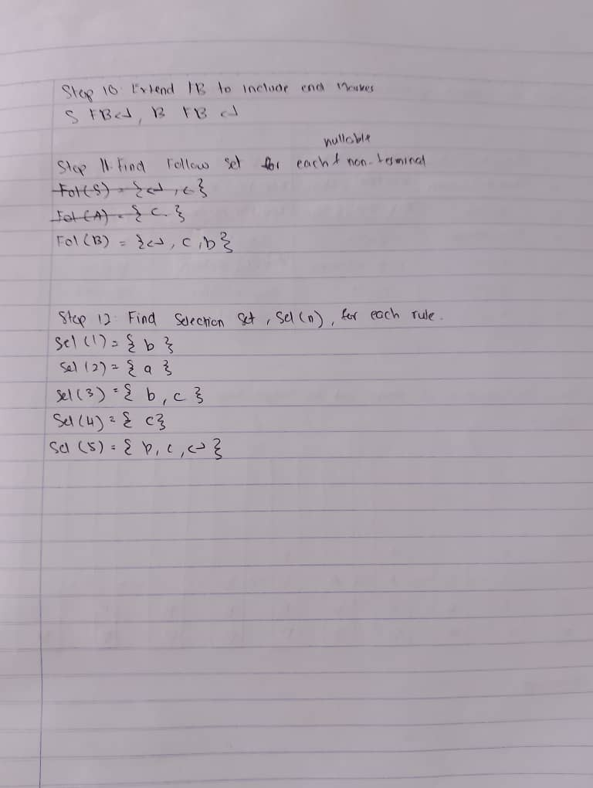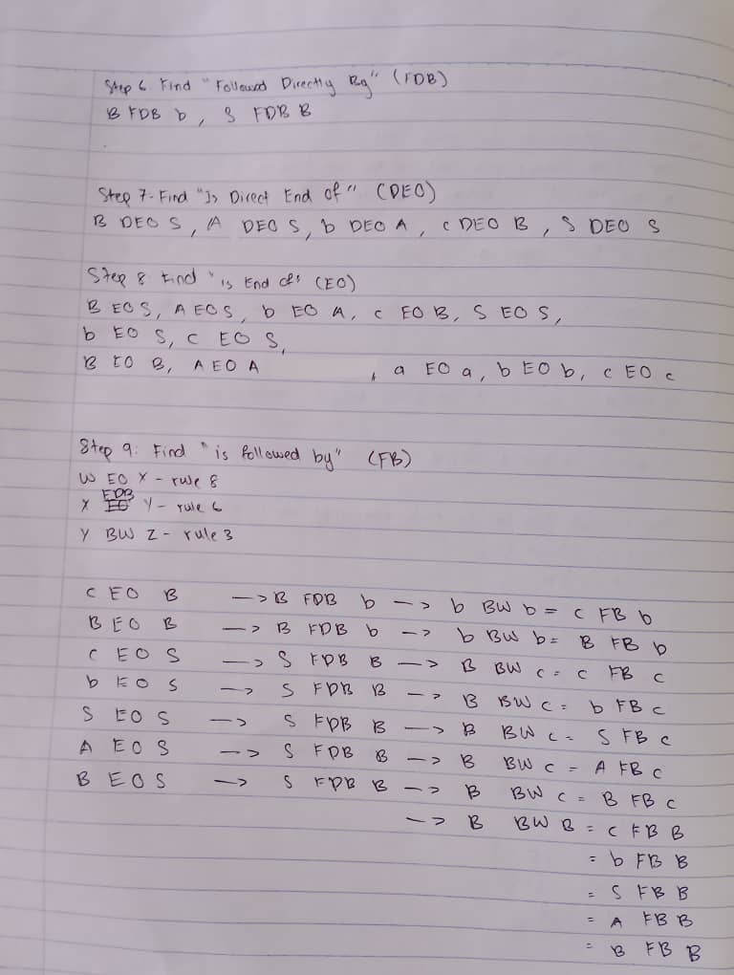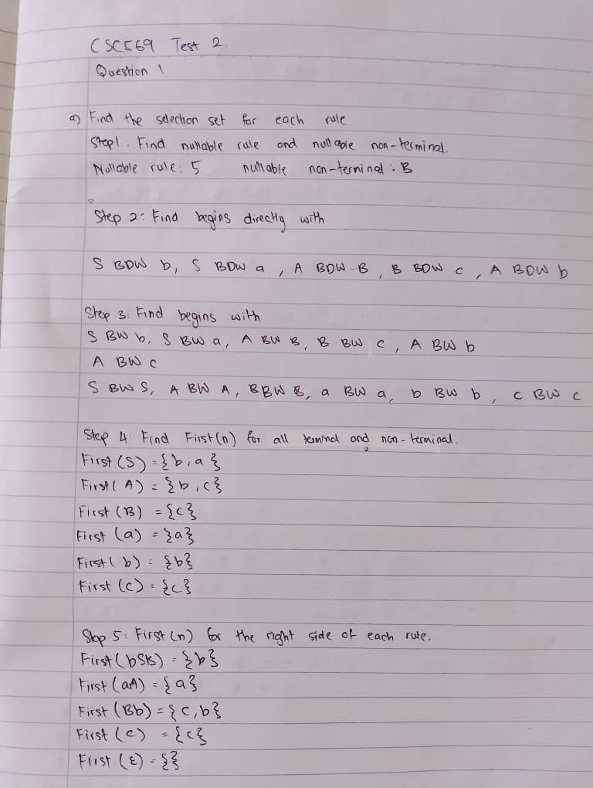

Show the Tokens and Productions sections of the Sablecc grammar file corresponding to this grammar.

(7 marks)

END OF QUESTIONS

