

**CSM3123 NATIVE MOBILE PROGRAMMING (K1)**

**BACHELOR OF COMPUTER SCIENCE (MOBILE COMPUTING) WITH HONORS**

**SEMESTER 2 2024/2025**

**LAB 2 – Layout types, Service Component, Simple Broadcast Receiver**

**Prepared for:**

DR. RABIEI BIN MAMAT

**Prepared by:**

MUHAMMAD HAZIQ AIMAN BIN MUSTAFA (S67978)

Source code github link:

Task 1

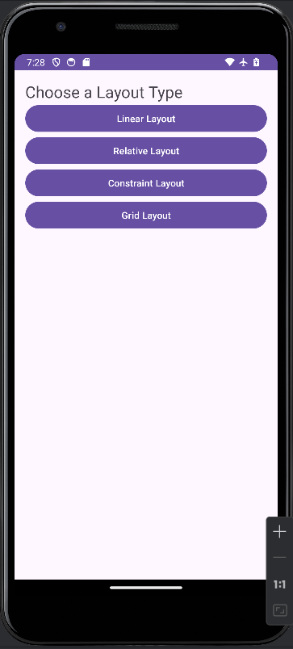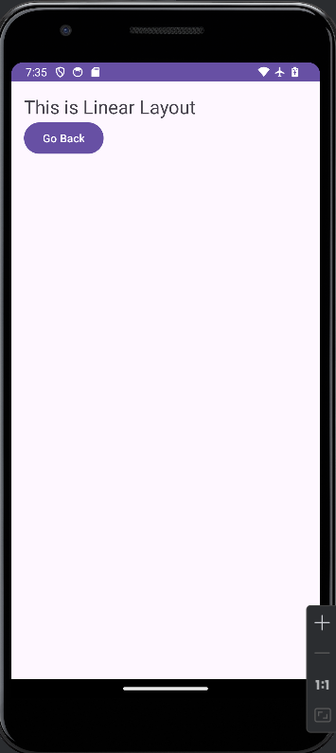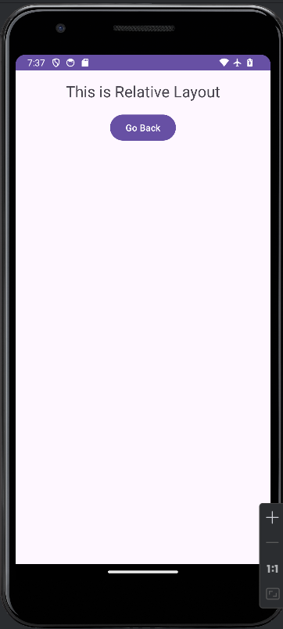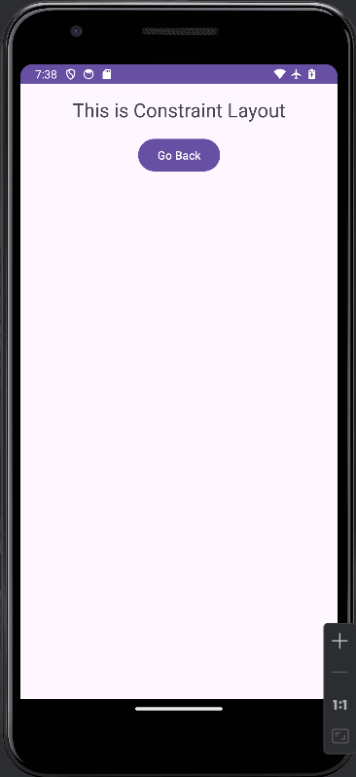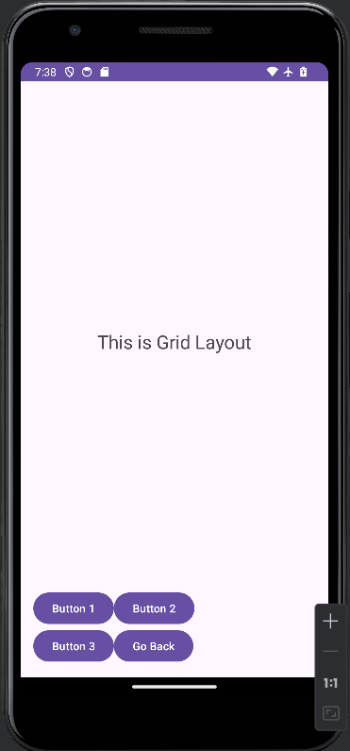

Explore and Experiment

1. Modify Layouts: Experiment with different attributes (e.g., margins, padding,

gravity) for each layout.

2. Add More Views: Include additional UI elements like EditText, ImageView, and

see how they are arranged in different layouts.

3. Styling: Try applying different themes and styles to enhance the appearance of your layouts.

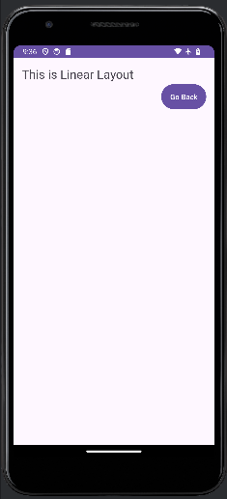 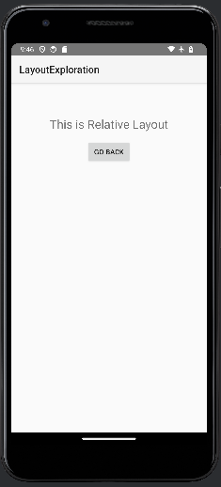 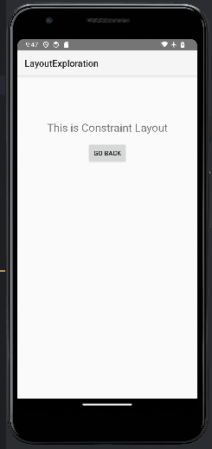 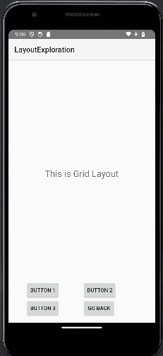

Changed theme:

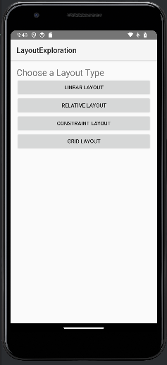

Task 2

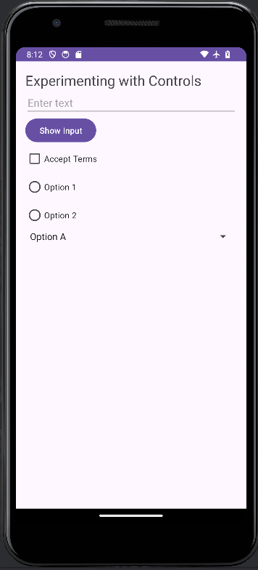 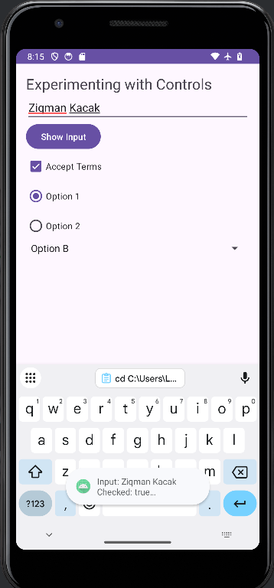

Explore and Experiment

1. Modify Controls: Change properties of controls (e.g., add

android:visibility="gone" to hide/show elements).

2. Additional Controls: Add more controls such as SeekBar, Switch, or ImageButton

to see how they work.

3. Layout Adjustments: Experiment with different layout types (e.g., RelativeLayout,

ConstraintLayout) to see how controls behave in different layouts.

4. Data Validation: Add validation logic to ensure the EditText is not empty before

showing the input

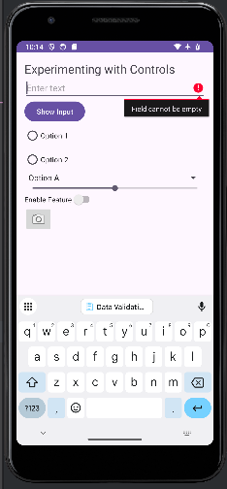

Task 3

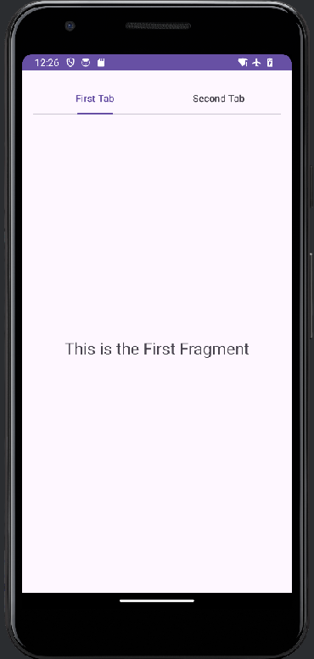 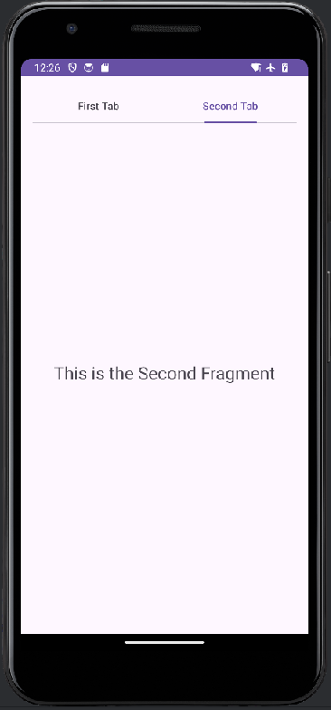

Explore and Experiment

1. Modify Fragments: Change the content of each fragment to include different UI

elements like buttons or images.

2. Add More Tabs: Create additional fragments and tabs to expand the functionality.

3. Customize Appearance: Use styles and themes to change the appearance of the

TabLayout and fragments.

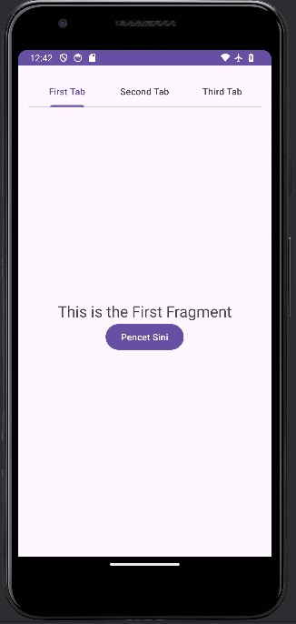 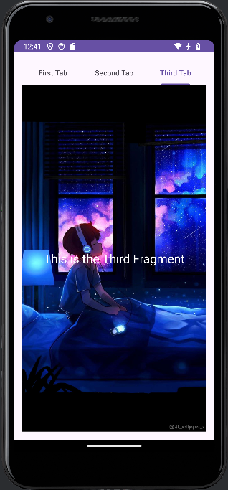 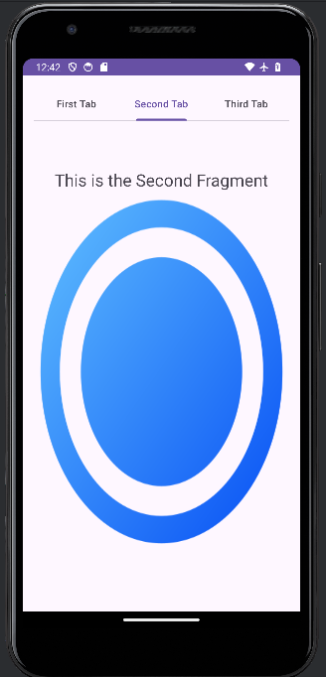

Task 4;

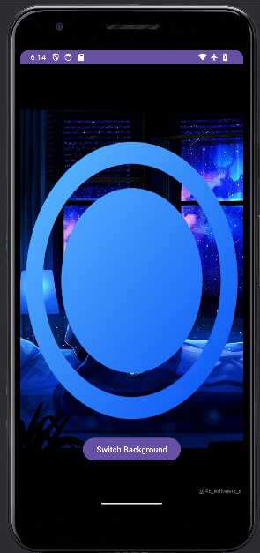 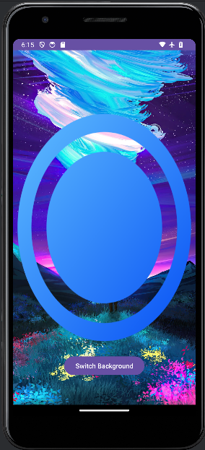

Explore and Experiment

1. Modify Button Images: Change the image used for the button by replacing

button_image.png with your own image.

2. Add More Backgrounds: Add additional background images and implement logic to

switch between more than two backgrounds.

3. Button States: Experiment with different button states (e.g., pressed, focused) by

creating different drawable resources for each state.

4. Animation: Implement simple animations when switching backgrounds to enhance

user experience.

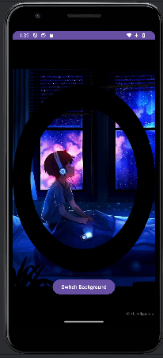 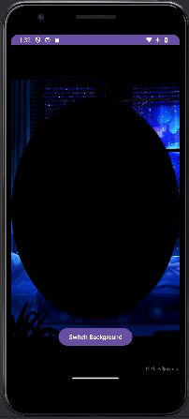 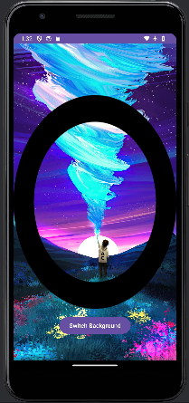 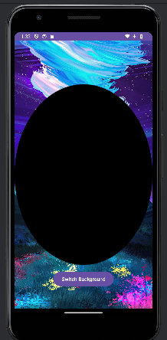

Task 5:

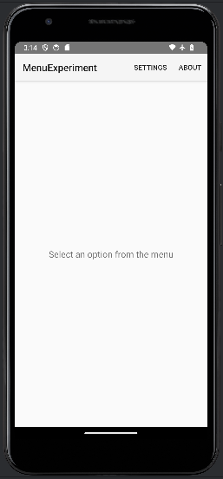 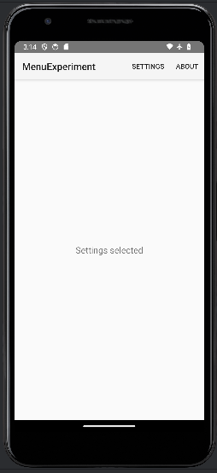 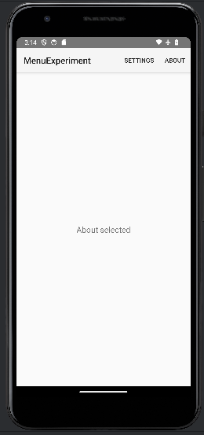

Explore and Experiment

1. Add More Menu Items: Experiment by adding more items to the main_menu.xml

file and implement their actions.

2. Customize Menu Appearance: Modify the attributes of menu items (like icons) and

observe how they change the appearance.

3. Implement Submenus: Create submenus by defining nested <menu> elements in your

XML.

4. Experiment with Action Bar: If using an Action Bar, customize its appearance and

behavior to include your menus.

