

**CSM3123 NATIVE MOBILE PROGRAMMING (K1)**

**BACHELOR OF COMPUTER SCIENCE (MOBILE COMPUTING) WITH HONORS**

**SEMESTER 2 2024/2025**

**LAB REPORT 3**

**Prepared for:**

DR. RABIEI BIN MAMAT

**Prepared by:**

MUHAMMAD HAZIQ AIMAN BIN MUSTAFA (S67978)

Source code github link:

Task 1:

Output:

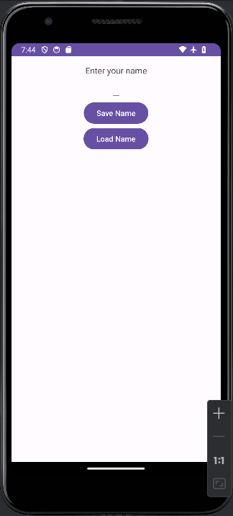 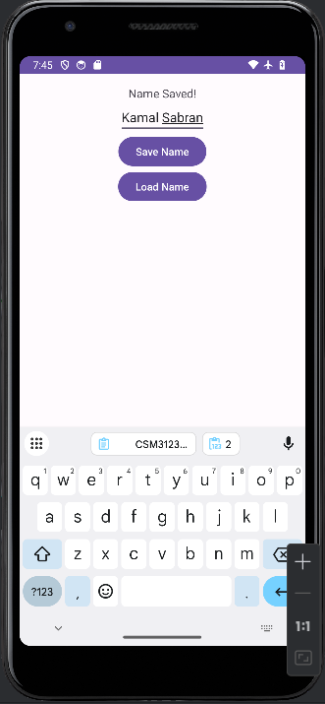 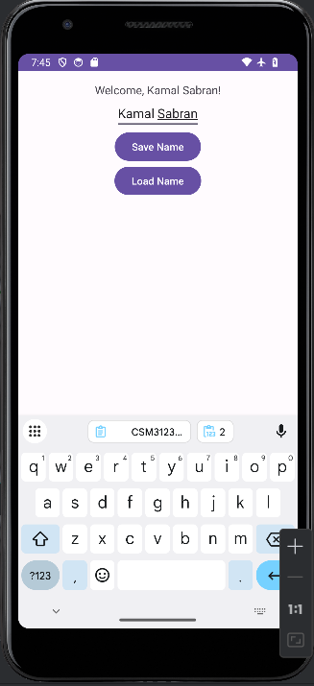

Modification:

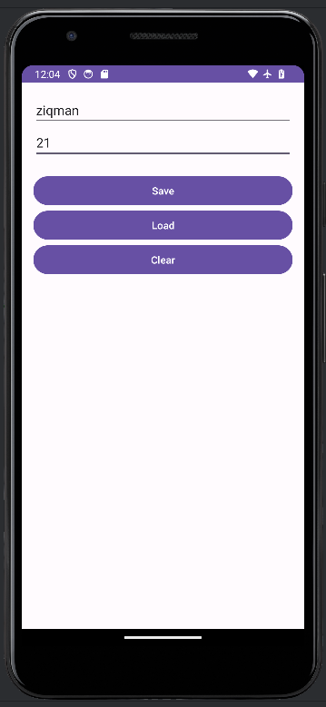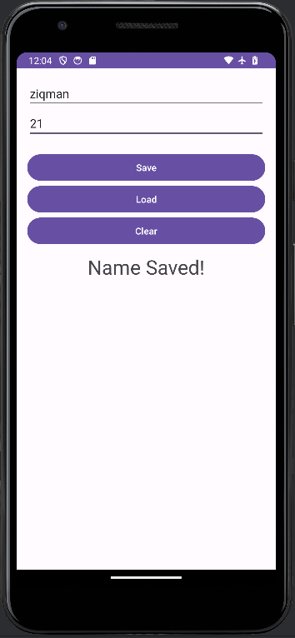 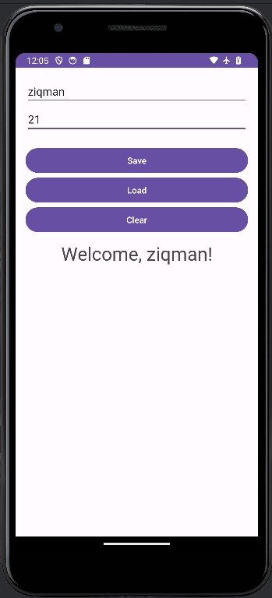 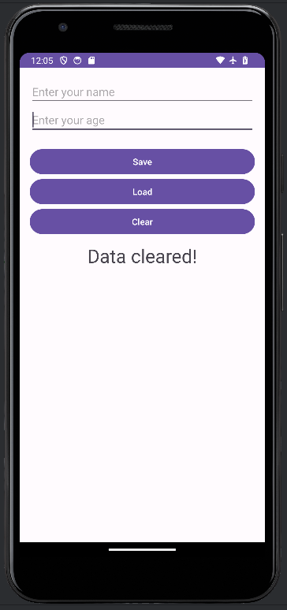

Task 2:

Output:

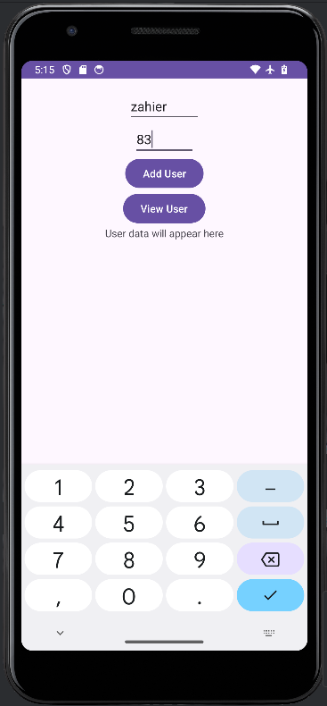 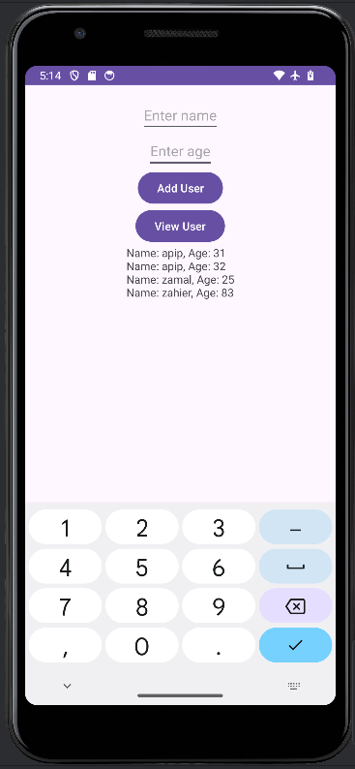

Data inside SQLite Browser:

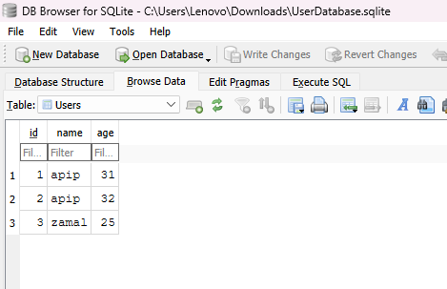

Task 3:

Output:

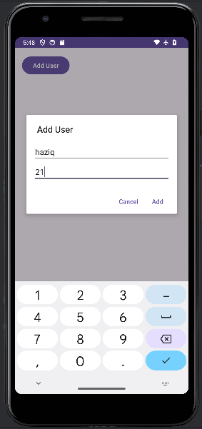 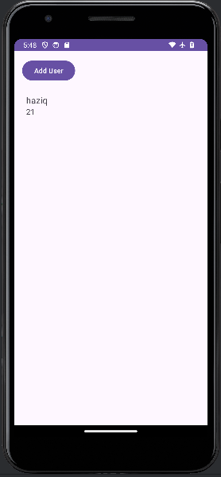

Task 4:

Output:

