Description and Tags XRM ToolBox Plugin

Developed by Paul Redstone at Clew Consulting (www.clew-consulting.com) – the developers of Scanner Plus for Dynamics CRM

Version 1.2018.1.5 September 29th, 2018

A common requirement in CRM projects is to produce a data dictionary, particularly for entities and attributes. The Description field with each entity/field is ideal to hold information about each but it is a slow process to update each one.

In various projects I’ve found it is also useful to be able to tag fields and entities, for example to show they are linked to specific fields in external systems, or to show they are not used.

Description and Tags provides these functions:

* It lets you export entity and field description fields to a CSV file, edit the descriptions (normally using Excel) then import it back. Much faster than updating individual fields! This can then be used by other XRMToolBox plugins which extract the data dictionary, in particular the excellent Metadata Document Generator
* You can also add tags as extra columns in the CSV which are appended to the description with delimiters – typically [ ] or [[]]. Tags might be used to classify fields in some way, perhaps show the names of linked fields in external systems, or simply show that the field is not used.

For example, I might want to populate the accountnumber description as shown below. The description has been made specific and the tag [External] used to show this is used to relate to an external system. The tag [Myaccounts.Accno] is the field in the external system.

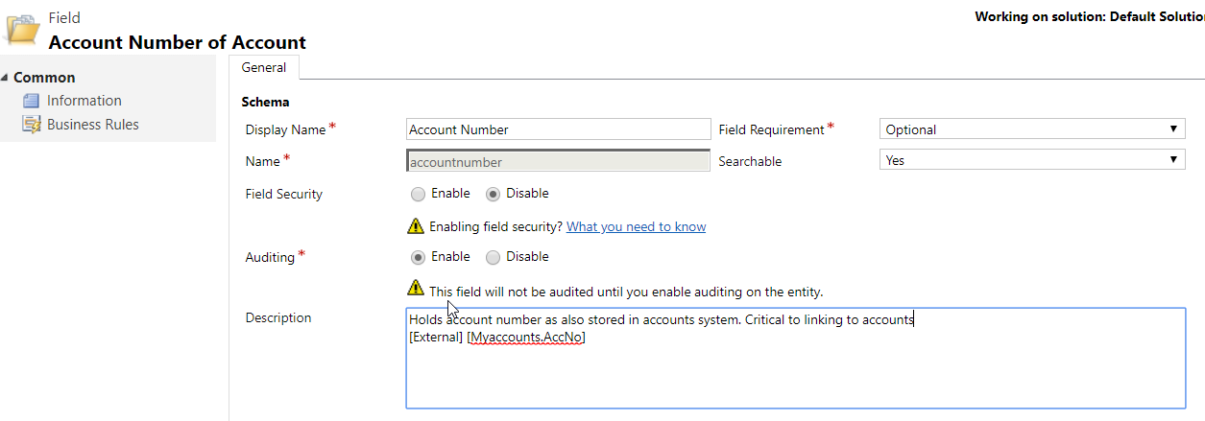

**Release Notes:**

1.2018.1.6 Fixed null exception when exporting without using tags

1.2018.1.5 Fixed package issues needed for XRMToolBox

Description and Tags does this through one screen shown below:

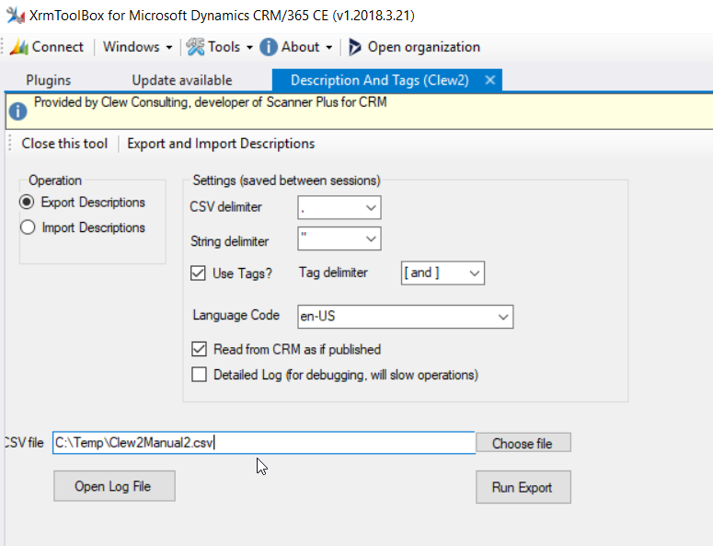

It should be pretty intuitive. You first run the export.

This gives a file part of which is shown below. You edit the description column and edit/add tags.. Tags if they exist are split out into separate columns. A small part of the Excel is shown below. Note how the tags have been split out – up to 10 tags are supported.

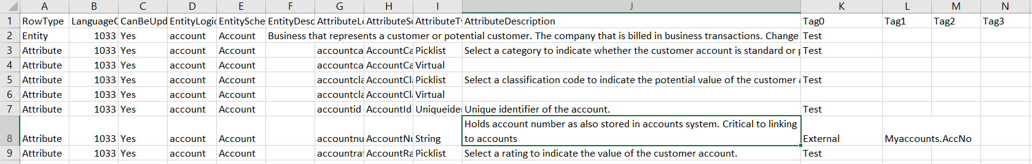

You simply edit the description and tags, then reimport.

Updating all descriptions would take a long time. So, Description and Tags reads all data first then only writes back values which have changed. It also counts the number which are to be changed and gives you a progress update.

Pretty simple but may be useful.

An irritation – probably not important – is that descriptions show up as hints when you hover over a field. This includes the tags. If you need to get rid of this, you could install and use a language which is not used by most users, then import into that language. I have not tried it but it should work.

One minor development point – the code uses the CRM SDK operations UpdateEntityRequest and UpdateAttributeRequest. With the latter it was found that with option set fields the default was overwritten and it automatically set the default to the first one. This is clearly an SDK bug. The code therefore reads the default values and updates them back if the field is an option set.

# Release Notes

This is the first public release