Redline FC Web Prototype: Documentation and Roadmap

1. Project Overview
Redline FC (formerly Bifa) is a football game prototype that has transitioned from the Unity engine to a browser‑centric stack. The goal is to deliver a playable prototype quickly, enabling rapid iteration and wider accessibility. The new stack uses TypeScript, Vite and Three.js, which provide a fast development loop and an easily shareable web build.

2. Quick Start Guide

2.1 Prerequisites
• Node.js 18+
• npm 9+

2.2 Setup and Development
Open a terminal in the project root and run:
npm install
npm run dev
Vite runs a development server with hot module replacement; open the indicated URL (for example, http://localhost:5173) in your browser to play.

2.3 Build & Test
For production builds, run:
npm run test
npm run build
npm run preview
The dist/ folder contains static assets suitable for hosting on services like Netlify, Vercel or GitHub Pages.

2.4 Controls
Player 1 Key | Action
WASD | Move
Shift | Sprint
Space | Pass
E | Shoot
Q | Tackle
Ctrl | Turbo Dash
Tab | Switch controlled player
Esc | Pause

3. Technical Architecture
The game’s architecture emphasises small, testable modules, a deterministic game state, and clear separation between state, rendering, input and HUD. It uses TypeScript for strong typing, Three.js for 3D rendering, Vite for rapid development and Vitest for unit testing.

3.1 Stack Components
• TypeScript – primary language for gameplay and infrastructure.
• Vite – development/build tool with hot module replacement.
• Three.js – lightweight 3D engine for visuals.
• Vitest – fast unit test framework.
• ESLint & Prettier – code quality tools.

3.2 Runtime Modules
The following modules reside in src/game/ and encapsulate gameplay logic:
- Game: Main loop orchestrator: advances match state and coordinates players, ball, AI, HUD and camera.
- Match: Source of truth for the match phase; tracks score, clock, half and pause state.
- Player: Stores player state, manages locomotion and exposes data to the game orchestrator and HUD.
- Ball: Owns ball state and movement, tracks possession and goal state, supports pass and shot behaviour.
- Combat: Resolves tackles and collisions, reporting foul outcomes back to the game loop.
- AI: Controls non‑human players, makes decisions on and off the ball.
- HUD: Updates DOM‑based score, timer, possession indicators and overlays.
- Input: Captures keyboard state and maps actions for single or two player modes.
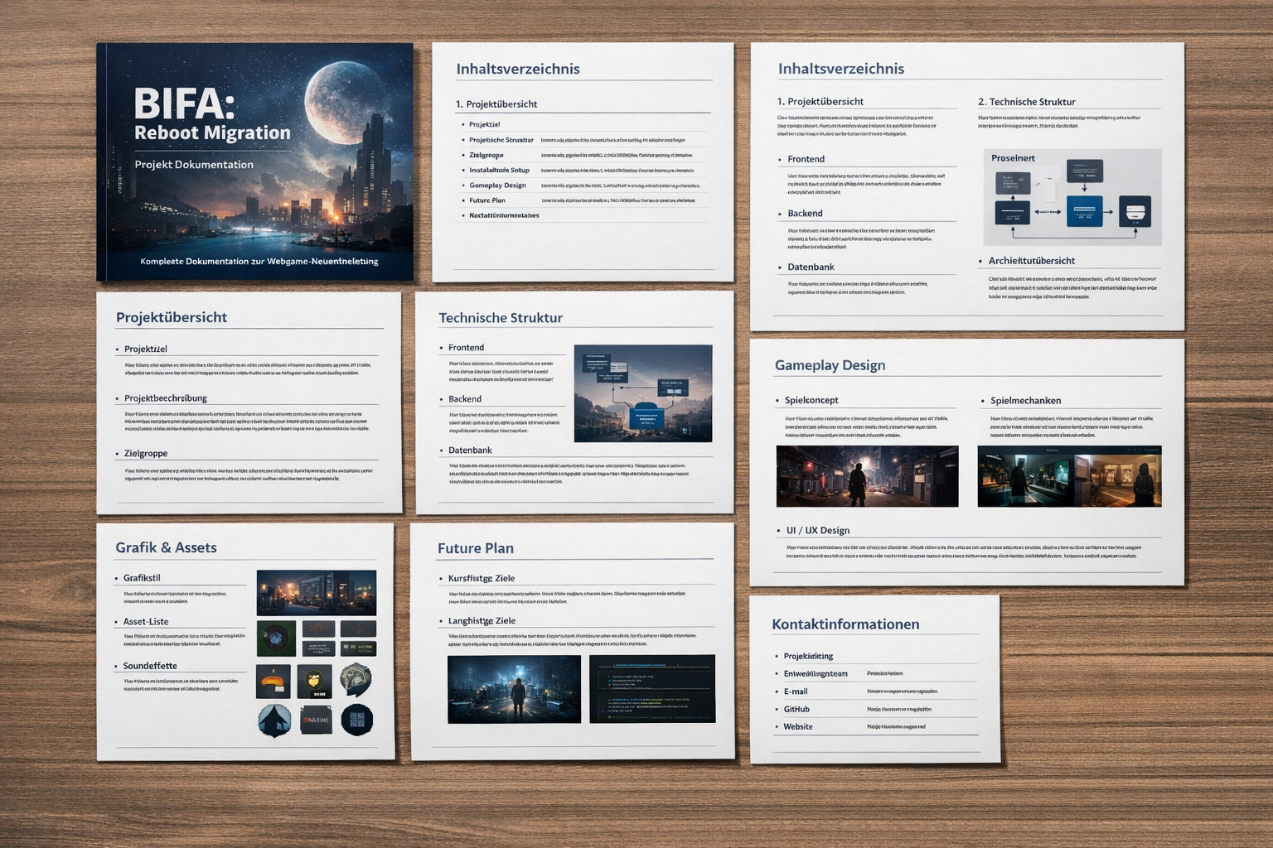

4. Project Structure
The repository is organised as follows:
- index.html: Browser shell and HUD mount points.
- game.html: Legacy standalone game surface; consider retiring in favour of modular code.
- src/: Source code root.
- src/game/: Core gameplay modules (Game, Match, Player, Ball, Combat, AI, HUD, Input).
- src/config/: Gameplay constants and character archetypes.
- src/audio/: Procedural audio helpers.
- src/match/: Shared match enums and types.
- public/: Static assets (models, textures, audio).
- docs/: Architecture documents, checklists, migration guidance.
- test/: Unit tests (via Vitest).

5. Gameplay Features
This prototype delivers a minimal yet playable football experience:
- 3D pitch with free movement, dynamic camera and basic match flow.
- Single‑player team control; press Tab to cycle between teammates.
- Persistent stadium ambience with vuvuzela sound for atmosphere.
- Captain selection and archetype‑driven team lineup in the start screen.
- Live lineup preview before match start, reflecting chosen archetypes.
- Support for local two‑player mode with shared keyboard control.
- Full match lifecycle: waiting to start, kickoff, half‑time, full‑time, overtime and sudden death.
- Primitive AI controlling the opposing team.
- Basic physics for ball possession, passing, shooting and tackling.
- An HTML/CSS HUD showing score, timer, possession indicator, stamina and match callouts.

6. Development and Quality
Maintaining code quality and reproducibility is critical to this project. Use the following commands to validate your environment:
- npm install – install dependencies
- npm run lint – enforce code style
- npm run test – run unit tests with Vitest
- npm run build – generate a production build
- npm run preview – launch a static preview of the build

6.1 Known Issues
Open issues remain in the current prototype:
- Set‑piece control restrictions are not enforced (corners, goal kicks, throw‑ins).
- Penalty sequences remain prototype‑grade – dedicated player‑controlled shoot‑outs are missing.
- Set‑piece variants (e.g., corner restarts) are incomplete.
- Captain and team selection flows are partially implemented.
- Pause menu and HUD need production‑level polish and UX consistency.
- Cross‑browser and mobile validation has not been fully executed.
- Legacy game.html is a monolithic surface awaiting refactor.
- Automated test coverage is limited to core match logic.
- Frame‑rate profiling and optimisation during active play are pending.

7. Migration Playbook (Unity → Web)
To transition Unity concepts into the web prototype, follow these mapping guidelines:
- Scene → Game + World module
- MonoBehaviour → TypeScript class or pure function
- Update() → Central render/tick loop
- Input System → Small Input module
- Prefab → Factory function or JSON definition
- Inspector values → Configuration objects / data modules
- UI Canvas → HTML/CSS overlay
- Build Target → Browser + static assets

7.1 Phases
- Phase 1 – Reset: discard Unity‑specific architecture, produce a browser‑ready spike and implement the core interaction.
- Phase 2 – Isolate mechanics: break down movement, interaction, triggers, game state and camera into independent modules.
- Phase 3 – Separate data from rendering: define a state model and treat rendering as a pure consumer of state.
- Phase 4 – Production readiness: add save games, audio, physics, debugging and a build/deployment pipeline.

8. Roadmap & Future Plan
The following items outline the planned evolution of Redline FC beyond the current prototype:
- Port the remaining core mechanics from the original Unity project into isolated TypeScript modules.
- Define a data model for entities, interactions and overall game state.
- Continue using HTML/CSS for UI/HUD until 3D UI requirements justify React Three Fiber.
- Add physics, save game support, networking or editor layers only when needed.
- Implement full set‑piece restrictions and dedicated penalty shoot‑out sequences.
- Finish captain and roster selection flows, enabling full team customisation.
- Polish the pause menu and finalise the production‑ready HUD layout.
- Conduct comprehensive cross‑browser and mobile viewport testing and optimise for responsiveness.
- Expand automated test coverage to include integration and smoke tests.
- Profile and optimise frame‑rate stability during matches, targeting 60 fps.
- Refactor or retire the legacy game.html in favour of modular pages.
- Add gamepad support and robust input onboarding.
- Prepare release date and owner processes, and document release notes.
- Investigate long‑term features after MVP: online multiplayer, additional arenas, replays and ranked progression.

9. Conclusion
This document summarises the current state of the Redline FC web prototype, its architecture, setup instructions, gameplay features and the roadmap ahead. By embracing a browser‑native stack and modular design, the project aims to deliver a responsive and extensible football experience while retaining the ability to iterate quickly. Continuous improvement of mechanics, UI polish, testing and cross‑platform validation will drive the journey toward a full‑featured release.

