**Implementering af en Windows Form for Archive – Kartotek over medarbejdere og studerende**

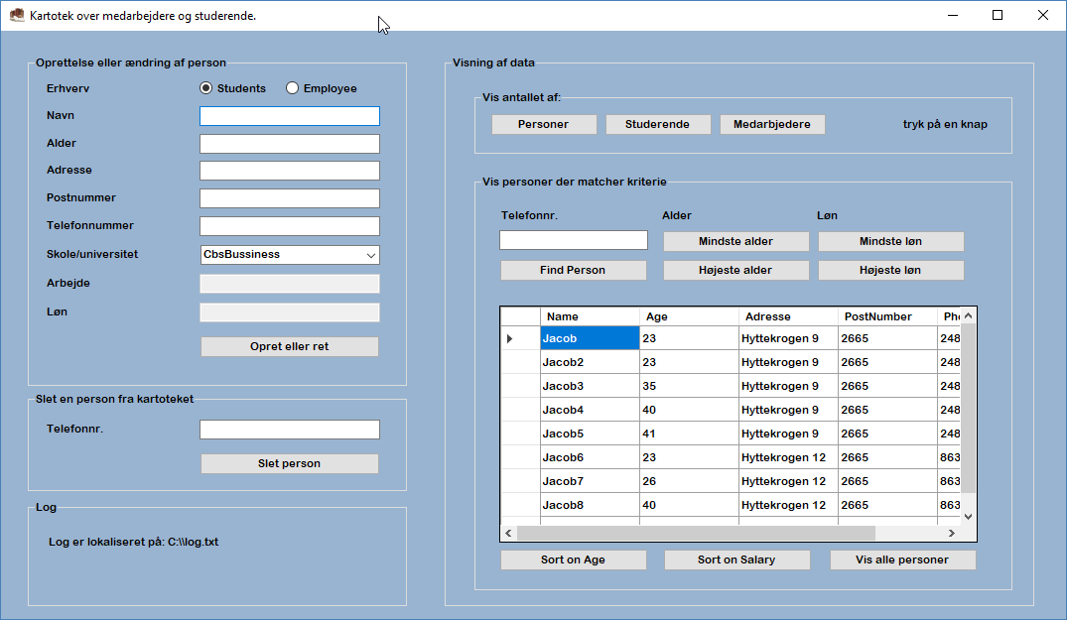

Forfatter: Jacob Kjærgaard

Dato: 20-04-2018

Version: 1.0

Indholdsfortegnelse

Kapitel 1 3

1. Bagrund 3

2. Problemstilling 3

Kapitel 2 3

1. Dataopsætning 3

2. DataStorage 3

3. Teknologi valg 3

4. Teststrategi 3

Kapitel 3 4

Kapitel 4 6

1. Klasse Archive 6

2. Klasse Employees 11

3. Klasse FilePrint 12

4. Klasse SortSalaryDescendingHelper 13

Kapitel 6 14

# Kapitel 1

Kartoteket er et CRUD program, hvor det er muligt at oprette, se, rette og slette studerende og medarbejdere. Herudover er der forskellige info om antal og sorteringer.

## Bagrund

Programmet laves som en obligatorisk afleveringsopgave i faget videregående programmering.

## Problemstilling

Der skal laves en C# applikation til at oprette en eller flere liste-struktur der kan indeholde objekter af en eller flere klasse datastruktur.

Der skal laves en base klasse, der hedder Person, hvor afledte klasser Student og Employee arver fra Person. De skal også arve fra en interface som gøre man kan lave en Compare af to objekter. Dette bruges til sortering.

# Kapitel 2

Det er en rimelig afgrænset problemstilling, som burde kunne løses uden at der skal afgrænses noget. Da det dog er en læringsopgave og det ikke er en applikation, der skal bruges, vil exception handling og unit test blive begrænset, hvor det ikke længere giver læringsmæssigt værdi i forhold til deadlinie.

## Dataopsætning

Systemet fødes med data for at gøre testen lettere, men ellers indsamles der kun de data, der indtastes i selve applikationen.

## DataStorage

Pt. Bliver data gemt i lister, hvilket kunne ændres til en database, hvis behovet viste sig at opstå.

## Teknologi valg

C#, og VS

## Teststrategi

Der er lavet et separat unit test project, hvor der er lavet unit test på enkelte metoder, men der er blevet

afgrænset at bruge al for meget tid her.

Der er lavet manuel test for at sandsynliggøre at programmet fungere efter hensigten i alle henseender. Der er fundet flere bugs i processen, som er løst med det samme.

Der udestår dog en enkelt bug, jeg ikke kunne løse. Hvis man sorter employees ved at trykke på ”Sort on Salary” sker der ikke noget når man trykker igen, hvor den burde vende listen om – men hvis man trykker på en anden knap og så sort igen, så vises listen med den korrekte sortering.

# Kapitel 3

Der er lavet følgende UML diagram, for at vise strukturen af programmet.

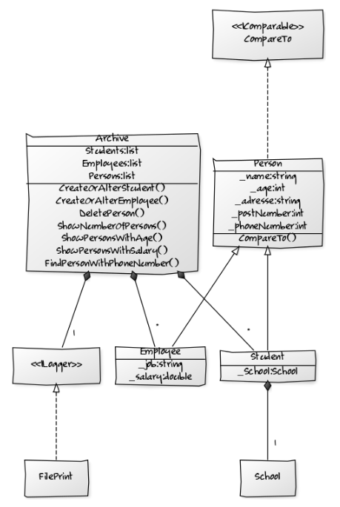

Herudover er der 3 klasser der implementerer icomparer, samt en et unit test project og en enum klasse (MessageType), der bliver brugt i FilePrint.

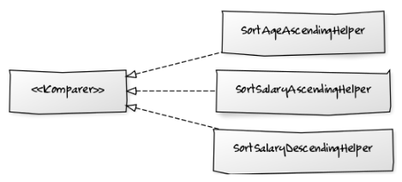

Person klassen er lavet som en abstrakt klasse, hvor der er to arvede klasser. Person klassen er lavet abstract, da opgaveteksten går meget på, at man skal være enten medarbejder eller studerende og det ikke er meningen, at der skal være en instans af person klassen.

Persons implementere interfacet IComparable, som giver en default sortering (alder descending), som student og employee arver. Der er herudover også blevet lavet 3 classes som implementerer Icomparer<person>/<Employee>, så der kan laves en alternativ sortering på alder i stigende og på faldende og stigende løn.

Sort() har en overload som tager et Icompare interface, det er altså den klasse, der implementer dette interface, der styrer sorteringen. Ved at give sort metoden en classe der sorter Employee efter salary desencending, er det den måde Sort funktionen sorter den pågældende liste af medarbejdere.

Jeg har valgt, at Archive skal holde 2 lister. En med students og en med employees. Jeg tænkte oprindeligt, at have én liste og så lave en for løkke og caste til student/employee (AS operatoren) for så at validere om casting er succesfuldt, så jeg ved om det er en studerende eller ej – Men endte med at konkludere, at det blev for beregningstungt fremfor ”bare” at lave en type-safe liste, der kun holdte det ene eller det andet og så må man lave to løkker hvis man skal gennemgå begge lister.

Det eneste der ellers er lidt interessant i min opbygning er, at jeg har valgt at salary skal være nullable, det er sket dels for at lære denne feature, men også da det ofte sker, at folk ikke ønsker at oplyse netop denne. Ved at lave den nullable, bliver feltet boxed til et objekt og det har en performance straf, men da det er et lille projekt og performace pt. Ikke er et issue accepteres dette.

I min Gui vil der i oprettelse være en radio button som bliver oversat til boolean værdi isStudent, så der bliver kaldt den korrekte CreateOrAlter metode – Jeg valgte 2 metoder, men man kunne have valgt én med optional parameters, hvor der var forskelle, men det virkede forkert.

I mine sorteringsknapper lavede jeg også en ”Toggle”, så hvis man trykker på den samme knap igen, sker sorteringen modsat.

For at udvide brugen af interfaces har jeg valgt at uddelegere beskeder både i form af exceptions og generelle log-beskeder til et interface, hvor jeg har oprettet en klasse, der implementerer interface, der udskriver til en fil. Det sker via dependecy injection i starten af formularen hvor objectet archive dannes (kunne også være lavet i Program.cs), så det vil være let at lave en ny klasse, der eksempelvis udskriver til en printer eller lign. Og så skal archive bare have denne, når den oprettes i stedet.

# Kapitel 4

Der er lavet mange klasser og enkelte vises her, mens de andre er vedlagt i rapporten bagerst.

## Klasse Archive

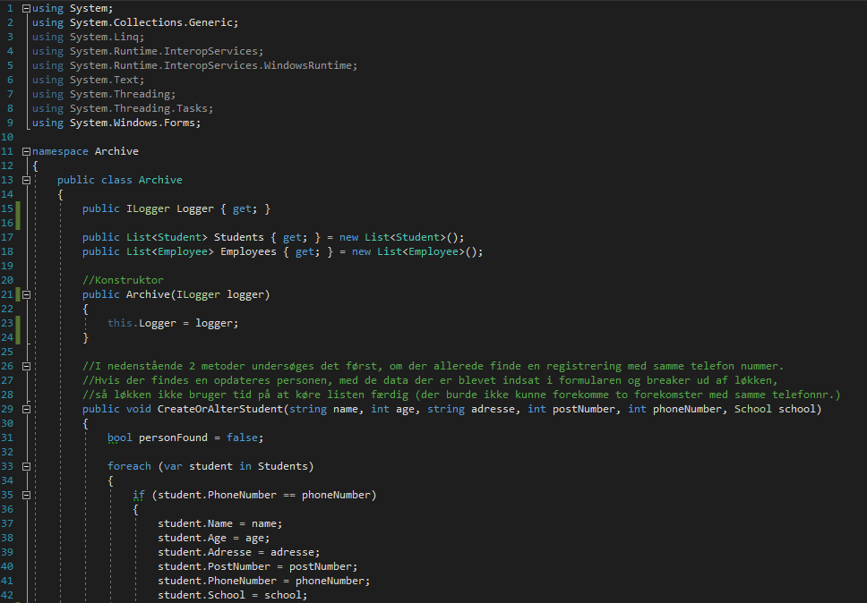

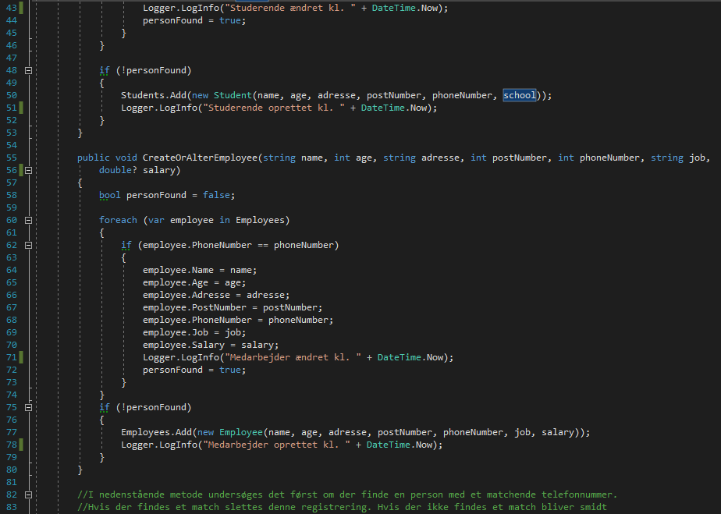

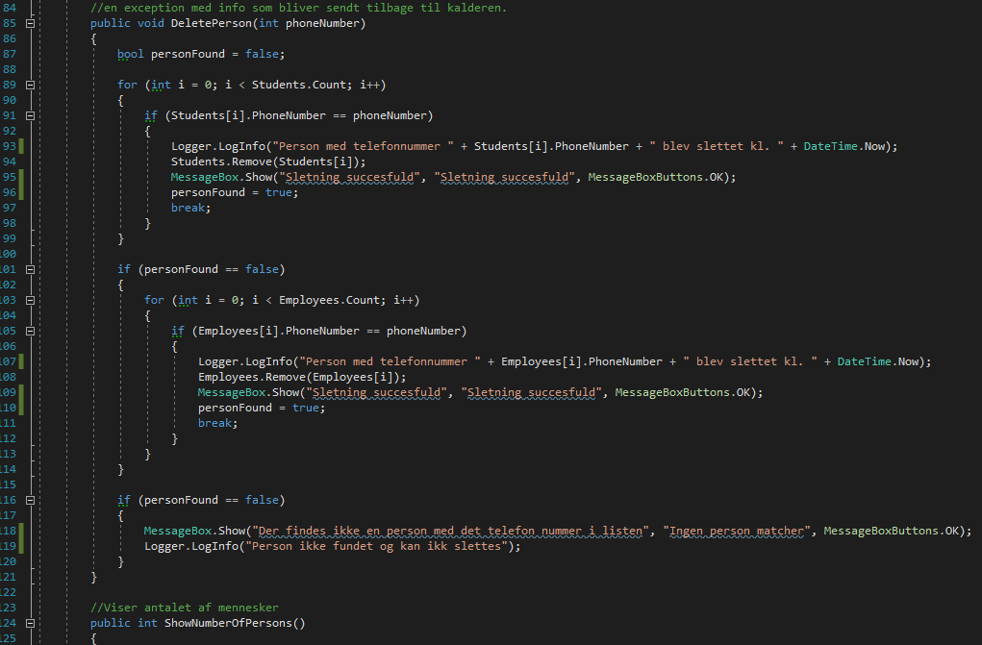

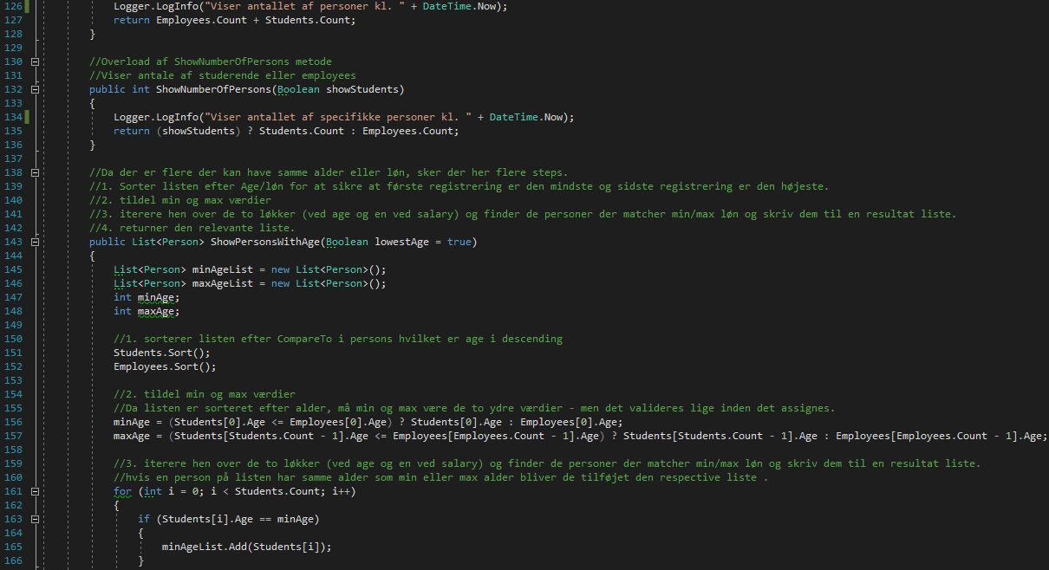

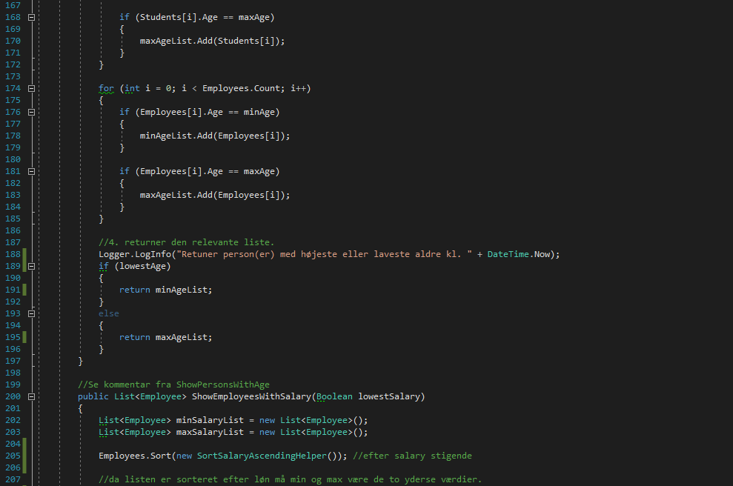

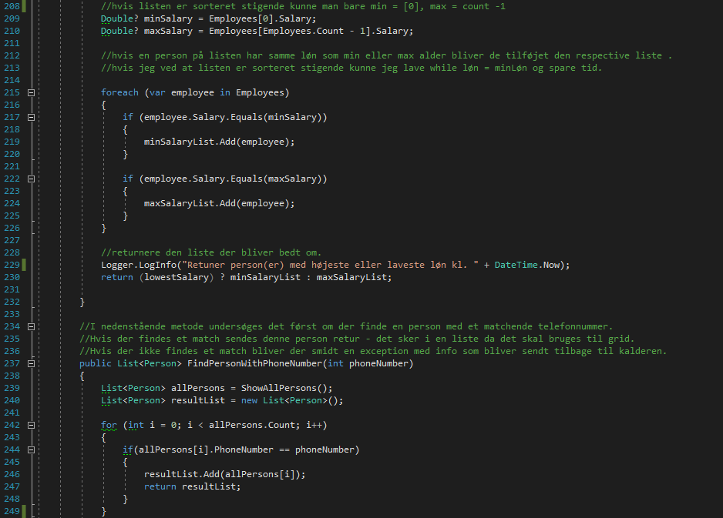

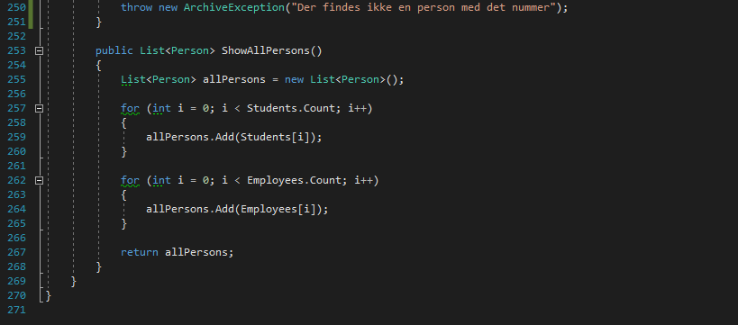

## Klasse Employees

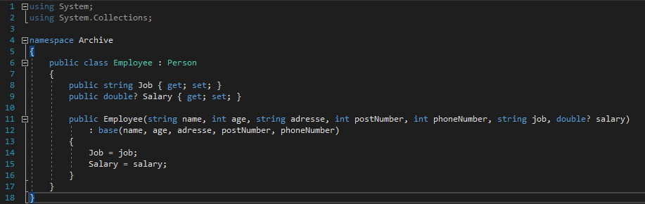

## Klasse FilePrint

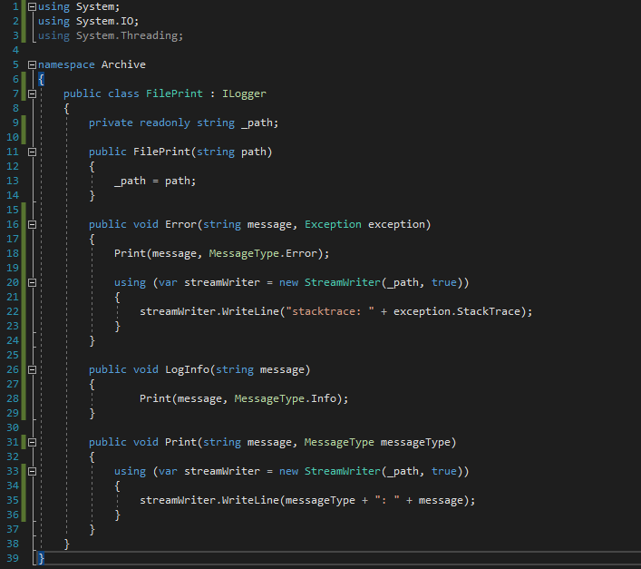

## Klasse SortSalaryDescendingHelper

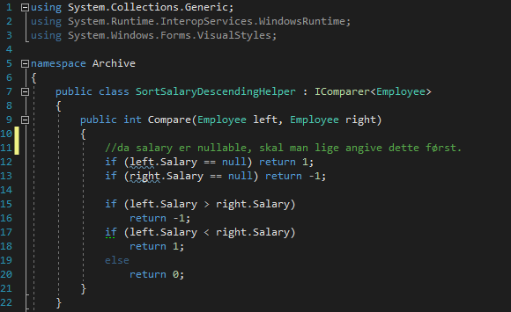

5.1. Fortæl kort om testen, screenshot, samt resultatet og tilrettelse hvis der var fejl

Der er lavet et unitTest project, hvor der er lavet en unit test for enkelte af de hoved metoder, der generer output. Der er lavet en test for hver af udgangene af metoden.

Disse er kørt for at sikre at back-end lever op til kravene.

Der er også lavet manuel test af front-end og for at gøre dette lettere, har jeg preudfyldt nogle studerende og medarbejdere, så man kan se min/max og antal uden at skulle oprette dem via brugergrænsefladen først.

5.2. Konklustion på test.

Det er en velfungerende applikation, dog kunne design og brugervenlighed forbedres.

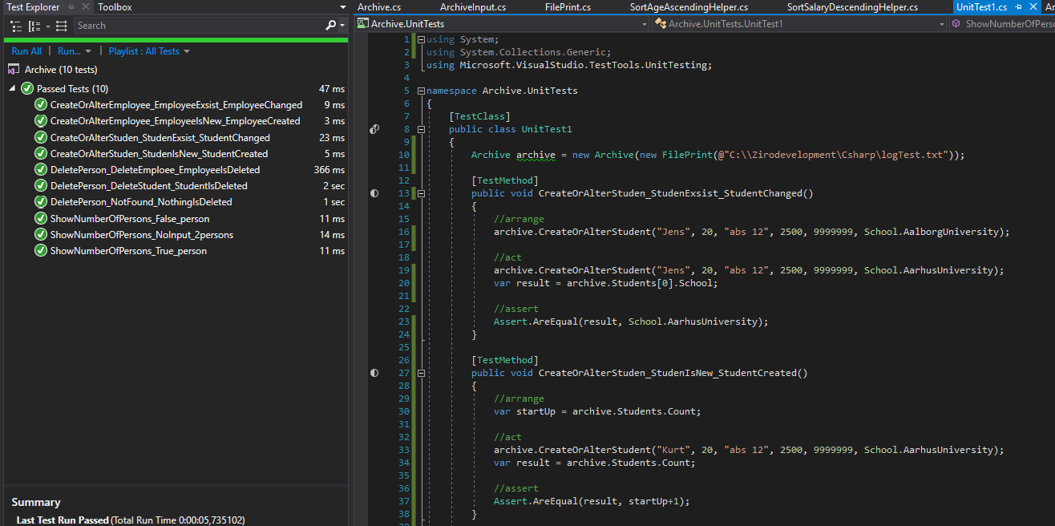

# Kapitel 6

Alt i alt synes jeg at opgaven var god til at lære mere om interfaces og få dem ind under huden.

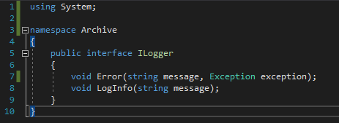

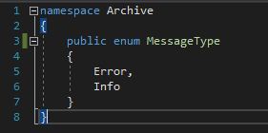

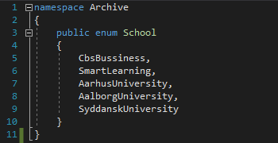

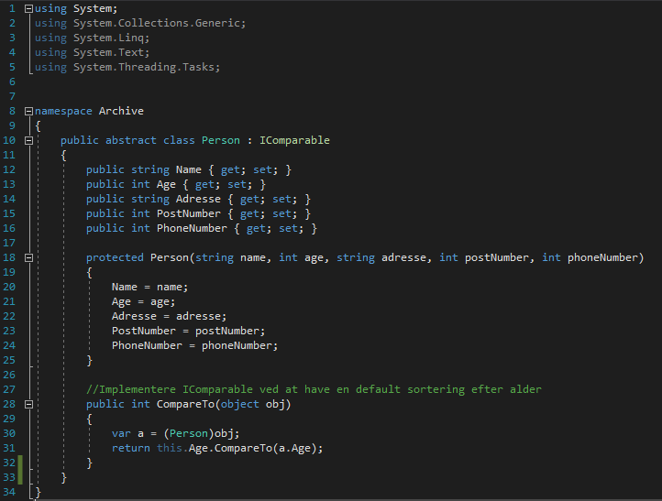

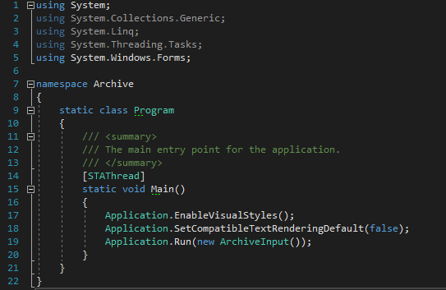

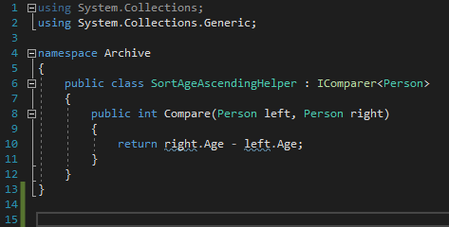

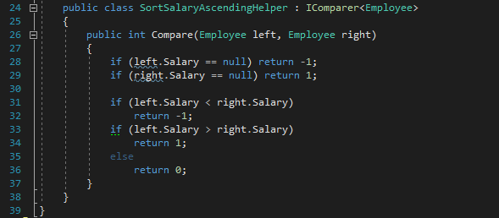

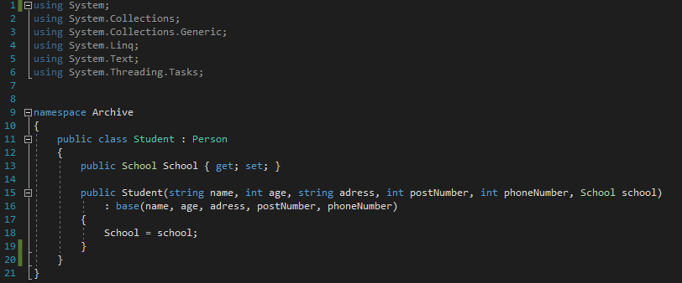

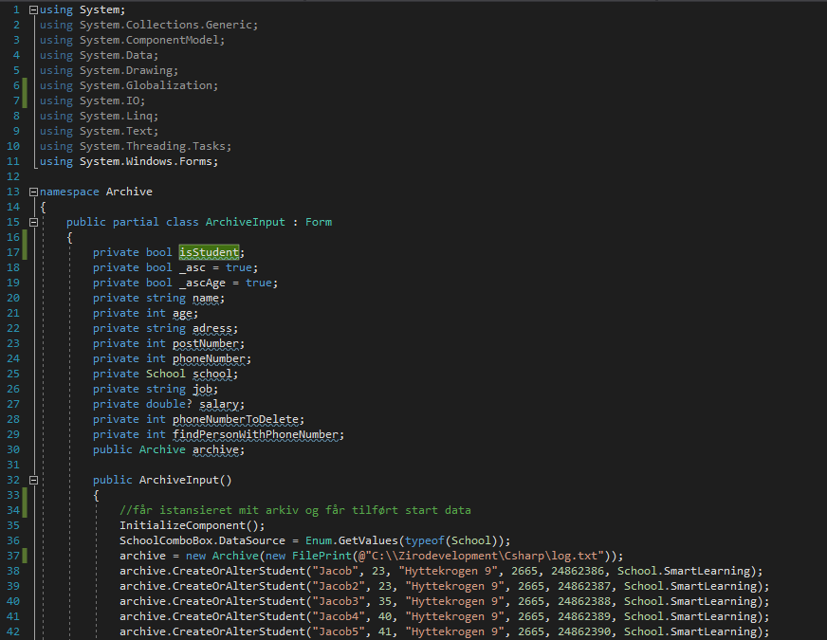

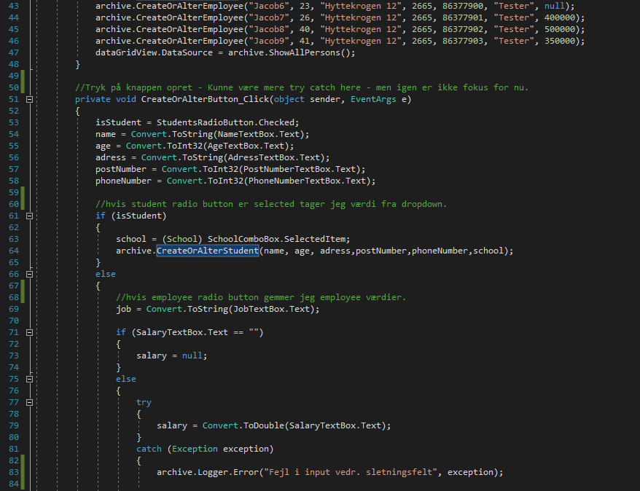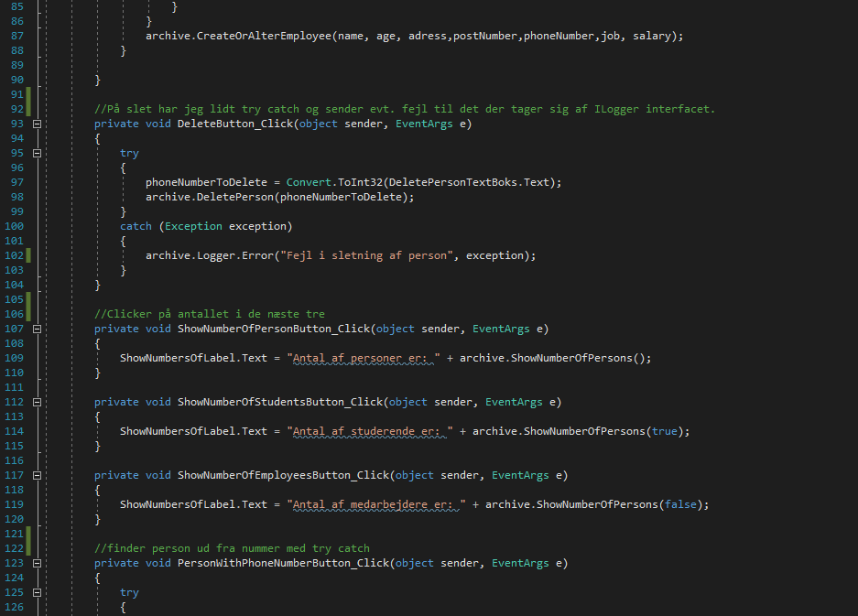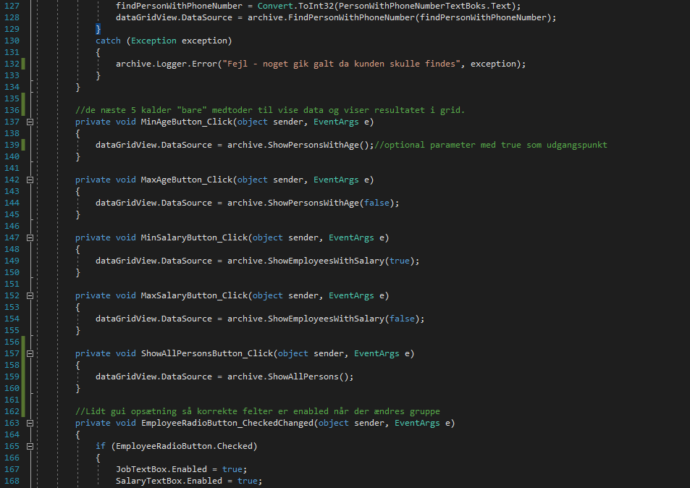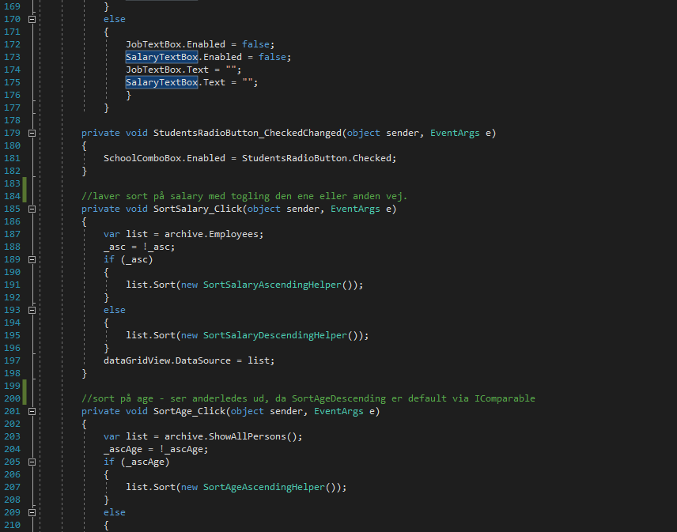

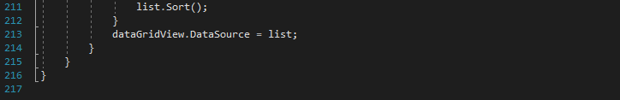

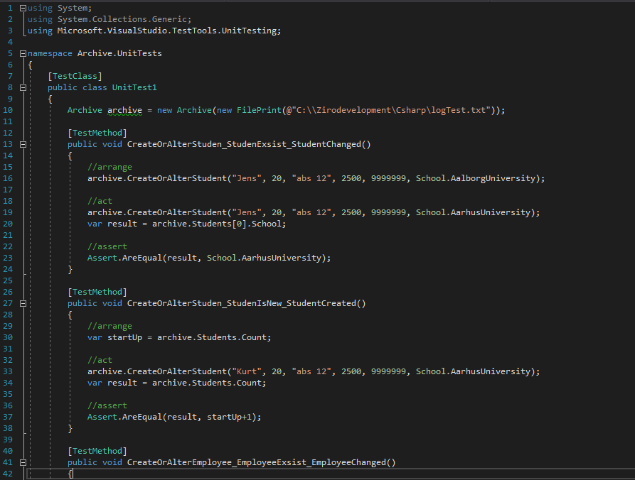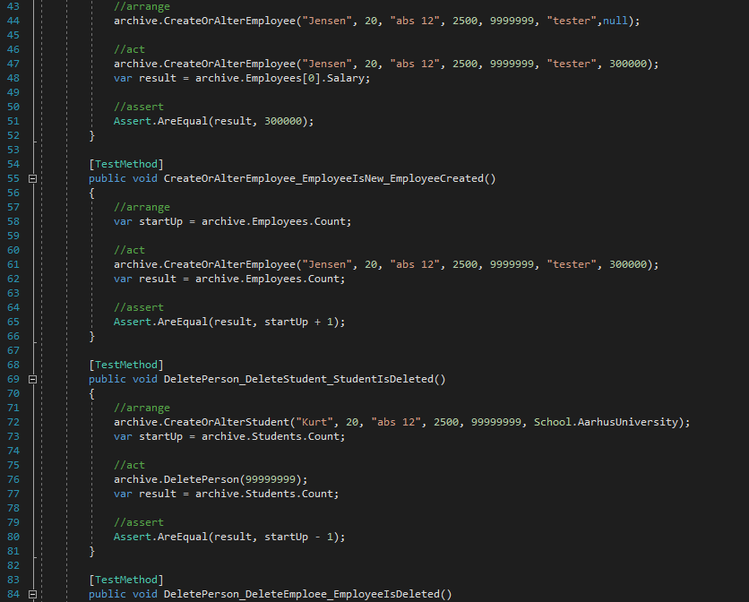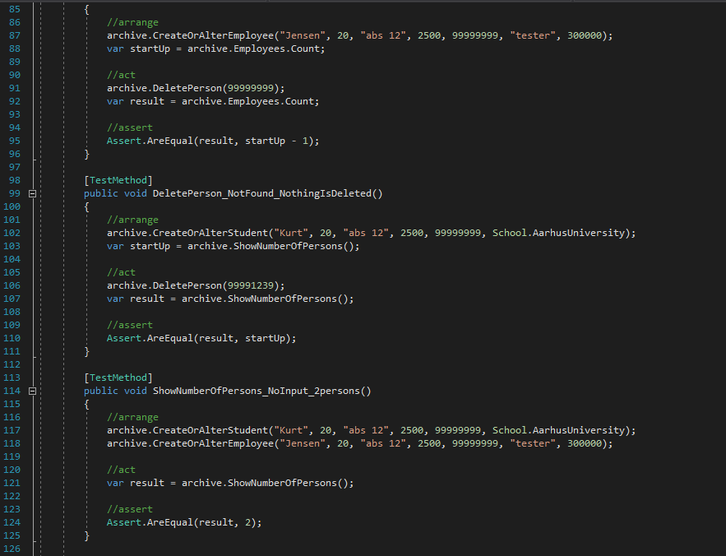

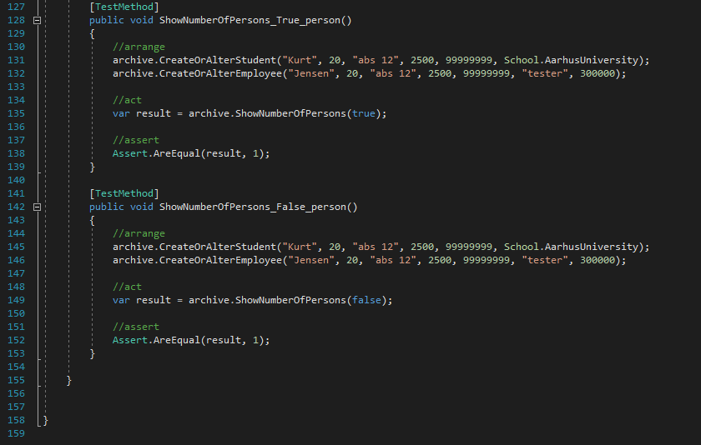

------ArchiveInput--------

namespace Archive

{

partial class ArchiveInput

{

/// <summary>

/// Required designer variable.

/// </summary>

private System.ComponentModel.IContainer components = null;

/// <summary>

/// Clean up any resources being used.

/// </summary>

/// <param name="disposing">true if managed resources should be disposed; otherwise, false.</param>

protected override void Dispose(bool disposing)

{

if (disposing && (components != null))

{

components.Dispose();

}

base.Dispose(disposing);

}

#region Windows Form Designer generated code

/// <summary>

/// Required method for Designer support - do not modify

/// the contents of this method with the code editor.

/// </summary>

private void InitializeComponent()

{

System.ComponentModel.ComponentResourceManager resources = new System.ComponentModel.ComponentResourceManager(typeof(ArchiveInput));

this.groupBox1 = new System.Windows.Forms.GroupBox();

this.SchoolComboBox = new System.Windows.Forms.ComboBox();

this.CreateOrAlterButton = new System.Windows.Forms.Button();

this.label9 = new System.Windows.Forms.Label();

this.SalaryTextBox = new System.Windows.Forms.TextBox();

this.label8 = new System.Windows.Forms.Label();

this.JobTextBox = new System.Windows.Forms.TextBox();

this.label7 = new System.Windows.Forms.Label();

this.label6 = new System.Windows.Forms.Label();

this.PhoneNumberTextBox = new System.Windows.Forms.TextBox();

this.label5 = new System.Windows.Forms.Label();

this.PostNumberTextBox = new System.Windows.Forms.TextBox();

this.label4 = new System.Windows.Forms.Label();

this.AdressTextBox = new System.Windows.Forms.TextBox();

this.label1 = new System.Windows.Forms.Label();

this.AgeTextBox = new System.Windows.Forms.TextBox();

this.label3 = new System.Windows.Forms.Label();

this.EmployeeRadioButton = new System.Windows.Forms.RadioButton();

this.StudentsRadioButton = new System.Windows.Forms.RadioButton();

this.label2 = new System.Windows.Forms.Label();

this.NameTextBox = new System.Windows.Forms.TextBox();

this.groupBox2 = new System.Windows.Forms.GroupBox();

this.groupBox5 = new System.Windows.Forms.GroupBox();

this.SortSalary = new System.Windows.Forms.Button();

this.SortAge = new System.Windows.Forms.Button();

this.ShowAllPersonsButton = new System.Windows.Forms.Button();

this.label13 = new System.Windows.Forms.Label();

this.label12 = new System.Windows.Forms.Label();

this.MaxSalaryButton = new System.Windows.Forms.Button();

this.MinSalaryButton = new System.Windows.Forms.Button();

this.MinAgeButton = new System.Windows.Forms.Button();

this.MaxAgeButton = new System.Windows.Forms.Button();

this.label11 = new System.Windows.Forms.Label();

this.dataGridView = new System.Windows.Forms.DataGridView();

this.PersonWithPhoneNumberTextBoks = new System.Windows.Forms.TextBox();

this.PersonWithPhoneNumberButton = new System.Windows.Forms.Button();

this.groupBox4 = new System.Windows.Forms.GroupBox();

this.ShowNumbersOfLabel = new System.Windows.Forms.Label();

this.ShowNumberOfPersonButton = new System.Windows.Forms.Button();

this.ShowNumberOfEmployeesButton = new System.Windows.Forms.Button();

this.ShowNumberOfStudentsButton = new System.Windows.Forms.Button();

this.DeletePersonTextBoks = new System.Windows.Forms.TextBox();

this.label10 = new System.Windows.Forms.Label();

this.DeleteButton = new System.Windows.Forms.Button();

this.groupBox3 = new System.Windows.Forms.GroupBox();

this.groupBox6 = new System.Windows.Forms.GroupBox();

this.label14 = new System.Windows.Forms.Label();

this.groupBox1.SuspendLayout();

this.groupBox2.SuspendLayout();

this.groupBox5.SuspendLayout();

((System.ComponentModel.ISupportInitialize)(this.dataGridView)).BeginInit();

this.groupBox4.SuspendLayout();

this.groupBox3.SuspendLayout();

this.groupBox6.SuspendLayout();

this.SuspendLayout();

//

// groupBox1

//

this.groupBox1.Controls.Add(this.SchoolComboBox);

this.groupBox1.Controls.Add(this.CreateOrAlterButton);

this.groupBox1.Controls.Add(this.label9);

this.groupBox1.Controls.Add(this.SalaryTextBox);

this.groupBox1.Controls.Add(this.label8);

this.groupBox1.Controls.Add(this.JobTextBox);

this.groupBox1.Controls.Add(this.label7);

this.groupBox1.Controls.Add(this.label6);

this.groupBox1.Controls.Add(this.PhoneNumberTextBox);

this.groupBox1.Controls.Add(this.label5);

this.groupBox1.Controls.Add(this.PostNumberTextBox);

this.groupBox1.Controls.Add(this.label4);

this.groupBox1.Controls.Add(this.AdressTextBox);

this.groupBox1.Controls.Add(this.label1);

this.groupBox1.Controls.Add(this.AgeTextBox);

this.groupBox1.Controls.Add(this.label3);

this.groupBox1.Controls.Add(this.EmployeeRadioButton);

this.groupBox1.Controls.Add(this.StudentsRadioButton);

this.groupBox1.Controls.Add(this.label2);

this.groupBox1.Controls.Add(this.NameTextBox);

this.groupBox1.Location = new System.Drawing.Point(27, 26);

this.groupBox1.Name = "groupBox1";

this.groupBox1.Size = new System.Drawing.Size(382, 333);

this.groupBox1.TabIndex = 0;

this.groupBox1.TabStop = false;

this.groupBox1.Text = "Oprettelse eller ændring af person";

//

// SchoolComboBox

//

this.SchoolComboBox.FormattingEnabled = true;

this.SchoolComboBox.Location = new System.Drawing.Point(174, 190);

this.SchoolComboBox.Name = "SchoolComboBox";

this.SchoolComboBox.Size = new System.Drawing.Size(181, 20);

this.SchoolComboBox.TabIndex = 22;

//

// CreateOrAlterButton

//

this.CreateOrAlterButton.Location = new System.Drawing.Point(173, 281);

this.CreateOrAlterButton.Name = "CreateOrAlterButton";

this.CreateOrAlterButton.Size = new System.Drawing.Size(182, 23);

this.CreateOrAlterButton.TabIndex = 21;

this.CreateOrAlterButton.Text = "Opret eller ret";

this.CreateOrAlterButton.UseVisualStyleBackColor = true;

this.CreateOrAlterButton.Click += new System.EventHandler(this.CreateOrAlterButton_Click);

//

// label9

//

this.label9.Anchor = System.Windows.Forms.AnchorStyles.Left;

this.label9.AutoSize = true;

this.label9.Location = new System.Drawing.Point(17, 251);

this.label9.MinimumSize = new System.Drawing.Size(150, 18);

this.label9.Name = "label9";

this.label9.Size = new System.Drawing.Size(150, 18);

this.label9.TabIndex = 20;

this.label9.Text = "Løn";

//

// SalaryTextBox

//

this.SalaryTextBox.Enabled = false;

this.SalaryTextBox.Location = new System.Drawing.Point(173, 248);

this.SalaryTextBox.MinimumSize = new System.Drawing.Size(150, 18);

this.SalaryTextBox.Name = "SalaryTextBox";

this.SalaryTextBox.Size = new System.Drawing.Size(182, 20);

this.SalaryTextBox.TabIndex = 19;

//

// label8

//

this.label8.Anchor = System.Windows.Forms.AnchorStyles.Left;

this.label8.AutoSize = true;

this.label8.Location = new System.Drawing.Point(17, 222);

this.label8.MinimumSize = new System.Drawing.Size(150, 18);

this.label8.Name = "label8";

this.label8.Size = new System.Drawing.Size(150, 18);

this.label8.TabIndex = 18;

this.label8.Text = "Arbejde";

//

// JobTextBox

//

this.JobTextBox.Enabled = false;

this.JobTextBox.Location = new System.Drawing.Point(173, 219);

this.JobTextBox.MinimumSize = new System.Drawing.Size(150, 18);

this.JobTextBox.Name = "JobTextBox";

this.JobTextBox.Size = new System.Drawing.Size(182, 20);

this.JobTextBox.TabIndex = 17;

//

// label7

//

this.label7.Anchor = System.Windows.Forms.AnchorStyles.Left;

this.label7.AutoSize = true;

this.label7.Location = new System.Drawing.Point(17, 193);

this.label7.MinimumSize = new System.Drawing.Size(150, 18);

this.label7.Name = "label7";

this.label7.Size = new System.Drawing.Size(150, 18);

this.label7.TabIndex = 16;

this.label7.Text = "Skole/universitet";

//

// label6

//

this.label6.Anchor = System.Windows.Forms.AnchorStyles.Left;

this.label6.AutoSize = true;

this.label6.Location = new System.Drawing.Point(17, 164);

this.label6.MinimumSize = new System.Drawing.Size(150, 18);

this.label6.Name = "label6";

this.label6.Size = new System.Drawing.Size(150, 18);

this.label6.TabIndex = 14;

this.label6.Text = "Telefonnummer";

//

// PhoneNumberTextBox

//

this.PhoneNumberTextBox.Location = new System.Drawing.Point(173, 161);

this.PhoneNumberTextBox.MinimumSize = new System.Drawing.Size(150, 18);

this.PhoneNumberTextBox.Name = "PhoneNumberTextBox";

this.PhoneNumberTextBox.Size = new System.Drawing.Size(182, 20);

this.PhoneNumberTextBox.TabIndex = 13;

//

// label5

//

this.label5.Anchor = System.Windows.Forms.AnchorStyles.Left;

this.label5.AutoSize = true;

this.label5.Location = new System.Drawing.Point(17, 136);

this.label5.MinimumSize = new System.Drawing.Size(150, 18);

this.label5.Name = "label5";

this.label5.Size = new System.Drawing.Size(150, 18);

this.label5.TabIndex = 12;

this.label5.Text = "Postnummer";

//

// PostNumberTextBox

//

this.PostNumberTextBox.Location = new System.Drawing.Point(173, 133);

this.PostNumberTextBox.MinimumSize = new System.Drawing.Size(150, 18);

this.PostNumberTextBox.Name = "PostNumberTextBox";

this.PostNumberTextBox.Size = new System.Drawing.Size(182, 20);

this.PostNumberTextBox.TabIndex = 11;

//

// label4

//

this.label4.Anchor = System.Windows.Forms.AnchorStyles.Left;

this.label4.AutoSize = true;

this.label4.Location = new System.Drawing.Point(17, 108);

this.label4.MinimumSize = new System.Drawing.Size(150, 18);

this.label4.Name = "label4";

this.label4.Size = new System.Drawing.Size(150, 18);

this.label4.TabIndex = 10;

this.label4.Text = "Adresse";

//

// AdressTextBox

//

this.AdressTextBox.Location = new System.Drawing.Point(173, 105);

this.AdressTextBox.MinimumSize = new System.Drawing.Size(150, 18);

this.AdressTextBox.Name = "AdressTextBox";

this.AdressTextBox.Size = new System.Drawing.Size(182, 20);

this.AdressTextBox.TabIndex = 9;

//

// label1

//

this.label1.Anchor = System.Windows.Forms.AnchorStyles.Left;

this.label1.AutoSize = true;

this.label1.Location = new System.Drawing.Point(17, 81);

this.label1.MinimumSize = new System.Drawing.Size(150, 18);

this.label1.Name = "label1";

this.label1.Size = new System.Drawing.Size(150, 18);

this.label1.TabIndex = 8;

this.label1.Text = "Alder";

//

// AgeTextBox

//

this.AgeTextBox.Location = new System.Drawing.Point(173, 78);

this.AgeTextBox.MinimumSize = new System.Drawing.Size(150, 18);

this.AgeTextBox.Name = "AgeTextBox";

this.AgeTextBox.Size = new System.Drawing.Size(182, 20);

this.AgeTextBox.TabIndex = 7;

//

// label3

//

this.label3.Anchor = System.Windows.Forms.AnchorStyles.Left;

this.label3.AutoSize = true;

this.label3.Location = new System.Drawing.Point(17, 53);

this.label3.MinimumSize = new System.Drawing.Size(150, 18);

this.label3.Name = "label3";

this.label3.Size = new System.Drawing.Size(150, 18);

this.label3.TabIndex = 6;

this.label3.Text = "Navn";

//

// EmployeeRadioButton

//

this.EmployeeRadioButton.AutoSize = true;

this.EmployeeRadioButton.Location = new System.Drawing.Point(260, 24);

this.EmployeeRadioButton.Name = "EmployeeRadioButton";

this.EmployeeRadioButton.Size = new System.Drawing.Size(77, 16);

this.EmployeeRadioButton.TabIndex = 5;

this.EmployeeRadioButton.Text = "Employee";

this.EmployeeRadioButton.UseVisualStyleBackColor = true;

this.EmployeeRadioButton.CheckedChanged += new System.EventHandler(this.EmployeeRadioButton_CheckedChanged);

//

// StudentsRadioButton

//

this.StudentsRadioButton.AutoSize = true;

this.StudentsRadioButton.Checked = true;

this.StudentsRadioButton.Location = new System.Drawing.Point(173, 24);

this.StudentsRadioButton.Name = "StudentsRadioButton";

this.StudentsRadioButton.Size = new System.Drawing.Size(72, 16);

this.StudentsRadioButton.TabIndex = 4;

this.StudentsRadioButton.TabStop = true;

this.StudentsRadioButton.Text = "Students";

this.StudentsRadioButton.UseVisualStyleBackColor = true;

this.StudentsRadioButton.CheckedChanged += new System.EventHandler(this.StudentsRadioButton_CheckedChanged);

//

// label2

//

this.label2.Anchor = System.Windows.Forms.AnchorStyles.Left;

this.label2.AutoSize = true;

this.label2.Location = new System.Drawing.Point(17, 26);

this.label2.MinimumSize = new System.Drawing.Size(150, 18);

this.label2.Name = "label2";

this.label2.Size = new System.Drawing.Size(150, 18);

this.label2.TabIndex = 3;

this.label2.Text = "Erhverv";

//

// NameTextBox

//

this.NameTextBox.Location = new System.Drawing.Point(173, 50);

this.NameTextBox.MinimumSize = new System.Drawing.Size(150, 18);

this.NameTextBox.Name = "NameTextBox";

this.NameTextBox.Size = new System.Drawing.Size(182, 20);

this.NameTextBox.TabIndex = 1;

//

// groupBox2

//

this.groupBox2.Controls.Add(this.groupBox5);

this.groupBox2.Controls.Add(this.groupBox4);

this.groupBox2.Location = new System.Drawing.Point(447, 26);

this.groupBox2.Name = "groupBox2";

this.groupBox2.Size = new System.Drawing.Size(594, 555);

this.groupBox2.TabIndex = 1;

this.groupBox2.TabStop = false;

this.groupBox2.Text = "Visning af data";

//

// groupBox5

//

this.groupBox5.Controls.Add(this.SortSalary);

this.groupBox5.Controls.Add(this.SortAge);

this.groupBox5.Controls.Add(this.ShowAllPersonsButton);

this.groupBox5.Controls.Add(this.label13);

this.groupBox5.Controls.Add(this.label12);

this.groupBox5.Controls.Add(this.MaxSalaryButton);

this.groupBox5.Controls.Add(this.MinSalaryButton);

this.groupBox5.Controls.Add(this.MinAgeButton);

this.groupBox5.Controls.Add(this.MaxAgeButton);

this.groupBox5.Controls.Add(this.label11);

this.groupBox5.Controls.Add(this.dataGridView);

this.groupBox5.Controls.Add(this.PersonWithPhoneNumberTextBoks);

this.groupBox5.Controls.Add(this.PersonWithPhoneNumberButton);

this.groupBox5.Location = new System.Drawing.Point(30, 120);

this.groupBox5.Name = "groupBox5";

this.groupBox5.Size = new System.Drawing.Size(542, 419);

this.groupBox5.TabIndex = 26;

this.groupBox5.TabStop = false;

this.groupBox5.Text = "Vis personer der matcher kriterie";

//

// SortSalary

//

this.SortSalary.Location = new System.Drawing.Point(190, 376);

this.SortSalary.Name = "SortSalary";

this.SortSalary.Size = new System.Drawing.Size(150, 23);

this.SortSalary.TabIndex = 34;

this.SortSalary.Text = "Sort on Salary";

this.SortSalary.UseVisualStyleBackColor = true;

this.SortSalary.Click += new System.EventHandler(this.SortSalary_Click);

//

// SortAge

//

this.SortAge.Location = new System.Drawing.Point(25, 376);

this.SortAge.Name = "SortAge";

this.SortAge.Size = new System.Drawing.Size(150, 23);

this.SortAge.TabIndex = 33;

this.SortAge.Text = "Sort on Age";

this.SortAge.UseVisualStyleBackColor = true;

this.SortAge.Click += new System.EventHandler(this.SortAge_Click);

//

// ShowAllPersonsButton

//

this.ShowAllPersonsButton.Location = new System.Drawing.Point(357, 376);

this.ShowAllPersonsButton.Name = "ShowAllPersonsButton";

this.ShowAllPersonsButton.Size = new System.Drawing.Size(150, 23);

this.ShowAllPersonsButton.TabIndex = 32;

this.ShowAllPersonsButton.Text = "Vis alle personer";

this.ShowAllPersonsButton.UseVisualStyleBackColor = true;

this.ShowAllPersonsButton.Click += new System.EventHandler(this.ShowAllPersonsButton_Click);

//

// label13

//

this.label13.Anchor = System.Windows.Forms.AnchorStyles.Left;

this.label13.AutoSize = true;

this.label13.Location = new System.Drawing.Point(343, 34);

this.label13.MinimumSize = new System.Drawing.Size(150, 18);

this.label13.Name = "label13";

this.label13.Size = new System.Drawing.Size(150, 18);

this.label13.TabIndex = 31;

this.label13.Text = "Løn";

//

// label12

//

this.label12.Anchor = System.Windows.Forms.AnchorStyles.Left;

this.label12.AutoSize = true;

this.label12.Location = new System.Drawing.Point(187, 34);

this.label12.MinimumSize = new System.Drawing.Size(150, 18);

this.label12.Name = "label12";

this.label12.Size = new System.Drawing.Size(150, 18);

this.label12.TabIndex = 27;

this.label12.Text = "Alder";

//

// MaxSalaryButton

//

this.MaxSalaryButton.Location = new System.Drawing.Point(345, 84);

this.MaxSalaryButton.Name = "MaxSalaryButton";

this.MaxSalaryButton.Size = new System.Drawing.Size(150, 23);

this.MaxSalaryButton.TabIndex = 30;

this.MaxSalaryButton.Text = "Højeste løn";

this.MaxSalaryButton.UseVisualStyleBackColor = true;

this.MaxSalaryButton.Click += new System.EventHandler(this.MaxSalaryButton_Click);

//

// MinSalaryButton

//

this.MinSalaryButton.Location = new System.Drawing.Point(345, 55);

this.MinSalaryButton.Name = "MinSalaryButton";

this.MinSalaryButton.Size = new System.Drawing.Size(150, 23);

this.MinSalaryButton.TabIndex = 29;

this.MinSalaryButton.Text = "Mindste løn";

this.MinSalaryButton.UseVisualStyleBackColor = true;

this.MinSalaryButton.Click += new System.EventHandler(this.MinSalaryButton_Click);

//

// MinAgeButton

//

this.MinAgeButton.Location = new System.Drawing.Point(189, 55);

this.MinAgeButton.Name = "MinAgeButton";

this.MinAgeButton.Size = new System.Drawing.Size(150, 23);

this.MinAgeButton.TabIndex = 28;

this.MinAgeButton.Text = "Mindste alder";

this.MinAgeButton.UseVisualStyleBackColor = true;

this.MinAgeButton.Click += new System.EventHandler(this.MinAgeButton_Click);

//

// MaxAgeButton

//

this.MaxAgeButton.Location = new System.Drawing.Point(189, 84);

this.MaxAgeButton.Name = "MaxAgeButton";

this.MaxAgeButton.Size = new System.Drawing.Size(150, 23);

this.MaxAgeButton.TabIndex = 27;

this.MaxAgeButton.Text = "Højeste alder";

this.MaxAgeButton.UseVisualStyleBackColor = true;

this.MaxAgeButton.Click += new System.EventHandler(this.MaxAgeButton_Click);

//

// label11

//

this.label11.Anchor = System.Windows.Forms.AnchorStyles.Left;

this.label11.AutoSize = true;

this.label11.Location = new System.Drawing.Point(25, 34);

this.label11.MinimumSize = new System.Drawing.Size(150, 18);

this.label11.Name = "label11";

this.label11.Size = new System.Drawing.Size(150, 18);

this.label11.TabIndex = 21;

this.label11.Text = "Telefonnr.";

//

// dataGridView

//

this.dataGridView.ColumnHeadersHeightSizeMode = System.Windows.Forms.DataGridViewColumnHeadersHeightSizeMode.AutoSize;

this.dataGridView.Location = new System.Drawing.Point(25, 131);

this.dataGridView.Name = "dataGridView";

this.dataGridView.RowTemplate.Height = 24;

this.dataGridView.Size = new System.Drawing.Size(482, 239);

this.dataGridView.TabIndex = 26;

//

// PersonWithPhoneNumberTextBoks

//

this.PersonWithPhoneNumberTextBoks.Location = new System.Drawing.Point(25, 55);

this.PersonWithPhoneNumberTextBoks.Name = "PersonWithPhoneNumberTextBoks";

this.PersonWithPhoneNumberTextBoks.Size = new System.Drawing.Size(150, 20);

this.PersonWithPhoneNumberTextBoks.TabIndex = 25;

//

// PersonWithPhoneNumberButton

//

this.PersonWithPhoneNumberButton.Location = new System.Drawing.Point(25, 84);

this.PersonWithPhoneNumberButton.Name = "PersonWithPhoneNumberButton";

this.PersonWithPhoneNumberButton.Size = new System.Drawing.Size(150, 23);

this.PersonWithPhoneNumberButton.TabIndex = 23;

this.PersonWithPhoneNumberButton.Text = "Find Person";

this.PersonWithPhoneNumberButton.UseVisualStyleBackColor = true;

this.PersonWithPhoneNumberButton.Click += new System.EventHandler(this.PersonWithPhoneNumberButton_Click);

//

// groupBox4

//

this.groupBox4.Controls.Add(this.ShowNumbersOfLabel);

this.groupBox4.Controls.Add(this.ShowNumberOfPersonButton);

this.groupBox4.Controls.Add(this.ShowNumberOfEmployeesButton);

this.groupBox4.Controls.Add(this.ShowNumberOfStudentsButton);

this.groupBox4.Location = new System.Drawing.Point(30, 35);

this.groupBox4.Name = "groupBox4";

this.groupBox4.Size = new System.Drawing.Size(542, 64);

this.groupBox4.TabIndex = 25;

this.groupBox4.TabStop = false;

this.groupBox4.Text = "Vis antallet af:";

//

// ShowNumbersOfLabel

//

this.ShowNumbersOfLabel.Anchor = System.Windows.Forms.AnchorStyles.Left;

this.ShowNumbersOfLabel.AutoSize = true;

this.ShowNumbersOfLabel.Location = new System.Drawing.Point(370, 27);

this.ShowNumbersOfLabel.MinimumSize = new System.Drawing.Size(150, 18);

this.ShowNumbersOfLabel.Name = "ShowNumbersOfLabel";

this.ShowNumbersOfLabel.Size = new System.Drawing.Size(150, 18);

this.ShowNumbersOfLabel.TabIndex = 11;

this.ShowNumbersOfLabel.Text = "tryk på en knap";

this.ShowNumbersOfLabel.TextAlign = System.Drawing.ContentAlignment.TopRight;

//

// ShowNumberOfPersonButton

//

this.ShowNumberOfPersonButton.Location = new System.Drawing.Point(16, 22);

this.ShowNumberOfPersonButton.Name = "ShowNumberOfPersonButton";

this.ShowNumberOfPersonButton.Size = new System.Drawing.Size(109, 23);

this.ShowNumberOfPersonButton.TabIndex = 22;

this.ShowNumberOfPersonButton.Text = "Personer";

this.ShowNumberOfPersonButton.UseVisualStyleBackColor = true;

this.ShowNumberOfPersonButton.Click += new System.EventHandler(this.ShowNumberOfPersonButton_Click);

//

// ShowNumberOfEmployeesButton

//

this.ShowNumberOfEmployeesButton.Location = new System.Drawing.Point(246, 22);

this.ShowNumberOfEmployeesButton.Name = "ShowNumberOfEmployeesButton";

this.ShowNumberOfEmployeesButton.Size = new System.Drawing.Size(109, 23);

this.ShowNumberOfEmployeesButton.TabIndex = 24;

this.ShowNumberOfEmployeesButton.Text = "Medarbjedere";

this.ShowNumberOfEmployeesButton.UseVisualStyleBackColor = true;

this.ShowNumberOfEmployeesButton.Click += new System.EventHandler(this.ShowNumberOfEmployeesButton_Click);

//

// ShowNumberOfStudentsButton

//

this.ShowNumberOfStudentsButton.Location = new System.Drawing.Point(131, 22);

this.ShowNumberOfStudentsButton.Name = "ShowNumberOfStudentsButton";

this.ShowNumberOfStudentsButton.Size = new System.Drawing.Size(109, 23);

this.ShowNumberOfStudentsButton.TabIndex = 23;

this.ShowNumberOfStudentsButton.Text = "Studerende";

this.ShowNumberOfStudentsButton.UseVisualStyleBackColor = true;

this.ShowNumberOfStudentsButton.Click += new System.EventHandler(this.ShowNumberOfStudentsButton_Click);

//

// DeletePersonTextBoks

//

this.DeletePersonTextBoks.Location = new System.Drawing.Point(173, 27);

this.DeletePersonTextBoks.MinimumSize = new System.Drawing.Size(150, 18);

this.DeletePersonTextBoks.Name = "DeletePersonTextBoks";

this.DeletePersonTextBoks.Size = new System.Drawing.Size(182, 20);

this.DeletePersonTextBoks.TabIndex = 22;

//

// label10

//

this.label10.Anchor = System.Windows.Forms.AnchorStyles.Left;

this.label10.AutoSize = true;

this.label10.Location = new System.Drawing.Point(17, 30);

this.label10.MinimumSize = new System.Drawing.Size(150, 18);

this.label10.Name = "label10";

this.label10.Size = new System.Drawing.Size(150, 18);

this.label10.TabIndex = 23;

this.label10.Text = "Telefonnr.";

//

// DeleteButton

//

this.DeleteButton.Location = new System.Drawing.Point(173, 60);

this.DeleteButton.Name = "DeleteButton";

this.DeleteButton.Size = new System.Drawing.Size(182, 23);

this.DeleteButton.TabIndex = 24;

this.DeleteButton.Text = "Slet person";

this.DeleteButton.UseVisualStyleBackColor = true;

this.DeleteButton.Click += new System.EventHandler(this.DeleteButton_Click);

//

// groupBox3

//

this.groupBox3.Controls.Add(this.DeleteButton);

this.groupBox3.Controls.Add(this.label10);

this.groupBox3.Controls.Add(this.DeletePersonTextBoks);

this.groupBox3.Location = new System.Drawing.Point(27, 365);

this.groupBox3.Name = "groupBox3";

this.groupBox3.Size = new System.Drawing.Size(382, 100);

this.groupBox3.TabIndex = 2;

this.groupBox3.TabStop = false;

this.groupBox3.Text = "Slet en person fra kartoteket";

//

// groupBox6

//

this.groupBox6.Controls.Add(this.label14);

this.groupBox6.Location = new System.Drawing.Point(27, 474);

this.groupBox6.Name = "groupBox6";

this.groupBox6.Size = new System.Drawing.Size(382, 107);

this.groupBox6.TabIndex = 3;

this.groupBox6.TabStop = false;

this.groupBox6.Text = "Log";

//

// label14

//

this.label14.AutoSize = true;

this.label14.Location = new System.Drawing.Point(19, 35);

this.label14.Name = "label14";

this.label14.Size = new System.Drawing.Size(176, 12);

this.label14.TabIndex = 0;

this.label14.Text = "Log er lokaliseret på: C:\\\\log.txt";

//

// ArchiveInput

//

this.AutoScaleDimensions = new System.Drawing.SizeF(7F, 12F);

this.AutoScaleMode = System.Windows.Forms.AutoScaleMode.Font;

this.BackColor = System.Drawing.SystemColors.ActiveCaption;

this.ClientSize = new System.Drawing.Size(1073, 593);

this.Controls.Add(this.groupBox6);

this.Controls.Add(this.groupBox3);

this.Controls.Add(this.groupBox2);

this.Controls.Add(this.groupBox1);

this.Font = new System.Drawing.Font("Arial Rounded MT Bold", 8.25F, System.Drawing.FontStyle.Regular, System.Drawing.GraphicsUnit.Point, ((byte)(0)));

this.Icon = ((System.Drawing.Icon)(resources.GetObject("$this.Icon")));

this.Name = "ArchiveInput";

this.Text = "Kartotek over medarbejdere og studerende.";

this.groupBox1.ResumeLayout(false);

this.groupBox1.PerformLayout();

this.groupBox2.ResumeLayout(false);

this.groupBox5.ResumeLayout(false);

this.groupBox5.PerformLayout();

((System.ComponentModel.ISupportInitialize)(this.dataGridView)).EndInit();

this.groupBox4.ResumeLayout(false);

this.groupBox4.PerformLayout();

this.groupBox3.ResumeLayout(false);

this.groupBox3.PerformLayout();

this.groupBox6.ResumeLayout(false);

this.groupBox6.PerformLayout();

this.ResumeLayout(false);

}

#endregion

private System.Windows.Forms.GroupBox groupBox1;

private System.Windows.Forms.TextBox NameTextBox;

private System.Windows.Forms.Label label3;

private System.Windows.Forms.RadioButton EmployeeRadioButton;

private System.Windows.Forms.RadioButton StudentsRadioButton;

private System.Windows.Forms.Label label2;

private System.Windows.Forms.Button CreateOrAlterButton;

private System.Windows.Forms.Label label9;

private System.Windows.Forms.TextBox SalaryTextBox;

private System.Windows.Forms.Label label8;

private System.Windows.Forms.TextBox JobTextBox;

private System.Windows.Forms.Label label7;

private System.Windows.Forms.Label label6;

private System.Windows.Forms.TextBox PhoneNumberTextBox;

private System.Windows.Forms.Label label5;

private System.Windows.Forms.TextBox PostNumberTextBox;

private System.Windows.Forms.Label label4;

private System.Windows.Forms.TextBox AdressTextBox;

private System.Windows.Forms.Label label1;

private System.Windows.Forms.TextBox AgeTextBox;

private System.Windows.Forms.GroupBox groupBox2;

private System.Windows.Forms.GroupBox groupBox5;

private System.Windows.Forms.Label label13;

private System.Windows.Forms.Label label12;

private System.Windows.Forms.Button MaxSalaryButton;

private System.Windows.Forms.Button MinSalaryButton;

private System.Windows.Forms.Button MinAgeButton;

private System.Windows.Forms.Button MaxAgeButton;

private System.Windows.Forms.Label label11;

private System.Windows.Forms.DataGridView dataGridView;

private System.Windows.Forms.TextBox PersonWithPhoneNumberTextBoks;

private System.Windows.Forms.Button PersonWithPhoneNumberButton;

private System.Windows.Forms.GroupBox groupBox4;

private System.Windows.Forms.Button ShowNumberOfPersonButton;

private System.Windows.Forms.Button ShowNumberOfEmployeesButton;

private System.Windows.Forms.Button ShowNumberOfStudentsButton;

private System.Windows.Forms.TextBox DeletePersonTextBoks;

private System.Windows.Forms.Label label10;

private System.Windows.Forms.Button DeleteButton;

private System.Windows.Forms.GroupBox groupBox3;

private System.Windows.Forms.GroupBox groupBox6;

private System.Windows.Forms.Button ShowAllPersonsButton;

private System.Windows.Forms.ComboBox SchoolComboBox;

private System.Windows.Forms.Label ShowNumbersOfLabel;

private System.Windows.Forms.Button SortSalary;

private System.Windows.Forms.Button SortAge;

private System.Windows.Forms.Label label14;

}

}