Description of Computation about Average Time

There is a time counter used to count the time of operation for each operations (Insert, Delete,

Sum, Average, Min, Median, others). When calculating the average time, the counter for last operation(others) will not be counted in. When calculating average operating time, the sum of the first 6 time counter will be divided by 6. The average time won’t be calculated until all first 6 time counters are not 0.

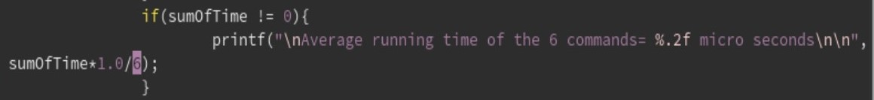

When calculating each counter, if the counter is equals to 0, then the counter is reassigned to new time value. If the counter is not 0, then the counter equals to the division of addition of the original value and the new time value by 2.