Tried Amazon Rekognition and Google vision OCRs with words and paragraphs for three pictures.

For each picture, there is a word detection accuracy(Top) and a book name accuracy(Bottom). In the matrix table, actual positive row and predicted positive column means correct result; actual positive row and predicted negative column means OCR detected the text but not given in true book name list; actual negative row and predicted positive column means the text is given in true book name list but not detected.

The followings are screenshots of accuracy for each combination:

Google Words picture 1:

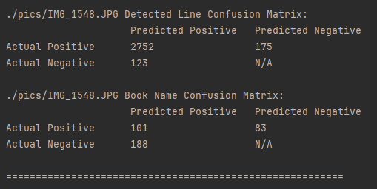

Google Words picture 4:

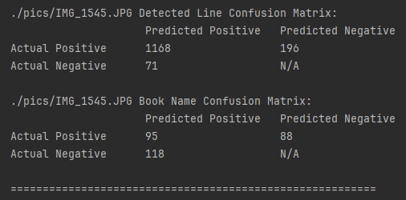

Google Words picture 5:

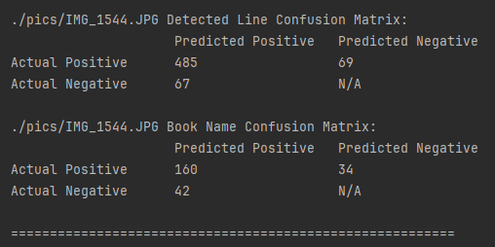

Amazon Lines picture 1:

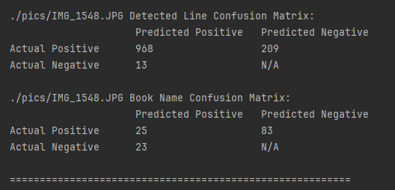

Amazon Lines picture 4:

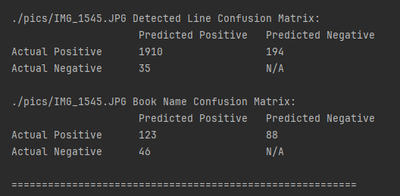

Amazon Lines picture 5:

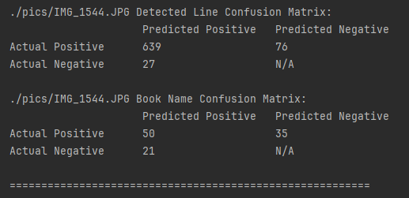

Amazon Words picture 1:

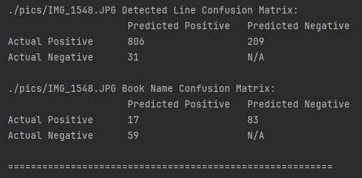

Amazon Words picture 4:

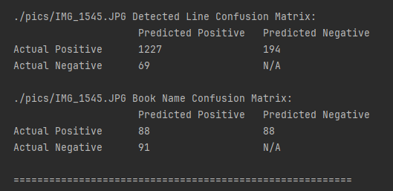

Amazon Words Picture 5:

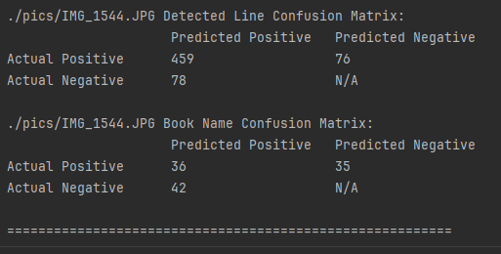

292，438，539