Bartender Haptic Game
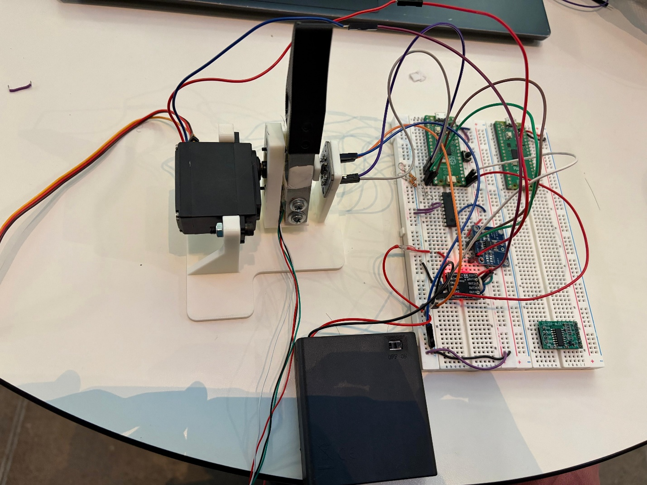

Demo video could be seen in the full_game_demo.mp4

I used impedance-haptic control architecture: an AS5600 magnetic encoder reads the handle angle, which drives a Pygame physics simulation of a pouring wine bottle, and that simulation computes the haptic effects (gravity, slosh, glug) and torque, and change it to desired current commands to the Pico over USB serial. The control is cascaded: a fast 1 kHz inner current-PI loop on the Pico renders a commanded current through the DRV8833 H-bridge (using the INA219 as current feedback, since motor torque is proportional to current), while the slower outer "loop", the game physics, decides what current to command based on handle position.
Because of the time constraint, I only the implemented the “glug” feedback feature, and used angle reading from the encoder as the input for the equations. The load cell was dropped from the control path because it’s really noisy.
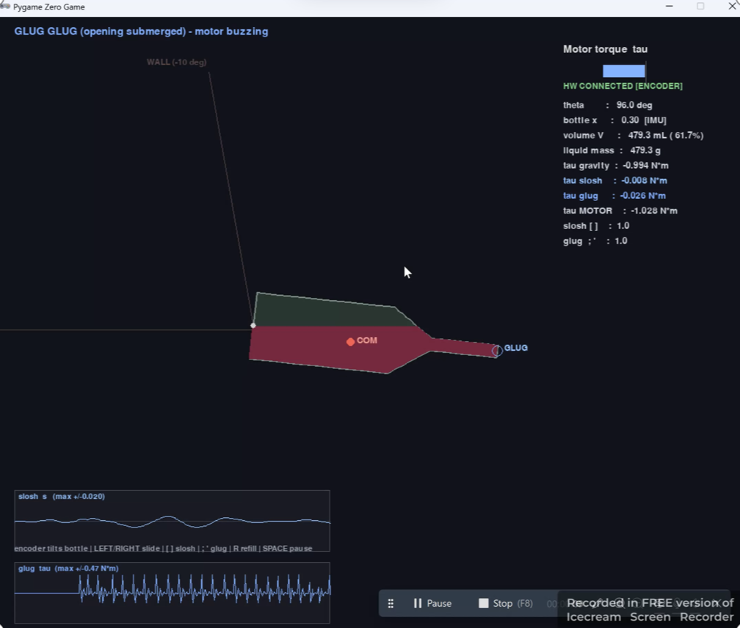

Control
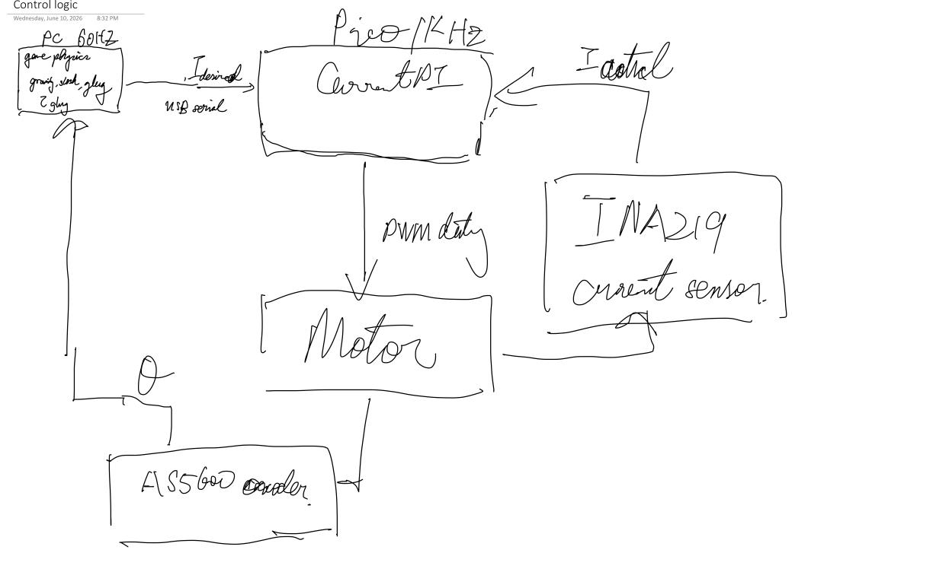
Python UI
