**AUTO BLOCKING AND HISTORY DELETION MESSAGING APP**

**CHOW ZI XUAN**

**A project report submitted in partial fulfillment of the**

**requirements for the award of Bachelor of Science**

**(Hons.) Software Engineering**

**Lee Kong Chian Faculty of Engineering and Science**

**Universiti Tunku Abdul Rahman**

**May 2017**

TABLE OF CONTENTS

TABLE OF CONTENTS ii

LIST OF TABLES iv

LIST OF FIGURES v

LIST OF SYMBOLS / ABBREVIATIONS vi

**CHAPTER**

1 INTRODUCTION 7

1.1 Introduction 7

1.2 Background of the problem 7

1.3 Problem Statement 8

1.4 Project Objectives 8

1.5 Proposed Approach 9

1.6 Scope of the Project 10

2 LITERATURE REVIEW 11

2.1 Comparison of Texting, Messaging, and Online Chatting 11

2.2 Push Notification 12

2.3 React – JavaScript Library for building user interfaces 14

2.3.1 Comparison between React and AngularJS 14

2.3.2 Advantages and Disadvantages of React 14

2.4 Messaging app with React Native and Socket.io 15

2.5 What do mobile app users complain? 17

3 METHODOLOGY AND WORK PLAN 19

3.1 Description of the project 19

3.2 Methodology Adopted 22

3.3 Work Plan 25

3.4 Development tools 27

4 PROJECT INITIAL SPECIFICATION 28

4.1 Use Case Diagram 28

4.1.1 Use-Case Diagram Description 29

4.2 Class Diagram 30

4.2.1 Class Diagram description 30

4.3 Requirement 31

4.3.1 Functional Requirements 31

4.3.2 Non-Functional Requirements 31

4.4 Project Prototype 32

REFERENCES 34

LIST OF TABLES

|  |  |  |
| --- | --- | --- |
| TABLE | TITLE | PAGE |
| Table 2.0 | Comparison of Texting, Messaging and Online Chatting | 6 |
| Table 2.1 | Comparison between React and Angular JS | 9 |

LIST OF FIGURES

|  |  |  |
| --- | --- | --- |
| FIGURE | TITLE | PAGE |
| Figure 1.0 | The development cycle of Lean Methodology | 4 |
| Figure 2.0 | The process of Android devices receive push notification from GCM Cloud Connection Server | 7 |
| Figure 2.1 | Process of push notification of Android Devices | 8 |
| Figure 2.2 | Example of Chat Room using Socket IO (Enter Nickname) | 10 |
| Figure 2.3 | Example of Chat Room using Socket IO (Chatting) | 11 |
| Figure 2.4 | 20 iOS app with different category | 12 |
| Figure 2.5 | Category of user complaint | 13 |
| Figure 3.0 | A prototype of auto blocking profile | 15 |
| Figure 3.1 | A prototype of message deletion setting | 16 |
| Figure 3.2 | Trello Board | 20 |
| Figure 3.3 | Trello Calendar | 21 |
| Figure 4.0 | Use-Case Diagram for messaging app | 24 |
| Figure 4.1 | Class Diagram for User and Contacts | 26 |
| Figure 4.4.1 | Prototype | 28 |
| Figure 4.4.2 | Prototype | 28 |
| Figure 4.4.3 | Prototype | 28 |
| Figure 4.4.4 | Prototype | 28 |

LIST OF SYMBOLS / ABBREVIATIONS

App - Application

GCM – Google Cloud Messaging

JS – JavaScript

HTML – Hyper Text Markup Language

## INTRODUCTION

### Introduction

Messaging applications or chat applications are instant messaging clients that allow messages to be sent and received between mobile devices or a computer. Text, photos, videos, and voice messages are used by the user to communicate with each other frequently.

Auto blocking and history deletion messaging app aims to deliver a new experience for the user. The app will be focusing on blocking the notification of the incoming messages and removing of older messages automatically. The purpose of creating this app is to help users to manage their own messages in a convenient way. Therefore, it will help user to spend less time to clear the trash of the phone, and it will help user to save a lot of times for other activities. It will also help the user that didn’t have the habit of removing messages frequently to free up more storage of the phone.

.

### Background of the problem

Auto blocking and history deletion messaging app is a mobile application to block the notification of incoming messages automatically, and delete messages by following the schedule by the user. There are a few messaging apps in the market, but the auto blocking and message deletion features is implemented with limited option for the user.

Auto blocking features in WhatsApp, Messenger, and WeChat have limited option for the user to preset the auto blocking period. User has limited choice will lead to inconvenience when using the application. Majority of the users don’t care much about history deletion of their messaging app. It will consume up plenty of time to delete the message when the phone pop-out insufficient of storage alert to inform user to free up the space of the phone in order to reserve storage for incoming messages.

### Problem Statement

* Messages that keep in local storage will use up the spaces of the internal memory of a smartphone after a long-term usage of messaging apps. It will cause insufficient of phone storage and degrade the performance of the phone.
* Clearing or deleting “tonnes” of messages manually is consider as a waste of time. It’s a tedious process for a user to keep track and manage their history of messages manually.
* Users have difficulties in searching for important messages by scrolling up and down the screen and check it one by one.
* The auto blocking function is not highly customizable by the users currently. There are also limited ~~of~~ options for users to block incoming messages automatically based on their preferences.

### Project Objectives

The objective of the project is to develop a messaging app that aims to

* prevent excessive storage usage by deleting messages automatically in order to free up the internal storage of the phone.
* save user’s time spent in deleting messages manually by providing customizable options to perform the deletion of messages automatically.
* ease the user to search for important messages by deleting unwanted messages automatically.
* stop disruption from certain groups or people by blocking notification of incoming messages based on the user’s customizations.

### Proposed Approach

The methodology that is going to implement in this project is Lean Methodology. The core idea of this methodology is to maximize in user value while minimizing waste. In other words, we can say that this methodology is creating more value and benefit for user with lesser resources. In this project, the Build-Measure-Learn principle (one of the central principle of Lean methodology) will be used. The development cycle of the methodology is a Build-Measure-Learn loop in order to improve the quality and requirement of the product.

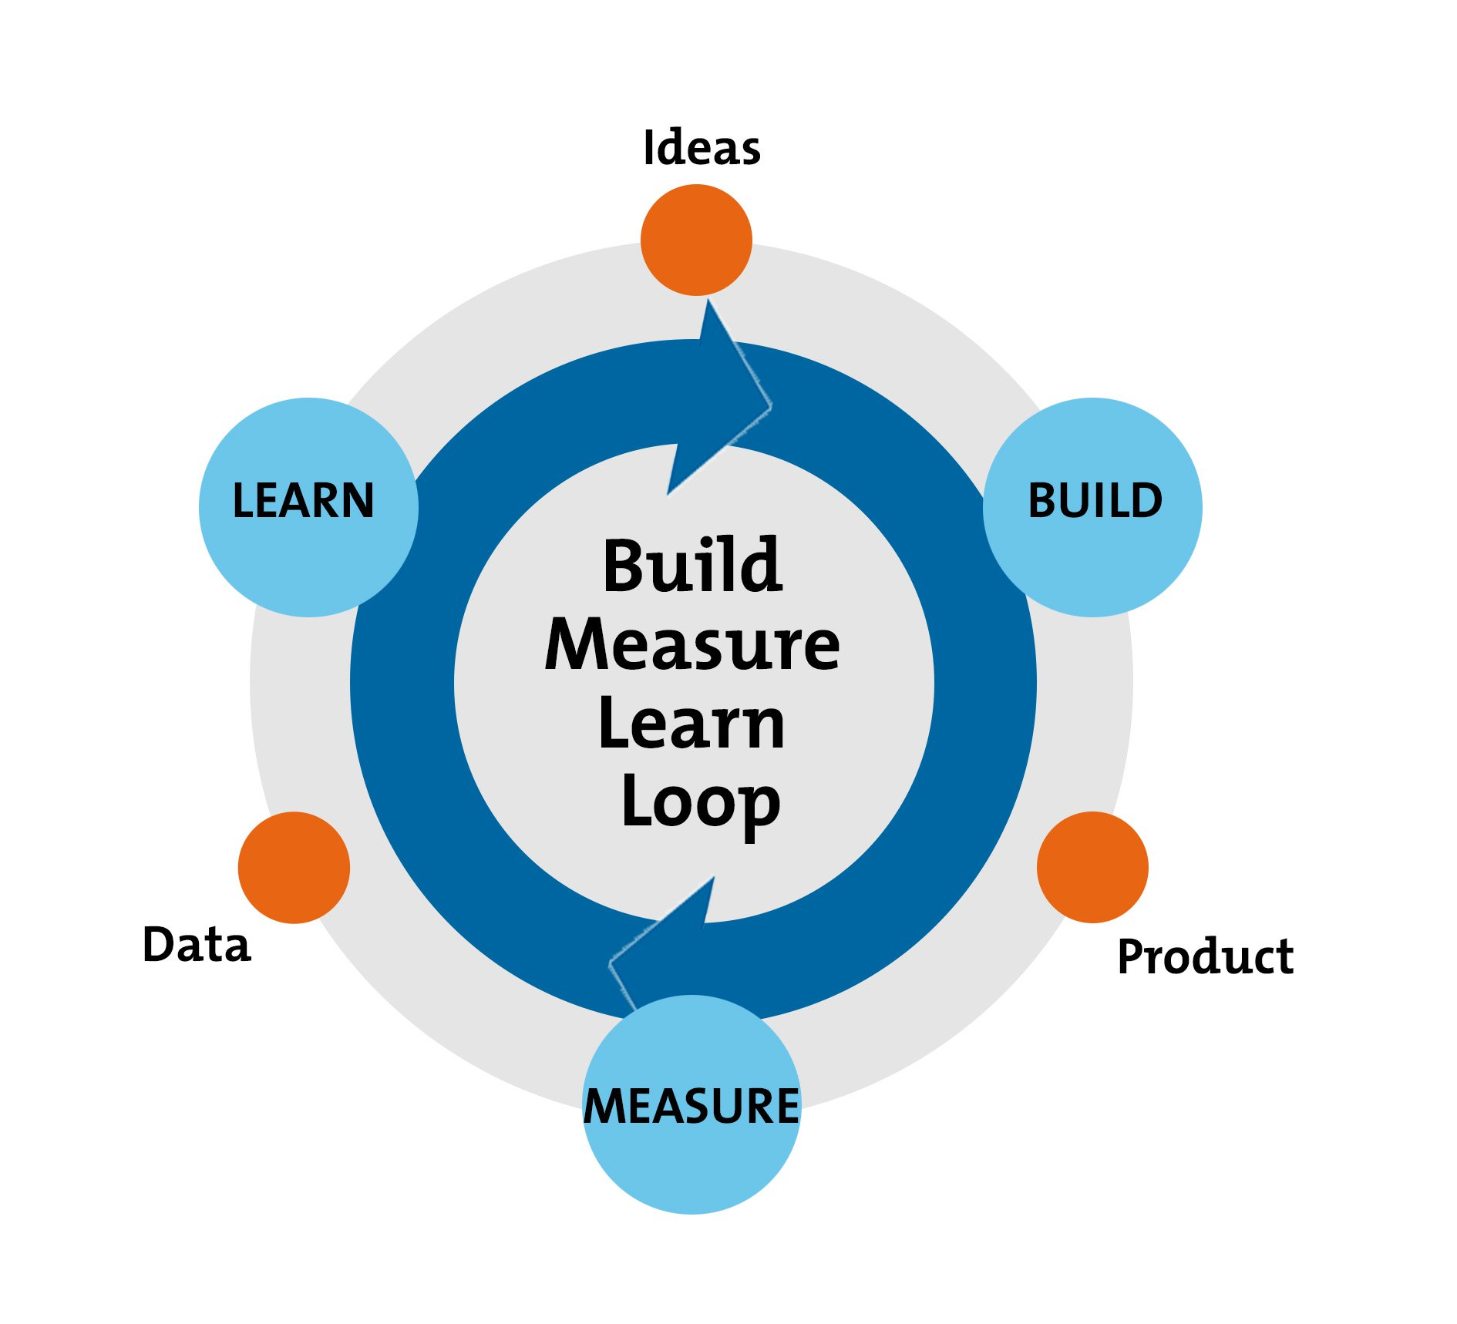

**Figure 1.0 The development cycle of Lean Methodology**

**(Diagram adapted from Ries, E. (2011) '**[**The Lean Startup**](https://www.amazon.com/Lean-Startup-Innovation-Successful-Businesses-ebook/dp/B004J4XGN6/)**,' New York: Crown Business.)**

Before the Build-Measure-Learn cycle, the project is better to start with a planning stage. First, develop a hypothesis that will happen during the project. The hypothesis can focus on the user ideas and the features of the product. After that, in the “Build” phase, create a Minimum Viable Product(MVP), it is a product that can work to fulfil the basic requirements to test out the hypothesis that create during the planning stage. During the “Measure” phase, the result in the “Build” phase is being analyse whether the idea is sufficient enough to continue the development of the product. It is good to question that whether the result is meeting the requirement of the product.

Lastly, the decision making will happen in the “Learn” phase. There are 2 ways to forward, it is “Persevere” and “Pivot”. We choose “Persevere” when the hypothesis is correct and repeat the development cycle loop to improve and refine the idea. If “Pivot” is chosen, that means the hypothesis is proven to wrong, but we can gain valuable knowledge from the mistakes. Therefore, the loop is going to reset with using the knowledge that we learnt in the previous hypothesis.

**Summary of the methodology:**

**Step 1**: Planning of the project followed by a formal hypothesis

**Step 2**: Build a Minimum Viable Product (MVP) and test it.

**Step 3**: Analyse the result against the hypothesis to decide whether the product can be continued to develop to fulfil the business needs.

**Step 4**: Learn from the result on step 3, and decide whether to persevere or pivot.

### Scope of the Project

The auto blocking and history deletion messaging app will include the basic features of a messaging app, i.e. the function of send and receive messages includes images and short videos. The application will provide a login interface for users to have their own identity. Moreover, the function of blocking the notification of incoming messages and deleting the previous messages will be implemented in the application. The application is able to mark important messages and customize messages deletion automatically. The messages being marked will be exempted from deleting. Furthermore, the app will have a filter to display important messages only. Backup and restore chat history function will also be implemented.

## LITERATURE REVIEW

### Comparison of Texting, Messaging, and Online Chatting

The term of texting, messaging, and chatting has the meaning of two-way communication between 2 individual or more. But, the three communication options have their own features and characteristics to best fit the requirement. The aim of the project is to develop a messaging app with certain features. Therefore, a clear picture to term of “Messaging” is important. The table below provides the comparison of the three types of communication.

|  |  |  |  |
| --- | --- | --- | --- |
|  | **Texting (SMS)** | **Messaging** | **Online Chatting** |
| Methods of obtaining the service | Pre-installed on the mobile phone before the release of smartphone. Available in mobile app or web-based after the smartphone was created | Comes with mobile app or web-based | Available in a form of website or a plugin |
| Example of usage in real world | Sending text messages via cellular network with the mobile service provider without Internet Service | Messaging apps like WhatsApp, Facebook Messenger, and WeChat that can get instant reply with mobile data or WiFi service. | Customer service of a website |
| Limitation of message size | 160 characters | Unlimited | Unlimited |
| Content support | Text | Text, Image, Video | Text |
| Platform support | Pre-installed in phone by phone manufacturer before the release smartphone .  Cross-platform in the form of mobile application in the app market of smartphone | Cross-platform  (mobile phone, web browser) | Web browser |

**Table 2.0 Comparison of Texting, Messaging and Online Chatting**

### Push Notification

Nowadays, push notification is an important feature in an app to engage the app’s users. It keeps users to get the latest information and notifications by the apps with running in the background of the phone. Push notification ensures that users able to read messsages by pop-out notification while the app is running in background or is suspended. Majority of Android devices are based on Google Cloud Messaging (GCM).

GCM is a service by Google company that transmits information from a server to Android devices which connected to Google Play Service. GCM can carry small size of messages with data payloads not exceeding 4KB (Abrosimova, n.d.). Figure 2.2.1 indicates how mobile devices get push notification.

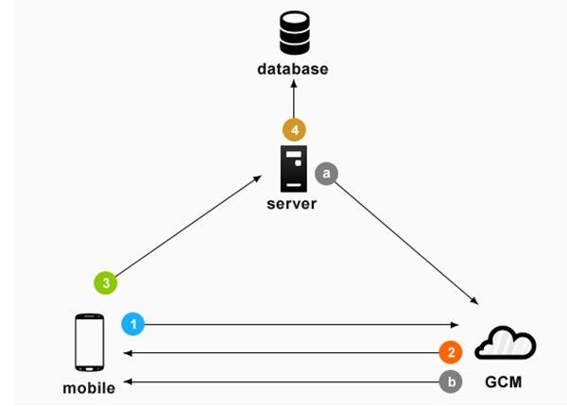

**Figure 2.2.1 The process of Android devices receive push notification from GCM Cloud Connection Server**

(Abrosimova, n.d.)

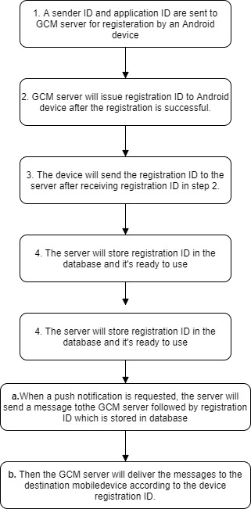

**Figure 2.2.2 Process of push notification of Android Devices**

### React – JavaScript Library for building user interfaces

Having a basic of HTML and JavaScript knowledge is the prerequisite for a software developer to code in React. React is also a cross-platform scripting language where write once, run anywhere. React is able to create interactive UIs and design simple views for each activity of the mobile app.

#### Comparison between React and AngularJS

React and AngularJS are both based on JavaScript language. Each of the frameworks has its own priority for any business. Table 2.1 is a comparison between React and AngularJS.

|  |  |  |
| --- | --- | --- |
|  | **React** | **AngularJS** |
| **Author** | Facebook community | Google |
| **Type** | Open source JavaScript library | Fully-feature MVC framework |
| **Language** | JSX | JavaScript, HTML |
| **Learning curve** | Low | High |
| **Rendering** | Server Side | Client Side |
| **DOM** | Virtual DOM | Regular DOM |

**Table 2.1 Comparison between React and Angular JS**

#### Advantages and Disadvantages of React

**Advantages of React**

React is using JSX, it is a JS syntax that supports HTML quotes and HTML tag syntax for rendering. React has the feature of prompt rendering which can mitigate the amount of DOM operation in the smart way and optimize the process. Virtual DOM is used while handling vast database.

**Disadvantages of React**

React is not a full-scale framework and it requires deeper programming knowledge. It is still not mature currently and has limited ecosystem.

### Messaging app with React Native and Socket.io

Socket.io is a framework that creates network socket for the server and client. It’s a real-time engine that supports instant messaging and chat with just a few lines of code. It works fine with the React Native. Socket.io supports communication between single client and multi clients once the socket is established and the users can speak freely without delay and it is more faster that a HTTP request. Socket.io can create a chat group for a certain number of users in the same port. Figure 2.4.1 is an example of chat room that requires user nickname to enter a chat room. Figure 2.4.2 is an example of conversation between 2 users.

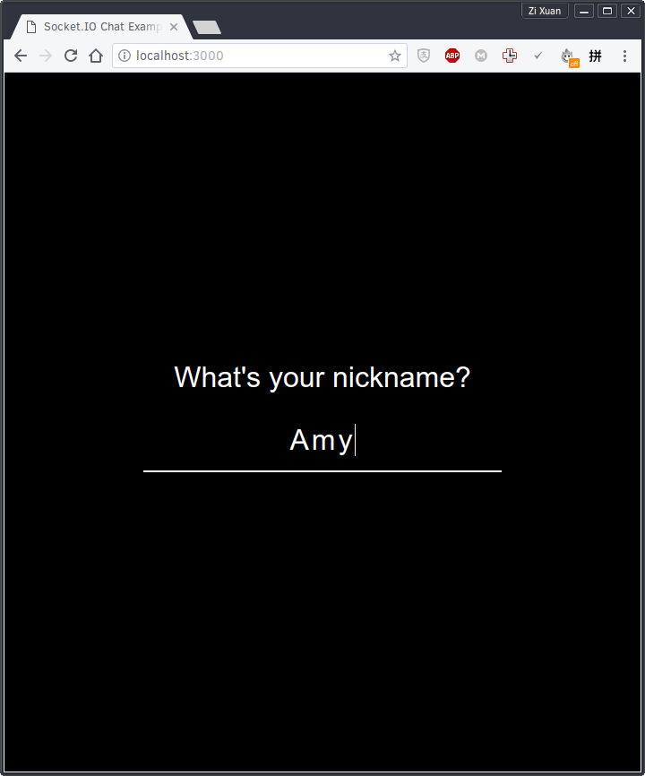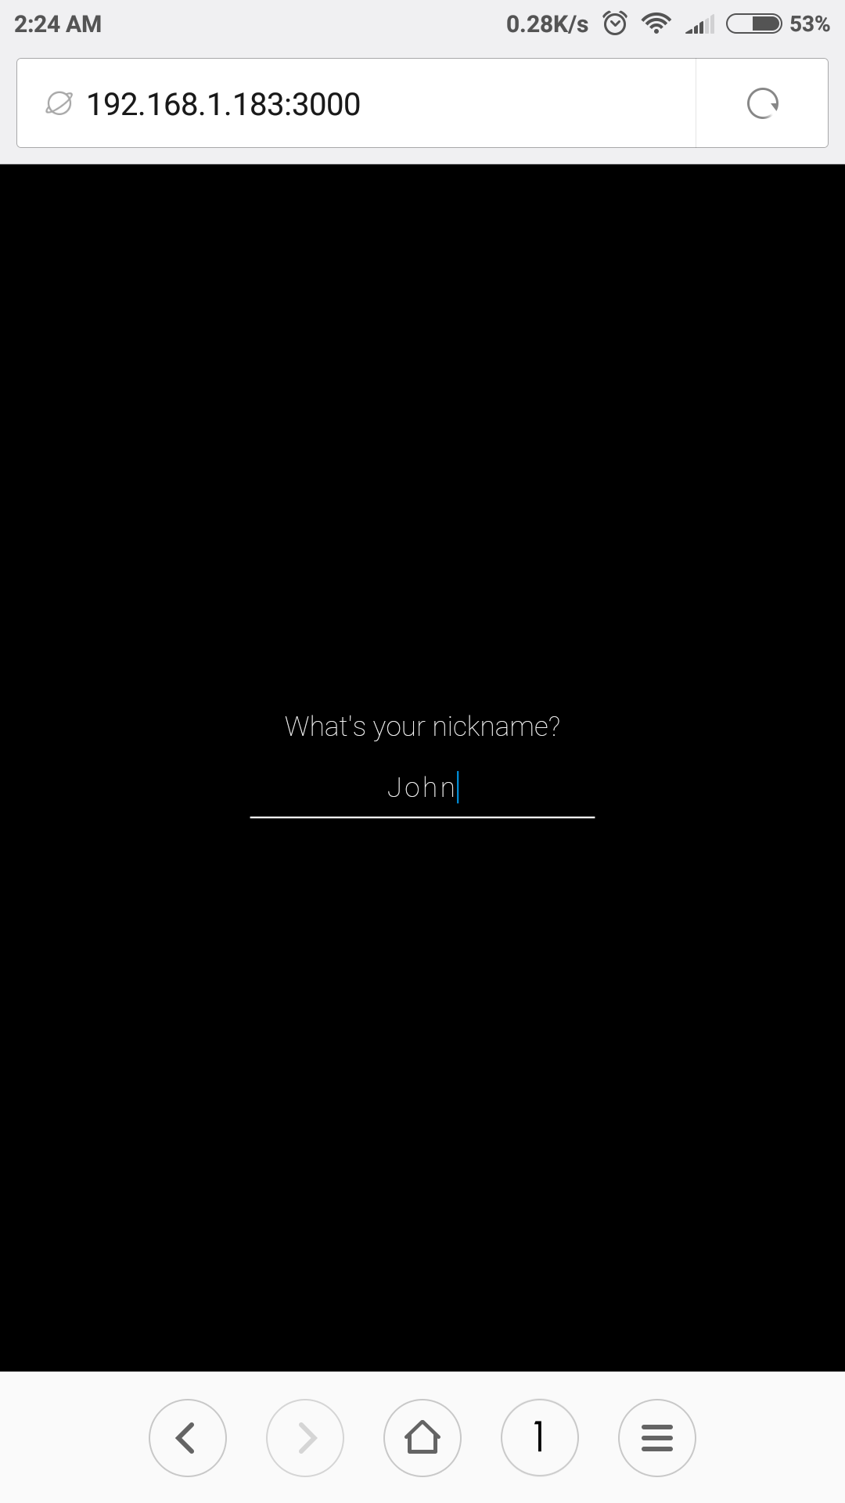

**Figure 2.2 Example of Chat Room using Socket IO (Enter Nickname)**

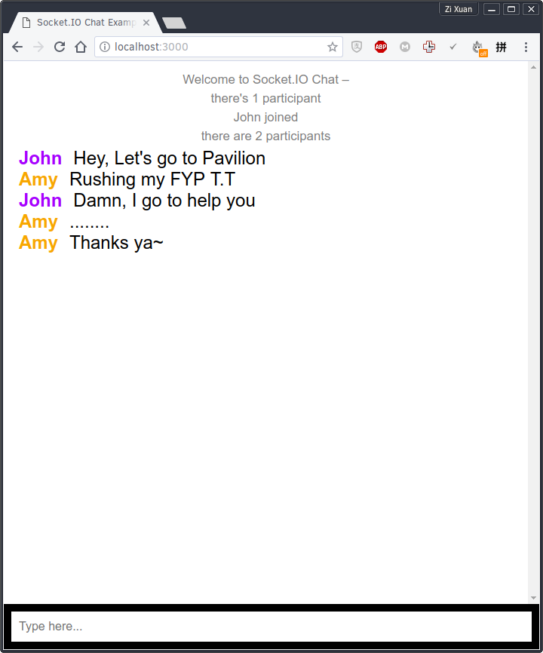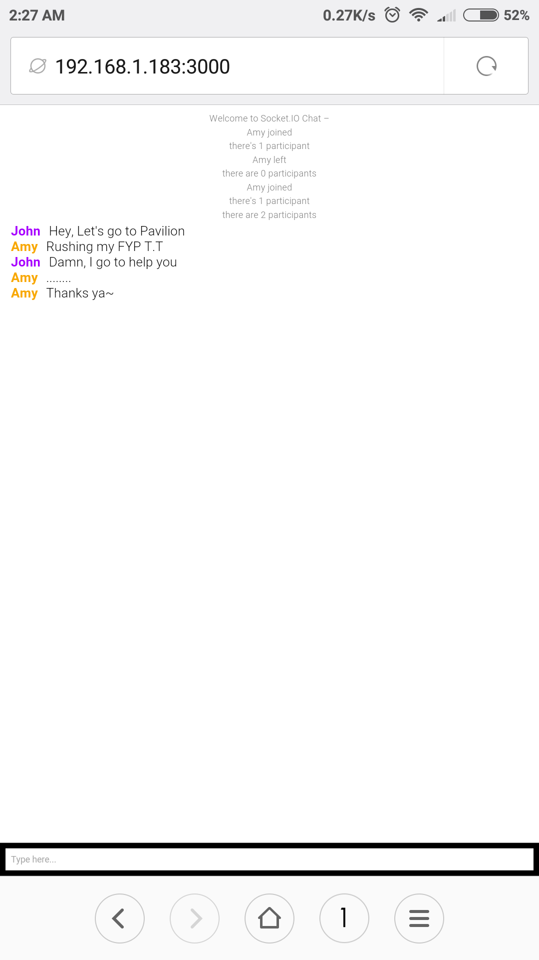

**Figure 2.3 Example of Chat Room using Socket IO (Chatting)**

### What do mobile app users complain?

The quality of app has been the main concern for the app company currently. A research is carried out to study the feedback from users of 20 iOS apps and Figure 2.5.1 shows the statistics of the studies. The 20 iOS apps are from different category.

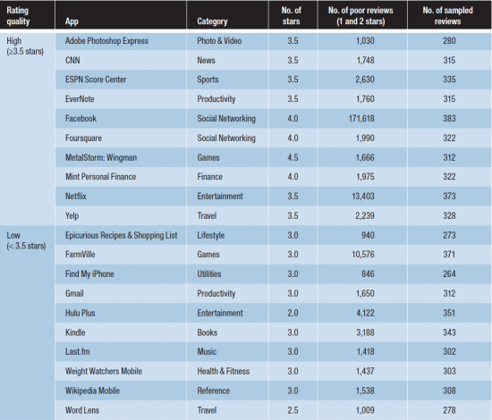

**Figure 2.4 20 iOS app with different category**

**(Khalid, Sahihab, Nagappan and Hassan, 2014)**

According to the research, there are 12 types of most frequent complaint by the mobile app users. The first three columns of Figure 2.5.2 show the type of most complaint issues by the users. Functional Error is ranked on the top column which indicates the most serious problem that encountered by the users. The examples of functional error are location identification issues and authentication problems. The feature request complaint is ranked in number 2. The most requests feature by the users were app specific. But, there are 6.12 percent of the request were for better notification support.(Khalid, Sahihab, Nagappan and Hassan, 2014). App crashing is also one of the critical complaints by the mobile app user which can affect the user experience and it indicates the stability of a mobile apps.

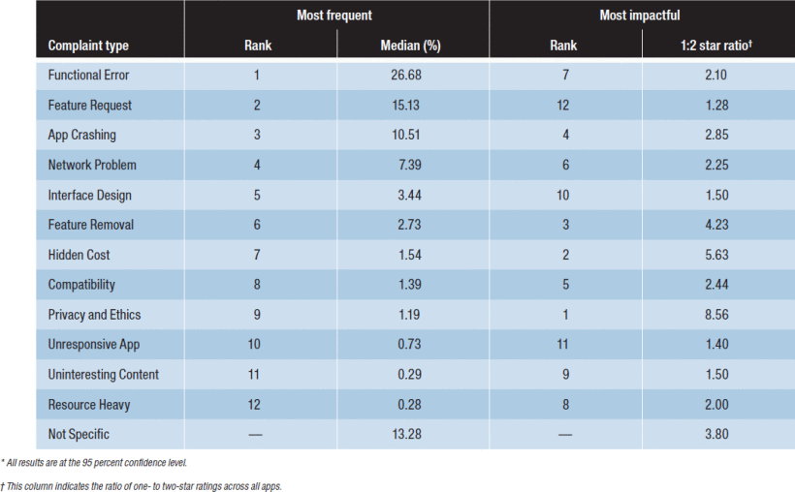**Figure 2.5 Category of user complaint**

**(Khalid, Sahihab, Nagappan and Hassan, 2014)**

## METHODOLOGY AND WORK PLAN

### Description of the project

The goal of the project is to develop a messaging app which has the auto blocking and history deletion features. The messaging app will also work like a normal messaging app which can send and receive text, image and video messages within 2 or more individuals.

One of the main features of auto blocking in the messaging app is to block incoming notifications and retain messages from the sender. Comparing to other messaging in the app market, there are more blocking options in the app. It will let user to customize the auto blocking period and it can be saved into a profile for future use. Besides that, users are able to customize the history deletion automatically, the messages that deleted automatically will uploaded to the cloud server as a backup. The older messages can be obtain when needed and it will to free up the local storage of the phone.

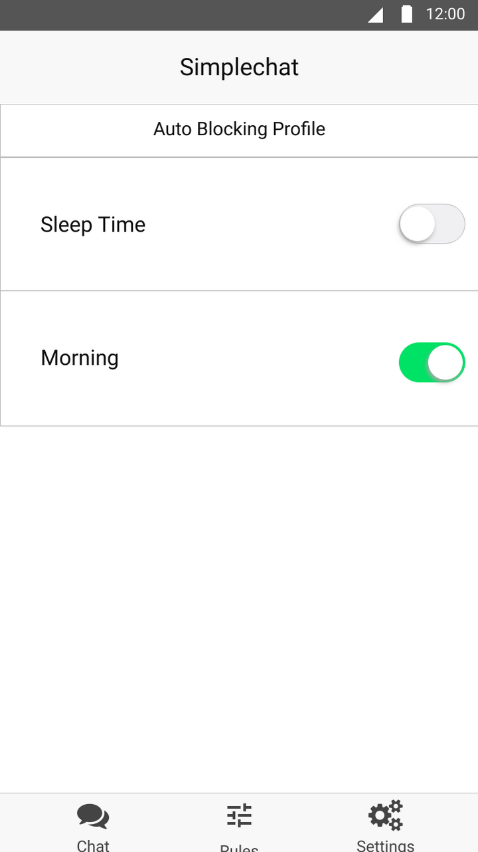

**Figure 3.0 A prototype of auto blocking profile**

Figure 3.0 is a prototype of auto blocking profile that can be customized by users. When the switch is turn on, the auto blocking period will start. The notification of the messaging app will auto mute but the messages will still receive by the phone. The auto blocking function will not applied to the whole app, users can tap in the and customize blocking profile and block specific contact.

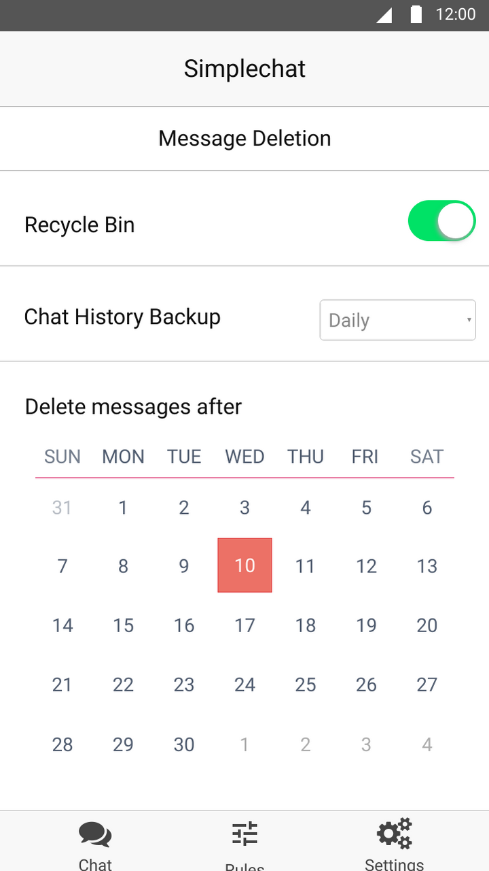

**Figure 3.1 A prototype of message deletion setting**

Figure 3.1 is a prototype of message deletion setting that allows users to customize their message deletion options. Recycle bin is a feature to archive deleted messages, users are able to restore deleted messages from recycle bin. Chat History Backup allows users to backup their previous messages to cloud server after the messages was removes permanently. Users can set the date to delete the messages every month or user can pick more specific date and time to delete the message automatically.

### Methodology Adopted

The methodology that adopted in this project is Lean Methodology. The main concern of Lean Methodology is suitable for mobile app development which maximize users’ value and minimize the waste of resources. The development cycle of the Lean Methodology is Build, Measure, and Learn. It is an effective way to build a mobile application that fulfill the requirements of users and speed up the development period. This method let the developer learns from the mistakes made during the development and help the developer to improve the product to match the hypothesis that made during the planning phase.



**Figure 1.0 The development cycle of Lean Methodology**

**(Diagram adapted from Ries, E. (2011) '**[**The Lean Startup**](https://www.amazon.com/Lean-Startup-Innovation-Successful-Businesses-ebook/dp/B004J4XGN6/)**,' New York: Crown Business.)**

**Summary of the Build-Measure-Learn Loop**

**Planning**

A planning of the project is needed before the process of development is going into the Build-Measure-Learn development cycle. The planning of the project must be followed by a formal hypothesis that made by the developer.

A messaging app will be developed in this project, the messaging app must planned with a few of hypothesis such as the messaging is able to send and receive messages with notifications. An auto blocking feature~~s~~ with customization period is needed. Message deletion must be able to be customized by users and could delete messages automatically based on setting.

**Build**

Build a Minimum Viable Product(MVP) based on the hypothesis that made during the planning phase. It must fulfill the basic requirements of the product before releasing for any testing.

the messaging app in this project must have at least ~~a~~ working functions of send and receive messages without any bugs. It must also support text, image, and video. The auto blocking feature must at least can block all incoming notification after the setting is enabled by users. It can at least delete messages automatically after the customization of setting is done. Make sure the basic functions of the app can work fine before going to the next phase of development.

**Measure**

In this phase, the product is being analyze whether the result of the product is similar or diverge with the hypothesis. If yes, it is suitable to continue to fulfill the users’ needs.

The auto blocking feature in the app doesn’t work like the hypothesis that made by the developer and it needs to block message manually, which means it failed to achieve the.

**Learn**

There are two ways to choose to bring the product to the next level. “Persevere” is chosen when the hypothesis is correct and fits the idea of product. Then, the product can undergo the cycle of Build-Measure-Learn again to improve or add-on some new features to the product. If the product doesn’t fit the hypothesis, “pivot” is chosen, which means the hypothesis is proven to be wrong, but it doesn’t matter, as long as the developer will gain valuable knowledge from the mistake that they made.

When the app basic functions fulfill the hypothesis, we choose “persevere” to go a step further to improve the basic functions to make it more reliable. If the function of the product is far away from expectation, choose “pivot” to find out how to deal with the mistakes or what is the core problem that makes the product failed to achieve the requirements.

### Work Plan

The project work plan is keep track with Trello, which is suitable for a small size or individual project. Figure 3.3.1 is Trello board that lists out the work plan to fulfill in Project 2. The work plan is divided into 3 lists which are To Do, Doing, and Done. The deadline of each task is set to prevent any of the task left out from the project.

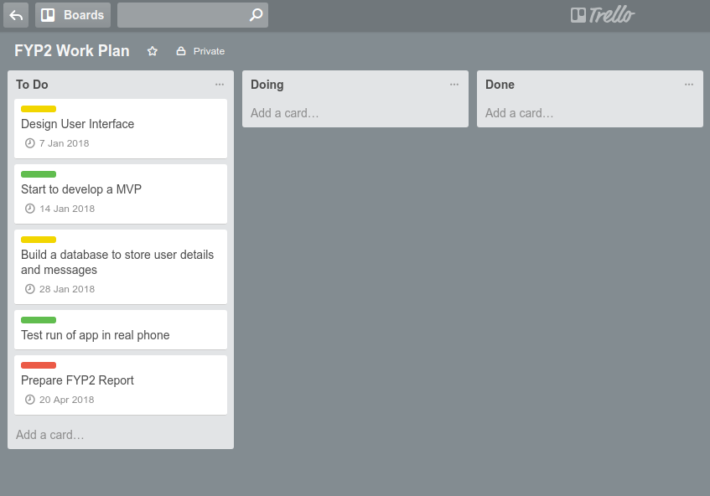

**Figure 3.2 Trello Board**

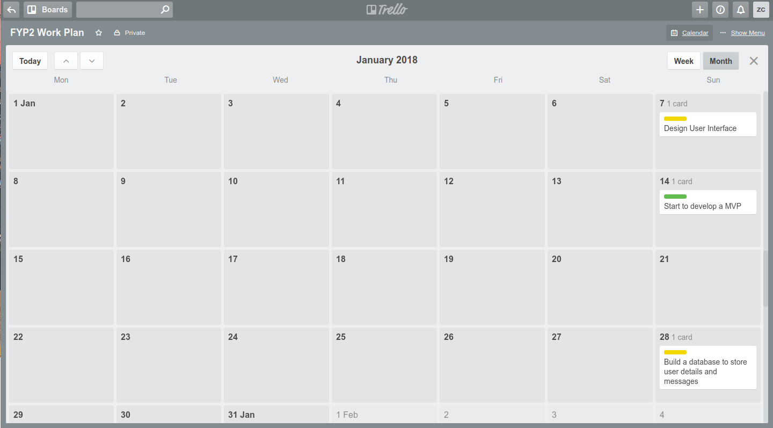Trello Calendar is able to display the deadline of each task clearly Different colour of label indicates different level of importance.

**Figure 3.3 Trello Calendar**

### Development tools

**React native**

It is used to develop the user interface of the mobile application with using React JS by Facebook community. It can build cross-platform mobile app which compactible with Android and iOS. The develop need to code once and then the mobile app can run on both OS.

**Sublime**

A text editor that can support the develop of React JS syntax and can code faster with the auto-complete function of the text editor. It has a nice folder and file management for a project. Using the plugin of Babel JS, the syntax of React JS can be shown clearly in its own colour tone.

**MockingBot**

It is a prototype tools that is easy to use to sketch the user interface of the mobile app. It includes the elements of iOS and Android which can produce a working prototype. The prototype can save and test run on a web browser on PC or a phone.

**BitBucket**

A version control repository that support Git. It can store project in private state for free which can access by the author only. Bitbucket can support up to 5 members in a team and manage the role of the 5 member to read, write or read and write permission of the repository.

**Android Virtual Device**

To test run the result of the app development before shipping out the workable mobile application. The Android Virtual Device comes with Android 6.0 Marshmallow which can support the development of React Native.

**Terminal**

To view the error when the app crash during the development with using React Native. It is mandatory to use it to run React Native. Terminal is available in macOS or Linux, it’s a powerful tools to manage a computer without using the Graphical User Interface(GUI) or Desktop Environment.

## PROJECT INITIAL SPECIFICATION

### Use Case Diagram

**Figure 4.0 Use-Case Diagram for messaging app**

#### Use-Case Diagram Description

User is the person that uses the messaging app and the use-case indicates the actions that can be done by the user. New user must register an account before login to the messaging app. After login to the messaging app, the user will be able to edit account information such as name, age, birth date, etc. User can view contacts that they added. User can create new chat include group chat. User can customize setting like auto blocking incoming notification and history deletion.

### Class Diagram

**Figure 4.1 Class Diagram for User and Contacts**

#### Class Diagram description

User table has userID, emailAddress, contactNumber and contactID as attributes. The contactID attributes is use to refer users’ contact number list. The actions that can be done by user are addBlockPeriod, clearHistoryPeriod, and addContact. The Contacts table contains contactID, contactNumber and contactName.

### Requirement

The requirements of the project will be divided into functional and non-functional requirements.

#### Functional Requirements

The messaging app should able to perform send and receive messages function. It includes text, image, voice and video messages. Auto blocking of incoming notification must be implemented to the messaging app to block incoming messages automatically after the setting is done by the user. The user must be able to customize the setting for auto blocking.

Previous messages should be deleted automatically according to the setting. User can set messages to be deleted by daily, weekly, monthly or by custom date. The messages that marked as important will not be removed automatically unless it is deleted by user manually.

#### Non-Functional Requirements

The app will be developed by using React Native to gain stability and cross-platform development at the same time. The performance of the messaging app must be fast in order to meet the instant send and receive of messages. The security level of the app must be high in order to secure the privacy of the users.

### Project Prototype

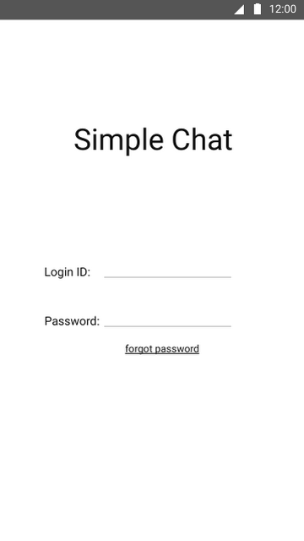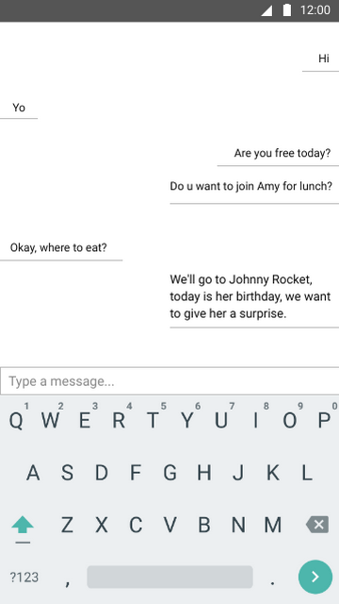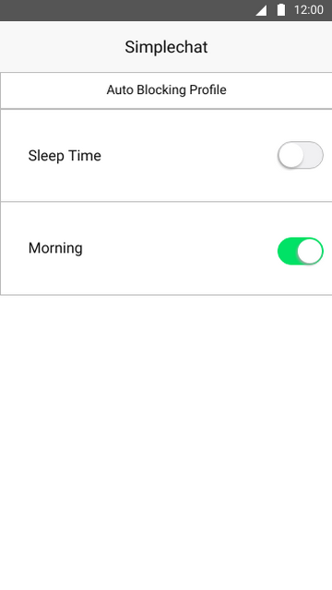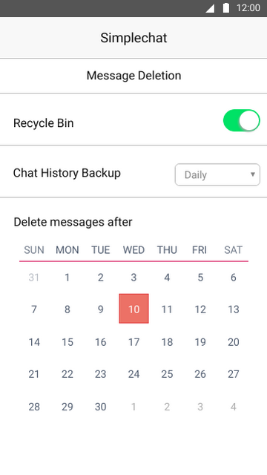

Figure 4.4.1

Figure 4.4.2

Figure 4.4.3

Figure 4.4.4

Figure 4.4.1 is a simple login user interface for user to login to their account with email, phone number, or username. It allows user to retrieve forgotten password with email address. Figure 4.4.2 is a sample of chatting interface of the messaging app, the left-side conversation indicates the receiver messages and the right-side conversation indicates the sender messages. Figure 4.4.3 is an user interface to let users set the auto blocking time or period and Figure 4.4.4 is the interface to customize message deletion to work automatically.

## REFERENCES

Clark.M., 2016. *Texting, Messaging & Chat Compare.* [blog] 14 September 2016. Available at: <http://info.contactsolutions.com/digital-engagement-blog/messaging-texting-chat-compared> [Accessed 20 July 2017]

Abrosimova.K., [No Date]. *Push Notifications Mechanism for iOS & Android.* [blog] No Date. Available at: <https://yalantis.com/blog/push-notifications-mechanism-outline-ios-and-android/> [Accessed 20 July 2017]

Grady.S., [No Date]. *Lean Startup methodology for mobile: How to build a more popular app with less money.* [blog] No Date. Available at: <https://blog.helpshift.com/lean-startup-methodology-build-popular-app-less-money/> [Accessed 20 July 2017]

Harrington.C., 2014. *React vs AngularJS – How the two Compare.* [online] 29 December 2014. Available at: <https://www.codementor.io/reactjs/tutorial/react-vs-angularjs> [Accessed 21 July 2017]

Woldu.D., 2017. *A multi-input field messaging app concept.* [online] 19 June 2017. Available at: <https://medium.freecodecamp.org/multi-input-field-messaging-app-concept-911096778de3> [Accessed 21 July 2017]

Le.V., 2016. *A simple messaging app with React Native and Socket.io.* [online] 24 December 2016. Available at: <https://hackernoon.com/a-simple-messaging-app-with-react-native-and-socket-io-e1cae3df7bda> [Accessed 21 July 2017]

Massart.F., 2016. *React Native vs Ionic: A Side-by-Side Comparison.* [online] 15 August 2016. Available at: <https://www.codementor.io/fmcorz/react-native-vs-ionic-du1087rsw> [Accessed 22 July 2017]

Miski.A., 2014. *Development of a Mobile Application Using the Lean Startup Methodology.* [online] Available at: <https://www.ijser.org/researchpaper/Development-of-a-Mobile-Application-Using-the-Lean-Startup-Methodology.pdf> [Accessed 22 July 2017]

Khalid.H., Sahihab.E., Nagappan.M. and Hassan.A., 2014. *What Do Mobile App Users Complain About?* [e-journal]. Available through: Universiti Tunku Abdul Rahman Library website <http://ieeexplore.ieee.org.libezp.utar.edu.my/document/6762802/> [Accessed 23 July 2017]

Mindtools.com. (n.d.). *The Build-Measure-Learn Feedback Loop: Creating Real Value by Testing Ideas*. [online] Available at: https://www.mindtools.com/pages/article/build-measure-learn.htm [Accessed 10 Jul. 2017].

Lean.org. (n.d.). *What is Lean?* [online] Available at: https://www.lean.org/WhatsLean/ [Accessed 10 Jul. 2017].