Practical Exercise 10 – Algorithms Analysis and Big-O Notation

Overall Objective
To estimate algorithm efficiency using the Big-O notation and determine the complexity of various types of algorithms.

Description
- Why is a constant factor ignored in the Big-O notation?

- Why is a non-dominating term ignored in the Big-O notation?

- What is the order of each of the following functions?
- 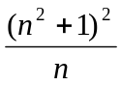

- 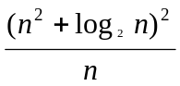

- 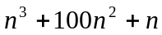

- 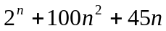

- 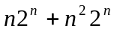

- What is the number of iterations in the following loop:

int count = 5;
while (count < n) {
count = count + 3;
}

- Use the Big-O notation to estimate the time complexity of the following methods:

- public static void method1(int n) {
for(int i = 0; i < n; i += 2) {
System.out.print(Math.random() + " ");
}
}

- public static void method2(int n) {
for(int i = 0; i <= n; i++) {
for(int j = 0; j < i; j++) {
System.out.print(Math.random() + " ");
}
}
}

- public static void method3(int[] m) {
for(int i = 0; i < m.length; i += 2) {
System.out.print(m[i] + " ");
}

for(int i = m.length – 1; i >= 0; i -= 2) {
System.out.print(m[i] + " ");
}
}

- Put the following growth functions in order:

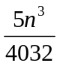, 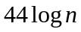, 500, 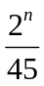, 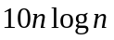, 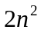, 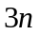

- Design/describe an algorithm for the following tasks, and analyse the time complexity of the algorithm.

  - Compute the sum of all numbers from n1 to n2 for (n1 < n2).

  - Find the occurrence of the largest element in an array.

  - Remove duplicate element in an array.

- What is dynamic programming? Give an example. (refer to recursive and non-recursive Fibonacci solutions)

