**PROGRAM VERIFICATION**

**5.1 Testing**

Mobile app testing is a collection of activities that similar with software testing in order to uncover as many errors as possible to improve customer satisfactions. The test will start from creating test cases of the mobile app, performing UAT and finally the device testing stage.

In this project, the testing project will be carried out by the app author. The test will be performed are listed below:

|  |  |
| --- | --- |
| **Testing stages** | **Description** |
| Content Testing | To test and verify the content of the app to ensure the visibility of the content is suitable for the users |
| Interface Testing | To test the verify the interface to the app in order to ensure it is easy to manipulate by the user. |
| Component Testing | The test and verify each component of the app to prevent bugs like app crashing. |
| Configuration Testing | To test and verify the app on different brand and screen size of android device to ensure that the app is able to perform well in different device |
| Performance Testing | To test and verify the speed of opening the app to ensure good user experience |
| Security and Compliance Testing | To test and verify the user information is secure from the database |

Table 5.1: Testing stages

**5.2 Content Testing**

|  |  |  |  |
| --- | --- | --- | --- |
| **Test Case:** Application information | | | |
| **Description:** To verify the adequacy of application information to the user in order to let user to have clear understanding on how to use the app. | | | |
| **Step No.** | **Step Description** | **Result** | **Step taken** |
| 1 | Find a user to test out the app without any help of user manual and guide. | Notification Blocking activity has confused the user on how to perform the function. | Pop-out a help manual to guide user to complete the function |

Table 5.2: Content Testing for App

|  |  |  |  |
| --- | --- | --- | --- |
| **Test Case:** Inconsistent of title | | | |
| **Description:** The title of activities is not consistent and it confuse the user when using it. | | | |
| **Step No..** | **Step Description** | **Result** | **Step taken** |
| 1 | Tap on the menu button, the “All User” option in drop-down bar is different with its activity | It will confuse user whether they have tap on the correct option | Change the name of activity to the name in the drop-down option |

Table 5.3: Content Testing for App

**5.3 Interface Testing**

|  |  |  |  |
| --- | --- | --- | --- |
| **Test Case:** Text Visibility | | | |
| **Description:** To enhance the text to ensure that user can be easily recognize and read. | | | |
| **Step No.** | **Step Description** | **Result** | **Step taken** |
| 1 | User’s Name doesn’t bold and the thickness of text is same with message description | It used up a little time for user to differentiate the user’s display name and message text | Bold the user’s display name |

Table 5.4: Interface Testing for App

|  |  |  |  |
| --- | --- | --- | --- |
| **Test Case:** Size of icon | | | |
| **Description:** The size of icon does not fit different size of phone. | | | |
| **Step No.** | **Step Description** | **Result** | **Step taken** |
| 1 | Check the of size of the icon for auto message deletion and auto blocking of notification is too big for a small size phone screen that below 5 inch | It affected the beauty of user interface and looked like a low quality product | Use constraint layout instead of relative layout in android. |

Table 5.5: Interface Testing for App

|  |  |  |  |
| --- | --- | --- | --- |
| **Test Case:** Blank Chat Fragment | | | |
| **Description:** The Chat Fragment is blank when there is no conversation created. | | | |
| **Step No.** | **Step Description** | **Result** | **Step taken** |
| 1 | Find a user to test it out in order to find out whether the user knows the purpose of the Chat Fragment | The user doesn’t know what is the purpose of Chat Fragment. | Add a line of text in the center of Chat Fragment to let the user know how to add conversation. |

Table 5.6: Interface Testing for App

**5.4 Component Testing**

|  |  |  |  |  |
| --- | --- | --- | --- | --- |
| **Test Case:** Testing on auto message deletion | | | | |
| **Description:** To test and ensure message will be deleted by following the preset time. | | | | |
| **Step No.** | **Step Description** | **Expected Result** | **Actual Result** | **Conclusion** |
| 1 | Test the auto message deletion button to ensure that the destination activity is correct. | The button navigate to Message deletion page | The button navigate to Message deletion page | The auto message deletion button is working fine as expected. |
| 2 | Test the radio button option “Daily”, “Weekly”, “Monthly”, and “Yearly”. | The button selected and saved, and all the deletion can be performed well. | The button selected and saved, and all the deletion can be performed well. | The radio button is working correctly. |
| 3 | Test “Disable” button | The button navigate back to the main activity, and the icon of auto message deletion will become red color to indicate the function is disabled | The button navigate back to the main activity, and the icon of auto message deletion is became red color to indicate the function is disabled | The disable button is working correctly as expected. |

Table 5.7: Component Testing for App

|  |  |  |  |  |
| --- | --- | --- | --- | --- |
| **Test Case:** Testing on auto blocking of notification | | | | |
| **Description:** To test and ensure message will be deleted by following the preset time. | | | | |
| **Step No.** | **Step Description** | **Expected Result** | **Actual Result** | **Conclusion** |
| 1 | Test the auto notification blocking button to ensure that the destination activity is correct. | The button will navigate to the notification blocking activity | The button navigate to the notification blocking activity | The auto notification blocking button is working fine as expected. |
| 2 | Test the radio button option “1 hour”, “3 hours”, and “5 hours” | The button will be selected and saved into the phone preference and performed notification blocking | The button is selected and saved into the phone preference and performed notification blocking | The radio button is working correctly. |
| 3 | Test “Set Custom Period” Button | A time picker dialog will pop-out and prompt user to select the start time and end time. The blocking period will be shown. | A time picker dialog is pop-out and prompt user to select the start time and end time. The blocking period will be shown. | The “Set Custom Period” button is working correctly. |
| 4 | Test “Disable” Button | The button navigate back to the main activity, and the icon of auto notification blocking will become red color to indicate the function is disabled | The button navigate back to the main activity, and the icon of auto notification blocking is became red color to indicate the function is disabled | The “Disable” button is working correctly |

Table 5.8: Component Testing for App

|  |  |  |  |  |
| --- | --- | --- | --- | --- |
| **Test Case:** Testing on chat components on Main Activity | | | | |
| **Description:** To test and ensure every chat function is working correctly. | | | | |
| **Step No.** | **Step Description** | **Expected Result** | **Actual Result** | **Conclusion** |
| 1 | Tap on the chat user to open profile and send message | A dialog box will pop-out with option of “Open Profile” and “Send message”. The “Open “Profile” option will navigate to user profile activity whereas the “Send message” option will navigate to a chat conversation activity. | A dialog box will pop-out with option of “Open Profile” and “Send message”. The “Open “Profile” option will navigate to user profile activity whereas the “Send message” option is navigate to a chat conversation activity. | The dialog box options are working correctly. |
| 2 | Menu button | A dialog box will pop-out with 3 options, “Account Settings”, “Global Users”, and “Logout” | A dialog box is pop-out with 3 options, “Account Settings”, “Global Users”, and “Logout” | The dialog box is working correctly. |
| 3 | Account Settings (From Menu button) | The option will navigate to user’s account settings activity | The option is navigated to user’s account settings activity | The “Account Settings” option is working correctly |
| 4 | Global Users (From Menu button) | The option will navigate to global users activity, and show all user of the app | The option is navigated to global users activity, and showed all user of the app | The “Global Users” option is working correctly |
| 5 | Logout (From Menu button) | The user will logout from firebase account and it will navigate to Login activity | The user is logout from firebase account and it is navigate to Login activity | The “Logout” option is working correctly |

Table 5.9: Component Testing for App

**5.5 Configuration Testing**

|  |  |  |  |
| --- | --- | --- | --- |
| **Test Case:** Test the app across different phone | | | |
| **Description:** To test the app content whether it is suitable for viewing by the user | | | |
| **No.** | **Phone Brand / Screen Size** | **Result** | **Step taken** |
| 1 | Xiaomi Redmi Note 2 / 5.5 inch | The size of text and icon is suitable for the phone | N/A |
| 2 | Xiaomi Redmi 1S / 4.7 inch | The size of text and icon is a little bit small but the content is still legible for the phone | N/A |
| 3 | Samsung Galaxy S3 Mini / 4 inch | The size of text and icon is small but the content is still legible for the phone | N/A |

Table 5.10: Configuration Testing for App

**5.6 Performance Testing**

|  |  |  |  |  |
| --- | --- | --- | --- | --- |
| **Test Case:** Test the app startup speed and the transition speed between activities | | | | |
| **Description:** To test and ensure every chat function is working correctly. | | | | |
| **Step No.** | **Initial Activity** | **Destination Activity** | **Time taken** | **Conclusion** |
| 1 | Launcher Activity | Main Activity | 2.7 seconds | The time taken is acceptable |
| 2 | Gorilla Fragment (Main Activity) | Auto Message Deletion Activity | 0.8 second | The time taken is acceptable |
| 3 | Gorilla Fragment (Main Activity) | Auto Notification Blocking Activity | 0.8 second | The time taken is acceptable |
| 4 | Chat Fragment  (Main Activity) | Chat Activity | 1.0 second | The time taken is acceptable |
| 5 | Main Activity | Account Settings Activity | 0.6 second | The time taken is acceptable |
| 6 | Main Activity | User Activity | 0.7 second | The time taken is acceptable |
| 7 | Main Activity | Login Activity | 0.5 second | The time taken is acceptable |
| 8 | Login Activity | Main Activity | 2.5 seconds | The time taken is acceptable |

Table 5.12: Performance Testing for App

**5.7 Security Testing**

|  |  |  |  |  |
| --- | --- | --- | --- | --- |
| **Test Case:** Testing on user authentication | | | | |
| **Description:** To test and ensure the user must enter the correct information to access their account | | | | |
| **Step No.** | **Step Description** | **Expected Result** | **Actual Result** | **Conclusion** |
| 1 | Login with incorrect username but correct password | User will be not able to login | User is unable to login | The authentication is working correctly. |
| 2 | Login with correct username but incorrect password | User will be not able to login | User is unable to login | The authentication is working correctly. |

**SYSTEM RESULT AND FUNCTIONALITY**

**6.1 Introduction**

In this section, the mobile app interface and the features will be shown. All the interface of the mobile app will be explained step by step on how to manipulate the function of the app. Beside the interface, the database of the mobile app will also be shown.

**6.2 System Interface**

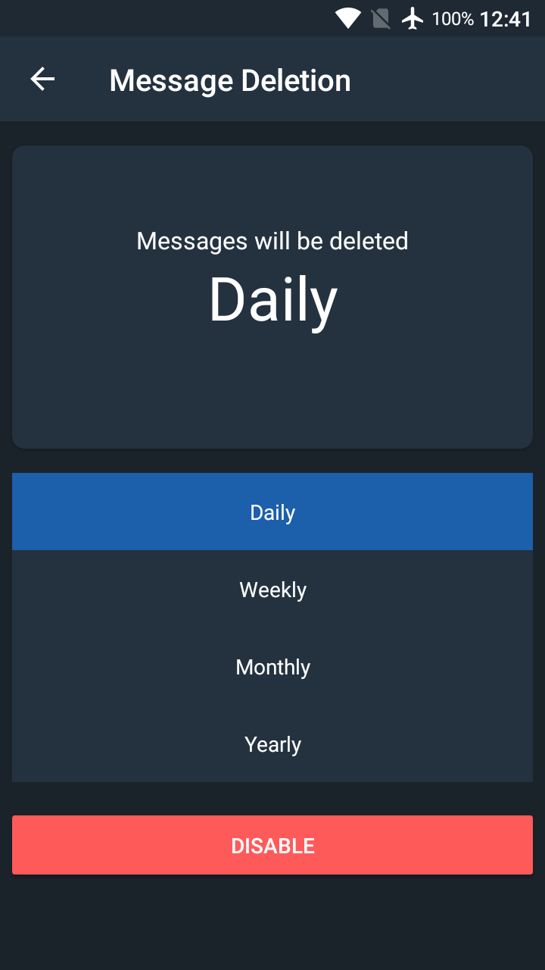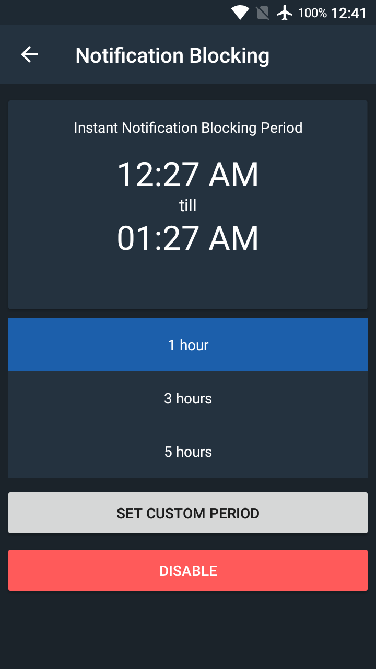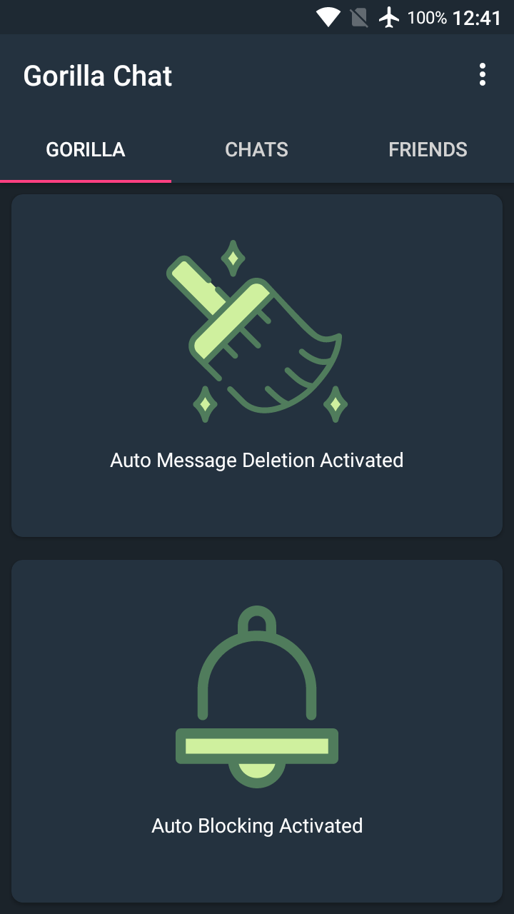

**Figure 6.1 Interface of Auto Blocking and History Deletion**

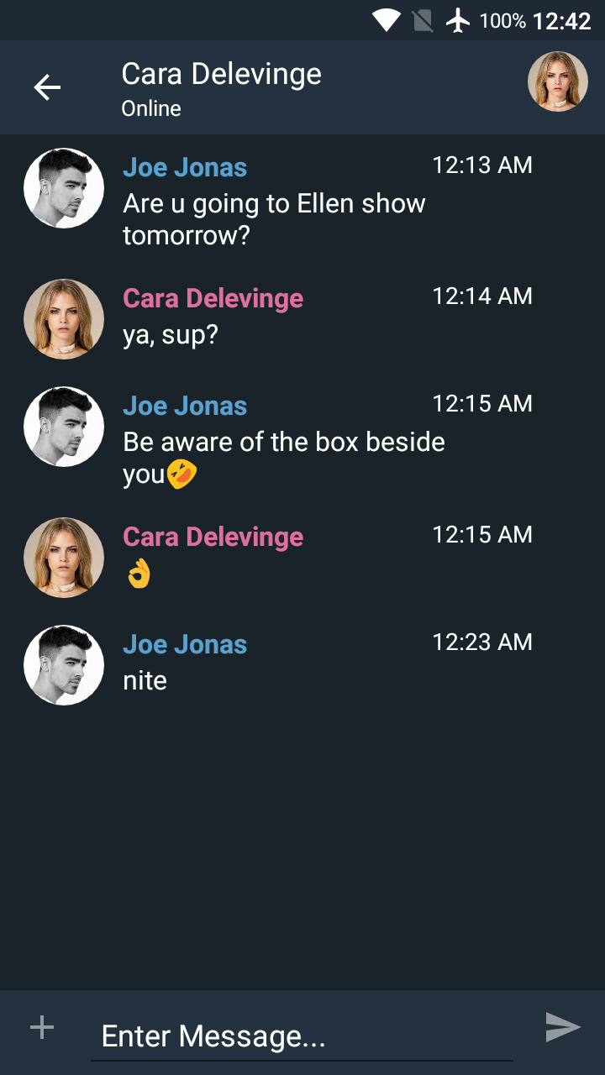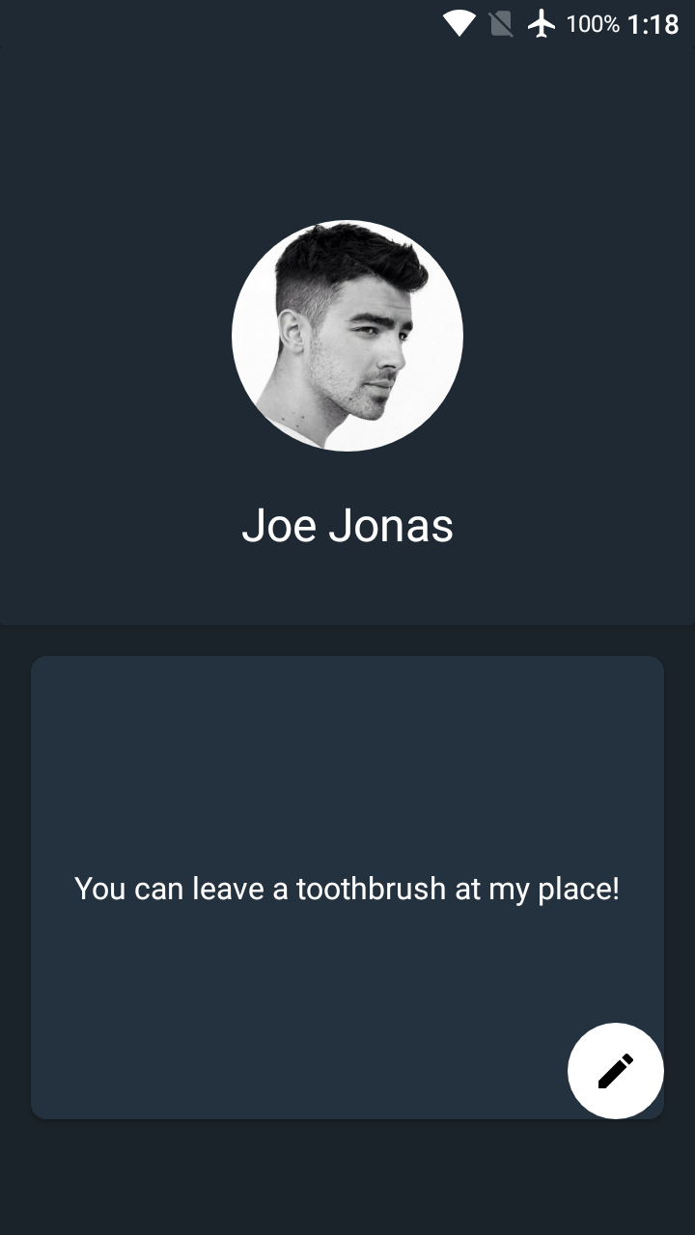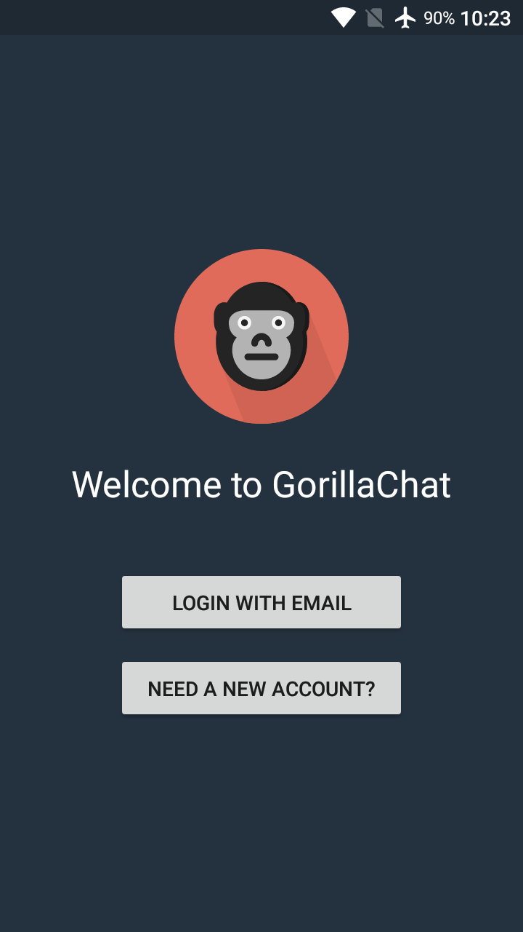

**Figure 6.2 Interface of Profile, Conversation, Register and Login**

**6.3 System demonstration**

The demonstration will be having on 2 mobile device for sending and receiving the messages.

**6.3.1 Register and Login**

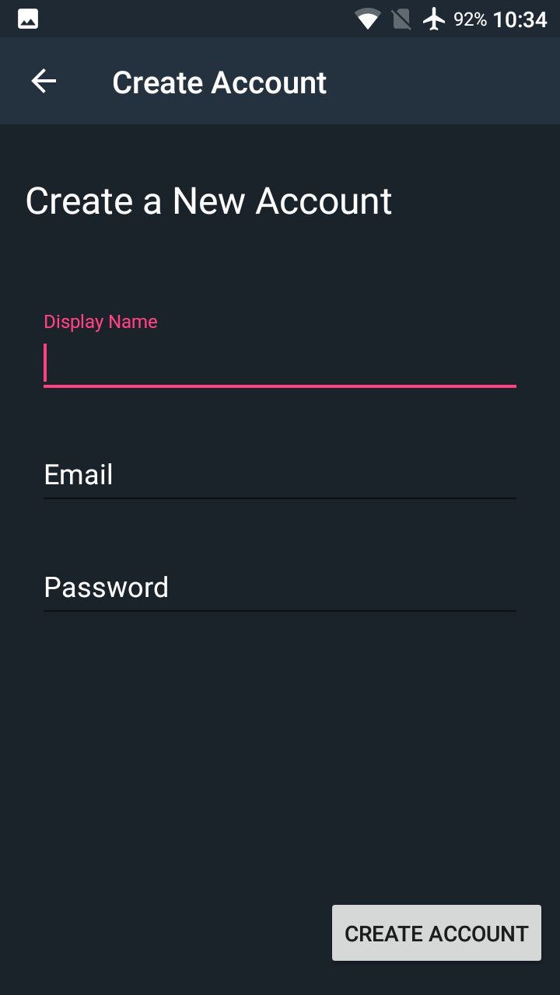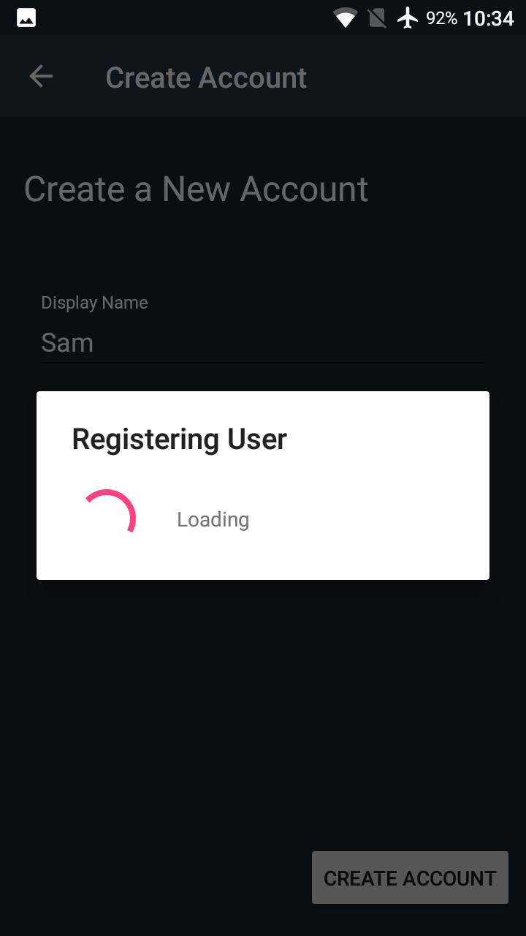

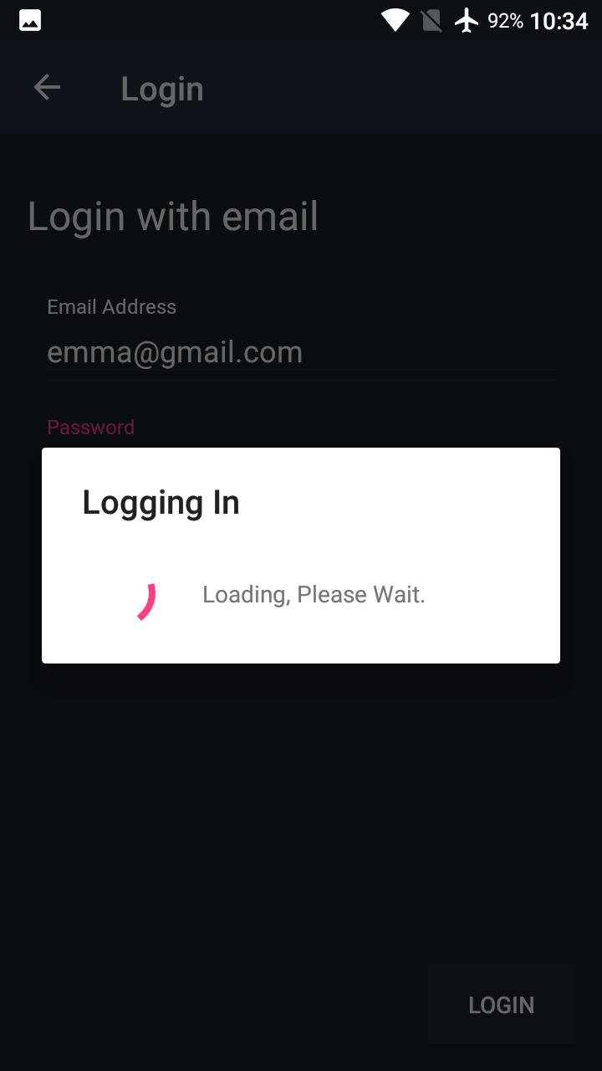**Figure 6.3.1.1 Figure 6.3.1.2 Figure 6.3.1.3**

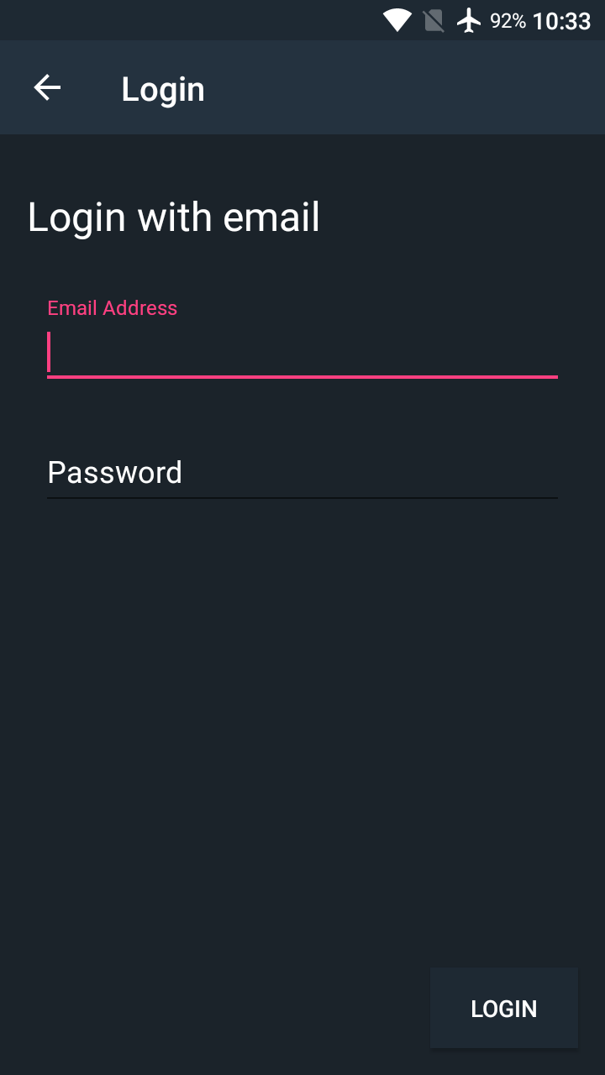

**Figure 6.3.1.4 Figure 6.3.1.5**

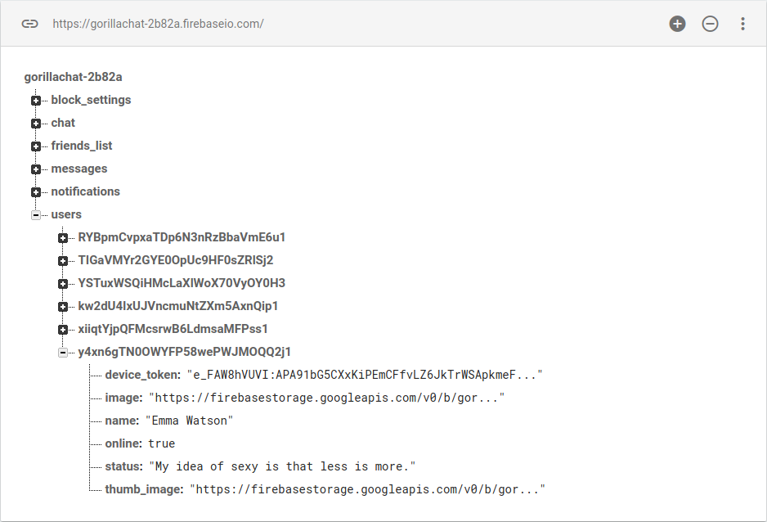Figure 6.3.1.6

**For registration of new user**

The user need to tap on “NEED A NEW ACCOUNT” button to navigate to the registration activity and fill in all the columns that needed, which are the display name, email, and password. Then the user tapped on the “CREATE ACCOUNT” button to create their own account. An alert dialog will pop-out while the user information is sending to the server. In Firebase, the user information will be recorded.

**For user to login**

The user need to tap on “LOGIN WITH EMAIL” button to navigate to the login activity and fill in all the columns that needed, which are email and password in order to login their account. Then the user tapped on “LOGIN” button and an alert dialog will pop-out while the authentication process is going on. If the user’s email and password is correct, user is able to login to their account.

**6.3.2 Send and Accept Friend’s request**

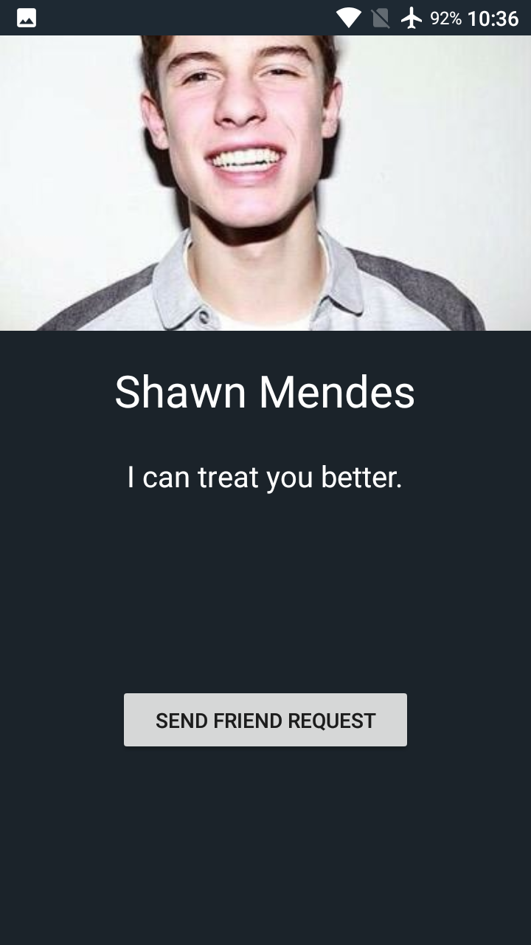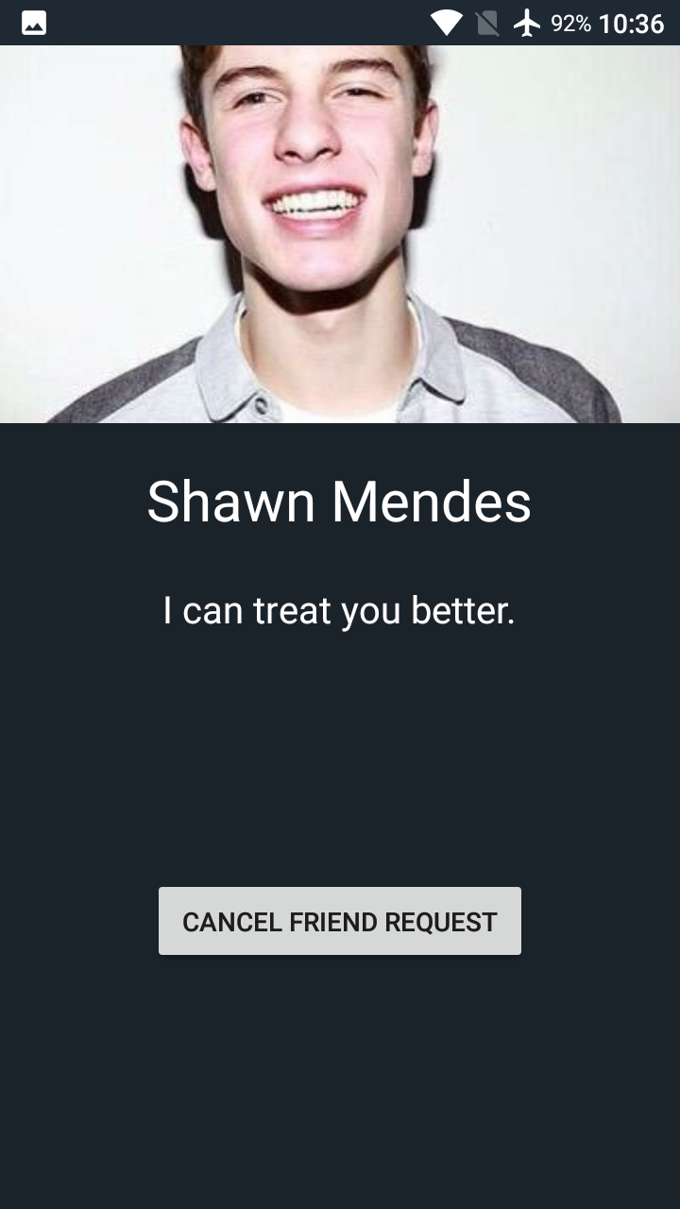

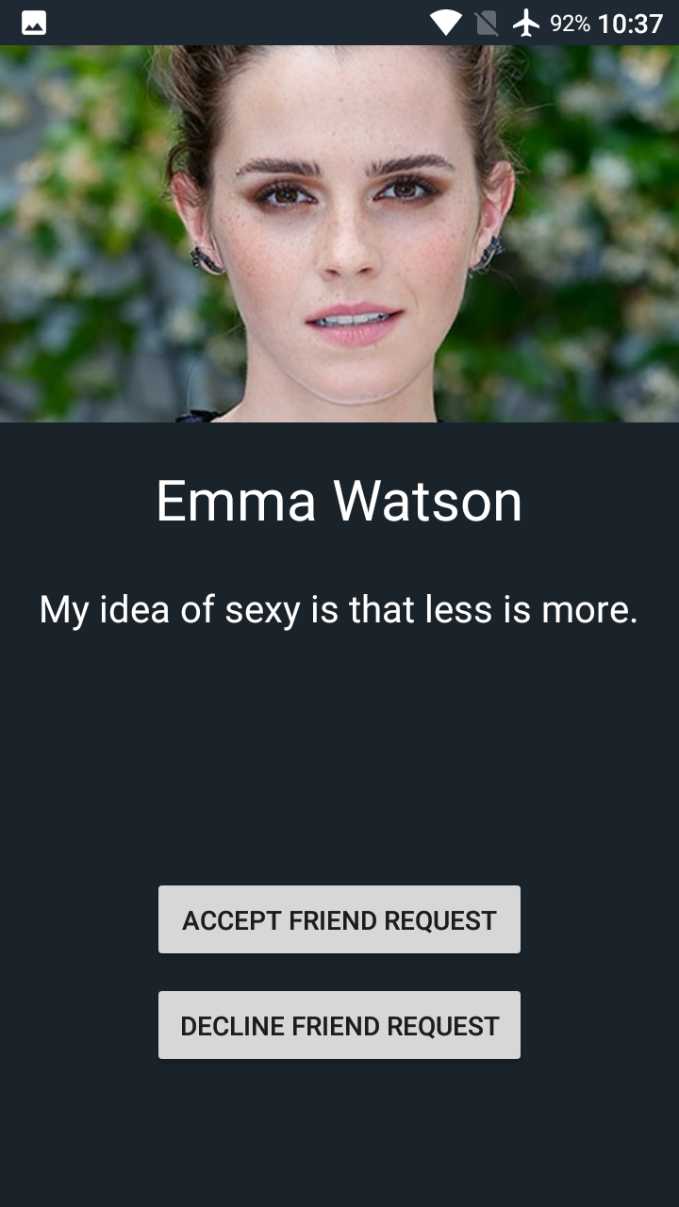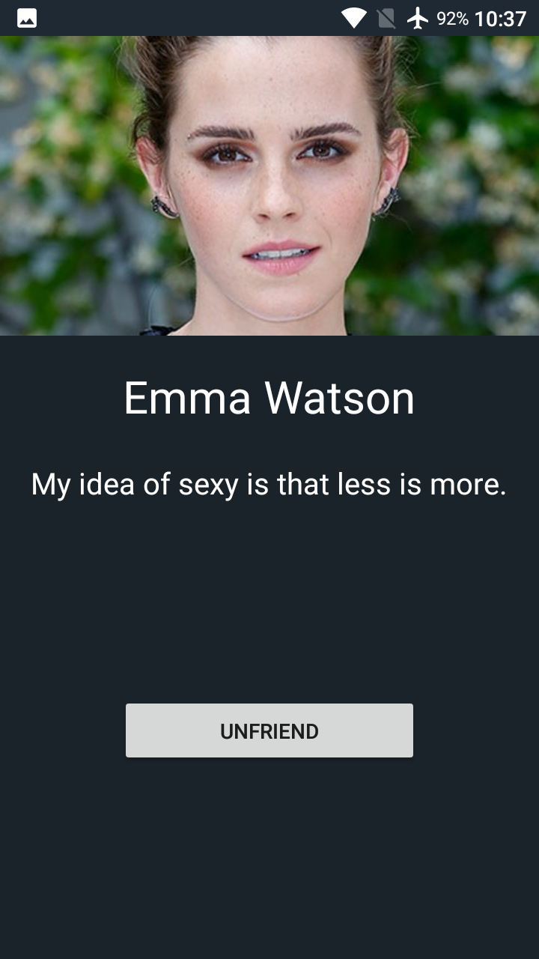

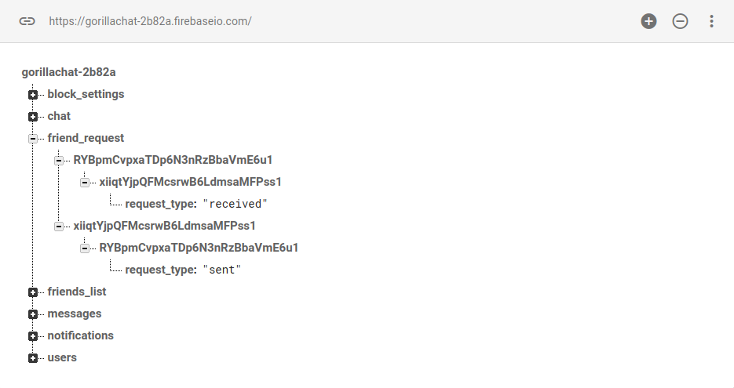

When the user need to add friend, he or she need to tap on the “SEND FRIEND REQUEST” button to perform the action. The “SEND FRIEND REQUEST” button will turn to “CANCEL FRIEND REQUEST” after the friend request was sent and the record was created on the database.

The person that received the friend request is able to perform 2 actions which are accept or decline friend request. It the “ACCEPT FRIEND REQUEST” button is tapped, the ‘ACCEPT FRIEND REQUEST” button will turn into “UNFRIEND” button, it is used to remove the friendship in the future.

**6.3.3 Start a conversation**

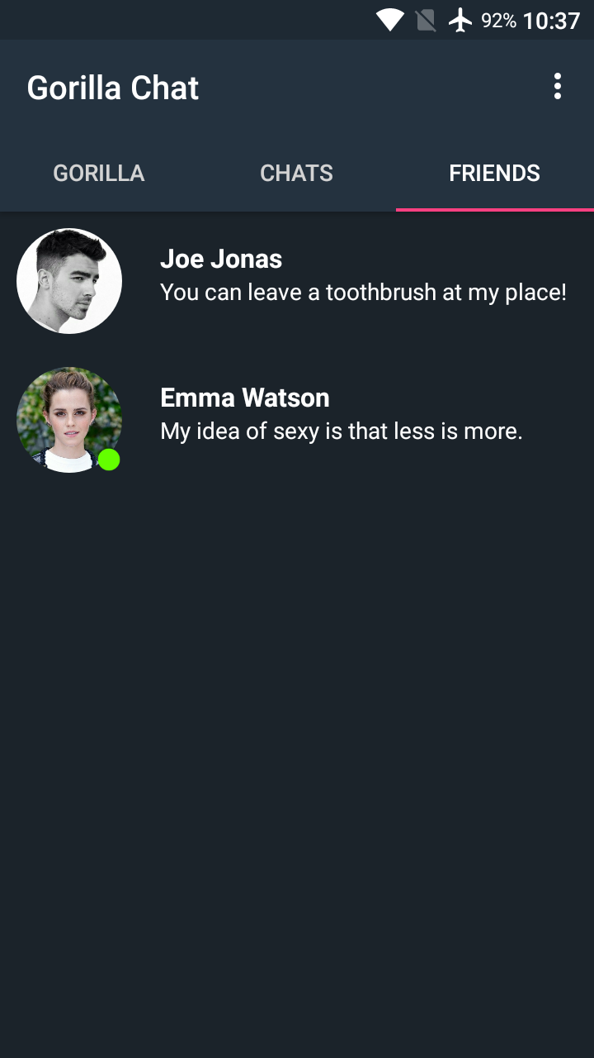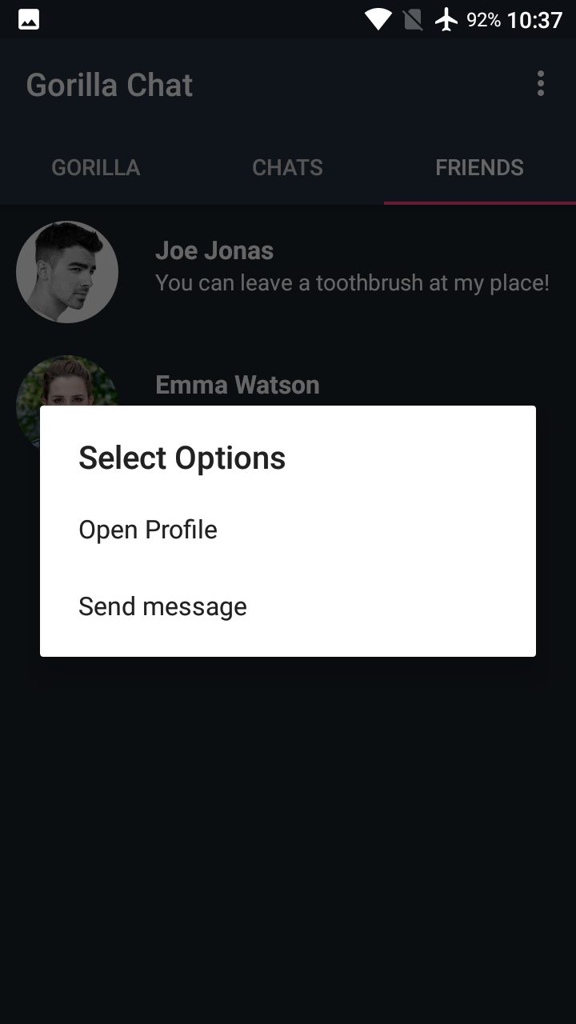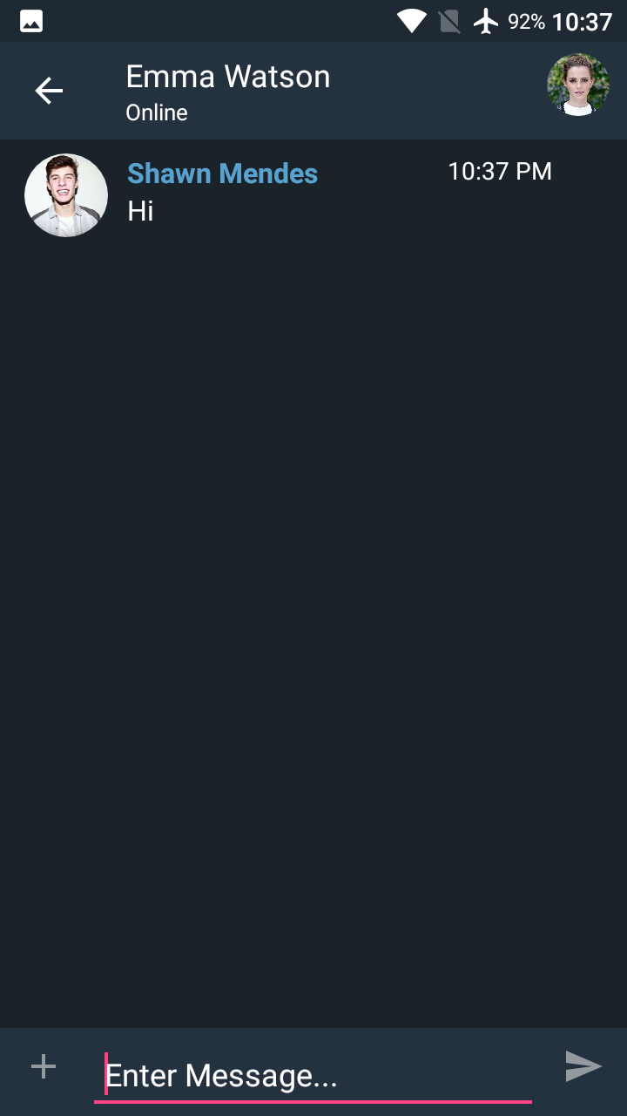

To start a new conversation, the user need to navigate to the “FRIENDS” tab, and tap on a friend , a dialog will pop-out to prompt the user for the next move. To check the profile, the user can tap on “Open Profile” option. To proceed on to a new conversation, user need to choose the “Send message” option. Then it will navigate to the chat activity, user can enter the message and send it to their friends.

**6.3.4 Auto Message Deletion**



It is easy to perform the auto message deletion function, user need to choose the first option with a broom icon from the “GORILLA” tab, then it will navigate to the “Message Deletion” activity. The system allow user to choose the message deletion frequency by daily, weekly, monthly, and yearly. After choosing, the option will be saved. To disable the function, user just need to tap on the disable button.

**6.3.5 Auto History Deletion**

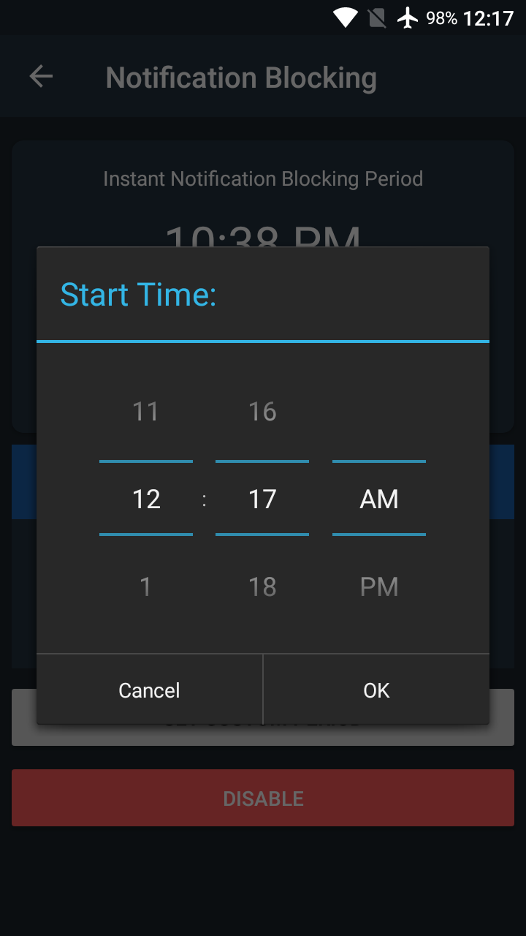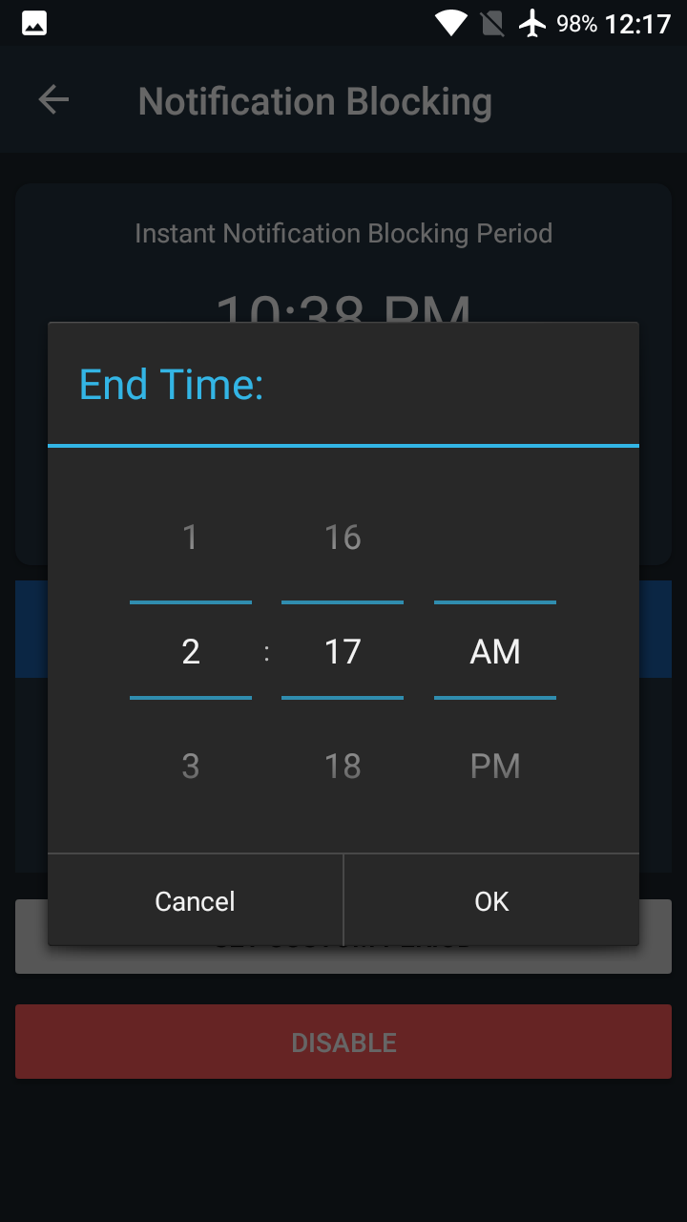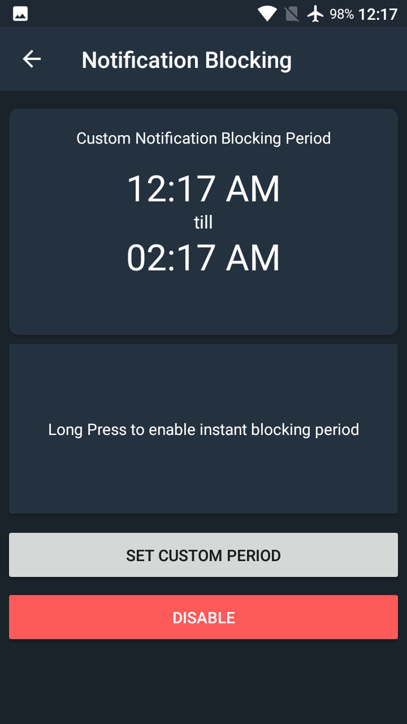

To perform auto notification blocking, the user need to choose the option with a bell icon on the “GORILLA” tab, then the notification blocking activity will show the instant notification blocking period in 1 hour by default. User can choose 1 hour, 3 hours, or 5 hours to block the message notification instantly for once. If the user decided to block it everyday, the user should tap on “SET CUSTOM PERIOD” button, and a time picker dialog will pop-out and prompt user for the start and end time for the blocking period. After setting, the period will be saved. To switch back to instant block period, user needs to hold on the “Long press to enable instant block period” button. To disable the function, user needs to tap on the “DISABLE” button.

**CONCLUSION AND RECOMMENDATION**

**7.1 Conclusion**

There are a few of messaging app in the market currently, but it is rare to see the messaging that implemented the auto message deletion function. Most of the messaging app in the market is letting their user to delete chat messages manually, it is consider time consuming for the process of message deletion. Therefore, to ease user for doing such a repetitive process, the auto message deletion function is implemented to the messaging app. The auto message deletion function can help user to remove their message by daily, weekly, monthly, or yearly. Besides that, the period auto notification blocking function is also able to fully customize by the user. The mobile app user can set the blocking period once and use it until they want to change it.

It is easy to setup a real-time database with Google Firebase for a messaging app. Firebase provides a NoSQL database for storing the data, therefore it is easy to store and access the data in real-time.

**7.2 Recommendation**

In order to in sync with the technology in the future, the massaging app should implement with block-chain technology in order to increase the security and integrity of massaging data. It can overcomes the limitations that related to identity control, eliminates intermediaries and third parties and allows any party involved to send and share value with other elements on the network, and ensuring speed, authenticity and verifiability.

For he automation of the notification blocking and message deletion, it should implement with machine algorithm in the future in order to track user habit and perform the relevant action. The messages also should be backup before the action of message deletion.