# How to run this programme?

1. Download the source code/clone the code from Git repository <https://github.com/zishanalitailor/MovementProcessor>
2. Got to **MovementProcessor.Business** folder where you will find the **sln** file.
3. Open the solution in visual studio and build the solution.
4. After successful build**.**
5. Go to **bin\Debug\MovementProcessor.Console** folder where you will find the **.exe** file.
6. Open Command Prompt and passed the argument as below. (Please change the path of exe)

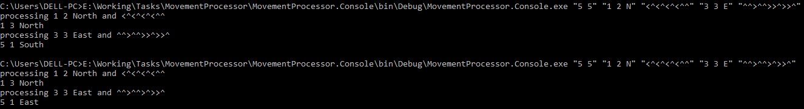

# Commands and output

1. C:\WINDOWS\system32>E:\Working\Tasks\MovementProcessor\MovementProcessor.Console\bin\Debug\MovementProcessor.Console.exe "5 5" "1 2 N" "<^<^<^<^^" "3 3 E" "^^>^^>>^>>^"

*processing 1 2 North and <^<^<^<^^*

*1 3 North*

*processing 3 3 East and ^^>^^>>^>>^*

*5 1 South*

1. C:\WINDOWS\system32>E:\Working\Tasks\MovementProcessor\MovementProcessor.Console\bin\Debug\MovementProcessor.Console.exe "5 5" "1 2 N" "<^<^<^<^^" "3 3 E" "^^>^^>^>>^"

*processing 1 2 North and <^<^<^<^^*

*1 3 North*

*processing 3 3 East and ^^>^^>^>>^*

*5 1 East*