Introduction

Document Title

Telecome API implementation.

Purpose of this document.

This document describes the implementation of Telecom API and how we can execute the APIs.

There are three APIs ware created and they are as follows.
- Get all phone numbers.
- Get all phone numbers of a single customer.
- Activate a phone number.
Below is the description of APIs.

- Get all phone numbers - Description
A new end point (API) will be created to get the all phone numbers which is stored in database. (Here I have used list instead of database.)

1.1 End points
The API URL would look similar to: -
GET : http://localhost:51301/api/telecom/GetAllPhoneNumbers

Or if you host this on IIS then it will be localhost (or IPAddress) instead of localhost:51301.

  - Inbound Request
None

1.3 Returning Response
Based on the request the API would form a Jason response with:
[
"112345671",
"123456761",
"112345778",
"312345671",
"323456761",
"312345778",
"323456364"
]
- Get all phone numbers of a single customer - Description
A new end point (API) will be created to get the all phone numbers of a single customer which is stored in database. (Here I have used list instead of database.)

2.1 End points
The API URL would look similar to: -
GET : http://localhost:51301/api/telecom/GetCustomerPhoneNumbers?customerId=2

Or if you host this on IIS then it will be localhost (or IPAddress) instead of localhost:51301.

  - Inbound Request
We need to pass customerId as parameter to get the phone numbers of that customer.

2.3 Returning Response
Based on the request the API would form a Jason response with:
[
"312345671",
"323456761",
"312345778",
"323456364"
]

- Activate a phone - Description
A new end point (API) will be created to activate a phone number for particular customer.

3.1 End points
The API URL would look similar to: -
POST : http://localhost:51301/api/telecom/ActivateNumber

Or if you host this on IIS then it will be localhost (or IPAddress) instead of localhost:51301.

  - Inbound Request
We need to pass customerId and phone number as parameter to activate a mobile number for particular customer.

Here, the request takes model as parameter not with query string so we need to send model from front end to get the result. We have to pass below model to get desire response.
{
CustomerId: 2,
PhoneNumer: "9898989898",
}

  - Returning Response
Based on the request the API would form a Jason response with:
The response will return list of phone number with new number set isActivated flag as true.
{
"CustomerId": 2,
"PhoneNumbers": [
{
"PhoneNumber": "312345671"
},
{
"PhoneNumber": "323456761"
},
{
"PhoneNumber": "312345778"
},
{
"PhoneNumber": "323456364"
},
{
"PhoneNumber": "9898989898"
} ],
"isActivated": true
}

Tool to check
I have used postmaster to check all the APIs are working or not. I have attached the postmaster collection for your testing purpose.

Working snap for all APIs.

- Get All phone numbers
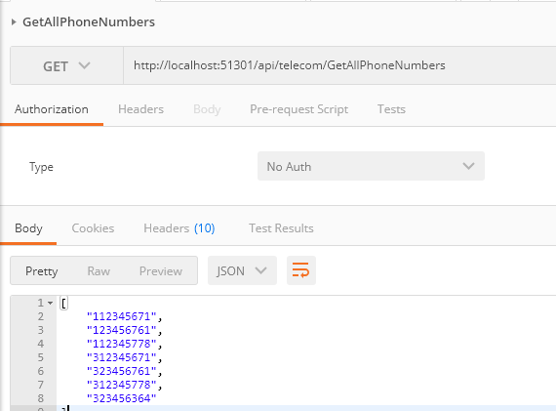

- Get All phone numbers of a single customer
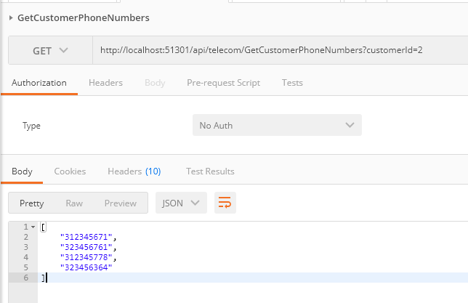

- Activate a Phone Number
