**Performing Analysis of Meteorological Data**

In this blog we are going to analyse the data from the Weather data-set of Finland, a country in the Northern Europe. You can find the data-set on Kaggle (<https://www.kaggle.com/muthuj7/weather-dataset>).We are going to use the numpy, pandas and the matplotlib libraries of Python.

Following is the Hypothesis of the Analysis: **“Has the Apparent temperature and humidity compared monthly across 10 years of the data indicate an increase due to Global warming.”**

Let us start by importing the required libraries and our data-set:

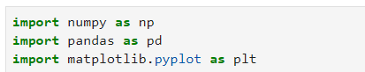

Libraries required for analysis

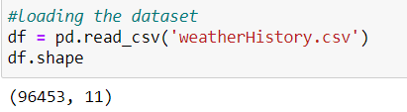

Importing our data-set

Here is a small preview of how our data-set looks:

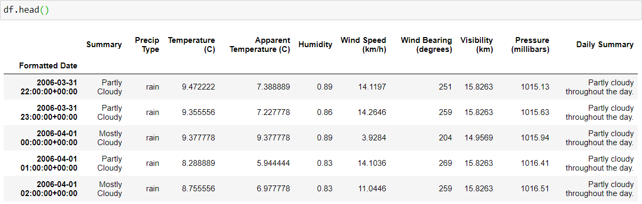

First 5 entries of our data-set

Now we need to drop the unwanted data, convert the data in to our need and resample our data :

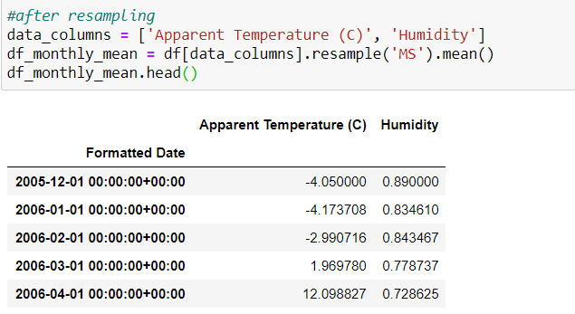

First 5 entries of resampled data-set

Now let us plot our data in a line graph

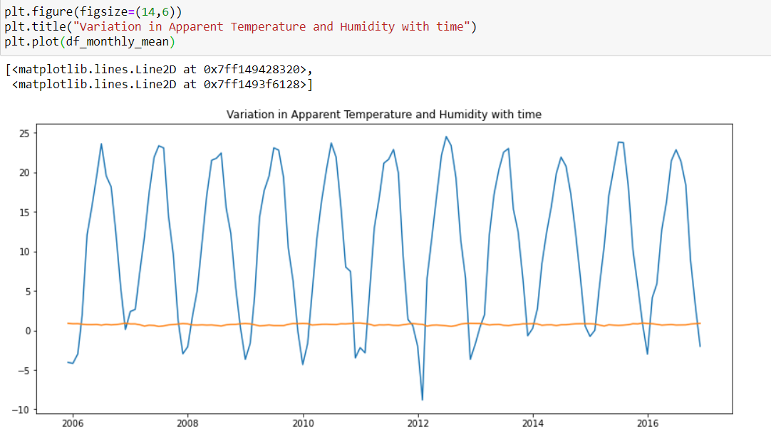

As we can see, both the peaks and the troughs are almost same throughout the period of 10 years. Here is a plot of the average temperature and humidity of the month of March over 10 years.

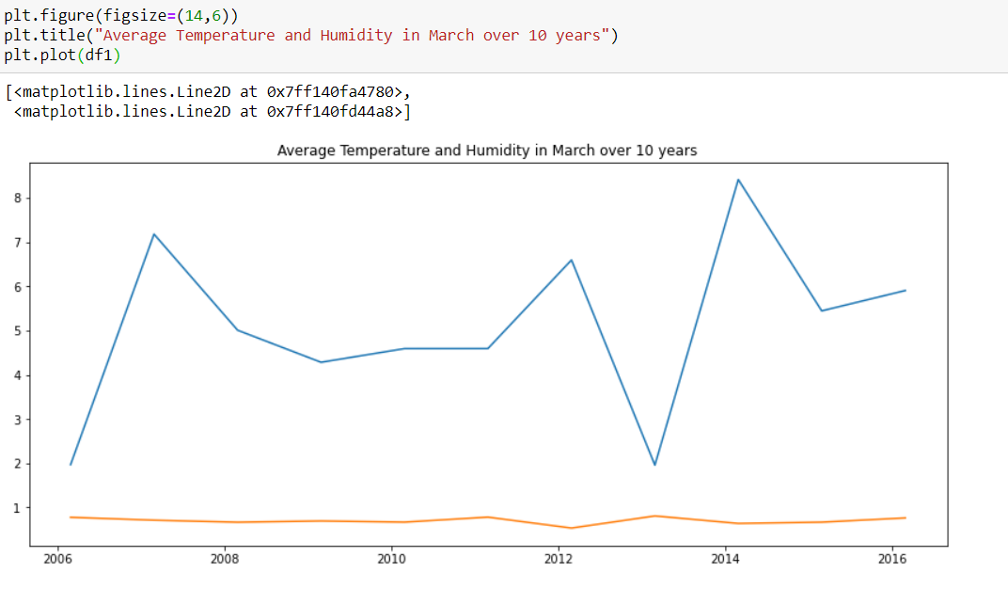

Obervation:

We can clearly see that there is a sharp rise in temperature in the year of 2007 whereas there is a fall in temperature in the year of 2013. Hence we can conclude that global warming has caused an uncertainty in temperature over the past 10 years while the average humidity as remained constant throughout the 10 years.