

International School

**Capstone Project 2**

**CMU-SE 451 – C2SE.28**

**Project Proposal**

**Version 1.0**

**Date: February 14th, 2025**

**Classroom Teaching and Trivia Platform**

**Created by C2SE.28**

Khoi, Le Vu Anh Khoi - 26211238818

Tuan, Phan Phu - 26211241675

Viet, Doan Ngoc Quoc - 27211225657

Tu, Dang Ngoc - 26211235773

Tu, Nguyen Minh - 26211241700

**Approval of Mentor:**

Name: Sanh Tran Kim, MSc Signature: Date: 18th May,2025

**PROJECT INFORMATION**

|  |  |  |  |
| --- | --- | --- | --- |
| **Project acronym** | **NQUIZ** | | |
| **Project Title** | Classroom Teaching and Trivia Platform | | |
| **Start Date** | 09 Feb 2025 | **End Date** | 18 May 2025 |
| **Lead Institution** | International School, Duy Tan University | | |
| **Project Mentor** | Sanh Tran Kim, MSc | | |
| **Scrum master/ Project Leader & contact details** | Khoi, Le Vu Anh  Email: levuanhkhoi123@gmail.com  Tel: 0985018002  ID: 26211238818 | | |
| **Partner Organization** | Duy Tan University | | |
| **Project Web URL** |  | | |
| **Team members** | **Name** | **Email** | **Tel** |
| 26211238818 | Khoi, Le Vu Anh | levuanhkhoi123@gmail.com | 0985018002 |
| 26211241675 | Tuan, Phan Phu | phutuan112@gmail.com | 0905978306 |
| 27211225657 | Viet, Doan Ngoc Quoc | doanngocquocviet1203@gmail.com | 0969195236 |
| 26211235773 | Tu, Dang Ngoc | tudangm10@gmail.com | 0347259766 |
| 26211241700 | Tu, Nguyen Minh | mtking4112@gmail.com | 0968538729 |

**DOCUMENT APPROVALS**

The following signatures are required for approval of this document.

|  |  |  |
| --- | --- | --- |
| Khoi, Le Vu Anh  Student ID: 26211238818  *Scrum Master* | Signature | Date |
| Tuan, Phan Phu  Student ID: 26211241675  *Product Owner* | Signature | Date |
| Viet, Doan Ngoc Quoc  Student ID: 27211225657  *Team Member* | Signature | Date |
| Tu, Dang Ngoc  Student ID: 26211235773  *Team Member* | Signature | Date |
| Tu, Nguyen Minh  Student ID: 26211241700  *Team Member* | Signature | Date |

**DOCUMENT NAME**

|  |  |  |  |
| --- | --- | --- | --- |
| **Document**  **Title** | Proposal Document | | |
| **Author(s)** | C2SE.28 | | |
| **Role** | Product Owner, Team Member, Scrum Master | | |
| **Date** | February 14, 2025 | File name: | C2SE.28_Proposal_NQUIZ_ver1.0.doc |

**REVISION HISTORY**

|  |  |  |  |  |
| --- | --- | --- | --- | --- |
| **Version** | **Date** | **Comments** | **Author** | **Approval** |
| 1.0 | February 14, 2025 | Initial Release | All members |  |

**TABLE OF CONTENTS**

**1.** **Project Title** 1

**2.** **Project Overview** 1

**2.1.** **Purpose of Document** 1

**2.2.** **Project Goal** 1

**3.** **Project Background and Motivation** 1

**4.** **Proposed Solution** 2

**4.1.** **Solution** 2

**4.2.** **System context diagram** 4

**4.3.** **System context description** 5

**5.** **Related Works or Projects on the Market** 5

**6.** **Objectives and Deliverables** 6

**7.** **Methodology and Tools** 7

**7.1.** **Technical Constraints** 7

**7.2.** **Scrum Process** 8

**8.** **Timeline** 9

**9.** **Project Team** 10

**10.** **Risk Management** 11

**11.** **Budget and Resources** 12

**12.** **Project constraints** 13

**13.** **Conclusion** 14

**14.** **References** 15

**15.** **Attached “DESCRIPTION OF PRODUCT REQUIREMENTS”** 15

**LIST OF TABLES**

**Table 1.** Current Status of Art 6

**Table 2.** Timeline of Project 9

**Table 3.** Project Team Roles and Responsibilities 10

**Table 4.** Risks Management Plan 11

**Table 5.** Total Cost Estimation 12

**Table 6.** Description Cost 12

**Table 7.** Constraints 13

**Table 8.** References 15

**LIST OF FIGURES**

**Figure 1.** System context diagram 4

**Figure 2.** Scrum Process 8

# **Project Title**

Classroom Teaching and Trivia Platform

# **Project Overview**

## **Purpose of Document**

* The document provides an overview of the project including the purpose and scope of the project.
* Identify business needs, problems, or situations related to the initialization and construction projects.
* Provide solutions for business needs and give an overview of system architecture.
* Provide an overview of resources, schedule, solution and budget for the project.

## **Project Goal**

The Classroom Teaching and Trivia Platform is a powerful AI-enhanced system that revolutionizes interactive learning, training, and entertainment. It empowers hosts to design quizzes customize various formats, and engage audiences through dynamic live sessions with real-time analytics. The platform integrates an AI-powered chatbot to provide explanations and insights for both teachers and students, helping them understand the questions better. Players join effortlessly using a game PIN, compete to answer questions, and track their rankings on a leaderboard. Administrators take charge of user management, content moderation, and platform security to ensure a smooth experience. With its advanced AI-driven question creation, vibrant.

# **Project Background and Motivation**

Traditional quiz platforms like Kahoot.com have dramatically transformed the landscape of interactive learning, making quizzes engaging and competitive. However, they often place an overwhelming burden on educators, trainers, and content creators, requiring them to manually craft questions which can be time-consuming and monotonous. The challenge of generating high-quality, diverse, and adaptive questions can stifle the growth of these platforms. Furthermore, many existing systems lack the AI-driven automation necessary to tailor quizzes to unique learning needs efficiently.

Enter the Next Generation Quiz and Trivia Platform—a revolutionary solution designed to overcome these hurdles. By harnessing the power of AI-powered question generation, this platform empowers hosts to create customized quizzes instantly tailored to a range of topics, difficulty levels, and educational goals. This not only elevates the quality of the content but also frees up valuable time for educators and trainers, allowing them to focus on what truly matters: teaching.

With features like real-time multiplayer engagement, personalized question generation, and advanced performance tracking, the platform guarantees a dynamic and adaptive learning experience. Players will enjoy an exciting and intuitive interface that fuels competition, while administrators gain access to powerful management tools for user control and content moderation. By merging AI-driven automation, gamification, and real-time analytics, this innovative project is poised to make learning not just more engaging, but also more efficient and accessible for all.

# **Proposed Solution**

## **Solution**

The Classroom Teaching and Trivia Platform leverages AI to enhance quiz creation, participation, and management for:

**User:**

* AI-powered quiz creation: Hosts can automatically generate quiz questions using GPT based on topic, difficulty level, and learning objectives.
* Customizable quiz formats: Supports multiple question types, including multiple choice, true/false, short answer, and AI-generated adaptive questions.
* Live quiz hosting and self-learning: Hosts can host quizzes in real-time, schedule sessions, and manage access through PIN-based participation.
* Performance analytics and insights: Detailed reports track player participation, scores, and learning outcomes to measure effectiveness.
* Easy Quiz Participation: Players can join quizzes instantly using a game PIN and QR code without the need for account setup.
* Interactive & Competitive Gameplay: Real-time feedback, leaderboards, and rewards create an engaging quiz experience.
* Adaptive Learning Experience: AI-generated questions adjust dynamically based on user responses for a personalized experience.
* Cross-Platform Accessibility: The platform is available on desktops, mobile devices, and tablets for seamless participation.

**Admin:**

* Monitor user roles and access.
* Ensure system security and integrity.
* Monitor system performance and resolve technical issues.

## **System context diagram**

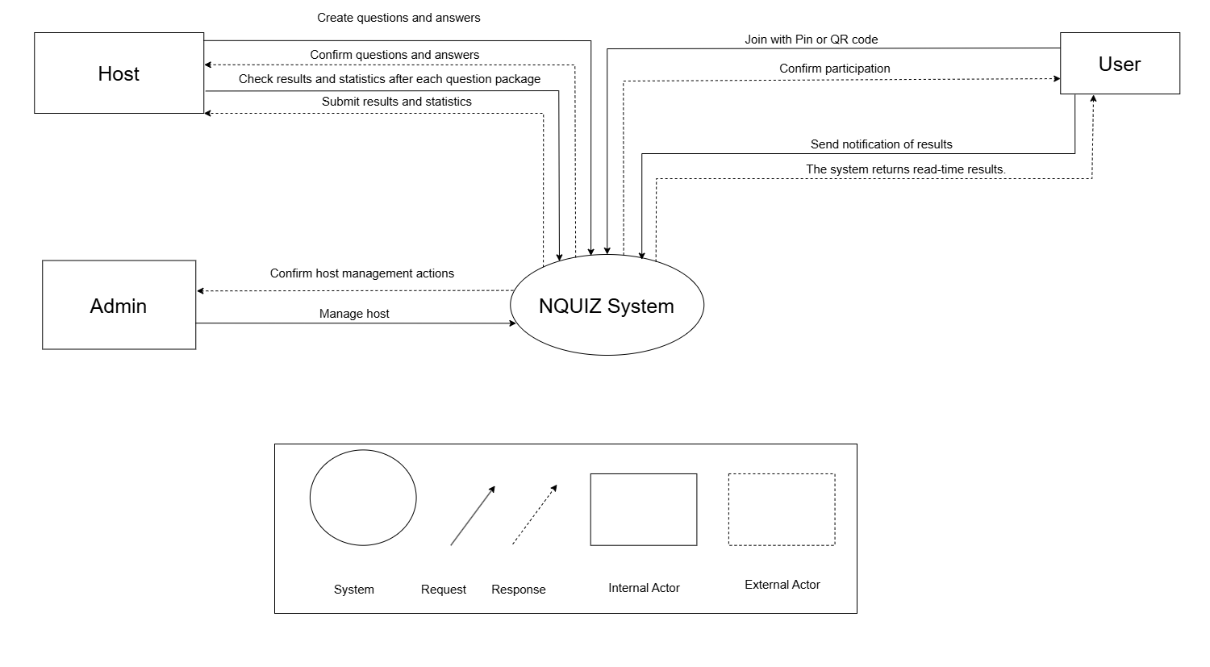

**Figure 1.** System context diagram

## **System context description**

**Admin:**

* Admin can monitor user roles and access rights.
* Admin can ensure system security and integrity.
* Admin can monitor system performance and resolve technical issues.

**User:**

* The host can create tests.
* The host can customizable test formats.
* The host can live test hosting and self-study.
* The host can performance analysis and insights.
* User can easily Quiz Participation.
* User can interact with competitive Gameplay.
* User can adapt their Learning Experience.
* User can cross-platform Accessibility.

# **Related Works or Projects on the Market**

There are various quiz and trivia platforms in the market, such as Kahoot!, Quiz.com, and our Next Generation Quiz & Trivia Platform. Although these platforms offer interactive learning and gaming experiences, they differ in terms of features, customization options, and AI integration. The following is a comparative analysis:

**Table 1.** Current Status of Art

|  |  |  |  |
| --- | --- | --- | --- |
| **Characteristics** | **NQUIZ** | **Kahoot!** | **Quiz.com** |
| **AI-Powered Question Generation (Including in the web)** | **+** |  |  |
| **Real-Time Feedback & Leaderboards** | **+** |  | **+** |
| **Adaptive Learning Experience** | **+** |  |  |
| **Cross-Platform Accessibility** | **+** | **+** | **+** |
| **Performance Analytics & Reports** | **+** | **+** | **+** |
| **User & Role Management** | **+** | **+** | **+** |

Our application overcomes disadvantages that competitors inconvenience users such as:

* Higher Development Complexity – Implementing AI-powered question generation and adaptive learning requires advanced technology, making development more complex.
* AI Accuracy & Bias – AI-generated questions might sometimes contain errors or biases, requiring strong moderation and quality control mechanisms.
* Increased Operational Costs – Running AI models, real-time quizzes, and analytics features requires powerful cloud servers, leading to higher costs.
* Data Privacy & Security Risks – Handling user-generated content and AI-driven analytics requires strict privacy policies and cybersecurity measures.

# **Objectives and Deliverables**

* **Objective 1:** Enhance Quiz Creation with A.
  + **Deliverable:** A system that enables automatic question creation using GPT based on predefined topics and difficulty levels.
* **Objective 2:** Improve Engagement & Interactivity.
  + **Deliverable:** A web-based quiz platform that supports multiple question formats, including MCQs, True/False, short answers, and AI-adaptive questions.
* **Objective 3:** Offer Adaptive Learning.
  + **Deliverable:** Functionality for hosting both real-time and self-paced quizzes, allowing flexibility for educators and event organizers.
* **Objective 4:** Ensure Cross-Platform Accessibility.
  + **Deliverable**: A user-friendly interface with real-time feedback, leaderboards, and performance tracking.
* **Objective 5:** Enable Role-Based Management.
  + **Deliverable:** A dashboard for administrators to oversee users, roles, content moderation, and system security.

# **Methodology and Tools**

## **Technical Constraints**

**Technologies to Develop:**

* Programming language:
* Frontend: React, React Native
* Backend: Node.js, Express
* Database: MySQL
* Database Management System: MySQL Workbench
* API: RESTful APIs for communication between frontend and backend

**Environments:**

* Development Environment:
  + IDE: Visual Studio Code
  + Code Repository: GitHub
  + Project Management: Trello.
  + Cloud Hosting: AWS

## **Scrum Process**

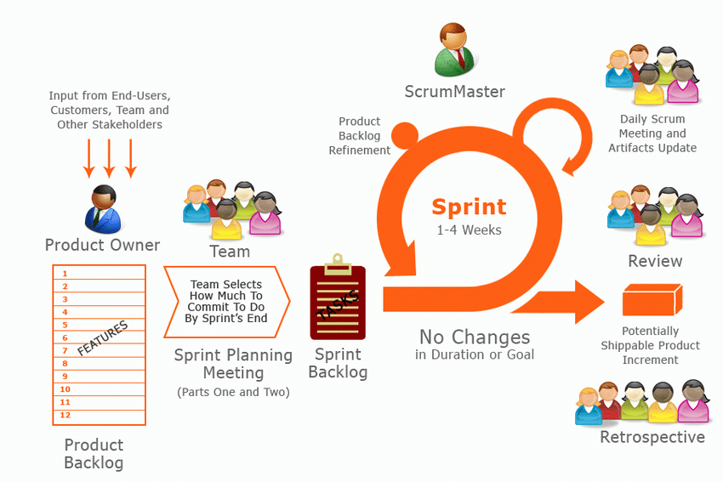

**Figure 2.** Scrum Process

* Scrum is an agile software development methodology designed to manage projects and product development through iterative and incremental processes.
* This approach is particularly useful for projects where detailed upfront planning is challenging due to the complexity or rapidly changing nature of requirements.
* Instead of using traditional command-and-control management, Scrum employs empirical process control mechanisms, with continuous feedback loops serving as the foundation for project management.
* Scrum encourages decision-making at the operational level, based on specific project information and conditions. This enhances flexibility and the ability to adapt to changes.
* Benefit of the methodology:
  + - Project can respond easily to change.
    - Problems are identified early.
    - Customers get the most beneficial work first.
    - The work done will better meet the customer’s needs.
    - Improved productivity.
    - Ability to maintain a predictable schedule for delivery.

# **Timeline**

**Table 2.** Timeline of Project

|  |  |  |
| --- | --- | --- |
| **Phase** | **Sprint/Week** | **Tasks** |
| **Overview** | **Week 1-2** | - Conduct a kick-off meeting to define project scope and key objectives.  - Gather requirements for quiz creation, hosting, and analytics.  - Design system architecture, database structure, and UI layout.  - Research and integrate GPT-based question generation. |
| **Development** | **Week 3-4** | - Develop user authentication and role-based access (Host, Player, Admin).  - Implement quiz creation with AI-powered question generation.  - Design and build UI for quiz hosting and player interaction. |
| **Development** | **Week 5-6** | - Develop real-time quiz hosting with game PIN access.  - Implement leaderboards, scoring system, and interactive gameplay.  - Finalize database integration for storing quizzes and user data. |
| **Development** | **Week 7** | - Build performance tracking and analytics for hosts.  - Implement adaptive learning features with AI-driven difficulty adjustment.  - Develop admin tools for user management and content moderation. |
| **Development** | **Week 8** | - Complete chatbot integration for automated quiz assistance.  - Ensure real-time feedback and communication features. |
| **Testing** | **Week 9** | - Conduct internal testing to verify functionality, security, and performance.  - Perform user acceptance testing with selected educators and trainers. |
| **Demo** | **Week 10** | - Release the final version of the platform.  - Present the project to stakeholders for review and feedback. |

# **Project Team**

**Table 3.** Project Team Roles and Responsibilities

|  |  |  |
| --- | --- | --- |
| **Name** | **Role** | **Responsibilities** |
| Khoi, Le Vu Anh | Scrum Master | Facilitates Scrum practices, organizes sprints, removes roadblocks, and ensures team productivity. |
| Tuan, Phan Phu | Product owner | Defines the vision, manages the product backlog, prioritizes features, and communicates with stakeholders. |
| Viet, Doan Ngoc Quoc | Developer | Develops the NQUIZ web UI using React, integrates APIs, and ensures a seamless user experience. |
| Tu, Dang Ngoc | Developer | Designs and develops backend systems in Node.js, including APIs |
| Tu, Nguyen Minh | Developer | Manages database structure, optimizes MySQL for scalability, and ensures secure data handling and storage. |

# **Risk Management**

**Table 4.** Risks Management Plan

|  |  |
| --- | --- |
| **Risk** | **Mitigation Strategy** |
| Real-time latency affecting gameplay | Optimize WebSocket connections, use CDNs, and deploy edge servers. |
| Server crashes or downtime | Use cloud-based auto-scaling, load balancing, and backup recovery strategies. |
| AI-generated questions may be inaccurate | Implement a review system, allow manual editing, and retrain AI models regularly with diverse datasets. |
| Delays in development due to unexpected technical challenges | Adopt Agile methodology, set realistic deadlines, and prioritize critical features first. |
| Lack of skilled developers for AI and real-time features | Offer competitive salaries, invest in training programs, and consider outsourcing some tasks. |
| Low user adoption due to competition | Conduct market research, offer unique AI-powered features, and invest in marketing campaigns. |

# **Budget and Resources**

**Table 5.** Total Cost Estimation

|  |  |  |  |
| --- | --- | --- | --- |
| **No.** | **Criteria** | **Prices (USD)** | **Total (USD)** |
| 1 | Working hour | **$**4 | **$**6300 |
| 2 | Other costs | **$**100 | **$**500 |
| **Total cost** | | | **$**6800 |

**Table 6.** Description Cost

|  |  |  |
| --- | --- | --- |
| **Description** | **Amount** | **Unit** |
| Number of Members | 5 | Person |
| Number of working hours per day | 3 | Hour |
| The cost of working per hour per person | 4 | USD |
| The duration of the project | 3 | Month |
| The number of working days | **105** | **Day** |

**Explain:**

* Amount of working hours = 5 members * 3 hours * 105 days
* Other cost = 5 members * 100 USD

# **Project constraints**

**Table 7.** Constraints

|  |  |  |
| --- | --- | --- |
| **Constraint** | **Constraints Description** | **Guidelines for Acceptance** |
| **Time Constraint** | The project must be completed within 10 weeks, following the planned timeline. | All core features (quiz creation, hosting, analytics, AI integration) must be fully functional by the final demo. |
| **Budget Constraint** | Limited resources for development, hosting, and AI usage. | The project must utilize cost-effective cloud services and open-source technologies where possible. |
| **Technology Stack** | The platform must be built using React (Frontend), Node.js (Backend), and GPT integration for AI-based question generation. | The system must run smoothly on the chosen stack, with seamless AI-powered quiz creation. |
| **Scalability** | The system should support multiple concurrent users, including hosts and players. | The platform should handle at least 500 simultaneous users without performance issues. |
| **Data Security** | User data, quiz content, and results must be securely stored and protected. | Compliance with data encryption, authentication, and privacy policies must be ensured. |
| **User Experience** | The UI should be intuitive and accessible across different devices. | The platform must be responsive on desktop, mobile, and tablet, ensuring smooth navigation. |
| **AI Accuracy** | GPT-generated quiz questions must be relevant and well-structured. | AI should generate accurate and contextually appropriate questions at least 90% of the time. |

# **Conclusion**

The Next Generation Quiz and Trivia Platform represents a transformative approach to interactive learning and entertainment. By leveraging AI technology, it empowers hosts to create dynamic quizzes that cater to diverse audiences, ensuring a personalized experience for every participant. With features like real-time analytics, competitive gameplay, and robust user management, the platform fosters an engaging environment that enhances knowledge retention and encourages collaboration. As we continually innovate and refine our offerings, we remain committed to making learning not only accessible but also enjoyable for all users. Join us in redefining the future of quizzes and trivia, where education meets excitement.

# **References**

**Table 8.** References

|  |  |  |
| --- | --- | --- |
| **No.** | **References** | **Document Information** |
| 1 | Scrum Model | <https://en.wikipedia.org/wiki/Scrum_(software_development)> |
| <https://www.atlassian.com/agile/scrum> |
| <https://www.digite.com/agile/scrum-methodology/> |
| <https://www.scrum.org/resources/scrum-guide> |
| 2 | Technical | <https://www.tensorflow.org/tutorials/quickstart/beginner?hl=vi> |
| [https://www.flutterclutter.dev/flutter/tutorials/implementing-edge-detection-in-flutter/2020/1509/](https://www.flutterclutter.dev/flutter/tutorials/implementing-edge-detection-in-flutter/2020/1509/%20) |
| <https://stackoverflow.com/questions/14248571/finding-properties-of-sloppy-hand-drawn-rectangles> |
| <https://www.tutorialspoint.com/how-to-detect-a-rectangle-and-square-in-an-image-using-opencv-python> |
| 3 | Standard | [https://www.nws.noaa.gov/oh/hrl/developers_docs/General_So](https://www.nws.noaa.gov/oh/hrl/developers_docs/General_Software_Standards.pdf) [ftware_Standards.pdf](https://www.nws.noaa.gov/oh/hrl/developers_docs/General_Software_Standards.pdf) |
| <https://standards.ieee.org/standard/12208-2017.html> |
| <https://en.wikipedia.org/wiki/Scrum_(software_development)> |

# **Attached “DESCRIPTION OF PRODUCT REQUIREMENTS”**