|  |  |
| --- | --- |
| Course | Advanced Software Design – CS525 |
| Assignment | Lab 2 |
| Week | 02 |
| Due | Feb 24, 2020 |
| Student name | Quan Hong Doan |
| Student ID | 986956 |

Online version:

**Problem 1**:

Problem 1 is the question a from the PDF file.

**Answer**:

There’re few ways to design. I start to change the DrawingCanvas class into an abstract class, then 3 other sub-classes implementing the abstract function from the abstract Canvas class.

Therefore, from the Application class, we just need to call draw(), and the JVM will understand to call the function draw() of the relevant class, respectively.

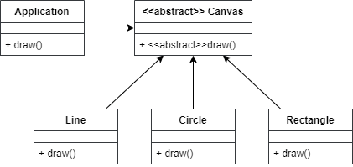

The sequence diagram would be for drawing a line, then 2 circles as below.

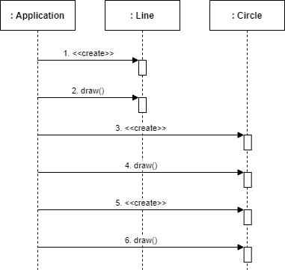

**Problem 2**:

Problem 2 is the combination of question b, c, and d.

**Answer**:

Like the problem 1, I start the design from certain points: