|  |  |  |  |  |  |  |
| --- | --- | --- | --- | --- | --- | --- |
| **Test Case ID** | **Description** | **Input** | **Expected Result** | **Actual Result** | **Pass/Fail** | **Remarks** |
| 1 | When player press enters start game | Keyboard input | Start game | Start game | Pass | Nil |
| 2 | When player hit obstacles lives minus | Scene input | Minus by 1 | Minus by 1 | Pass | Nil |
| 3 | When play lives hit to 0 go to game over scene | Scene input | Game over scene | Game over scene | Pass | Nil |
| 4 | When player on trigger with walrus | Scene input | Game over scene | Game over scene | Pass | Nil |
| 5 | When player on trigger with ice | Scene input | Game over scene | Game over scene | Pass | Nil |
| 6 | When player on trigger with barrel | Scene input | Game over scene | Game over scene | Pass | Nil |
| 7 | When player on trigger with tire | Scene input | Game over scene | Game over scene | Pass | Nil |
| 8 | When player press restart button back to scene | Mouse input | Restart game | Restart game | Pass | Nil |
| 9 | Inside the game got back gourd sound | Inside game scene | Have | Have | Pass | Nil |
| 10 | When player at game clear scene press restart button go back to main scene | Mouse input | Restart game | Restart game | Pass | Nil |

GitHub URL : <https://github.com/zito1314/GIT_PA02.git>

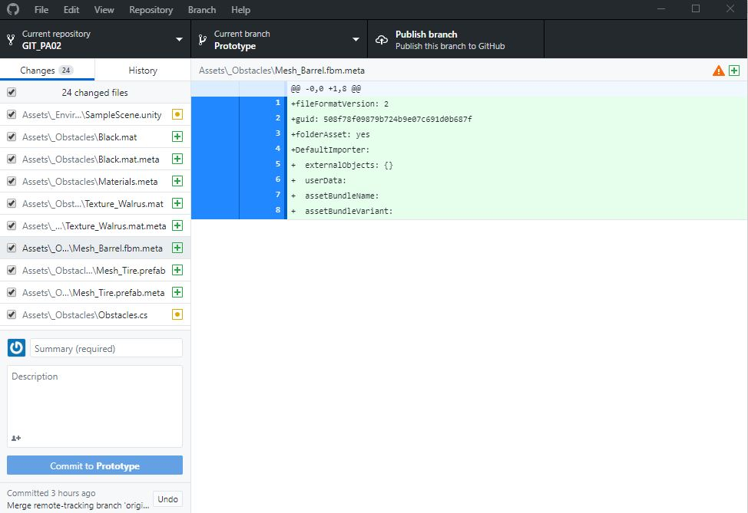

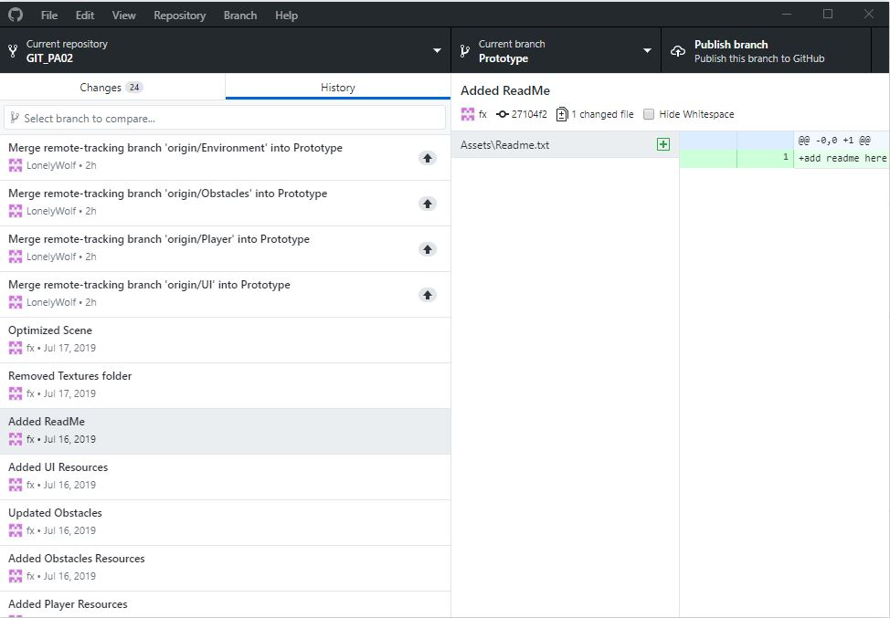

This game is an endless game about dodge all of the obstacle until your player have 0 live then will lead player to game over scene.