Other funchion for Guided Tour

All below package are in AsiaGo hotel collection function ( Page 11)

Amara Singapore
165 Tanjong Pagar Road, Singapore 088539, Singapore
Example Hotel Package :
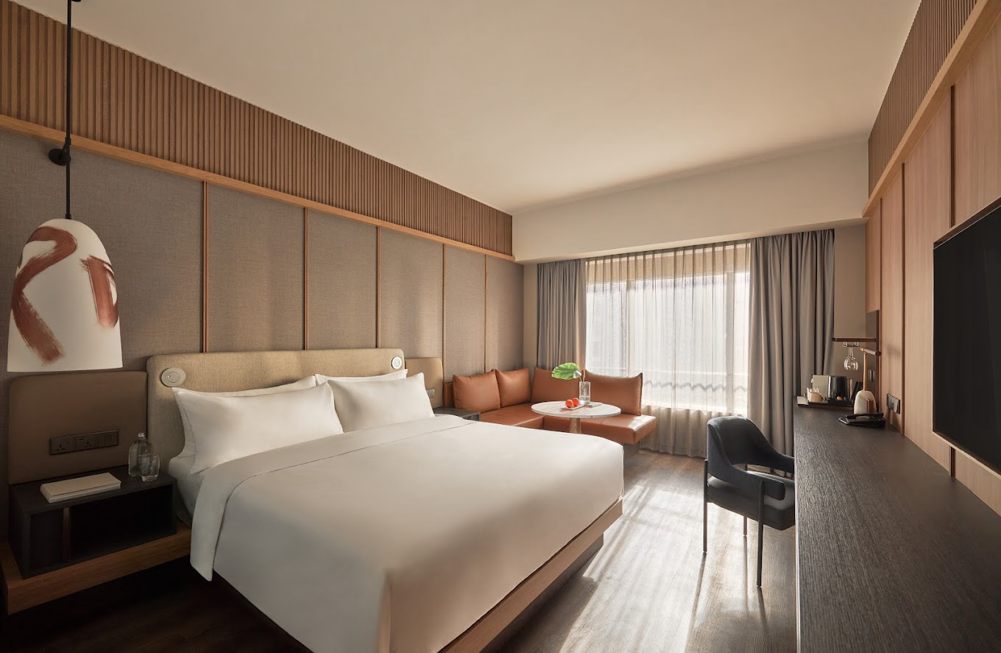

Club Room for 2 person
status credits
Daily buffet breakfast at The Club or Element
Nightly two-hour free-flow cocktails and canapes at The Club Lounge (12+)
View more inclusions
3 nights from
888Credits total with

- Dining inclusions do not include drinks (unless otherwise stated). Menus are subject to change without notice.
- Daily buffet breakfast is served in The Club or Element between 7am–10.30am.
- Club privileges include daily breakfast, evening cocktails, in-room non-alcoholic minibar (replenished daily) and 2pm late checkout (subject to availability).
- Nightly free-flow drinks are served in The Club from 5.30pm–7.30pm and include a selection of cocktails, wines, beers, soft drinks and canapes.
- Guests must be aged 12+ to access The Club.
- One-time dining credit can be used at Element and Cafe Oriental. No minimum spend applies. The included credit must be used during your stay. Any unused credit will be forfeited and is not transferable or redeemable for cash.
- For bookings of three guests in the Club Room, a king bedding configuration will automatically be assigned to allow for space for an extra bed (twin bedding configuration is not possible).
- Fine print
- Valid for travel until 9 June 2027 (bookings must be made before 10 May 2027).
- Blackout Dates & Surcharges: A non-refundable surcharge per room, per night may apply, payable at the time of booking. Dates and prices are identified in the Booking Calendar. Blackout dates may apply.
- We reserve the right to modify prices for marketing and commercial reasons. Please note that full terms and conditions apply. Refer to the website’s terms and conditions.
- Fine Print and package inclusions are accurate at the time of purchase and not subject to change, unless updates or corrections are specifically noted in the latest Fine Print with a timestamp. Please check the Fine Print prior to departure for any updates.
- Images are for illustrative purposes and may not be reflective of the package purchased. See individual offers and packages for details.

Mandai Rainforest Resort By Banyan Tree
Example Package : Mandai Rainforest Resort By Banyan Tree
Sanctuary Room-Double Double /King Room
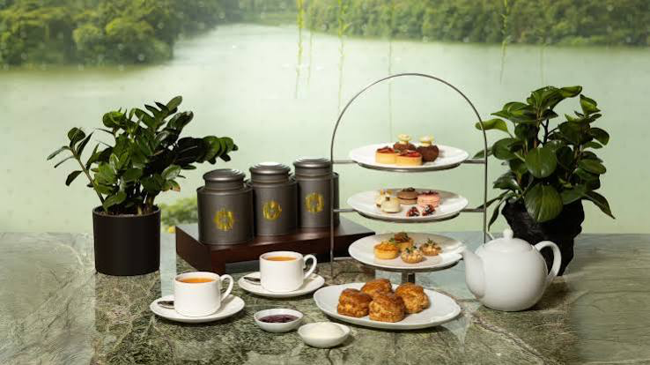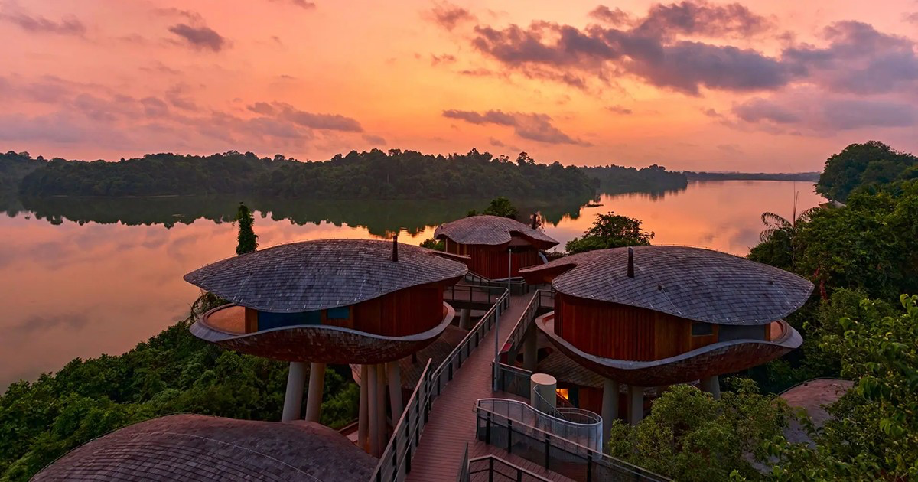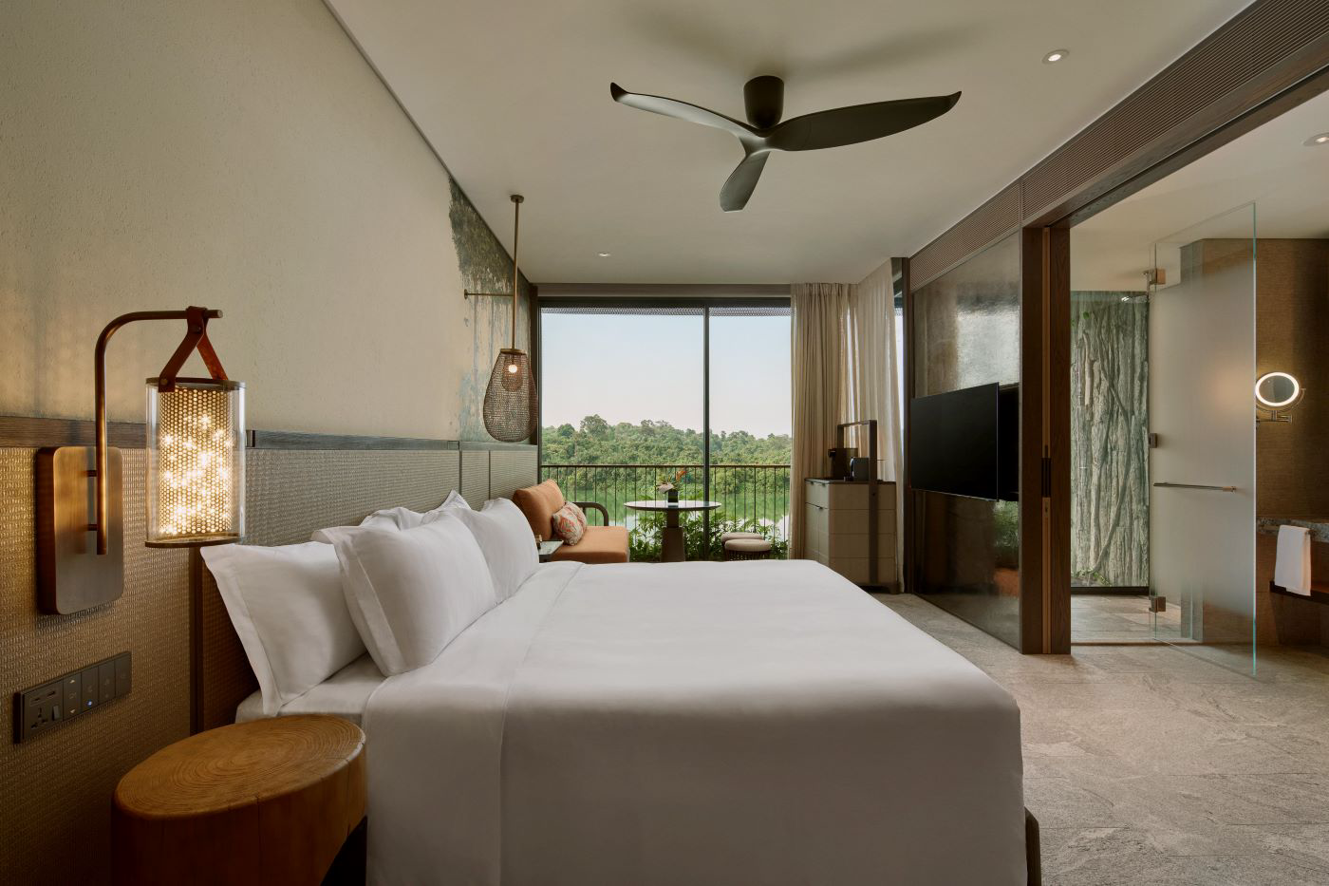

View more inclusions
3 nights from
1998 Credits total with
Status Credit :
- Daily Breakfast for 2 person
-Afternoon Tea A perfect afternoon break with stunning view of the reservoir and lush jungle (Rack rate 48++per pax)
- Complimentary Welcome drink
- Late check out ( Subject to room availability )
- Admission tickets to Rainforest Wild Adventure with Adventure+ activities for 2 adults (1 Day ticket)
5 park-night safari _ Bird Paradise + Rainforest Wild Asia + Zoo + River Wonders
-Complimentary Minibar in room .

Children Policy
- Children under 6 years (Up to 1 child per room) with accompanying adult can share an existing bed and enjoy complimentary breakfast daily. Baby cot may be requested at no extra charge subject to availability.
- Children 6 and up to 12 years (Up to 1 child per room) with accompanying adult can share existing bedding with our compliments and dine at 50% off regular menu prices, except for kid’s menu.

Term and condition :

- Promotion is valid from 1 January 2027for check-in till 29 December 2027.
- Promotion rates may vary depending on selected stay dates, subject to changes without prior notice.
- Booking and stay period excludes Super Peak and Black-Out Dates.
- Dated e-Ticket is valid for park entry on date of visit selected for each attraction.
- Promotion is valid for online purchase at www.luxurytours.com.
- Payment must be made with AsiaGO! Pass Credit.
- Limited number of packages is available for reservation per day. Confirmation is subject to availability.
- Rate is applicable for up to 2 persons, on a per package basis.
- Cancellation and Amendment Policy: The promotion/package is fully prepay and non-refundable.
- Not valid in conjunction with other promotional offers.
- Rates are subject to change without prior notice.
- No refund will be extended for any unused services or tickets included in the package.
- Amendment of dates is not permitted after package is confirmed.

RWS : Stay & Play with AsiaGO Credits

Enjoy hotel stay and tickets to 2 attractions from S$999Credits
Package includes:

  - 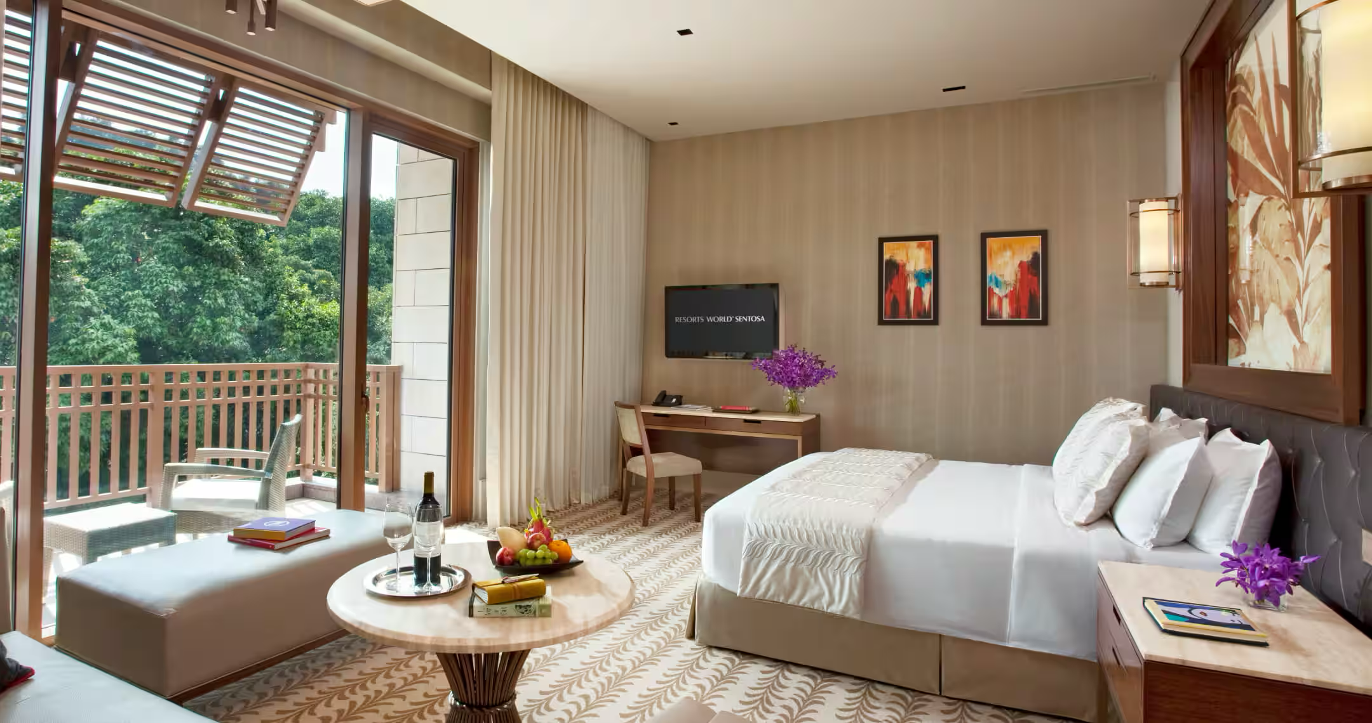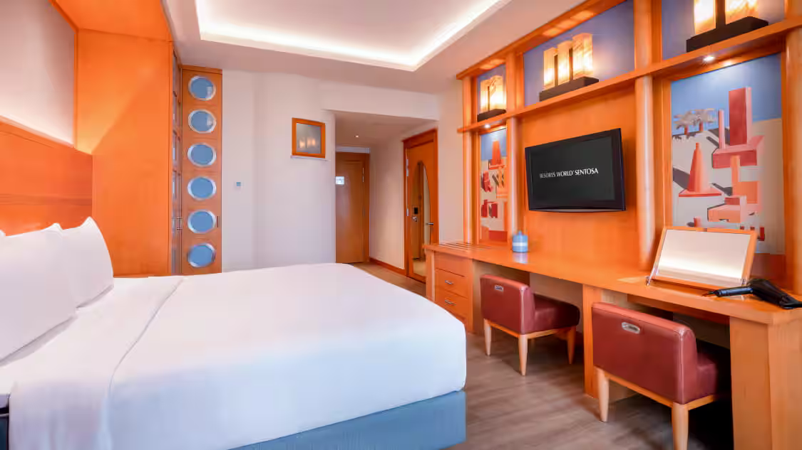

- Two (2) Nights stay in a choice at the following hotels:
  - Equarius Hotel (Deluxe Room)
  - Hotel Michael (Deluxe Room)
- Two (2) Universal Studios Singapore™ Adult Dated One-Day Tickets*
- Two (2) Oceanarium™ Adult Dated One-Day Tickets*
- Two (2) Daily Breakfast
- Early Check in and Late Check Out ( Subject to availability )

Term and condition :

- Promotion is valid from 1 January 2027for check-in till 29 December 2027.
- Promotion rates may vary depending on selected stay dates, subject to changes without prior notice.
- Booking and stay period excludes Super Peak and Black-Out Dates.
- Dated e-Ticket is valid for park entry on date of visit selected for each attraction.
- Promotion is valid for online purchase at www.luxurytours.com.
- Payment must be made with AsiaGO! Pass Credit.
- Limited number of packages is available for reservation per day. Confirmation is subject to availability.
- Rate is applicable for up to 2 persons, on a per package basis.
- Cancellation and Amendment Policy: The promotion/package is fully prepay and non-refundable.
- Not valid in conjunction with other promotional offers.
- Rates are subject to change without prior notice.
- No refund will be extended for any unused services or tickets included in the package.
- Amendment of dates is not permitted after package is confirmed.
- Rate is inclusive of 8% Government Tax and 10% Service Charge.
- Resorts World Sentosar eserves the right to amend or add to the Terms and Conditions at any time without prior notice.

ASIAGO Pass Package (Example)

Kalima Resort & Spa : Deluxe Seaview

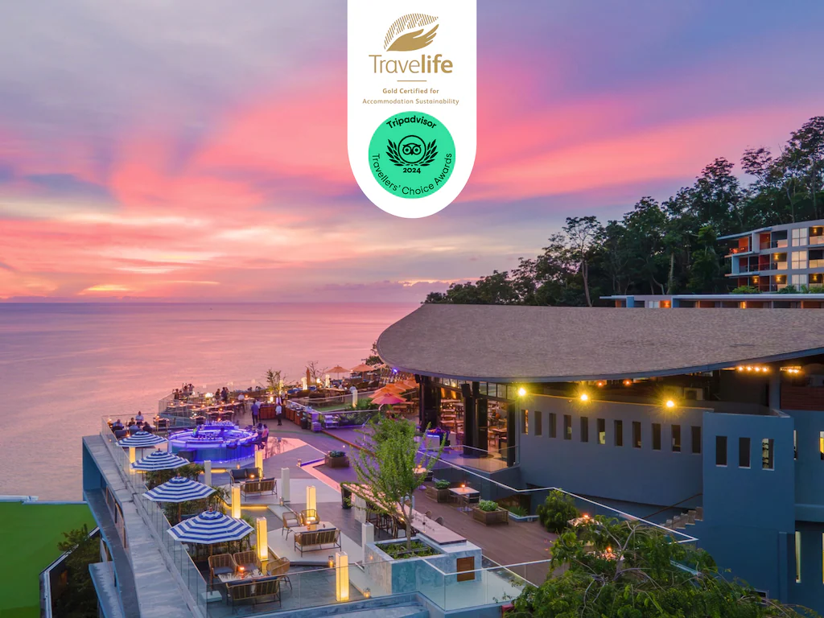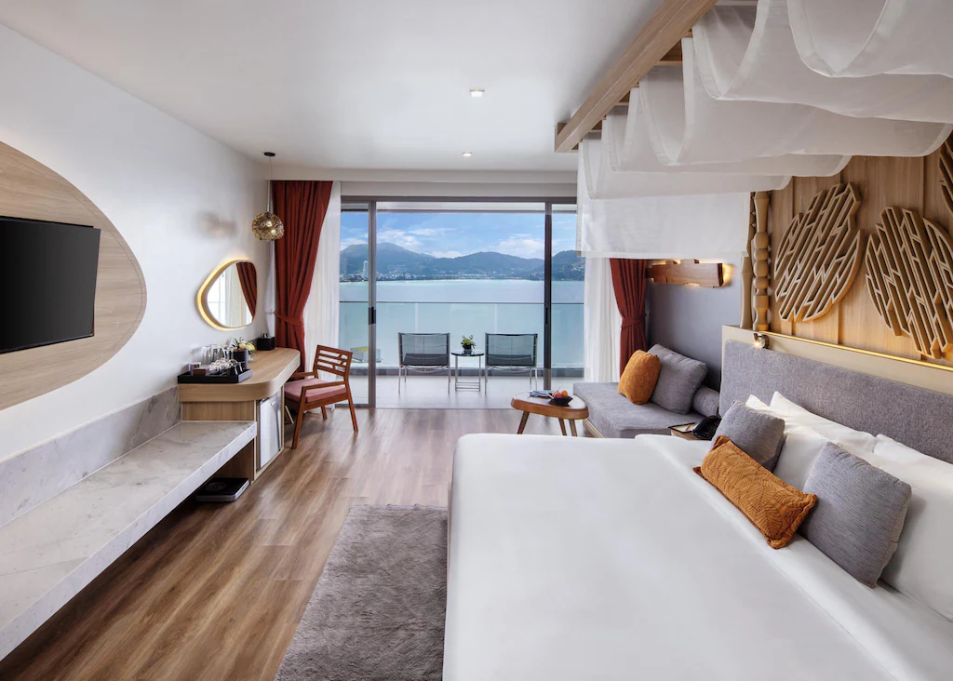

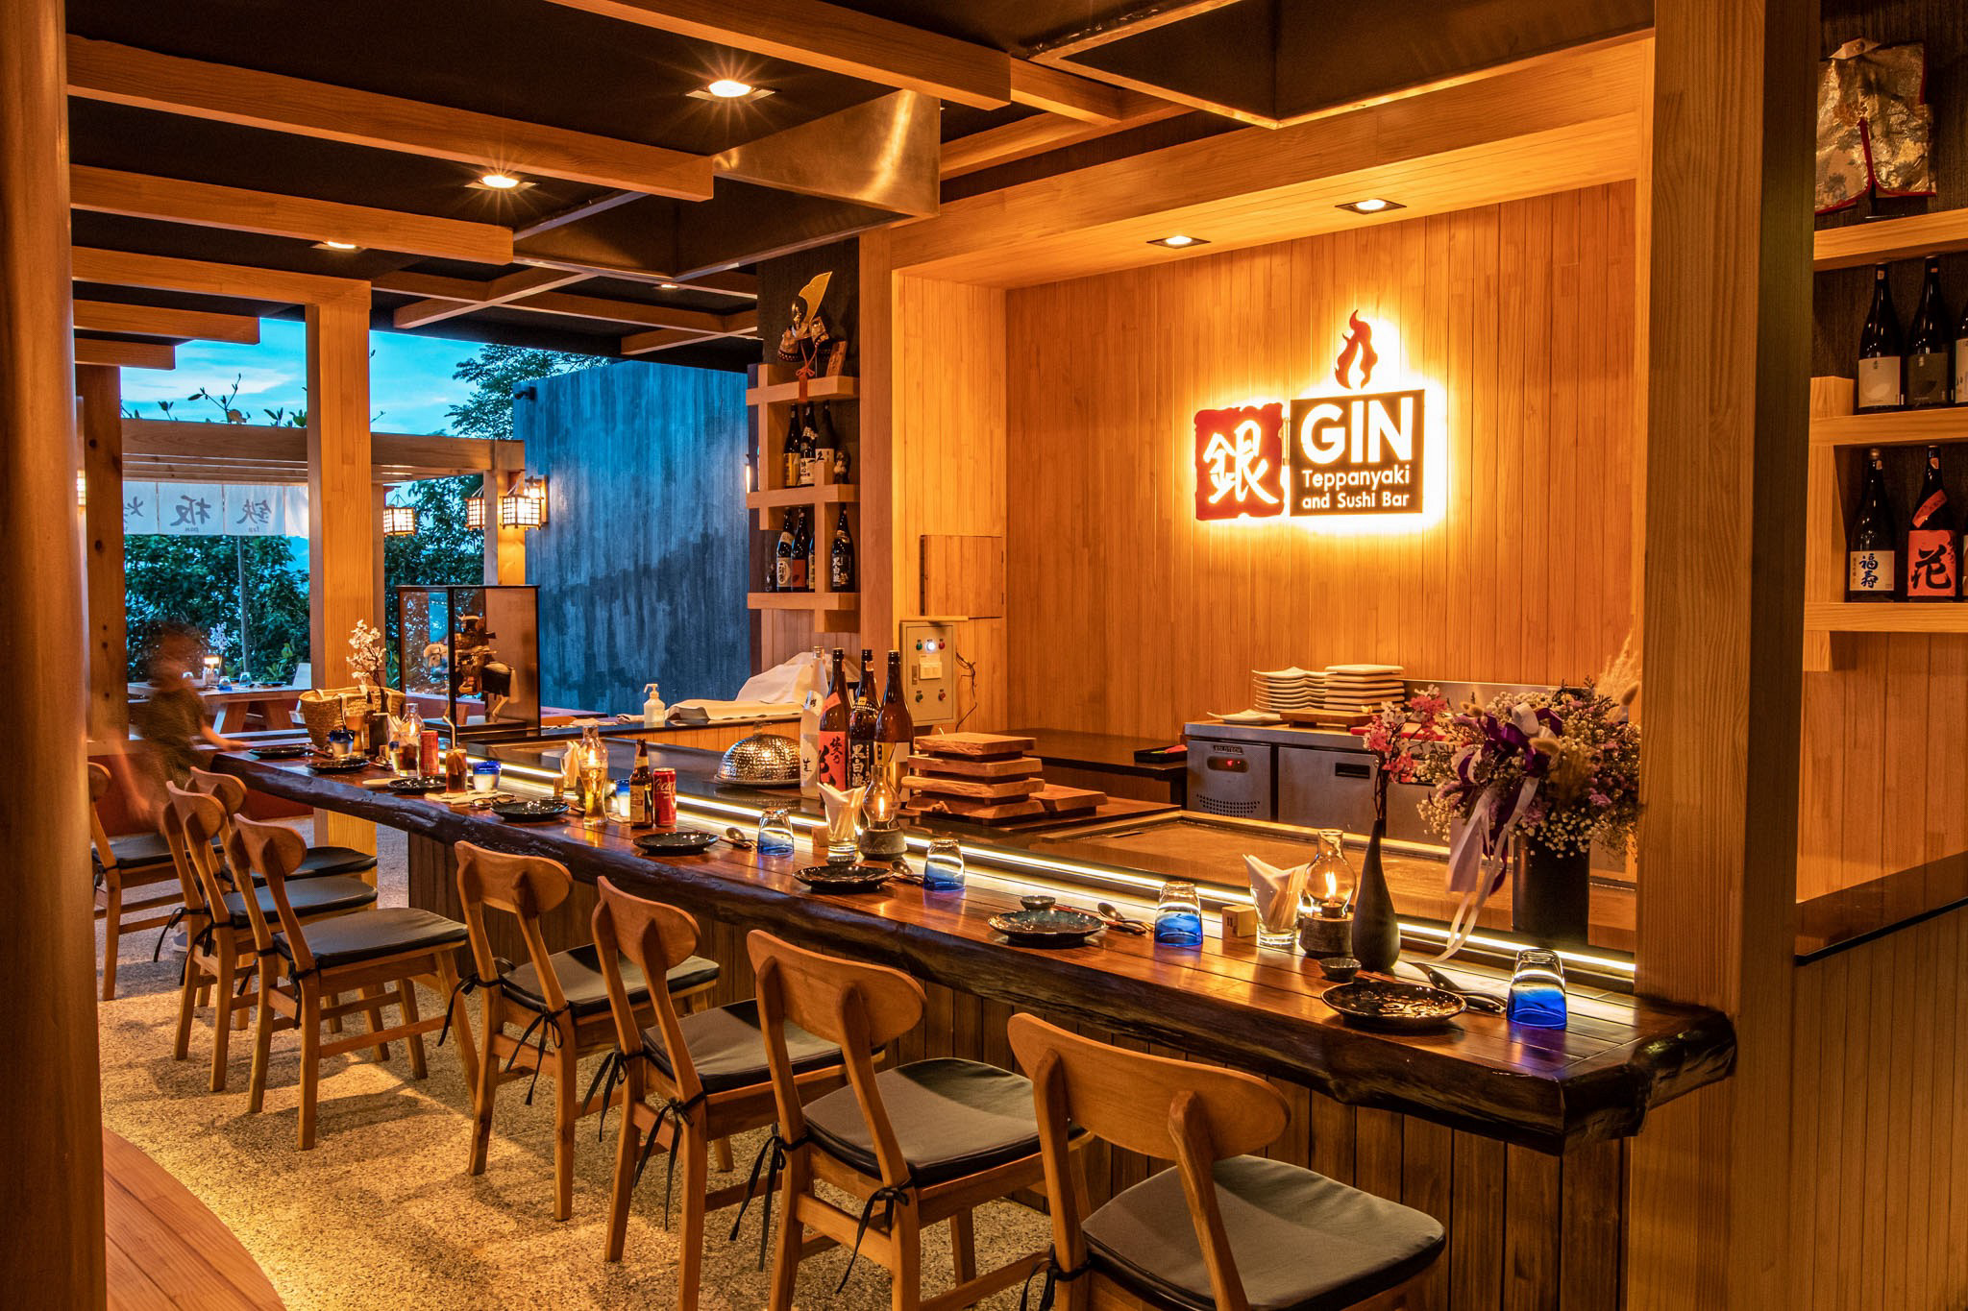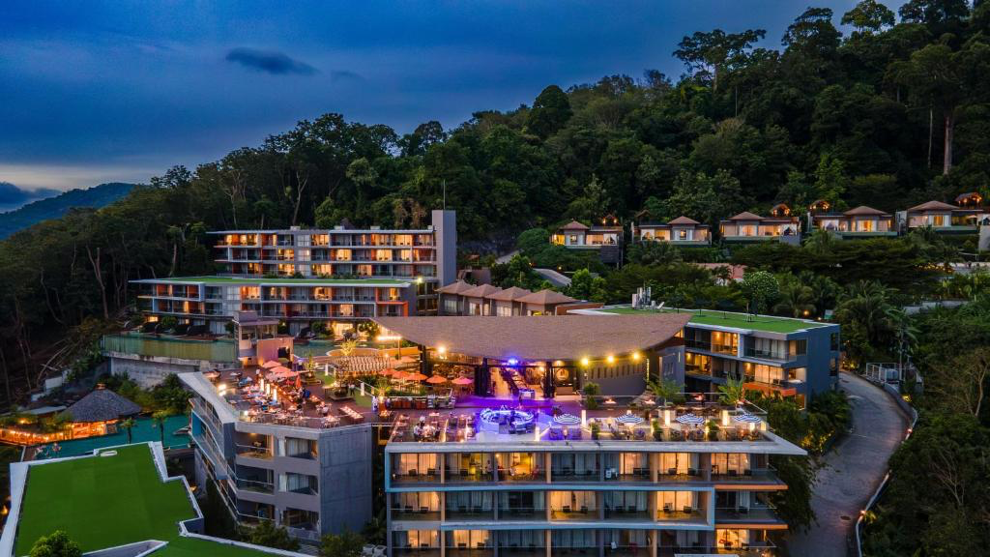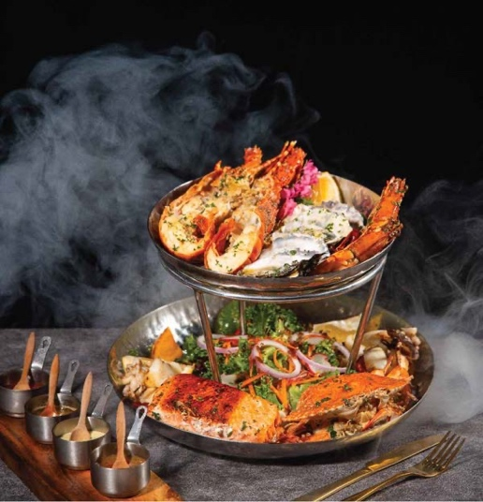

View more inclusions
5 nights from
789 Credits total with
Status Credit :
- Daily Breakfast for 2 person
-Round Trip Airport transfer for 2 peerson
- Complimentary welcome local snack
-Cocktails Drink at Malika Sky Bar for 2 person
-1time Set Terrace with Barbecue Seafood Tower for 2 person at Malika Sky Bar
- Dinner at Gin Tepanyaki & Sushi Bar, 1time 4Rolls set Tasting Set manu for 2 person
- Complimentary Welcome drink
- Complimentary Early Check-in and Late check out ( Subject to room availability )
- -Complimentary Minibar in room .

Children Policy
- Children under 6 years (Up to 1 child per room) with accompanying adult can share an existing bed and enjoy complimentary breakfast daily. Baby cot may be requested at no extra charge subject to availability.

Term and condition :

- Promotion is valid from 1 July 2027 for check-in till 31st October 2027
- Promotion rates may vary depending on selected stay dates, subject to changes without prior notice.
- Booking and stay period excludes Super Peak and Black-Out Dates.
- Dated e-Ticket is valid for park entry on date of visit selected for each attraction.
- Promotion is valid for online purchase at www.luxurytours.com.
- Payment must be made with AsiaGO! Pass Credit.
- Limited number of packages is available for reservation per day. Confirmation is subject to availability.
- Rate is applicable for up to 2 persons, on a per package basis.
- Cancellation and Amendment Policy: The promotion/package is fully prepay and non-refundable.
- Not valid in conjunction with other promotional offers.
- Rates are subject to change without prior notice.
- No refund will be extended for any unused services or tickets included in the package.
- Amendment of dates is not permitted after package is confirmed.

Hotel in Bintan

2D1N at Holiday Inn Resort Bintan offers a vibrant and family friendly beachfront escape.

678 Credits total with
- 1 night stay at Holiday Inn Bintan Standard Pond View Room. One room maximum 2 adults and 2 childs (under 11 yo). For 3 adults, an extra bed is required at additional cost
- Daily breakfast for 02 persons at Warung Pak Lagoi
- Return transfers between Hotel and Bandar Bentan Telani Ferry Terminal, on shared basis
- Refreshing welcome drink and cold towel upon arrival
- 2 way Return Economic Class Return Ferry Ticket By Bintan Resort Ferries. (We will liase with you on whatsapps on the timings and date)

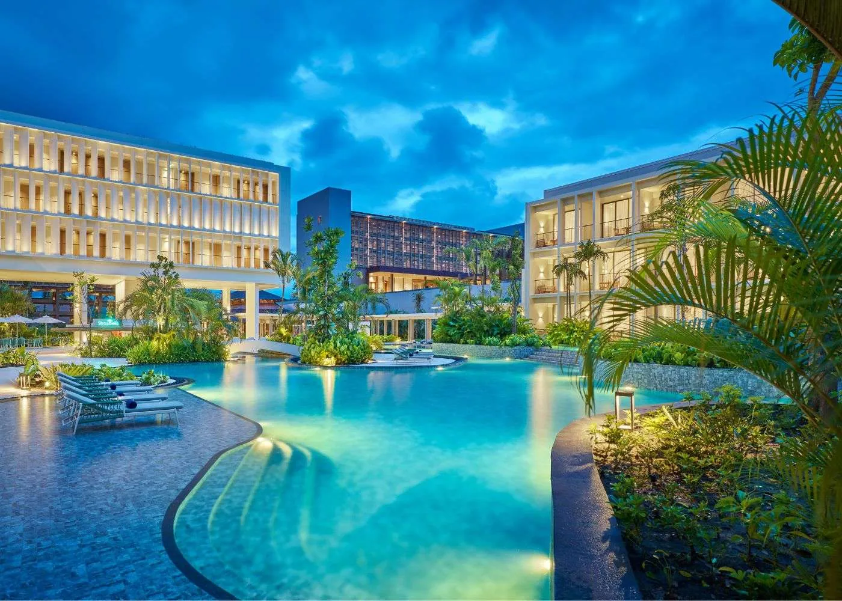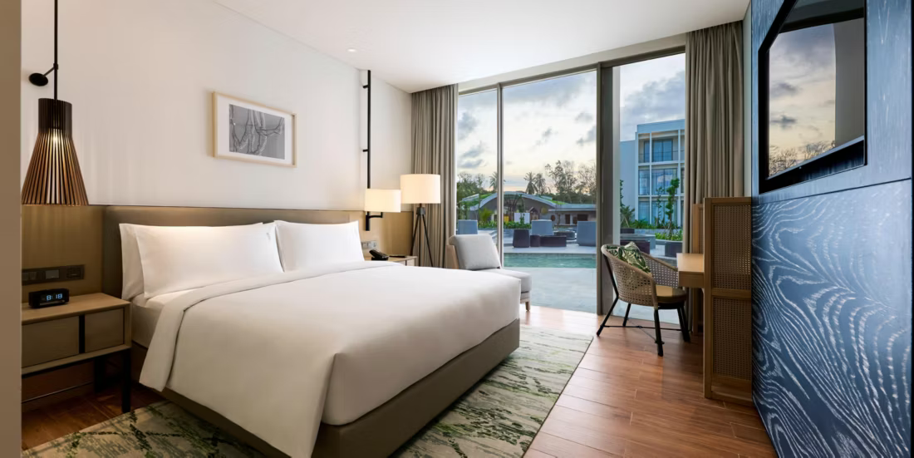

Day 1 :Optional Add On Half Day Tour
10:10 am – Arrive at Tanah Merah Ferry Terminal
• Collect boarding passes from Bintan Resort Ferry counter at level 1. Just need to provide passport after booking with us.
• Departure time: 11:10 am.
• Board high-speed air-conditioned ferry to Bandar Bentan Telani (~1 hour 10 mins journey).
• Arrival at Bandar Bentan Telani Ferry Terminal around 11:20 am. Bintan is 1 hour behind SGP.
• Allow approximately 30 minutes for immigration clearance by 12:00 noon. Use restroom facilities and purchase snacks/drinks at ferry terminal. Our friendly staff will meet you at the exit of the ferry terminal with you name on a white board.
12:00 pm – Proceed for to Rindu Selalu Seafood Restaurant
• Duration: 30 minutes.
12:30 pm – Lunch at Rindu Selalu Seafood Restaurant (included in package)
• Duration: 1 hour.
13:30 pm – Blue Lake & Sand Dunes Bintan Attraction With ATV Ride
• Head to Blue Lake Bintan. Journey about 30 mins.
• Enjoy 15 mins of ATV Riding Experience at Blue Lake. (ATV ride cost is excluded from this package)
(If time permits, you can also visit Coffee and Honey Farm)
• Duration: 2 hours.
16:00 pm – Check in to hotel. Check in timing is after 15:00pm only.
• Proceed to the hotel. Journey takes approximately 30 mins.
• Check-in and freshen up.
• Free & Easy For the evening.
• Duration: 1 hour.
Day 2 : Return Day
Morning:
• Rise and Shine. Enjoy breakfast at the Bintan Resort. Breakfast timing is 06:30 – 10:00 am.
• Duration: Flexible, depending on individual schedules.
09:00 am – 12:00 pm: Free and Easy Activities
12:00 pm – Gather and Check-out
• Check-out of the hotel by 12:00 pm.
• Lunch from 12:00 – 13:00 pm at own expense.
13:00 pm – Take hotel shuttle from hotel to ferry terminal.
• Ensure arrival at by 13:30 pm at the latest at Bandar Bentan Telani ferry terminal for ferry back to Singapore at 14:35pm.
• Duration: 15-30 mins to travel from Bintan Resort to Ferry terminal. **
14:35 pm – Departure to Singapore (Tanah Merah Ferry Terminal)
• Ferry departs for Singapore. It takes 1 hour 10 mins to reach Singapore Tanah Merah Ferry Terminal. Arrive at 16:45pm Singapore time.
*This is just a suggested itinerary. The optional half day tour only covers the activities in Day 1. All our customers enjoy free hotel shuttle on day 3 (at stipulated times) to the ferry terminal.
Excluded:
- Visa on arrivals
- Personal expenses
- Additional Meals and Activities

