Date | 06-DEC-2012
Check# | 1061
Amount Written | SEVENTY FIVE
Amount | 75.00
Pay to | STERLING JAMES
Memo1 | PURCHASING
Memo1 Amount | 75.00

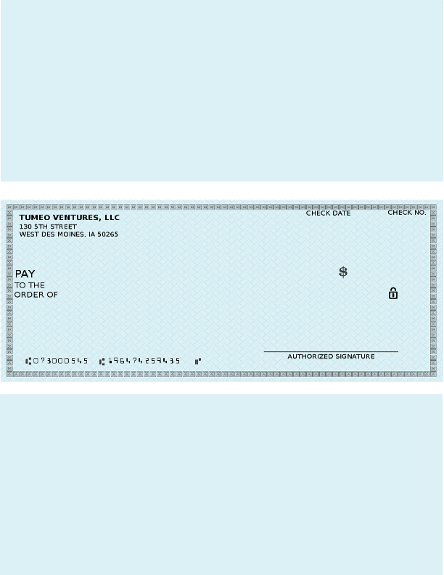

TUMEO VENTURES, LLC 1045

NA $-

Check Amount $25.00

12-NOV-2012 | 1045

TWENTY FIVE DOLLARS************************************************ | *******************25.00

WRIGLEE EWING

1045

TUMEO VENTURES, LLC 1045

NA $-

Check Amount $25.00

