***P8,Fig 3: How did you set the Cw from the Ziska et al., 2013 paper for regions in the Artic that where covered by sea-ice at present time but are not longer covered in the future?***

The water concentration used for the simulation (from Ziska et al., 2013), does not take into account the ice cover (see figure 1)

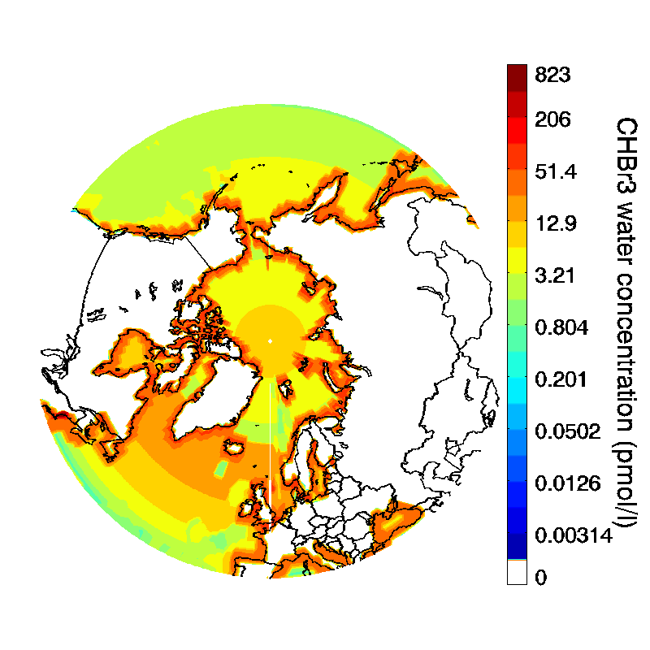In the airsea module, if ice cover is greater than 0.5 (with ice cover range between 0 and 1) then the total transfer velocity (ktot) is equal to zero else ktot is scale depend on the percentage of sea cover.

Figure 1: CHBr3 water concentration in pmol l-1 from Ziska et al. (2013)