**Draft 28.06.2018**

**Stratospheric forcing of surface climate in model simulations with a prescribed stratosphere**

Björn-Martin Sinnhuber1 and Stefanie Falk1,2

1. Karlsruhe Institute of Technology, Institute of Meteorology and Climate Research (IMK-ASF), Germany

2. now at University of Oslo, Norway

Abstract. The stratospheric impact on extra-tropical surface climate is investigated by model simulations with prescribed stratospheric temperatures and circulation. We have used the ECHAM5-MESSy (EMAC) climate model, with temperature and wind fields nudged towards ECMWF ERA-Interim re-analyses in the stratosphere (pressures lower than 100 hPa) over the period 1979–2014. Sea surface temperatures and sea ice distributions in these simulations are prescribed from a fixed climatology (repeating annual cycle) to suppress tropospheric inter-annual variability. Greenhouse gas concentrations are kept constant. The surface pressure response to weak versus strong vortex events in the model simulations is significant over much of the extra-tropics in both hemispheres and similar to the Northern and Southern Hemisphere Annular Modes. In the Southern Hemisphere this is associated with the well known surface temperature response to a positive phase of the Southern Annular Mode with a cooling over most parts of Antarctica and a warming over southern South America and the Antarctic Peninsula during summer. In the Northern Hemisphere, however, the modelled surface temperature response to a strong winter vortex differs from the Northern Annular Mode/Arctic Oscillation pattern and that found in reanalysis: A strong and cold stratospheric vortex in our model simulations leads to a significant warming of surface temperatures over the central Arctic and Europe during winter. We find that changes in the stratosphere over the 35 year period can explain most of the observed extra-tropical surface pressure changes in the Southern Hemisphere in summer and in the Northern Hemisphere in winter and has contributed to the winter surface cooling over Eurasia in recent decades.

**Introduction**

How and to what extent the stratosphere can impact surface weather and climate has received considerable attention over recent years. Although many details of the stratosphere-troposphere coupling still remain unclear at present, there is now clear evidence from observational and from modelling studies that the stratosphere has a significant and profound impact on extra-tropical surface weather and climate on time scales ranging from days to decades [Kidston et al., 2015]. A strengthening or weakening of the stratospheric polar vortex couples down to the troposphere, leading to a poleward or equator-ward shift of the tropospheric jet, respectively, with a corresponding decrease of increase of surface pressure over high latitudes. This surface impact is closely coupled to the leading modes of surface pressure variability, known as the Arctic Oscillation (AO) or Northern Annular Mode (NAM) in the Northern Hemisphere and the Southern Annular Mode (SAM) in the Southern Hemisphere [Thompson and Wallace, 1998; 1999]. In the Southern Hemisphere, both observations and modelling studies consistently show, that the Antarctic ozone hole due to anthropogenic ozone depleting substances has led to a cooling of the high latitude stratosphere in spring with a strengthening of the stratospheric polar vortex and a resulting increase in the Southern Annular Mode in summer [Thompson and Solomon, 2002; Thompson et al., 2011]. These changes dominate Southern Hemisphere surface climate change over recent decades, with a decrease of high latitude surface pressure, an increase in westerly winds over the Southern Ocean and a cooling of surface temperatures over eastern and central Antarctica and a warming over the Antarctic peninsula and the southern tip of South America [Thompson et al., 2011]. Stratosphere-troposphere coupling is of great interest for a range of topics, including seasonal weather prediction [Baldwin and Dunkerton, 2001;], the impact of ozone recovery on surface climate and the regional impacts of climate change through changes in the stratospheric circulations [Kidston et al., 2015].

Earlier model experiments with imposed stratospheric heating in a simple general circulation model [Polvani and Kushner, 2002] or with perturbed stratospheric circulations [Norton, 2003; Scaife et al., 2005; Jung and Barkmeijer, 2006] have confirmed the finding of a significant stratospheric influence on surface climate. Here we present climate model simulations with a free running troposphere, but with the stratosphere prescribed with observed temperatures and wind fields for the years 1979 to 2014. Unlike earlier studies based on statistical analyses of observations or fully coupled models there is thus a direct cause and effect in our model simulations. And unlike earlier idealized modelling studies we can use our model simulations to directly attribute observed trends in surface pressure and surface temperature to changes in the stratosphere. Technically we do this by nudging temperature and wind fields in the stratosphere at pressures less than 100 hPa in the EMAC model towards ERA-Interim re-analyses (see Methods). We compare the model with prescribed stratosphere to ERA-Interim re-analysis data. In the following we focus on December to February (DJF) seasonal means, as this is in both hemispheres the season where stratosphere-troposphere coupling is most active and we see the largest impact on surface weather and climate.

**Results**

*Northern Hemisphere*

The prescribed stratospheric conditions over the 35 years of the model simulation show in the Northern Hemisphere fluctuations between warm and cold winters in the polar stratosphere; Fig. 1a shows DJF North Pole temperatures at 48 hPa, roughly at 20 km altitude in the lower stratosphere. The North Pole temperatures are strongly correlated with the 48 hPa DJF temperatures over much of the polar cap and also strongly correlated with geopotential heights in the lower stratosphere and the strength of the polar vortex. Thus we will get very similar results when using instead of 48 hPa North Pole temperatures any of the other related quantities that describe the strength of the polar vortex. North Pole temperatures have the advantage of being a simple and direct measure of the stratospheric state. In our following analysis, we group the winters with a stronger and colder than average polar vortex and the winters with a weaker and warmer than average polar vortex and look for differences in surface response for these two groups. More specifically, we have selected the 12 winters with 48 hPa DJF North Pole temperature more than ½ standard deviation above the 35-year mean, and the 14 winters with North Pole temperatures with more than ½ standard deviation below the mean (Fig. 1a). Fig. 2a shows the DJF surface pressure difference for the cold (strong) minus warm (weak) vortex winters. The response in surface pressure is significant over most of the Arctic and large areas of the mid-latitudes with a reduction in surface pressure over the Arctic and an increase in surface pressure over mid-latitudes with centers of action over the North Atlantic, Europe and the Aleutian, resembling the well known AO or NAM pattern [Thompson and Wallace, 1998]. The surface pressure signal is similar to that found in ERA-Interim reanalysis sampled in the same way (Fig. 2c), but shows some significant differences, in particular over Siberia and the Eastern Arctic.

Surface temperature differences between the cold (strong) minus the warm (weak) vortex winters from the model simulations with prescribed stratosphere exhibit significant warming over most of the Arctic and central and northern Europe and a significant cooling over North America and Asia (Fig. 2b). This surface temperature response is markedly different from the surface temperature response found in ERA-Interim reanalyses (Fig. 2d), that agrees more closely with the temperature signal of the AO or NAM pattern [Thompson and Wallace, 1998], which exhibits a warming over Siberia and the Eastern Arctic, a cooling over North America and little signal over the central high Arctic. The different result in our model simulations can be understood in terms of the differences in the surface pressure response: The stronger wave 2 pattern in the surface pressure response and the lack of a low pressure signal over the Eastern Arctic favours advection of warmer air masses into the central high Arctic, rather than towards mid-latitudes over Siberia.

The surface response to anomalously weak or strong stratospheric winter vortex is similar and even more significant if we consider a one-month time lag, i.e. correlate January to March surface pressure and temperature with stratospheric vortex strength in DJF (not shown – maybe supplement?).

*Southern Hemisphere*

In a similar way as for the Northern Hemisphere during winter we analyse the surface impact on the Southern Hemisphere. As noted above, we focus here as well on the DJF season. Again, as in the Northern Hemisphere we group years with anomalously strong polar stratospheric vortex and years with anomalously weak vortex using South Pole temperature. However, in the Southern Hemisphere we use 96 hPa South Pole temperatures (instead of 48 hPa in the north) because during DJF the polar vortex has disappeared already at 48 hPa. Fig. 1b shows the time series of 96 hPa DJF South Pole temperatures: the general trend towards a colder and more stable polar vortex with time, very likely as a result of ozone depletion due to anthropogenic emissions of ozone depleting substances, means that most of our warm and weak vortex years are in the first half of the period considered and all of the strong and cold vortex years are in the second half. The difference between cold and warm years in the Southern Hemisphere stratospheric polar vortex will thus be similar to the long-term trend over this period.

The surface pressure difference in the Southern Hemisphere during DJF between the cold and the warm stratosphere is shown in Fig. 3a. The pressure response is significant over much of the Southern Hemisphere extra-tropics and resembles the Southern Annular Mode, with pressure reductions over the high latitudes and increased pressure over mid-latitudes. The response is similar in ERA-Interim re-analyses (Fig. 3c). The modelled temperature difference for the cold minus warm stratosphere agrees well with the surface temperature response for the positive SAM, with cooling over much of Antarctica and a significant warming over the Antarctic peninsula and the southern part of South America (Fig. 3b). The corresponding ERA-Interim analysis (Fig. 3d) is qualitatively similar, but shows a more widespread cooling over the Southern Ocean and no significant cooling over central Antarctica. The lack of a similar cooling signal over the Southern Ocean in our EMAC simulations may be due to the use of a fixed SST climatology which prevents any large temperature changes over the oceans.

*Trends*

The stratospheric impact on long-term trends in surface pressure and surface temperature over the 1980 – 2014 period can be directly addressed with our model simulation with prescribed stratosphere. Zonal mean trends are shown in Fig. 4 in comparison with observed trends according to ERA-Interim. During DJF temperatures in the lowermost stratosphere at 97 hPa exhibit a statistically significant cooling trend in Southern Hemisphere mid- and high latitudes, likely as a result of the Antarctic ozone hole. At Northern Hemisphere winter high latitudes there is a tendency for a warming and weakening of the polar vortex, which is just statistically significant. In the inner-tropics at 97 hPa during DJF there is a small warming, in contrast to a significant cooling higher up in the stratosphere. Overall our EMAC simulations coincide with ERA-Interim by construction; small differences can be explained by the weak nudging near 100 hPa which increases with altitude. The resulting zonal mean surface pressure trends from the imposed stratospheric changes show the well known decrease in Southern Hemisphere high latitudes which agrees well with observed trends due to ERA-Interim. The modelled zonal mean response is only marginally significant, whereas the ERA-Interim trend is significant at the 90% confidence level. The Southern Hemisphere high latitude surface pressure decrease is consistent with a zonal mean cooling trend over high latitudes in both the model and ERA-Interim, which are however only marginally statistically significant.

In Northern Hemisphere high latitudes the model simulation shows a positive trend in zonal mean surface pressure which is statistically significant and a corresponding negative zonal mean temperature trend, which however is not significant. The observations according to ERA-Interim show a strong winter warming over the Arctic [Ref. to Arctic Temperature Trends / Arctic Amplification?] that cannot be explained by the stratospheric forcing.

It has been argued, that some of the hiatus in surface temperature warming over the first decade of the 21st century may be due to a pronounced cooling of Eurasian surface air temperature during winter which may be forced by changes in the stratosphere since 1990 [Garfinkel et al., 2017]. Our model simulation with imposed stratosphere exhibits indeed a statistically significant cooling over northern Eurasia and the eastern Arctic since 1990 that explains part of the observed Eurasian cooling during DJF (Fig. 5). However, the observed cooling is found further south than calculated by the model with the stratospheric forcing. This is consistent with the pattern of temperature response in the model to a strong versus weak stratospheric vortex (Fig. 2) that is more towards the Arctic than observed. Moreover the strong observed warming of the central Arctic, which is largely absent in the model simulation with stratospheric forcing only, may also influence the position of the Eurasian winter cooling.

**Discussion and Conclusions**

The model simulations with a prescribed stratosphere clearly demonstrate the profound impact of the stratosphere on surface weather and climate on the seasonal to decadal time scale. The response of surface pressure and temperature over the extra-tropics of both hemispheres shows a close resemblance to the annular modes as identified in numerous previous studies [e.g., Thompson and Wallace, 1999; Thompson and Solomon, 2002]. This forcing of surface pressure and temperature is statistically significant over large parts of the extra-tropics of the respective hemispheres and explains a large fraction of the inter-annual variability in surface pressure and temperature (see Supplementary Figures). Moreover, we find that the response of surface pressure and temperature during the season of the stratospheric forcing is largely linear to the strength of the stratospheric forcing. The most significant result of our study probably is that we explicitly show how surface pressure and temperature respond to a given stratospheric state. Previous studies based on the vertical coherence of the annular modes [e.g., Thompson and Wallace, 1998, Black, 2002] or on the downward propagation of anomalies [e.g., Baldwin and Dunkerton, 2001] did not demonstrate a causal relation between stratospheric forcing and tropospheric response. Previous modelling studies with imposed stratospheric perturbations used either highly idealized situations [e.g., Polvani and Kushner, 2002; Norton, 2003; Scaife et al., 2005; Jung and Barkmeijer, 2006] or investigated only specific forcings such as model simulations with and without the Antarctic ozone hole [e.g., Gillett and Thompson, 2003].

In our model experiments the stratospheric variability and changes were externally imposed (based on observations) with no considerations as to the cause and origin of these stratospheric changes. In reality the stratospheric variability and long-term changes may either be due to internal stratospheric variability, being forced from the troposphere below [e.g., Jaiser et al., 2013], or forced within the stratosphere, such as resulting from chemical ozone changes due to ozone depleting substances. Our results may then be used to estimate the surface impact of these stratospheric changes.

The largest difference of our model results to previous studies based on the Northern Annular Mode/Arctic Oscillation is the strong response of temperatures across the central Arctic to stratospheric forcing that we find in our simulation. It could either mean that there is a real difference between the direct stratospheric impact on surface temperatures and the NAM related signal, but this does not seem to be very likely, given the robustness of the NAM signal to a wide range of timescales and different forcings. Other possibilities could be, that (a) this is a particular feature of the EMAC model, (b) it is a response to the particular SST and sea ice climatology that we impose or, related to this, (c) it may result from missing feedbacks between atmospheric circulation anomalies and anomalies in sea ice concentration and thickness. Rigor et al. (2002) argue that interaction between anomalous atmospheric circulations, sea ice motion and resulting changes in ocean atmosphere heat fluxes provide an important feedback that is missing in our model simulation by construction. Whether or not the strong surface temperature response is a particular feature of the EMAC model could best be addressed when repeating our experiments in a similar setup but with other independent models.

In addition to providing a measure for the impact of stratospheric variability and changes on the surface, we note that the established causal relation between the stratospheric state and surface pressure and temperature anomalies may be used for a reconstruction of the stratospheric state from surface observations, similar as has been done with the NAM index on a statistical basis [Ref? Brönnimann?].

**Methods**

EMAC T42L90 Version ?

SST/SIC ?

Nudging: parameters, altitude region, relaxation time ?

Compare this with EMAC simulation with nudging towards ERA-Interim over full altitude region, including surface pressure.

Statistics: We test the significance of the differences between cold and warm stratospheric winters with a Student t-test, using the pooled variance of the cold and warm winters to estimate the standard error of the difference of the means. We report significance at the 90% confidence level. Similarly, for linear trends we use the standard error of the trends, estimated from the variance of the residuals, to calculate the 90% confidence level with a Student t-test. [One sided or two-sided??]

**Acknowledgements**

Thanks to … Stefan Versick … Parts of this work were funded by the German Science Foundation (DFG) through the Research Unit SHARP …

**Author contributions**

BMS devised the model experiments and conducted the analyses. SF prepared and performed the model simulations. Both authors contributed to the discussion of the results and writing of the paper.

**References**

Ambaum, M. H. P., and B. J. Hoskins, The NAO troposphere–stratosphere connection. J. Climate, 15, 1969–1978, 2002.

Baldwin, M. P., and T. J. Dunkerton, Stratospheric harbingers of anomalous weather regimes, Science, 244, 581-584, 2001.

Black, R. X., Stratospheric forcing of surface climate in the Arctic Oscillation. J. Climate, 15, 268–277, 2002.

Boville, B. A., The influence of the polar night jet in the tropospheric circulation in a GCM. J. Atmos. Sci., 41, 1132–1142, 1984

Dee, D. ERA-Interim

Garfinkel, C. I., S.-W. Son, K. Song, V. Aquila, and L. D. Oman, Stratospheric variability contributed to and sustained the recent hiatus in Eurasian winter warming, Geophys. Res. Lett., 44, 374–382, doi:10.1002/2016GL072035, 2017.

Gillett N. P., and D. W. J. Thompson, Simulation of recent Southern Hemisphere climate change, Science, 302, 273-275, doi: 10.1126/science.1087440, 2003.

Jaiser, R., K. Dethloff, and D. Handorf, Stratospheric response to Arctic sea ice retreat and associated planetary wave propagation changes, Tellus A, 65, 19375, doi: 10.3402/tellusa.v65i0.19375, 2013.

Jöckel, P., EMAC

Jung, T. and J. Barkmeijer, Sensitivity of the tropospheric circulation to changes in the strength of the stratospheric polar vortex, Monthly Weather Review, 134, 2191-2207, 2006.

Kidston, J., A. A. Scaife, S. C. Hardiman, D. M. Mitchell, N. Butchart, M. P. Baldwin and L. J. Gray, Stratospheric influence on tropospheric jet streams, storm tracks and surface weather, Nature Geoscience, 8, 433-440, 2015.

Norton, W. A., Sensitivity of Northern Hemisphere surface climate to simulation of the stratospheric polar vortex. Geophys. Res. Lett., 30, 1627, doi:10.1029/2003GL016958, 2003.

Polvani, L. M., and P. J. Kushner, Tropospheric response to stratospheric perturbations in a relatively simple general circulation model, Geophys. Res. Lett., 29, doi:10.1029/2001GL014284, 2002.

Rigor, I.G., J. M. Wallace, and R. L. Colony, Response of sea ice to the Arctic oscillation, J. Climate, 15, 2648-2663, 2002.

Scaife, A. A., J. R. Knight, G. K. Vallis, and C. K. Folland, A stratospheric influence on the winter NAO and North Atlantic surface climate, Geophys. Res. Lett., 32, doi:10.1029/2005GL023226, 2005.

Thompson, D. W. J, and J. M. Wallace, The Arctic Oscillation signature in the wintertime geopotential height and temperature fields, Geophys. Res. Lett., 25, 1297-1300, 1998.

Thompson, D. W. J, and J. M. Wallace, Annular Modes in the Extratropical Circulation. Part I: Month-to-Month Variability, J. Clim., 13, 1000-1016, 1999.

Thompson, D. W. J., and S. Solomon, Interpretation of recent Southern Hemisphere climate change, Science, 296, 895-899, 2002.

Thompson, D. W. J., S. Solomon, P. J. Kushner, M. H. England, K. M. Grise, and D. J. Karoly, Signatures of the Antarctic ozone hole in Southern Hemisphere surface climate change, Nature Geosci., 4, 741-749, 2011.

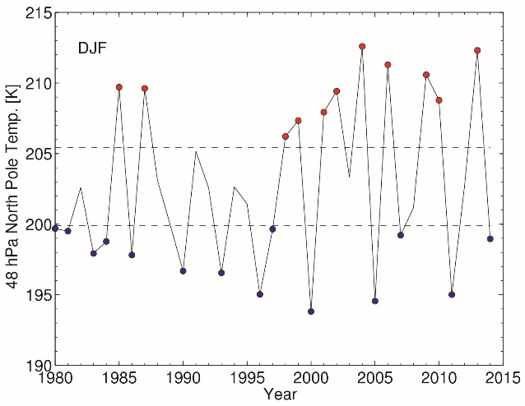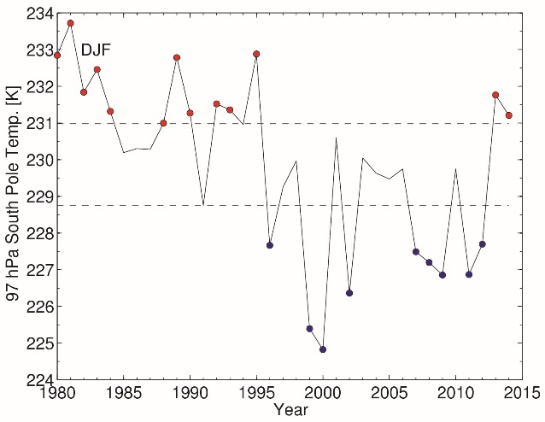

**Figure 1.** Time series of polar stratospheric temperatures over 1980 – 2014. Left: December – February (DJF) North Pole temperatures at 48 hPa, right: DJF South Pole temperatures at 97 hPa. Upper and lower dashed lines are the mean temperature plus or minus ½ standard deviations, respectively, to define the set of warm years (red dots) or cold years (blue dots).

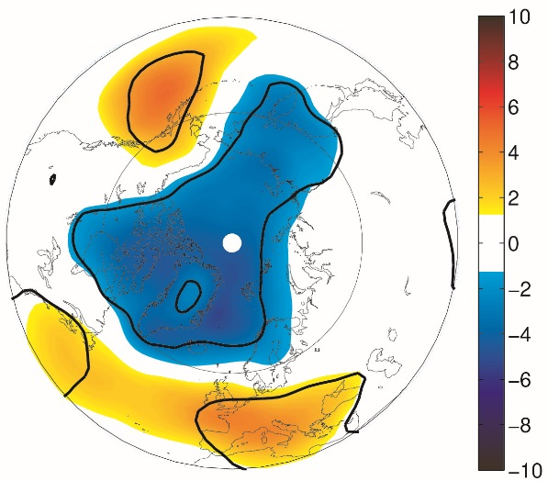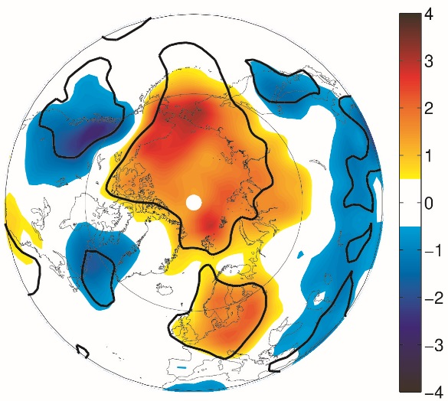

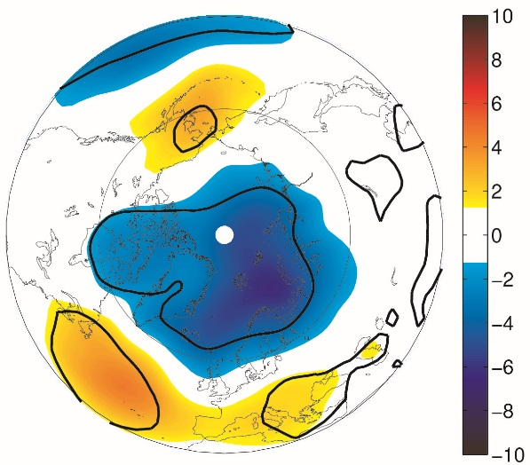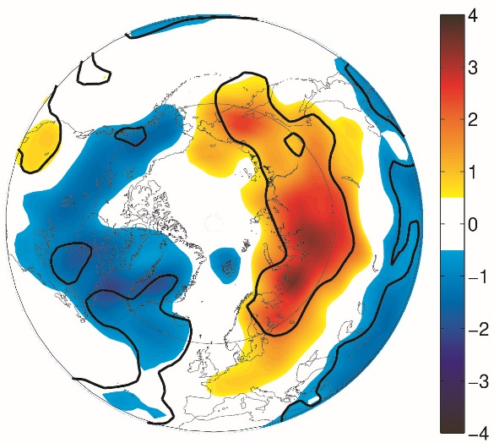

**Figure 2.** Northern Hemisphere surface pressure and surface temperature difference for weak minus strong polar vortex conditions in EMAC simulations with prescribed stratosphere and ERA-Interim. A (top left): EMAC model surface pressure response (in hPa), B (top right): EMAC surface temperature response (in K), C (bottom left): ERA-Interim surface pressure difference and D (bottom right): ERA-Interim surface temperature difference. Shown are December – February (DJF) differences between the 14 years with cold stratosphere and the 12 years with warm stratosphere according to Fig. 1a. Black contour lines significant at 90% confidence level.

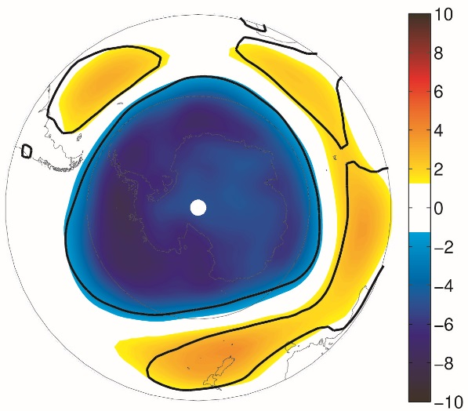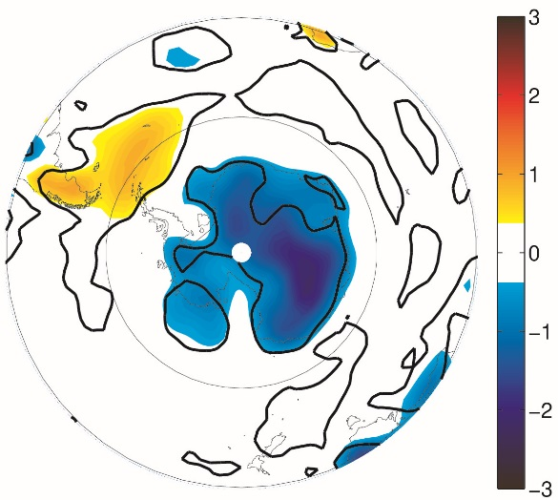

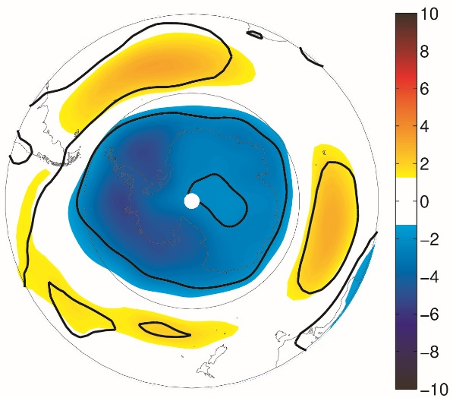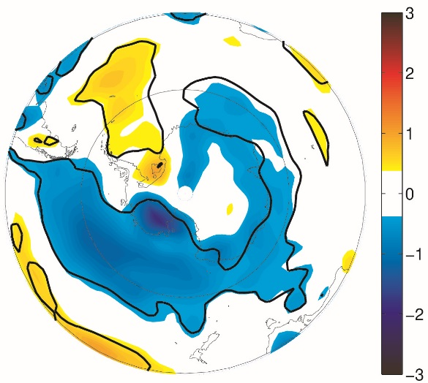

**Figure 3.** Southern Hemisphere surface pressure and surface temperature difference for weak minus strong polar vortex conditions in EMAC simulations with prescribed stratosphere and ERA-Interim. A: EMAC model surface pressure response (in hPa), B: EMAC surface temperature response (in K), C: ERA-Interim surface pressure difference and D: ERA-Interim surface temperature difference. Shown are December – February (DJF) differences between the 9 years with cold stratosphere and the 13 years with warm stratosphere according to Fig. 1b. Black contour lines significant at 90% confidence level.

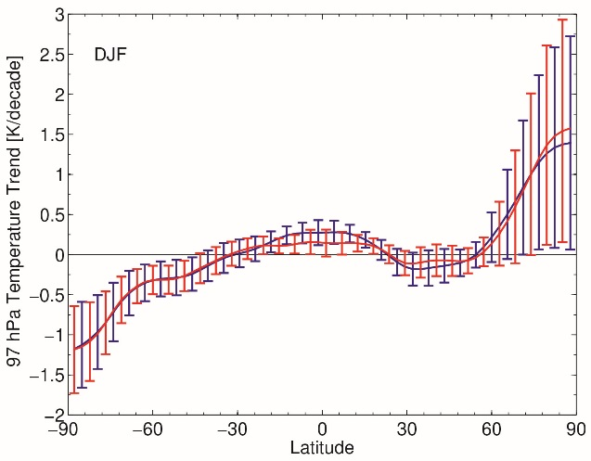

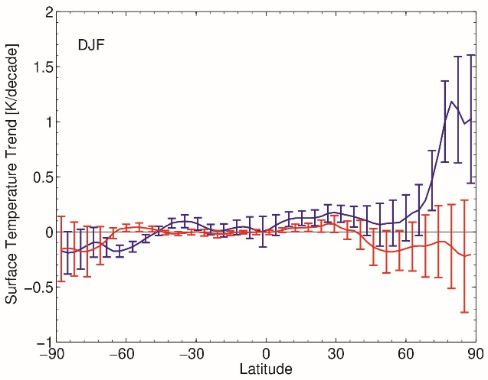

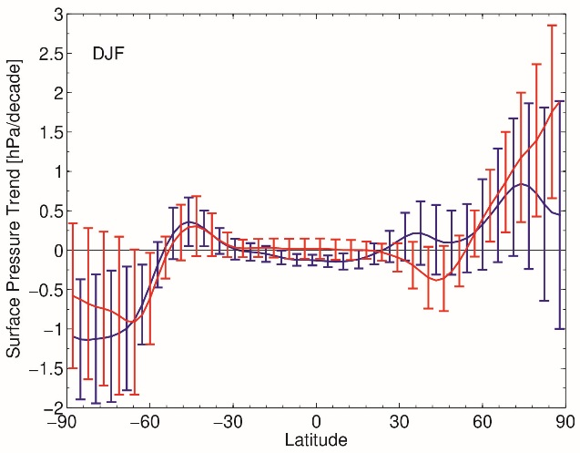

**Figure 4.** Linear trends over 1980 – 2014 in EMAC simulations with prescribed stratosphere and ERA-Interim. Top: Stratospheric temperatures at 97 hPa, middle: Surface temperature and bottom: Surface pressure. Error bars indicate 90% confidence interval.

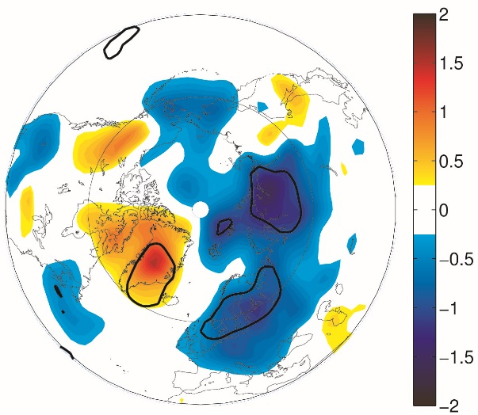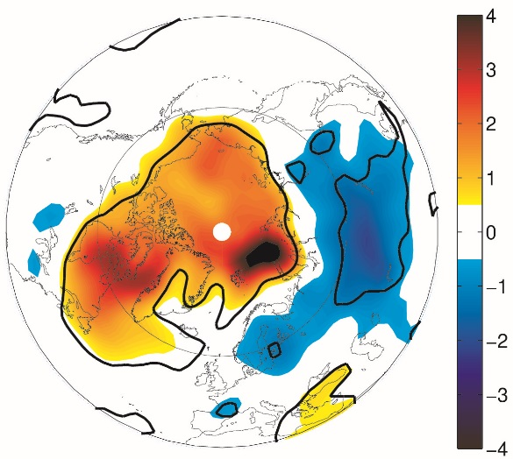

**Figure 5.** Surface temperature trends over 1990 – 2014. Left: EMAC simulation with prescribed stratosphere, right: ERA-Interim, colour shaing in Kelvin per decade, black contour lines significant at the 90% confidence level. Note different colour scales.

**Supplementary Figures**

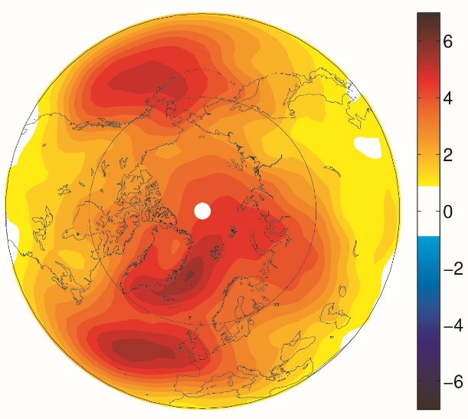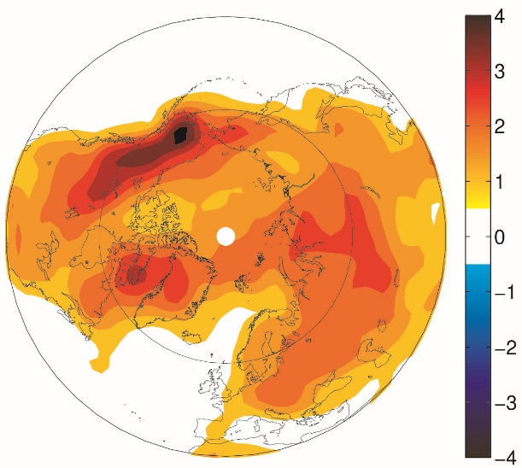

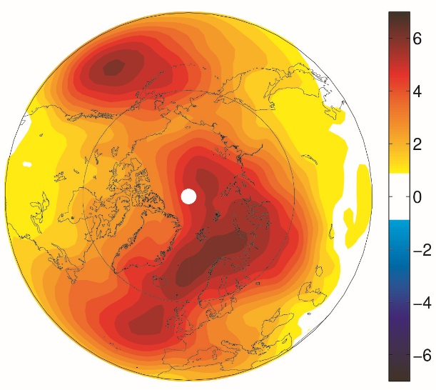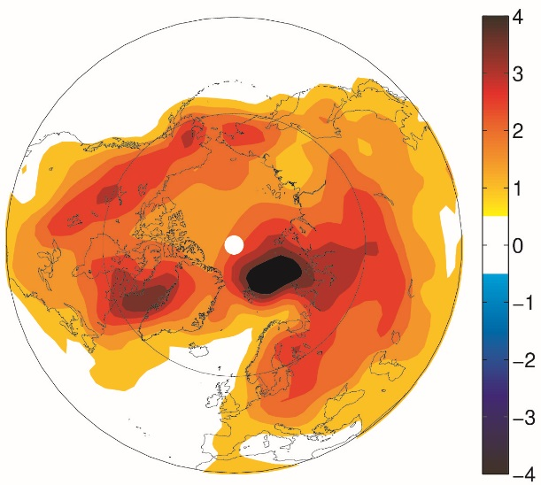

**Figure S1.** Standard deviation of EMAC with prescribed stratosphere (top row) and ERA-Interim (bottom row) for Northern Hemisphere DJF surface pressure (in hPa, left) and surface temperature (in K, right).

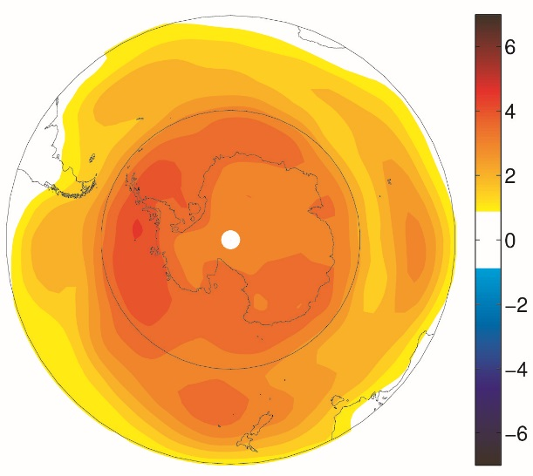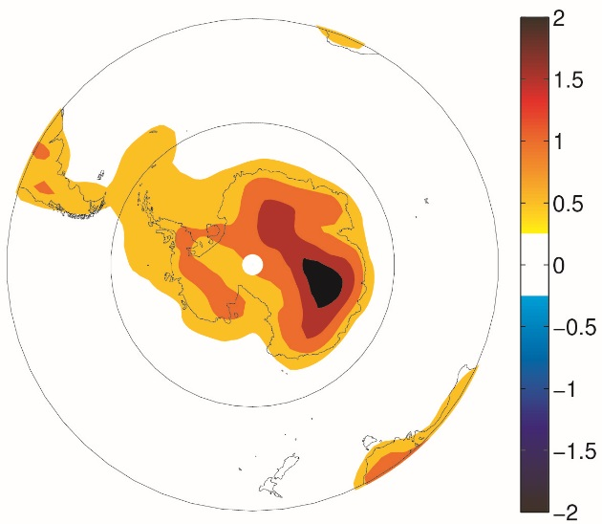

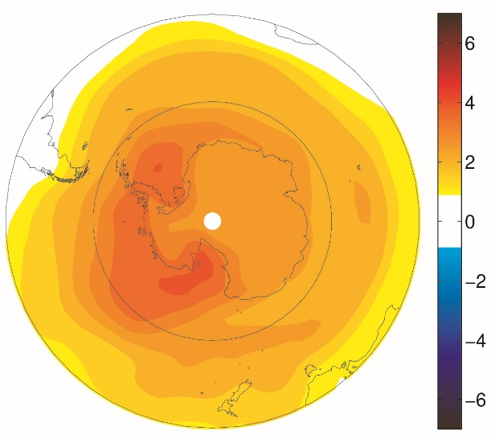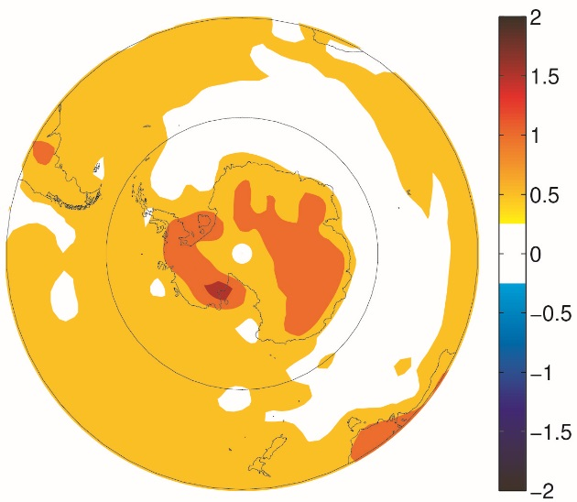

**Figure S2.** Standard deviation of EMAC with prescribed stratosphere (top row) and ERA-Interim (bottom row) for Southern Hemisphere DJF surface pressure (in hPa, left) and surface temperature (in K, right).