1. **Enable ssh as root:**

sudo apt-get install ssh

sudo passwd root

sudo vim /etc/ssh/sshd_config

(<https://askubuntu.com/questions/469143/how-to-enable-ssh-root-access-on-ubuntu-14-04>)

#PermitRootLogin without-password

PermitRootLogin yes

*sudo service ssh restart*

1. **Backupsystem using DD**
   1. Find targer to backup using “df” of “lsblk”

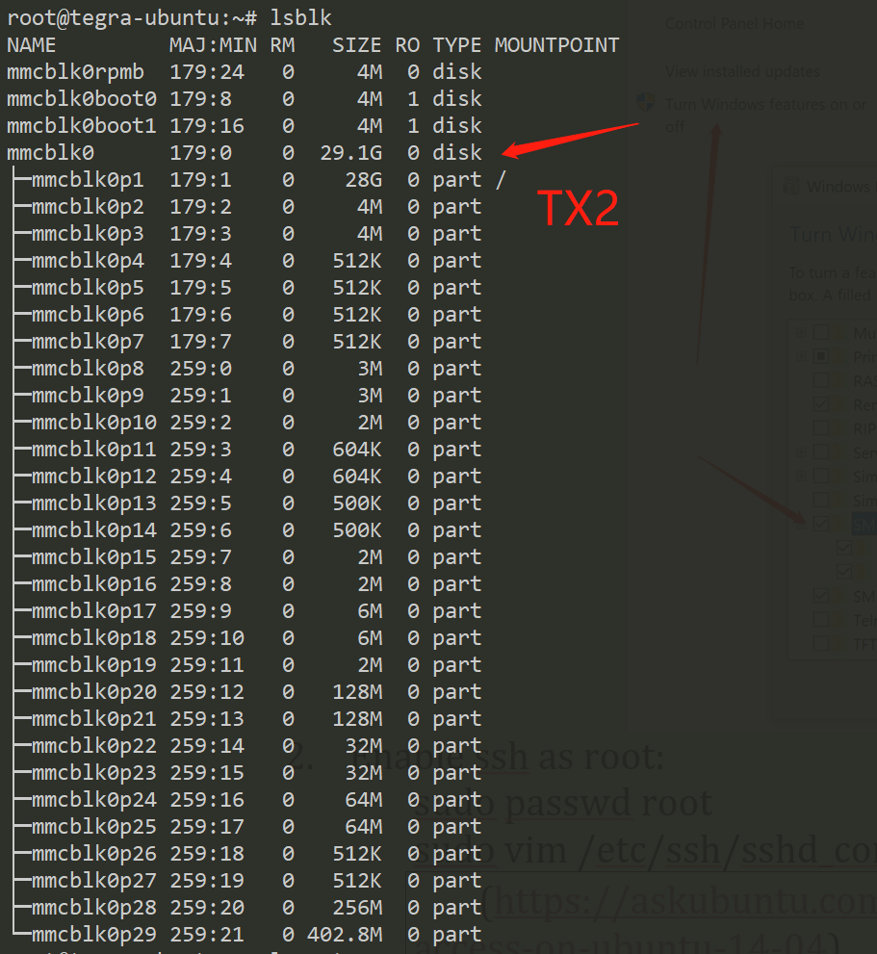

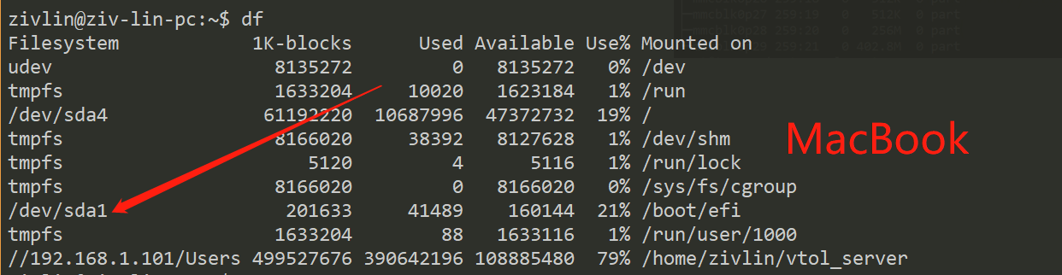

* 1. Backup system using remote ssh and dd following this guide

<https://unix.stackexchange.com/questions/132797/how-to-dd-a-remote-disk-using-ssh-on-local-machine-and-save-to-a-local-disk>

Tx2 bakup example

*ssh root@192.168.1.102 "dd if=/dev/mmcblk0 | gzip -1 -" | dd of=tx2_mirror_2018_11_29.img*

Macbook backup example:

*ssh root@192.168.1.116 "dd if=/dev/sda4 | gzip -1 -" | dd of=image.gz*

And you can be your network is busing when backuping system.

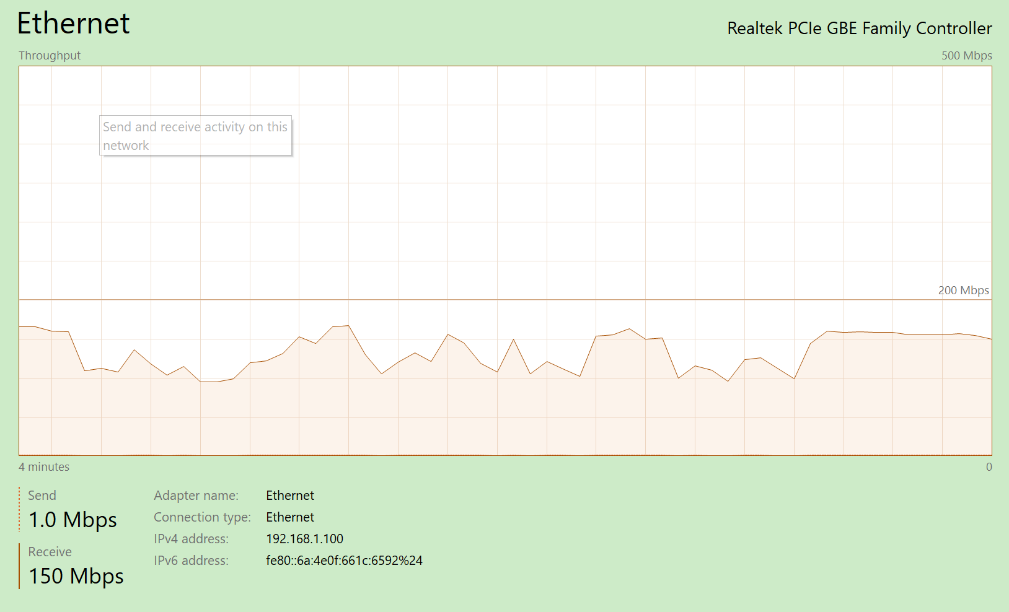

Restore example:

*dd if=tx2_mirror_2018_11_29.img | gzip -1 - | ssh root@192.168.1.120 dd of=/dev/mmcblk0*

1. ***Backup tx2 using official tools***

Reference to the official tutorial (<https://elinux.org/Jetson/TX2_Cloning>), you can backup your mirror, but remember, you should not enable “-k” option while restore image since your carrier board is not the official one.

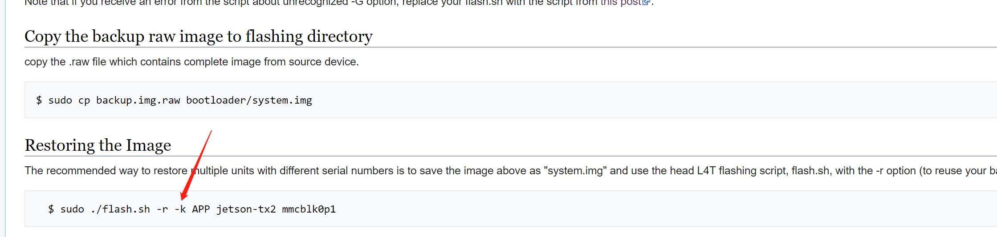

The recommend way to backup is following the scripts given in this repo.

