**Run ros across mutiple machine**

***Introduction:*** Suppose I want to run master at my TX2 [*nvidia@tegra-ubuntu*](mailto:nvidia@tegra-ubuntu), and my listener is at macbook: [zivlin@ziv-lin-pc](mailto:zivlin@ziv-lin-pc), the following step help you setup your environmet

1. Determine the ip of your pcs using *ifconfig, for example:*

*a. tx2:* [*nvidia@tegra-ubuntu*](mailto:nvidia@tegra-ubuntu) *===>* 192.168.1.102

*b. macbook:* [zivlin@ziv-lin-pc](mailto:zivlin@ziv-lin-pc)===> 192.168.1.143

Tips. If your environment can be fixed, you can fix yours ip at “setting→network”.

2. Add ip in your host file respectly: *sudo vim /etc/hosts*

a. at MAC:

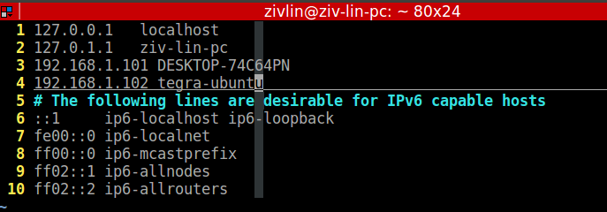

192.168.1.102 tegra-ubuntu

b. at tx2:

192.168.1.143 ziv-lin-pc

3. declear ros_remote_ip at your listener pc: *sudo vim ~/.bashrc*

export ROS_MASTER_URI=http://192.168.1.102:11311

