1. Since win10 dose not enable Samba_1.0 as default, you have to enable its policy as following:

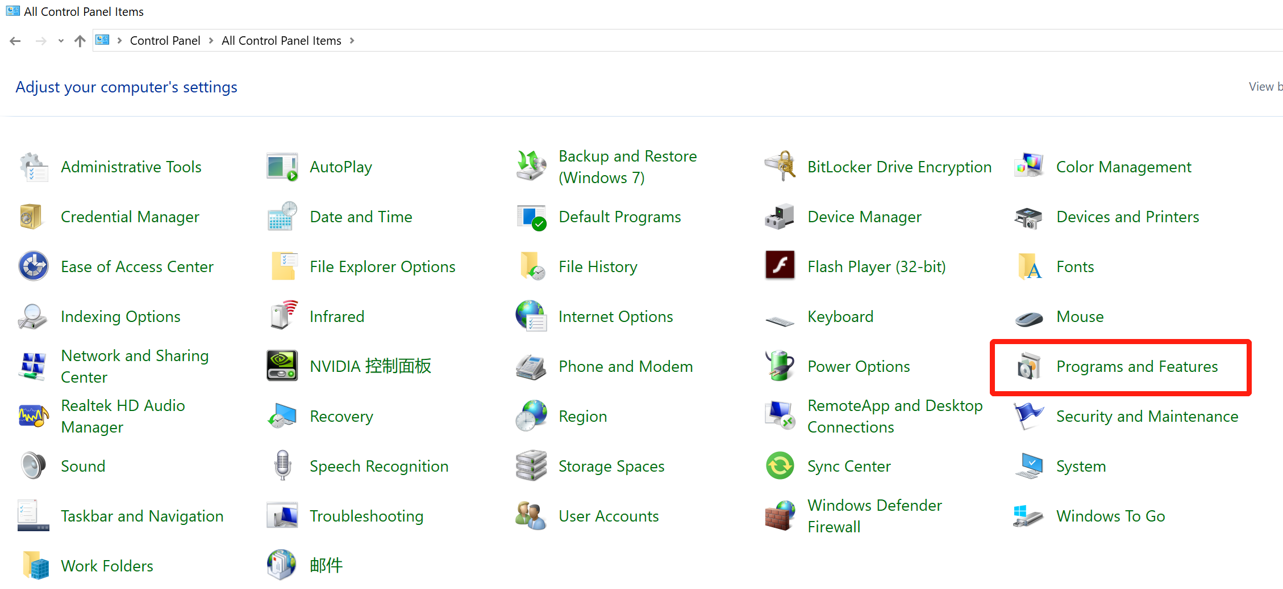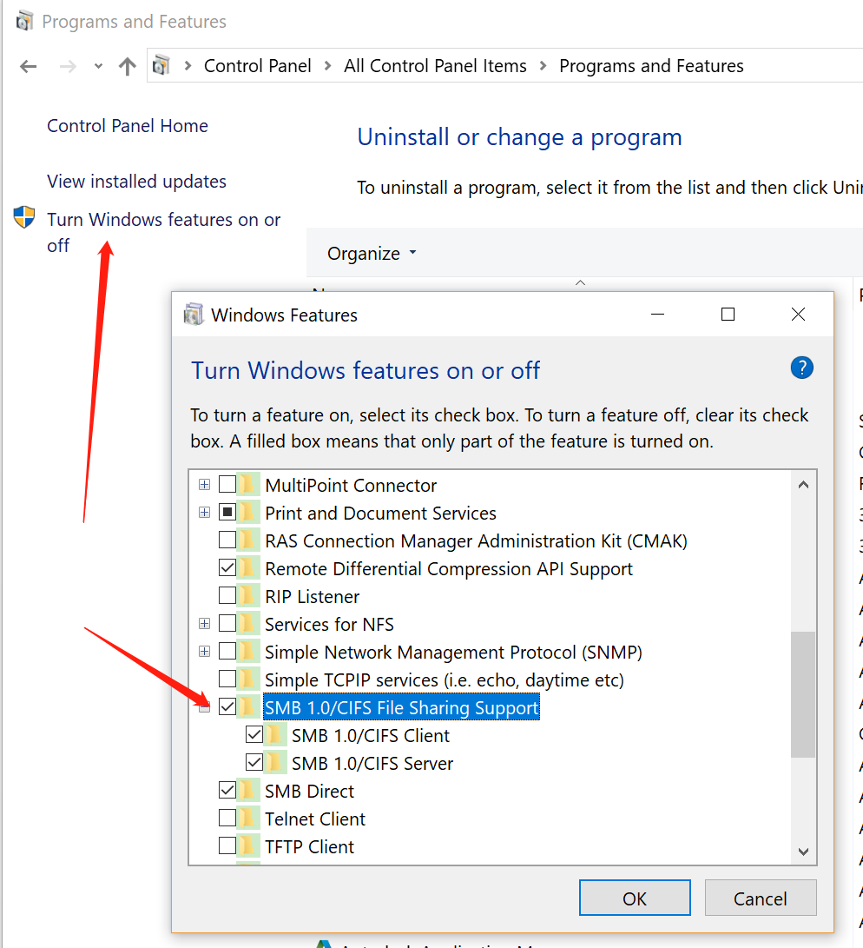

1. Edit samb.conf at ubuntu

*sudo cp /etc/samba/smb.conf sudo cp /etc/samba/smb.conf_bak*

*sudo vim /etc/samba/smb.conf*

**example**

[global]

workgroup = WORKGROUP

server string = Samba Server %v

netbios name = ubuntu

security = share

map to guest = bad user

name resolve order = bcast host

dns proxy = no

[work]

comment = samba home directory

path = /home/user/

public = yes

browseable = yes

public = yes

read only = no

valid users = nvidia

create mask = 0777

directory mask = 0777

force user = nobody

force group = nogroup

available = yes

guest ok = yes

# add to the end

[Public]

comment = Ubuntu File Share

path = /srv/samba/share

browsable = yes

writable = yes

guest ok = yes

read only = no

create mode = 0777

directory mode 0777

force user = nobody

[public_share]

comment = Anonymous share access

path = /home/nvidia/share/

browsable = yes

writable = yes

guest ok = yes

read only = no

force user = nobody

force group = nogroup