**Name:**

***Study Guide 1630 ~*** *Gym Socks Full of Germs*

Check Two-Step Solutions

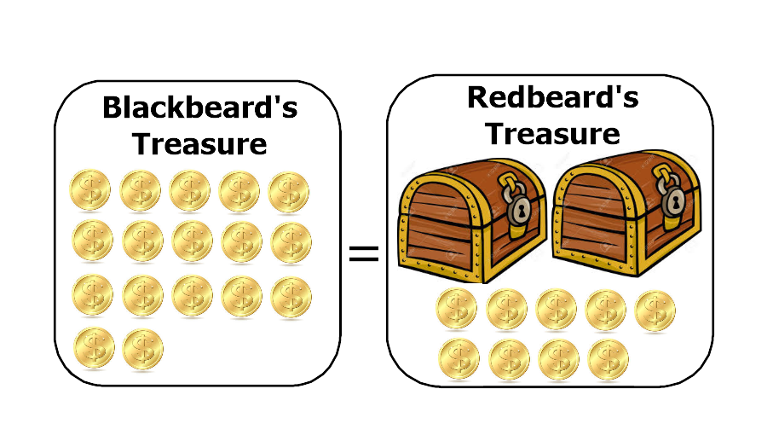 **The Puzzle**

Note: If you’ve completed the Study Guide “1629 ~ Equal Treasure”, you’ve seen this puzzle before. That’s okay.

This diagram shows the legendary puzzle of “Blackbeard and Redbeard’s Treasure”.

Students with strong math skills like to solve these kind of puzzles by writing equations. If we use the variable t to represent the number of coins in one treasure chest, then a good equation is

**17 = 2t + 9**

1) Explain in your words why this equation describes the pirate puzzle from the diagram.

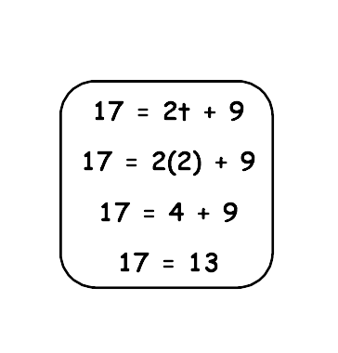 **Checking a number**

Rosarita wonders if “2” is the solution to the equation. She tries it like this diagram.

2) Was Rosarita correct when she guessed that “2” is the solution? Why or why not?

3) What is the value of 2t + 9 if t = 5? (This is the same as asking “How many coins would Redbeard have if each treasure chest holds five coins?”)

4) What is the value of 2t + 9 if t = 4?

5) What is the solution to the equation? In other words, How many gold coins are in each of Redbeard’s treasure chests?

**Smelly Gym Socks Full of Germs**

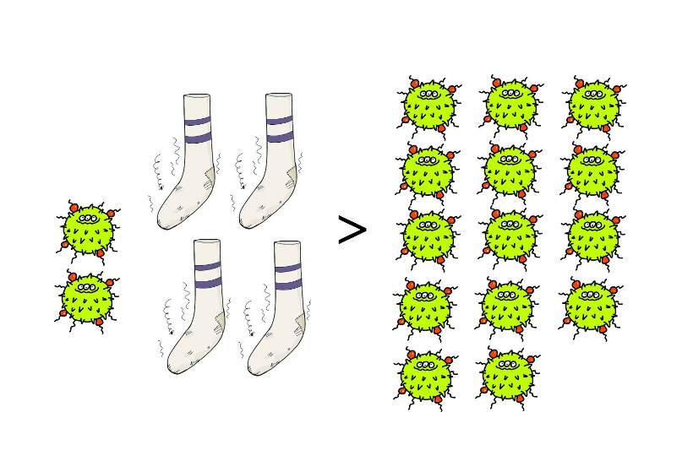

How many germs can each dirty sock hold? Notice that this puzzle uses a “>” symbol instead of an equal symbol. So the left side of the puzzle holds more germs than the right side. All four socks are full and there are two extra germs on the left side that couldn’t fit into a sock.

6) If each sock holds six germs, how many germs are on the left side?

7) Does six germs in a sock make the puzzle true or false? (The puzzle is true if the “>” symbol is correct. In other words, if there are more germs on the left side than on the right.)

8) Tell another number that makes the puzzle true.

9) Tell a number that makes the puzzle false.

**Practice Without Pictures**

**11a + 16 ≤ 115**

10) Is 8 a solution to this inequality? 11) Is 9? 12) Is 10?

**59 = 4z + 7**

13) Is 14 a solution to this equation? 14) Is 13?

15) Do you think there can be more than one solution to this equation? Why or why not?

**Quiz Practice**

16) Which of these numbers is the solution to the equation 117 = 14z + 19

5 6 7 8 9 10

17) When solving an equation, why is it helpful to have a list of choices?

18) Circle all of the numbers that are solutions to the inequality 28 + 6w ≥ 214

31 32 33 34 35 36

**Answers**

2) No. Her result was “17 = 13”. This is not true.

3) 19

4) 17

5) There are 4 coins in each chest. “4” is the solution

6) 26 germs

7) True. 26 germs > 14 germs

8) Example: 7 germs in each sock

9) Example: 2 germs in each sock

10) Yes 11) Yes 12) No

13) No 14) Yes

15) Answers may vary. But as you get to understand equations better, you’ll learn that equations like this can only have one solution.

16) 7

17) Example answer: You can try each number in the list to see whether it’s a solution.

18) 33, 34, 35, and 36 should be circled