**Name:**

***Study Guide 1010 ~*** *Surfing Gators*

Composite Comparatives

 **Students and Screen Time**

Do you watch too much TV? Or do you use your phone or tablet too much? The American Academy of Pediatrics says that children should have 60 minutes of screen time or less each day (this includes screens of any kind).

1) How much screen time do you usually spend in a day? Are you following the advice of the American Academy of Pediatrics?

2) Cindy spends about 45 minutes a day making comments on Instagram. Is she following the advice?

3) Roberto watches his favorite show on Netflix. It lasts 60 minutes long. Is he following the advice?

4) Soo Yin stays up after her parents go to sleep. She usually plays about two hours of Fortnite. Is she following the advice?

**A new symbol**

It’s important to notice that Roberto IS following the screen-time advice. Since the Academy suggests “60 minutes OR less”, it’s okay if your screen time is EQUAL to 60 minutes.

In math language, we describe the situation like this: Screen Time ≤ 60

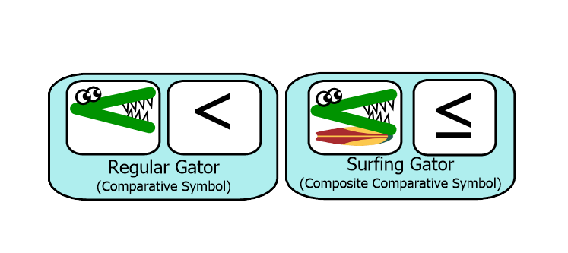There’s a new symbol in that math sentence. The symbol “≤” means “less than or equal to”. That new symbol is today’s main objective. You’ve already mastered regular alligators. Now you’re ready to try…SURFING GATORS!

5) There is also a symbol for “greater than or equal to”. What do you think that symbol looks like?

**Quiz Practice**

Fill in the blank with one of the given choices.

6) Choose > or ≤

7 + 5 ⬜ 10 + 1

9) Choose < or ≥

52 + 12 ⬜ 15 + 40

7) Choose > or ≤

7 + 3 ⬜ 10 + 1

10) Choose < or ≥

52 + 12 ⬜ 25 + 40

8) Choose > or ≤

7 + 4 ⬜ 10 + 1

11) Choose < or ≥

52 + 12 ⬜ 24 + 40

Circle the true statements. Cross out the false statements.

12) 8 x 4 > 30

16) 60 ≤ 8 x 8

13) 40 > 8 x 5

17) 8 x 9 ≤ 72

14) 40 ≥ 8 x 6

18) 8 x 10 < 70

15) 8 x 7 ≥ 56

19) 88 < 8 x 11

Circle all of the numbers that could go into the blank to make a true statement.

20) 9 x 7 ≥ ⬜ Choices: 60 61 62 63 64 65

21) 7 x 11 ≤ ⬜ Choices: 75 76 77 78 79 80

What is the greatest whole number that could go into the blank to make a true statement? (Reminder: A whole number doesn’t include a fraction or decimal. “3” is a whole number. “3.5” is not.)

22) 4 x 5 ≥ ⬜ 23) 6 x 7 > ⬜

What is the least whole number that could go into the blank to make a true statement?

24) 8 x 9 < ⬜ 25) 10 x 11 ≤ ⬜

26) Ravi says, “It’s kind-of silly to write ‘Screen Time ≤ 60’.

Why don’t we just write it like this instead? ‘Screen Time < 61’ ”

Do you agree or disagree with Ravi? Explain.

**Answers**

2) Yes 3) Yes 4) No

5) ≥

6) > 7) ≤ 8) ≤

9) ≥ 10) < 11) ≥

12) True 13) False 14) False 15) True

16) True 17) True 18) False 19) False

20) 60, 61, 62, and 63 21) 77, 78, 79, and 80

22) 20 23) 41

24) 71 25) 121

26) Ravi’s suggestion is not quite correct. In the statement “Screen Time ≤ 60”, the number 60 ½ cannot be included. In the statement “Screen Time < 61”, it is okay to include 60 ½.