**Name:**

***Study Guide 805 ~*** *Sticks in Dominos*

Diagrams for 1x2 digit multiplication

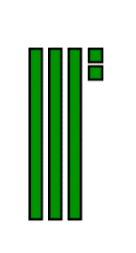We can model “32” by drawing place value blocks like this. The bars represent tens, and the small squares represent ones.

1) How would you model 21?

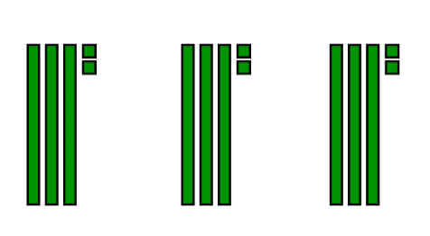

We could model 3 x 32 like this

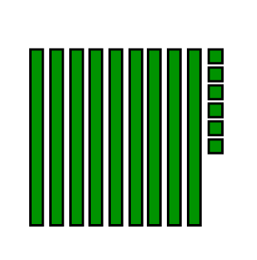But how do we see the product? (Remember that a **product** is an answer to a multiplication question.) It’s helpful to sort the blocks to group tens together and ones together.

So 9 tens and 6 ones makes 96.

3 x 32 = 96

2) Draw a model for 3 x 21

3) Re-draw your model with the tens grouped together and the ones grouped together.

We can time if we group the tens and ones together in the first step. A frame is helpful. We can call this frame a “domino”. This domino shows 3 x 23.

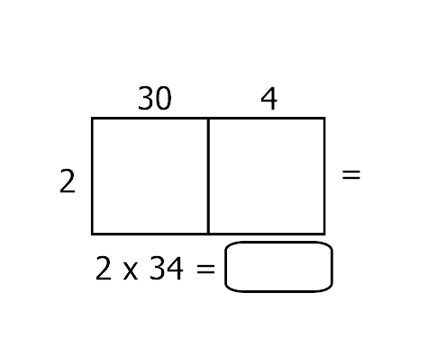4) Fill out this domino to show 2 x 34.

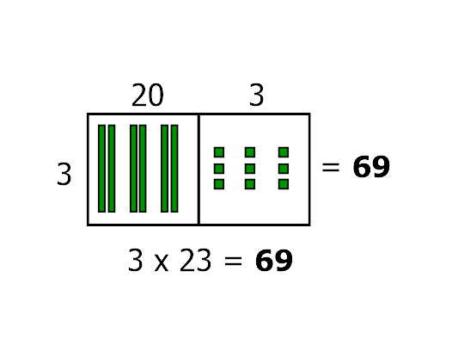

**In big kid math, we have to regroup**

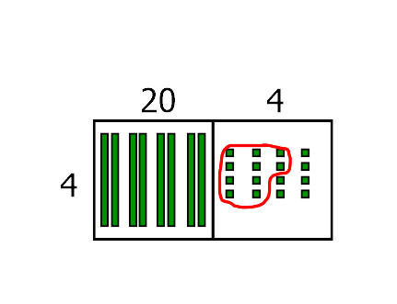So far, we’ve used pretty small numbers. This example shows what happens if we need to regroup some ones to make another ten.

Draw a model for 4 x 24.

Notice that we have a group of ten.

5) How many tens in total? 6) How many ones? 7) What is the final product?

**Practice**

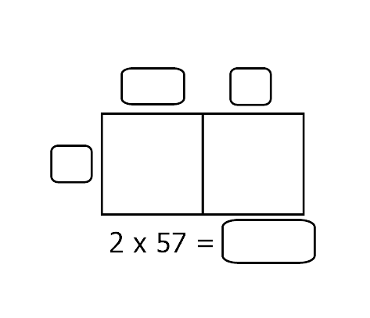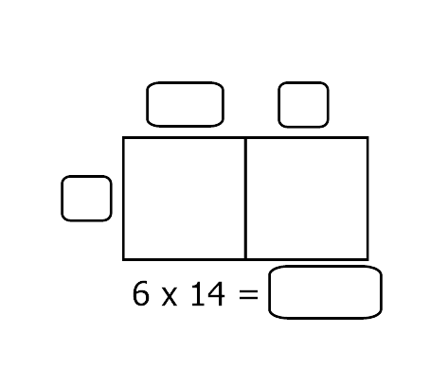Complete all blanks.

**10)**

**9)**

**8)**

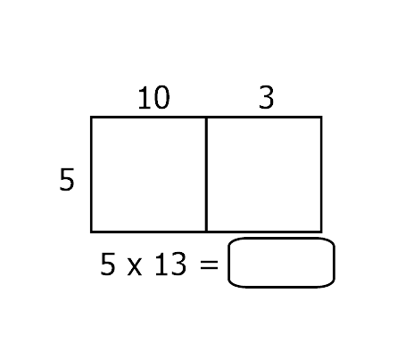

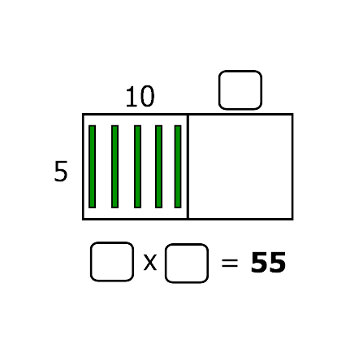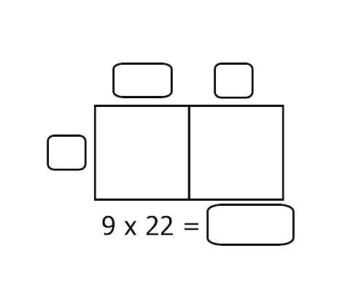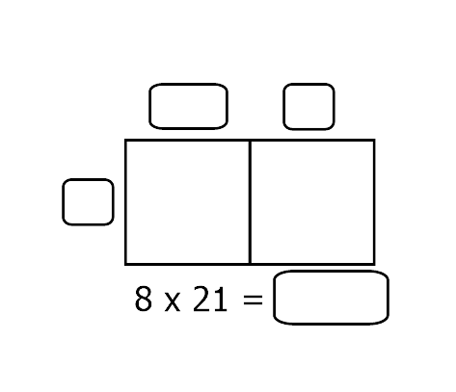

**13)**

**12)**

**11)**

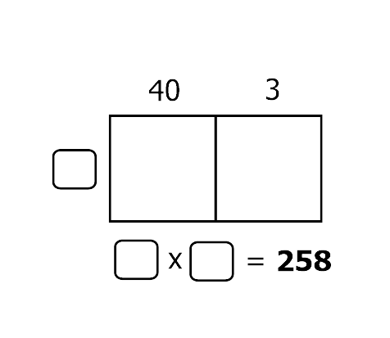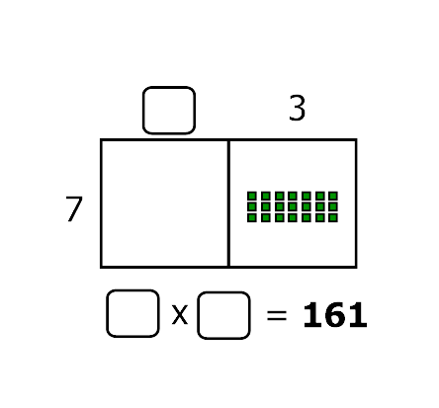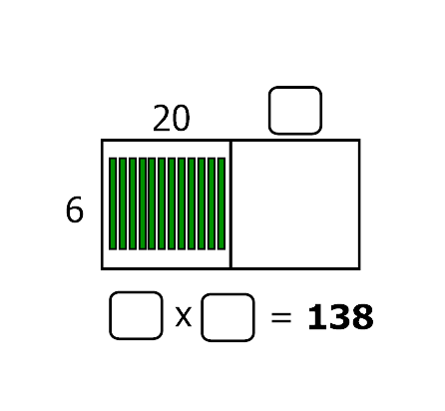

**16)**

**15)**

**14)**