**Name:**

***Study Guide 174 ~*** *Intro to the Distributive Property*

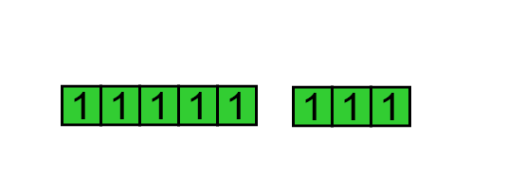The expression (5 + 3) could be represented as

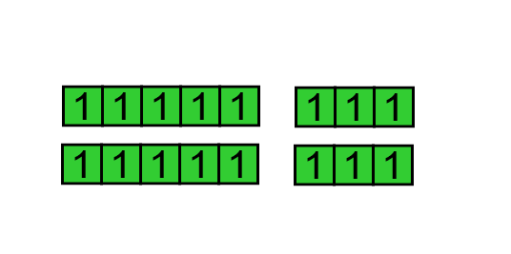

So the expression 2(5 + 3) could be represented as

There are two different ways to look at this diagram:

You could look at it as two groups of eight. We could also look at the diagram as a

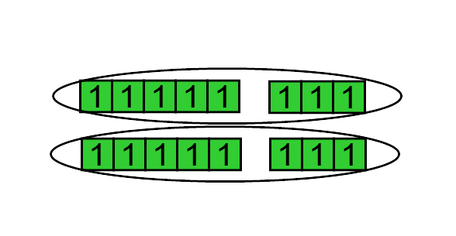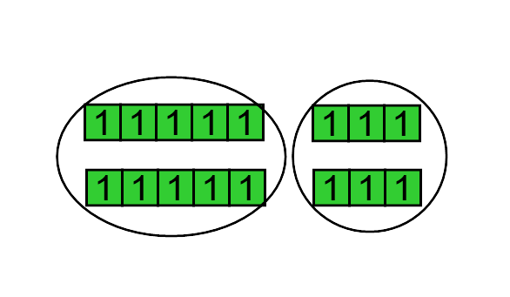 group of fives and a group of threes.

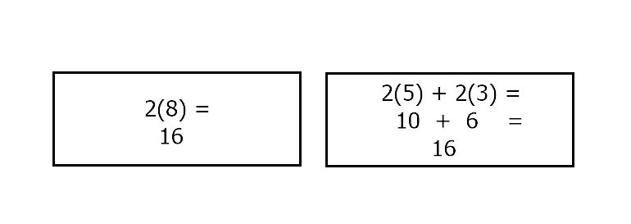Either way, the result is 16.

**You try it**

1. Draw a diagram to represent 3(5 + 1). Circle groups to show how somebody could look at the diagram as three groups of six.

2. Draw another diagram to represent 3(5 + 1). This time, circle groups to show how somebody could look at the diagram as a group of fives, and a group of ones.

3. Show calculations to prove that both ways to look at the diagram have the same result.

**But what if there are variables?**

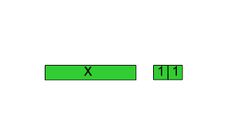The expression (x + 2) could be represented in a diagram like this:

(Keep in mind that this x block represents a variable. It could have the value of any number. In this picture, the x-block happens to have the same length as four and a half one-blocks, but that does **not** mean x is equal to four and a half.)

4. Draw a diagram to represent 4(x + 2). Circle groups to show how somebody could look at the diagram as four groups of (x + 2)

5. Draw another diagram of 4(x + 2). This time, circle groups to show a group of x’s and a group of sevens.

**The Simplest Version**

Referring to the previous problem, the second version shows us that expression could be written as 4x + 8. The version without parentheses is considered the simpler version.

Here’s another example: 9(x + 10). The simplest version of the expression is 9x + 90. The “distributive” way to group them is to see a groups of nine x’s and a group of nine 10’s.

**You try it**

For each expression, give the simplest form, without parentheses.

6. 6(x + 7) 7. 9(12 + x)

**The most common mistake**

When students are learning the Distributive Property, the following mistake is very common:

8(x + 3) = 8x + 3

8. If your friend wrote the work above, how would you explain to your friend why this is not the correct way to simplify the expression?

9. What is the correct way to simplify the expression?

**Practice**

For each of the next few problems, simplify the given expression by distributing. In other words, rewrite the expression without parentheses.

10. 3(x + 11) 11. 4(a + 10) 12. 10(b + 3)

13. 11(2 + y) 14. (z + 5)6 15. 452(c + 15)

16. -2(d + 6) 17. 18. 0.25(f + 20)

19. 3(-4 + j) 20. 3(g + 4) + 5 21. 7 + 4(h + 6)

22. 2(x + 7) + 3x 23. 4i + 3(i + 9) 24. 5m + 13(2 + m)

**Summary**

25. Check your answers. For any problems that you missed, try to make sure you understand why the correct solution is correct.

26. Look back at your work on this study guide. Choose one of the problems to copy into the notes section of your binder.

27. Plan a time when you will re-study your notes and this study guide.

**Answer Key**

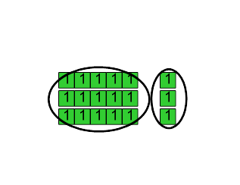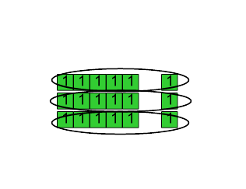1. 2.

3. 3(6) = 18,

and 3(5) + 3(1) = 15 + 3 = 18

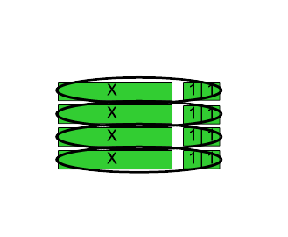

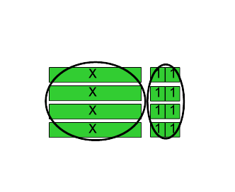4. 5.

6. 6x + 42 7. 9x + 84 (or 84 + 9x. They’re equivalent)

8. Example: There should be a group of eight 3’s. If you write 8x + 3, that’s only a group of one 3.

9. 8x + 24

10. 3x + 33 11. 4a + 40 12. 10b + 30

13. 11y + 22 14. 6z + 30 15. 452c + 6780

16. -2d – 12 17. 18. 0.25f + 5

or -2d + (-12)

19. 3j – 12 20. 3g + 17 21. 4h + 31

or 3j + (-12)

22. 5x + 14 23. 7i + 27 24. 18m + 26