**Name:**

***Study Guide 6 ~*** *Evaluate Expressions with Negative Numbers*

In this lesson, you will gain practice with adding, subtracting, multiplying, and dividing negative values. For many 8th grade topics, you will need to be able to do several of those things. Often, you’ll need to work with negative numbers several different times in one problem!

**Part I ~ The story of Rowdy Rudy**

In Mr. Negnum’s math class, all students begin a term with 50 positive behavior points. Rowdy Rudy loves math class, but he keeps forgetting to raise his hand to speak. This causes him to lose two points every day (To keep this problem simple, let’s say that he isn’t earning any new points).

1. How many points does Rudy still have after twelve days?

1. How many points does he have after fifteen days?

When you solved those two problems, you completed some version of the expression 50 – 2d, where the variable d stands for the number of days. Sometimes it’s more useful to write that expression as -2d + 50.

Rachel has Mrs. Posnum for math. Students in Mrs. Posnum start out with more points than students in Mr. Negnum’s class. Rachel decided to write her own expression to describe her points. She came up with -3d + 60.

1. How many points do students begin with in Mrs. Posnum’s class?
2. How many points does Rachel lose each day?
3. Evaluate the expression for d = 8
4. What does the result from the previous problem tell you about Rachel?

**Part II—Drawing Diagrams to represent expressions**

This diagram shows one possible way to represent 2(-4) + 7

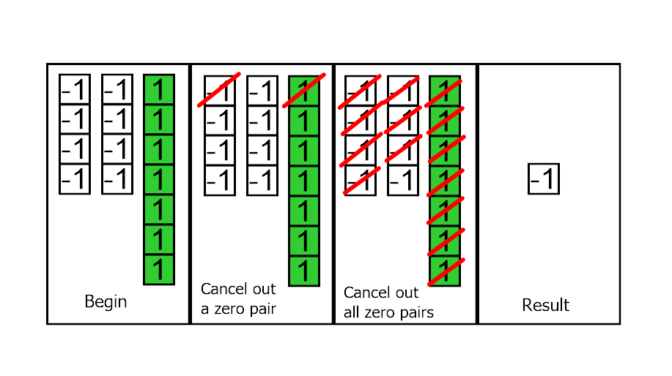

On the next page is an explanation about why this diagram represents the expression. But before you read it, do you best to study this diagram and write your own explanation:

1. Why does this diagram model the expression 2(-4) + 7?
2. What number problem is represented by this diagram?

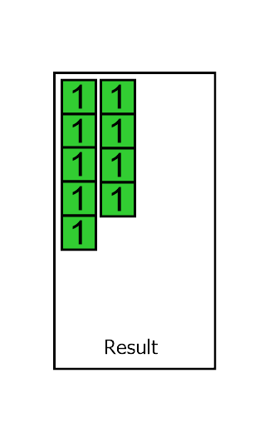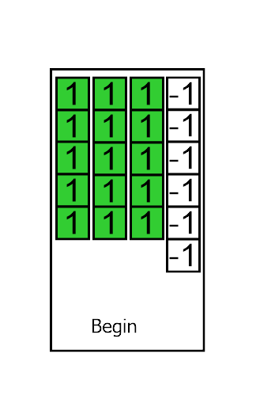

1. Draw a diagram to represent the expression 2(-5) + (-1). Evaluate. (Find the result)

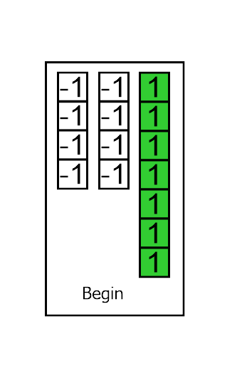**Explanation for Diagram 1** Our expression is 2(-4) + 7. If we translated that into English, it would read something like, “Multiply two by negative 4, then add seven.” To show multiplication, we can draw two groups of four negative blocks. Then we can draw seven positive blocks. That gets us started in the first panel.

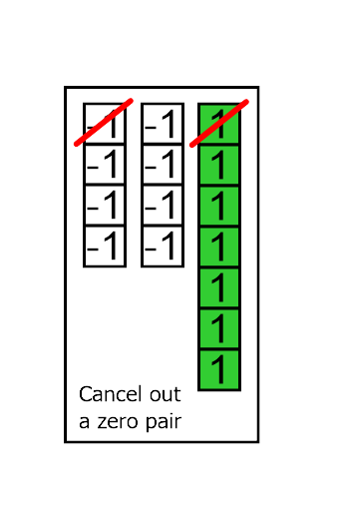The second panel demonstrates that a pair of one positive block and one negative bock make zero. We can cross out one of each kind of block to show this.

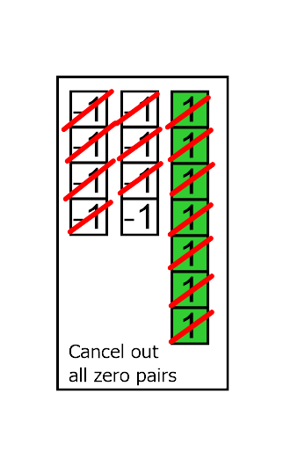In the third panel, we take that idea about “pairs that make zero” and cross off as many as we can. (Many people call these “zero pairs” for short.)

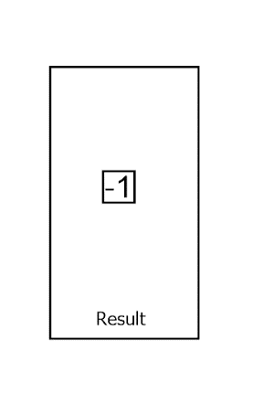

Finally, the last panel shows all of the zero pairs erased. Then it’s even easier to see what’s left. We can see that only a single negative block remains. So the result of the expression is (-1)

Or, 2(-4) + 7 = -1

1. Circle all the expressions that have positive results. If drawing diagrams helps you, then you might want to use a separate sheet of paper to draw diagrams for these problems.

6 + (-4)

(-6) + (-4)

6 – (-4)

(-6) – (-4)

6 x (-4)

(-6) x (-4)

$$\frac{6}{-4}$$

$$\frac{-6}{-4}$$

4 – (-6)

(-4) – (-6)

(-4) + (-6)

Evaluate each expression for the given value of the variable

11. 6r + 11 if r = 5 12. 6r + 11 if r = -5

13. 6r + 11 if r = -6 14. 4k + 2 if k = -9

15. 4(k + 2) if k = -9

1. Use the answer key at the end of this packet to check your answers. If you can, try to figure out the problems that you missed and see if you can do the work to arrive at the correct answer.
2. Choose one of the problems from this study guide to copy into your notes. It’s a good idea to choose a problem that you missed on your first try.

**Answer Key**

1. 26 points
2. 20 points
3. 60 points
4. 3 points
5. -3(8) + 60 = 36
6. Rachel has 36 points left after eight days.
7. Your opinion. Make sure to study the explanation on page three if you need help.
8. 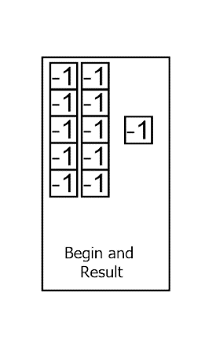3(5) + (-6) = 9
9. Example:
10. You should circle:

6 + (-4) 6 – (-4)

$\frac{-6}{-4}$ 4 – (-6)

(-4) – (-6) (-6) x (-4)

1. 41
2. -19
3. 25
4. -34
5. -28