**1. Electrical and electronic technology**

***Electrification***

Basic mean:

The process of gradually powering by electricity.

Distinct Features:

1. Concerning the power type people use.
2. Takes a long time. (1831 - about 1935)
3. Didn’t make tons of job as informatization

***Informatization***

Basic mean:

refers to the extent by which a geographical area, an economy or a society is becoming information-based, i.e. the increase in size of its information labor force.

Distinct Features:

1. Have a enormous impact on economic, political, social and cultural development
2. Carrying on very quickly and has a unprecedented growth in the speed, quantity, and popularity of information production and distribution."

Great engineer in electrification: Nikola Tesla(1856.7.10.－1943.1.7) 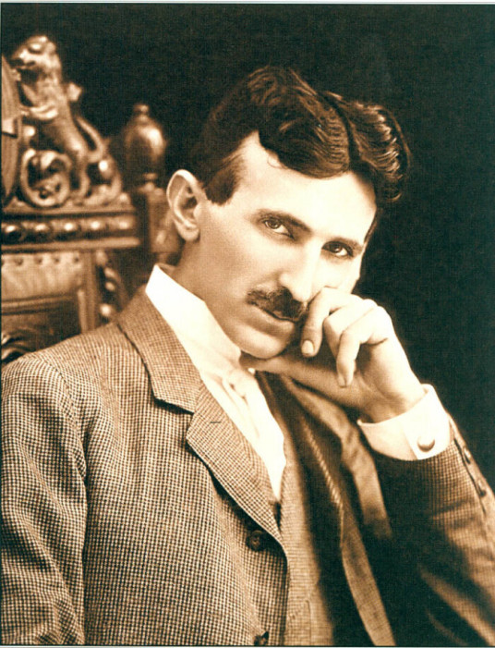

**Representative invention:** polyphase induction motor

This brought human step into the AC era and made it much more feasible to send large amounts of energy over a large area, speeding hugely the process of electrification. Most of modern electrical systems are AC system, which results the products designed by electrical engineers use AC.

**How’s the invention work:**

The external force powers a coil to rotate in a stationary magnetic field , making the [magnetic flux](https://en.wikipedia.org/wiki/Magnetic_flux" \o "Magnetic flux) change,then as per faraday’s law of induction, The electromotive force appear and change the direction when the coil has turned 180°,forming AC.

**2. Linear resistive network**

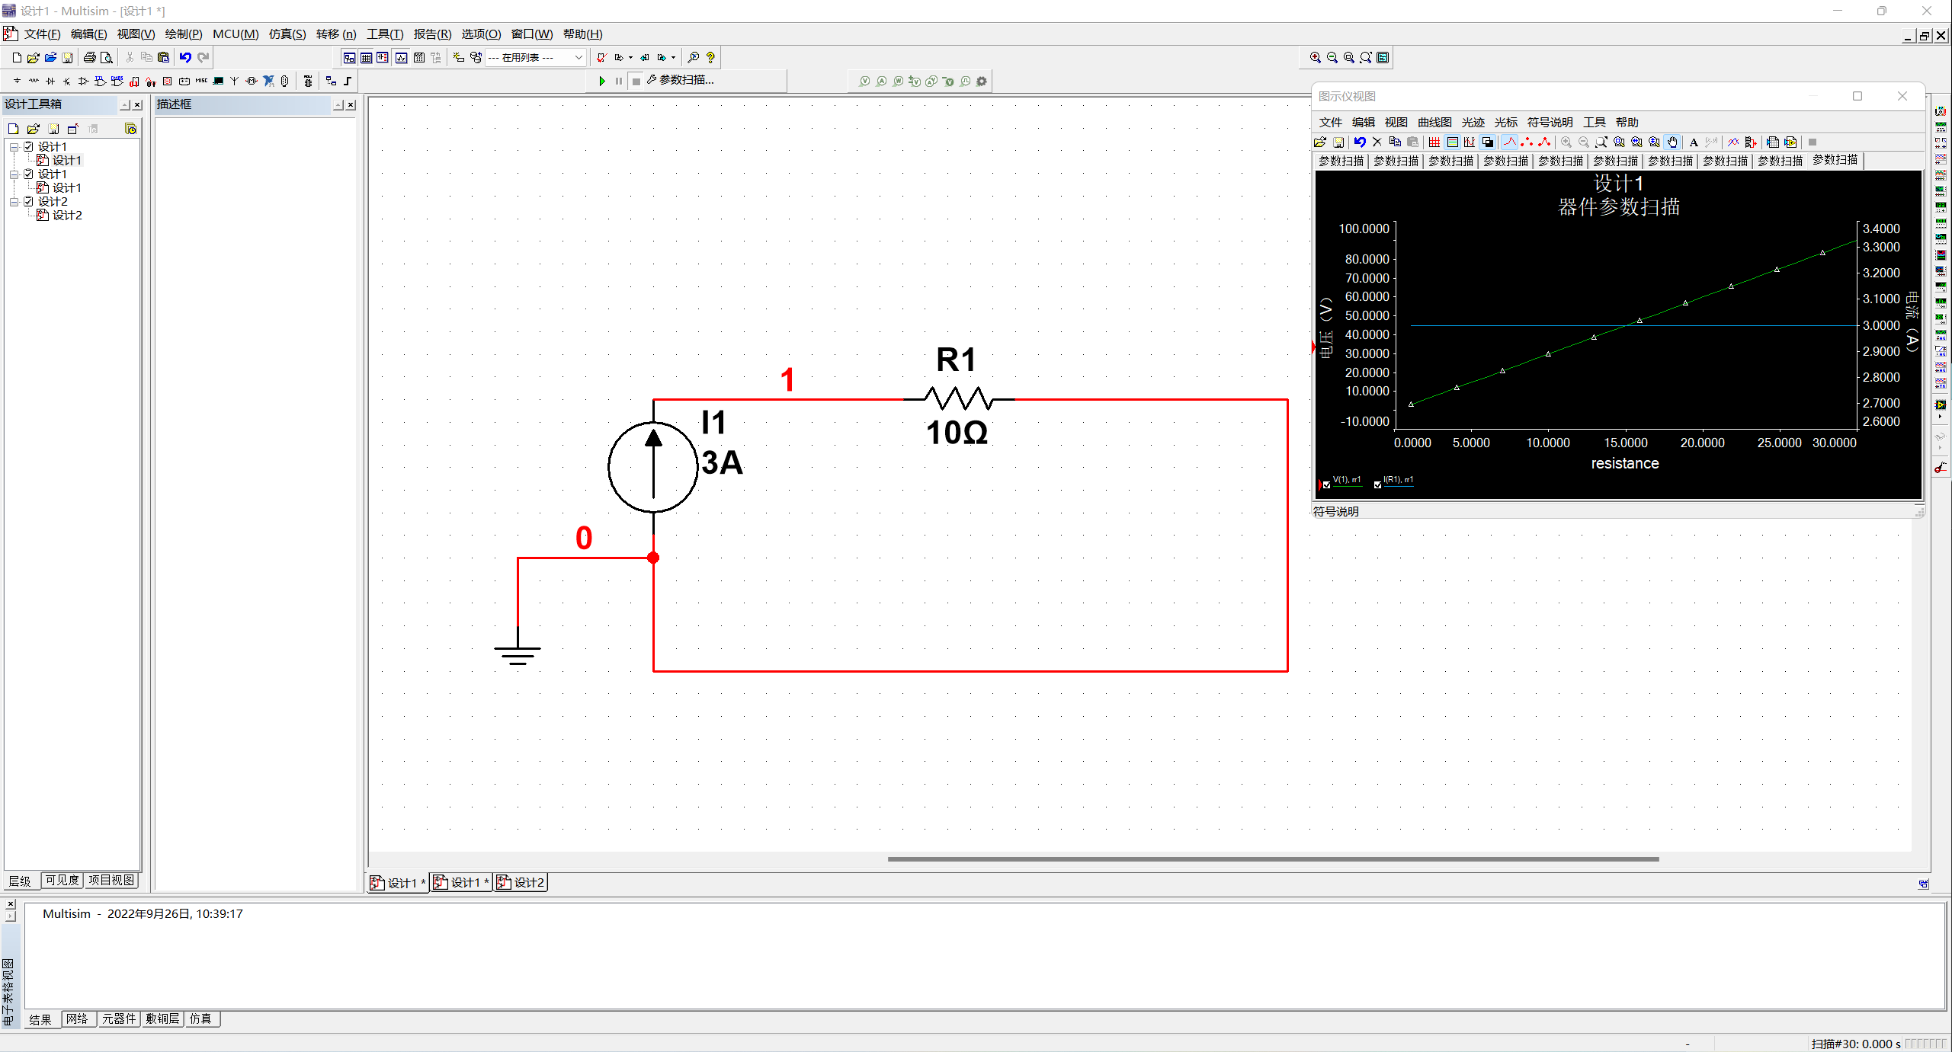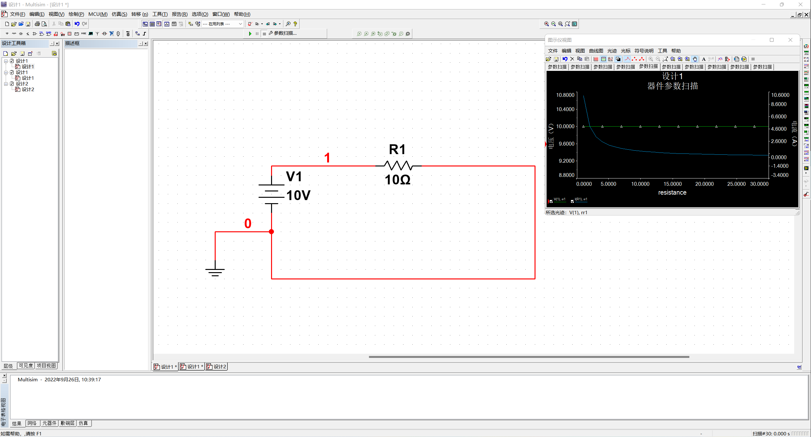

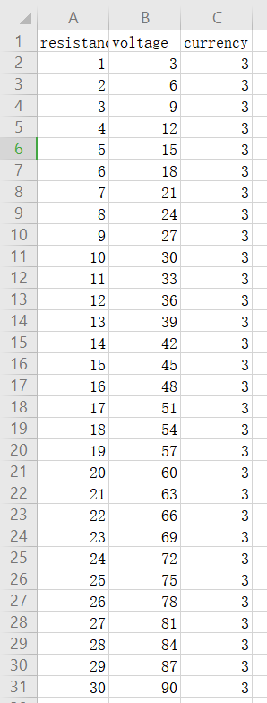 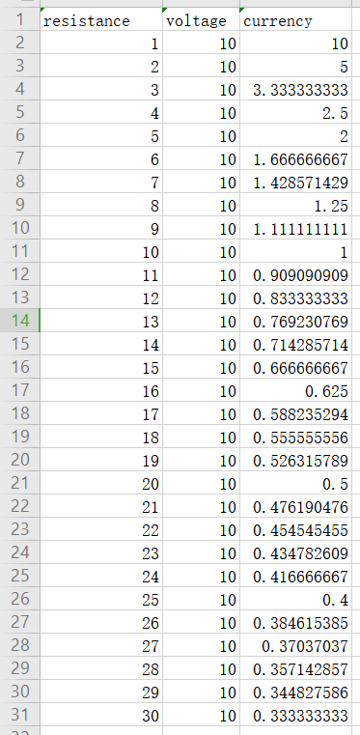

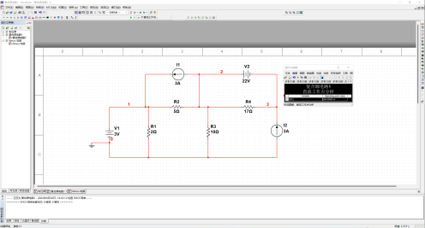

As in the image, the i1 is 200mA

3. Transistor characteristics.

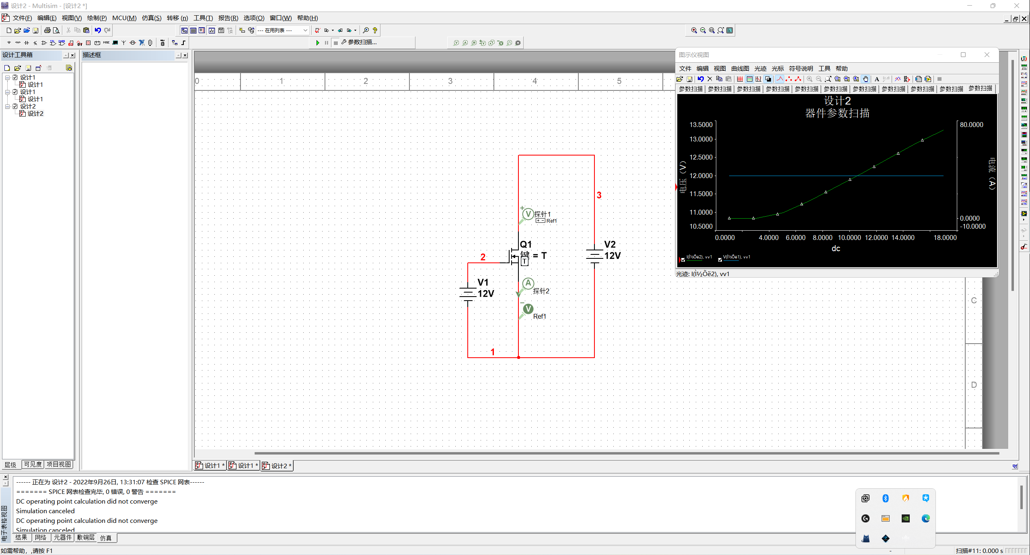

To turn on the NMOS, we need to apply voltage on the Gate electrode, then there will open the path between Source electrode and Drain electrode, i.e. turn on the NMOS

To turn it off we just need to make sure there’s no voltage on the Gate electrode.