MECHANICAL ENGINEERING PORTFOLIO
Adjustable Motor Mount
for a NEMA 17 Stepper Motor
Completed portfolio CAD project with preliminary static checks
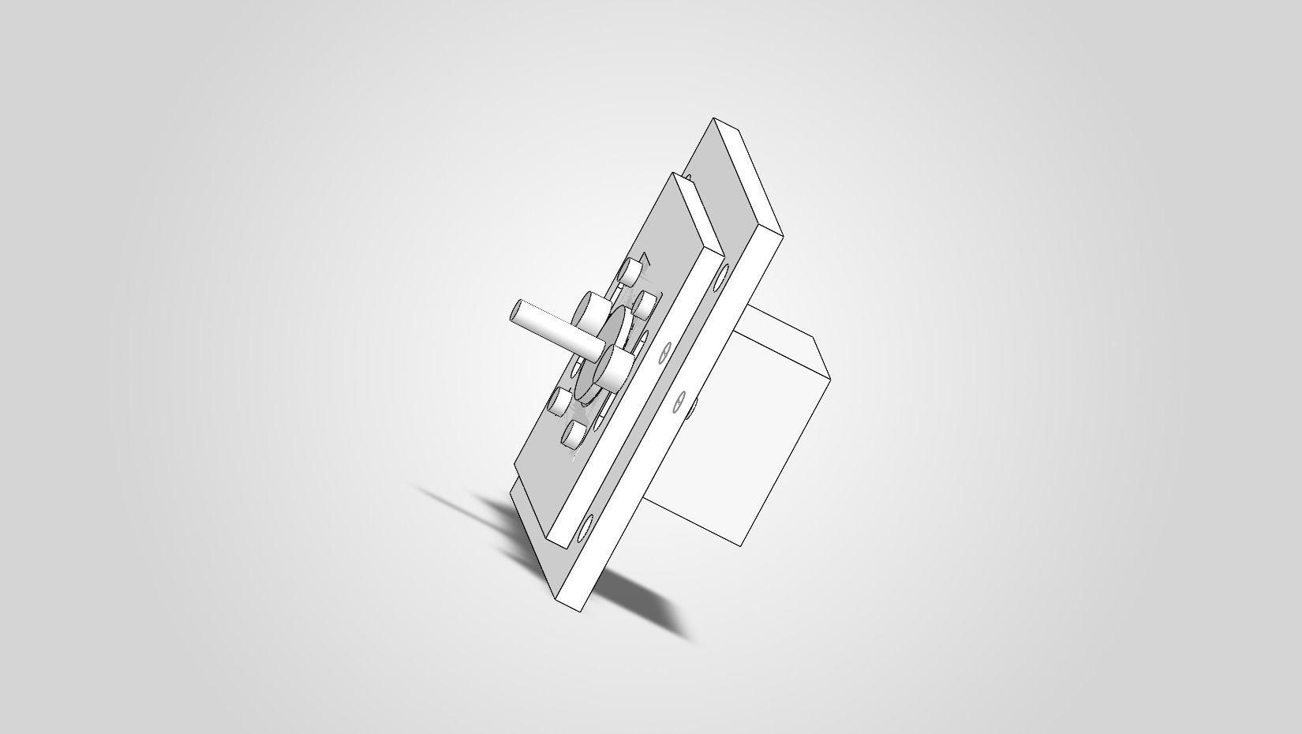
Figure 1. Assembled view of the adjustable motor mount.

Project Overview
The project develops a compact, adjustable mount for a simplified NEMA 17-style stepper motor representation. The design uses a motor plate that translates relative to a base plate so the motor position can be adjusted along one axis for alignment or belt tensioning.
The portfolio package includes SolidWorks part and assembly models, drawing PDFs, an exploded view, a bill of materials, requirements, and simplified static calculations. The calculations demonstrate basic design reasoning; they are not a certified structural analysis.

Design Requirements
The approved requirements define the existing CAD geometry, the intended adjustment function, the standard fastener interfaces, and the scope of verification. The key measurable requirements are summarized below.
Requirement area | Approved target / value
Motor interface | 40 x 40 mm simplified motor body; four M3 holes on a 31 x 31 mm pattern
Motor plate | 70 x 70 x 5 mm nominal
Base plate | 100 x 90 x 6 mm nominal
Adjustment slots | 6 mm wide; 18 mm between end-arc centers; 24 mm overall length
Usable adjustment | At least 18 mm of linear movement along one axis
Adjustment joint | Two standard M5 adjustment fasteners consistent with the CAD and BOM
Motor mounting | Four M3 motor fasteners consistent with the CAD and BOM
Base attachment | At least four accessible base-mounting locations
Motor interface limitation: The 40 x 40 mm motor body is a simplified NEMA 17-style CAD representation, not a verified commercial NEMA 17 envelope. Final fit with a specific commercial motor requires datasheet review and a physical fit check.
The approved requirements also call for clearance through the full adjustment range, accessible fasteners for common hand tools, and a drawing package containing dimensioned plate drawings and an assembly drawing. Those requirements define the intended verification activities; this report does not claim physical validation.

Mechanical Design
The assembly consists of a fixed base plate, an adjustable motor plate, the simplified motor representation, and standard fastening hardware. Four M3 x 10 mm bolts attach the motor to the motor plate. Two M5 x 16 mm bolts pass through the adjustment slots and work with M5 flat washers and hex nuts to clamp the motor plate to the base plate.
Each slot is 24 mm long overall and 6 mm wide, with a 3 mm radius at each end. The 18 mm distance between the end-arc centers is used as the conservative linear travel. After the motor position is set, tightening the two M5 fasteners clamps the plates; friction at the plate interface is the simplified mechanism used to resist sliding.
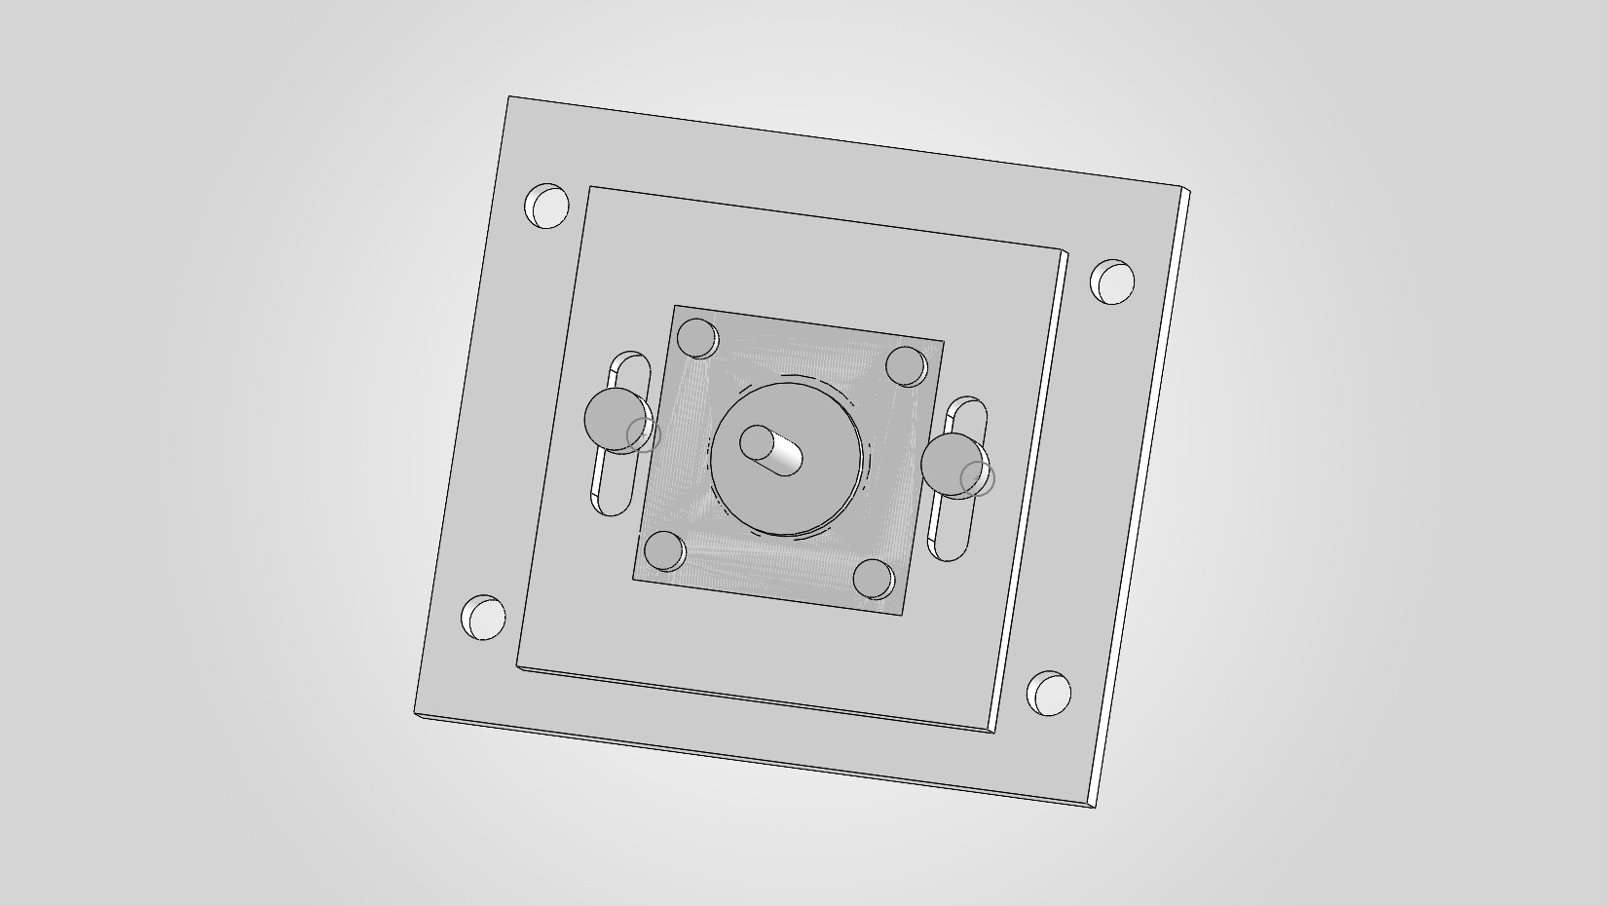
Figure 2. Close-up of the two-slot adjustment mechanism.

Material Selection
Aluminum 6061-T6 is the selected material for both custom plates. The approved BOM specifies standard zinc-plated steel for the M3 and M5 fasteners, washers, and nuts. These material designations are specifications for the CAD project.

Engineering Calculations
Five approved calculations check the adjustment geometry and the simplified static load path. The 30 N lateral load is a provisional portfolio design assumption. Equal load sharing is assumed between the two M5 bolts, and the dry aluminum-to-aluminum friction coefficient of 0.20 is an engineering assumption that was not experimentally measured.
Check | Equation | Substitution | Result
Usable adjustment travel | s = L - 2r | 24 mm - 2(3 mm) | 18 mm
Load per M5 bolt | Fbolt = Ftotal / n | 30 N / 2 | 15 N
Slot bearing stress | sigma = F / (t d) | 15 N / [(5 mm)(5 mm)] | 0.60 MPa
Average bolt shear stress | tau = F / A | 15 N / 19.63 mm2 | Approx. 0.76 MPa
Required clamping force | N = F / mu | 30 N / 0.20 | 150 N total; 75 N/bolt

Interpretation
The slot geometry provides 18 mm of conservative center-to-center motion. Under the provisional 30 N lateral load and equal sharing assumption, each M5 bolt carries 15 N for the bearing and direct-shear checks. The resulting nominal stresses are 0.60 MPa at the motor-plate slot and approximately 0.76 MPa in each M5 bolt.
Using the assumed friction coefficient of 0.20, the joint requires 150 N of total clamping force, or 75 N per bolt under equal sharing, to resist the provisional lateral load. This is a clamping-force requirement only; no tightening torque or achieved bolt preload was calculated.
Analysis scope: The results are simplified static checks intended to demonstrate basic design reasoning. No FEA, fatigue analysis, bending analysis, bolt preload torque calculation, or physical prototype testing was performed.
Calculation record: Motor Mount Calculations.pdf

BOM and Manufacturing
The approved bill of materials contains seven line items: two custom aluminum plates, one simplified motor representation, and standard purchased fasteners. Estimated costs remain TBD. The BOM does not add procurement grades or supplier-specific requirements beyond the approved specifications.
Item | Part | Qty. | Material / specification | Make / Buy
1 | Base_Plate | 1 | Aluminum 6061-T6 | Make
2 | Motor_Plate | 1 | Aluminum 6061-T6 | Make
3 | M5_Bolt_16mm | 2 | Zinc-plated carbon steel, standard M5 | Buy
4 | NEMA17_Simplified | 1 | Commercial motor; simplified CAD representation | Buy
5 | M3_Bolt_10mm | 4 | Zinc-plated carbon steel, standard M3 | Buy
6 | M5_Washer | 2 | Zinc-plated steel, standard M5 flat washer | Buy
7 | M5_Hex_Nut | 2 | Zinc-plated steel, standard M5 hex nut | Buy
The custom components use flat-plate construction. The approved manufacturing requirement identifies conventional cutting, drilling, and slot-machining operations as the intended basic workshop processes. No parts were manufactured for this project, so manufacturability has not been confirmed through production or inspection.
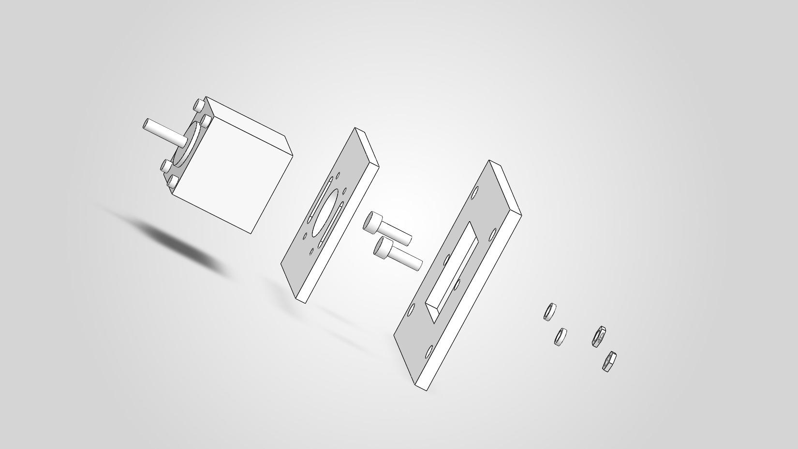
Figure 3. Exploded view of the motor, plates, and adjustment hardware.
Approved BOM: Motor_Mount_BOM.xlsx
CSV BOM: Motor_Mount_BOM.csv

Drawings and Assembly
The portfolio drawing set provides PDF references for the assembly, base plate, and motor plate. The assembly is represented with the motor mounted to the adjustable plate and the plate clamped to the base using the two M5 fastener sets. The exploded view supports identification of the component sequence and purchased hardware.
Assembly drawing: Motor_Mount_Assembly_Drawing.pdf - assembly views and BOM
Base plate drawing: Base_Plate_Drawing.pdf - base-plate geometry
Motor plate drawing: Motor_Plate_Drawing.pdf - motor-plate geometry

Limitations and Future Improvements

Motor fit verification
The 40 x 40 mm body is a simplified CAD representation. A future release should select a specific commercial NEMA 17 motor, compare the mounting and body envelope with its datasheet, and complete a physical fit check.

Load and joint validation
The 30 N lateral load and friction coefficient of 0.20 are provisional assumptions. Future work should define the actual operating load and surface condition, then repeat the calculations using verified inputs and measure whether the assembled joint retains its position.

Prototype and drawing release
No physical prototype testing was performed. A prototype would allow the 18 mm adjustment travel, component clearance, fastener access, and resistance to sliding to be checked. Before manufacture, the drawing package should also be reviewed for the required units, materials, general tolerances, fasteners, and adjustment direction.

Conclusion
The adjustable motor mount meets the intended scope of a first mechanical engineering portfolio CAD project: a compact two-plate assembly, standard fasteners, a documented 18 mm adjustment mechanism, an approved BOM, drawing references, and preliminary static checks. Aluminum 6061-T6 is specified for both custom plates. The design remains a portfolio-level engineering study until a specific commercial motor, actual operating loads, and physical prototype performance are verified.

