Lab1

Ziwen Zhang

2022-11-05

## Question 1

TrueCI <- function(pi){  
 set.seed(123)  
 piest <- rbinom(n = 1000, size = 40, prob = pi)/40  
 lower <- piest - qnorm(0.975) * sqrt(piest*(1-piest)/40)  
 upper <- piest + qnorm(0.975) * sqrt(piest*(1-piest)/40)  
 sum(lower <= pi & upper >= pi) / 1000  
}  
  
pi <- seq(0,1,by=0.01)  
plot(pi, lapply(pi, TrueCI), ylim = c(0,1), ylab="Confidence Level", xlab="pi values", main = "True Confidence Level vs. pi")

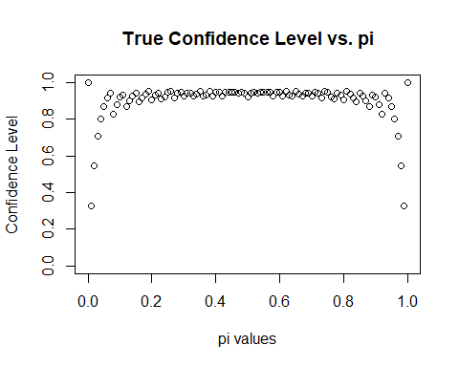

When the pi values are close to 0 and 1, the confidence levels become lower, and this trend seems to be significant with the extreme π values. Otherwise, the confidence levels are relatively stable at around 0.95.

## Question 2

set.seed(123)  
bin_sample = rbinom(n = 1000,  
 size = 10,  
 prob = 0.6)  
Pr3 <- sum(bin_sample == 3) / length(bin_sample)   
Pr3

## [1] 0.046

The estimated probability is 0.046