Plots made by Zian Wang:

Plot1: Divide-and-Conquer, fixed n change k.

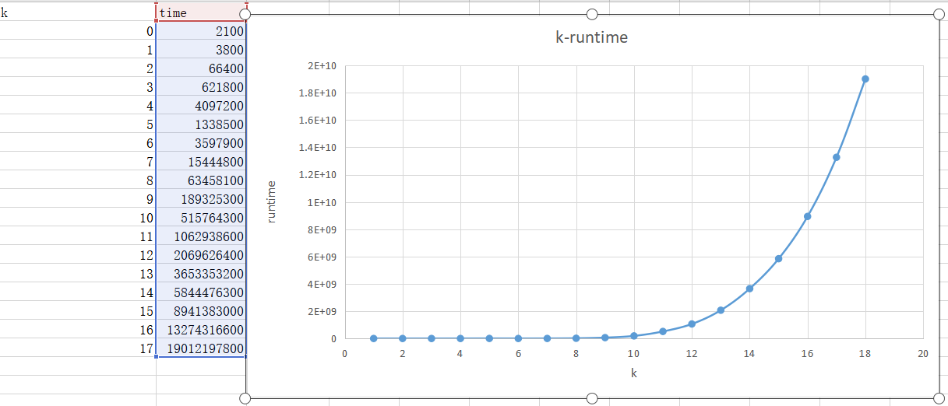

The trend is like 2^k.

Plot2: Dynamic Programming, fixed n change k.

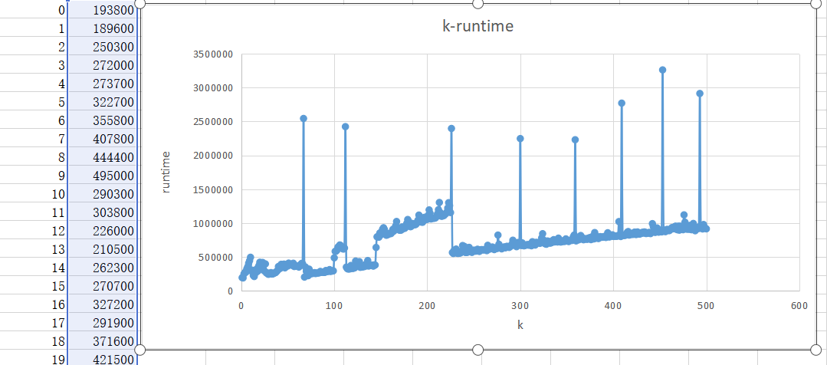

This plot is a little bit strange. Although the trend is linear, it seems the line has some out points and even one segment is not on the line. I think this is because:

1. There are some other processes running in my laptop.
2. The development tool and OS maybe have some influence.
3. Another point that should be noticed is when n and k are big, the result will exceed the range of the long int variable in java. Therefore the result will become negative and then positive when the range has been exceeded. I don’t know whether this will influence the calculate, but in my opinion, the number of digits of the result won’t increase when the range has been exceeded, so maybe at this time, the calculation will actually be simplified, so the run time won’t increase so rapidly.

Plot3: Divide-and-Conquer, fixed k change n.

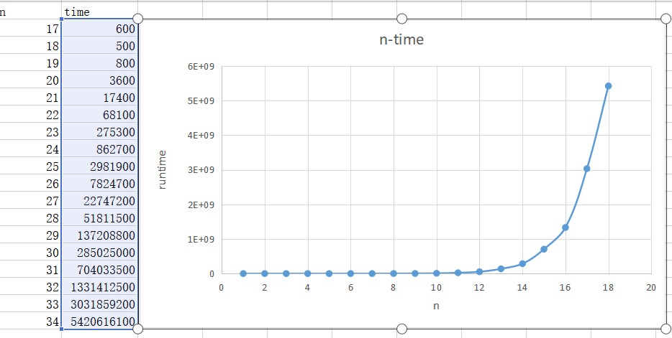

The trend is like 2^n.

Plot4: Dynamic Programming, fixed k change n.

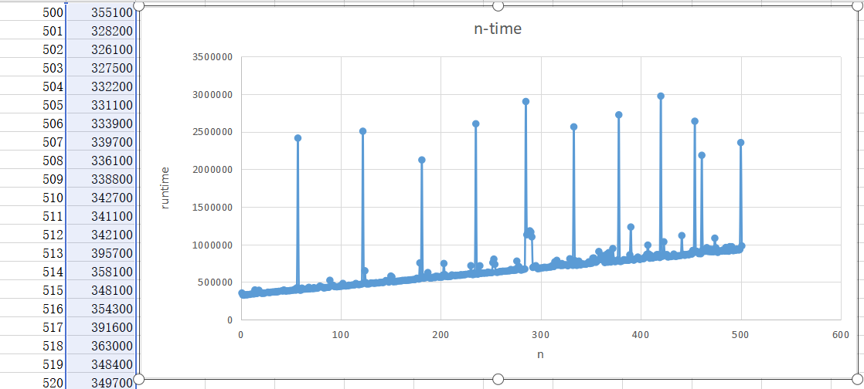

The trend is like linear. This plot is not as strange as plot2, even it also has some out points (looks some out points are equal spaced on n), the trend is clearly a linear trend.