CSCI 1480
University of Central Arkansas
Lab 8 Out-class Assignment

Topic: Classes- Operator Overloading - 20 Points
Reading: Ch. 14

*Note: Include the following set of comments at the top of your source code for all assignments.
//Your Name
//Assignment # (Example: Lab8out)
//Brief description of the purpose of the program (Example: //Calculates the area of a square.)

Overview
Lab8out is a continuation of lab8in. Additional operators (++,--,<,>) are added to the Color class first introduced in lab8in. The modified declaration for the Color class is shown below (additional methods are highlighted in yellow):
#ifndef COLOR_H
#define COLOR_H

class Color
{
private:
int r;
int g;
int b;

public:
Color();
Color(int r, int g, int b);
void setColor(int r, int g, int b);
int getRed();
int getGreen();
int getBlue();
Color operator+(Color right);
Color operator-(Color right);
Color operator/(int right);
Color operator*(int right);
bool operator==(Color right);
bool operator!=(Color right);
void operator=(Color right);
Color operator!();
Color operator++();
Color operator++(int dummy);
Color operator--();
Color operator--(int dummy);
bool operator<(Color right);
bool operator>(Color right);
void draw(int x, int y, int w, int h);
};

#endif

The example main first used in lab8in is modified to include these additional operators as shown below:
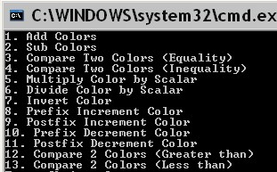
The first 7 menu items are identical to those used in lab8in. Selecting menu #8 (Prefix Increment Color) results in the following prompt for 1 color:
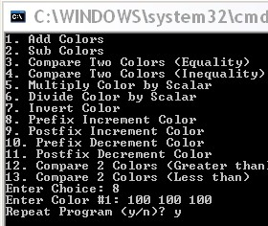
The definition of Prefix Increment Color is:

Increment the r,g,b data field of the modified color object (i.e., the object to the right of the ++) by 25. Values greater than 255 are set to 255. The modified value is returned from the method.

As an example, consider the following color declarations/initializations:

Color c1;
Color result1;
….
c1.setColor(r,g,b); //Sets r,g,b pdfs to prompted r,g,b values

A statement utilizing prefix increment is as follows:

result1 = ++c1;

The r,g,b data fields of c1 are 125,125,125. The r,g,b data fields for result1 is also 125,125,125 since it is prefix increment.
The Graphics display then shows the prefix increment operation and the resulting color from this selection:
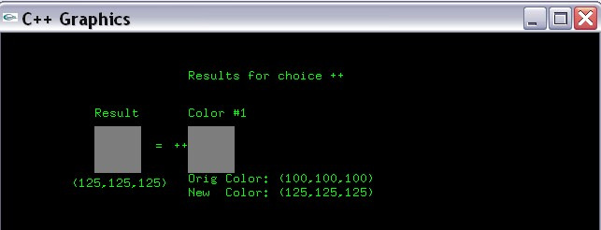

The initial color is (100,100,100). Prefix increment results in (125,125,125). Since it is prefix increment, the result is also (125,125,125).

Re-running the program and selecting menu item #9 results in the following prompts:
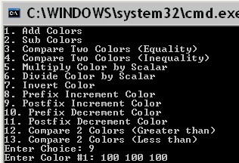
The definition of postfix increment is

Increment the r,g,b data field of the modified color object (i.e., the object to the left of the ++) by 25. Values greater than 255 are set to 255. The original Color value is returned from the method.

As an example, consider the following color declarations/initializations:

Color c1;
Color result1;
….
c1.setColor(r,g,b); //Sets r,g,b pdfs to prompted r,g,b values

A statement utilizing postfix increment is as follows:

result1 = c1++;

The r,g,b data fields of c1 are 125,125,125 once the statement completes. The r,g,b data fields for result1 is 100,100,100 since it is postfix increment.

The Graphics display then shows the postfix increment operation and the resulting color from this selection:

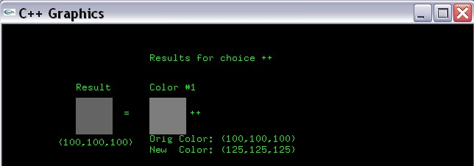
The initial color is (100,100,100). Postfix increment results in (125,125,125) for c1 (Color #1) once the statement completes. Since it is postfix increment, the result is the original color (100,100,100). Note the result is slightly darker than Color #1.

Re-running the program and selecting Menu item #10 results in the following prompts:
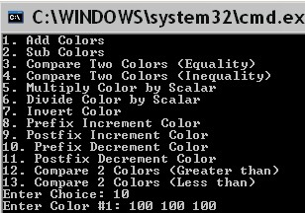
The definition of prefix decrement is

Decrement the r,g,b data field of the modified color object (i.e., the object to the right of the --) by 25. Values less than 0 are set to 0. The modified Color value is returned from the method.

As an example, consider the following color declarations/initializations:

Color c1;
Color result1;
….
c1.setColor(r,g,b); //Sets r,g,b pdfs to prompted r,g,b values

A statement utilizing prefix decrement is as follows:

result1 = --c1;

The r,g,b data fields of c1 are 75,75,75. The r,g,b data fields for result1 is also 75,75,75 since it is prefix decrement.

The Graphics display then shows the prefix decrement operation and the resulting color from this selection:
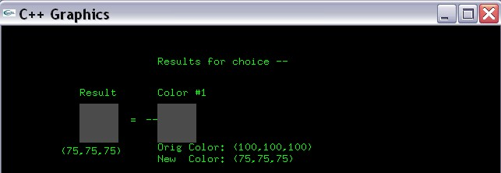
The initial color is (100,100,100). Prefix decrement results in (75,75,75). Since it is prefix decrement, the result is also (75,75,75).

Re-running the program and selecting Menu item #11 results in the following prompts:
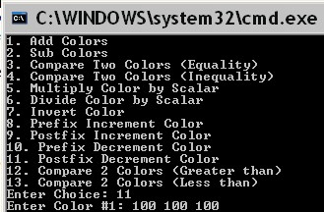

The definition of postfix decrement is:

Decrement the r,g,b data field of the modified color object (i.e., the object to the left of the --) by 25. Values less than 0 are set to 0. Return the original color value from the method

As an example, consider the following color declarations/initializations:

Color c1;
Color result1;
….
c1.setColor(r,g,b); //Sets r,g,b pdfs to prompted r,g,b values

A statement utilizing postfix decrement is as follows:

result1 = c1--;

The r,g,b data fields of c1 are 75,75,75 once the statement completes. The r,g,b data fields for result1 is 100,100,100 since it is postfix decrement.

The Graphics display then shows the prefix decrement operation and the resulting color from this selection:
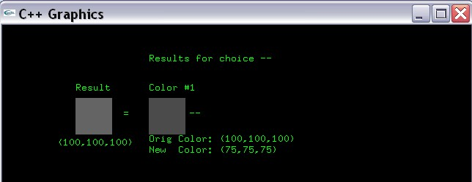
The original color is (100,100,100). Postfix decrement results in (75,75,75) for Color #1 once the statement completes. Since it is postfix decrement, the result is the original color (100,100,100).

Re-running the program and selecting menu item #12 results in the following prompts:
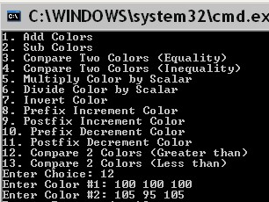
The purpose for Menu item #12 is to compare 2 colors based on the greater than operator. Comparing 2 colors for greater than is based on comparing the magnitude of the colors. The magnitude of the color (mag) is defined as:

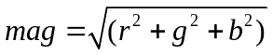

Where r,g,b are the private data fields of the given color. An example statement testing if Color c1 is greater than Color c2 is given below:

result3 = c1 > c2;

Where result3 is declared as bool. The result of this menu selection is then displayed in the graphics window as shown below:
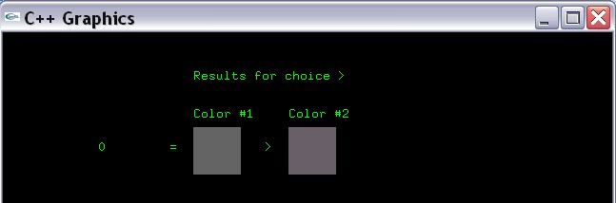
The magnitude of Color #1 is 173.20508. The magnitude of Color #2 is 176.28103. Since Color #1 is not greater than Color #2, a 0 is displayed as the result.

Re-running the program and selecting Menu item #13 results in the following prompts:
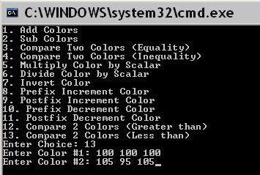
The purpose for Menu item #13 is to compare 2 colors based on the less than operator. Comparing 2 colors for less than is based on comparing the magnitude of the colors. The magnitude of the color (mag) is defined as:

Where r,g,b are the private data fields of the given color. An example statement testing if Color c1 is less than Color c2 is given below:

result3 = c1 < c2;

Where result3 is declared as bool. The result of this menu selection is then displayed in the graphics window as shown below:
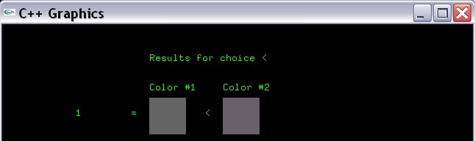
The magnitude of Color #1 is 173.20508. The magnitude of Color #2 is 176.28103. Since Color #1 is less than Color #2, a 1 is displayed as the result.

Private Data field Description

Utilize the following datafields in the Color class:

int r;
int g;
int b;

Each data field corresponds the r,g,b component of the color.

Method Description

The Color class utilizes the following methods:

Color();
Default Constructor sets r,g,b color components all to 0.

Color(int r, int g, int b);
Parameterized Constructor. Set r,g,b private datafields to values in the formal parameters.

void setColor(int r, int g, int b);
Setter for r,g,b private datafields.

int getRed();
int getGreen();
int getBlue();
Getters for private datafields.

Color operator+(Color right);
Adds two Color objects based on the following rule:

Add the corresponding r components, g components, and b components together. Values greater than 255 are set to 255. Returns the result of adding the two colors.

Color operator-(Color right);
Subtracts two Color objects based on the following rule:

Subtracts the corresponding r components, g components, and b components. Values less than 0 are set to 0. Returns the result of subtracting the two colors.

Color operator/(int right);
Divides a Color by an integer. Each r,g,b component of the Color object is divided by the integer. Returns the results of this division.

Color operator*(int right);
Multiplies a Color by an integer. Each r,g,b component of the Color object is multiplied by the integer. Returns the results of this multiplication.

bool operator==(Color right);
Tests the equality of 2 colors. Return true if the r,g,b components of both colors exactly match. Otherwise, return false.

bool operator!=(Color right);
Tests the inequality of 2 colors. Return true if any of the r,g,b components of either color does not match. Otherwise, return false.

void operator=(Color right);
Assignment operator. Assigns the r,g,b component of the Color object on the right side of th eassignment operator to the r,g,b component on the left side of the assignment operator.

Color operator!();
Computes the inverse of a Color object. The inverse of a Color object is defined as:

Subtract the corresponding r,g,b value from 255. Return a Color object containing these values.

This inverse can be computed as:

result.r = 255 - r;
result.g = 255 -g;
result.b = 255 -b;

Where result is returned from this method.

void draw(int x, int y, int w, int h);
Draws a rectangle positioned at coordinate (x,y) with width set to w and height set to h. The rectangle is then colored to r,g,b color maintained by this Color object.

Color operator++();
Prefix increment operation. Increment each r,g,b component by 25. Those values greater than 255 are set to 255. Returns the modified Color object. Examples given on page 3.

Color operator++(int dummy);
Postfix increment operation. Increment each r,g,b component by 25. Those values greater than 255 are set to 255. Returns the original Color object. Examples given on page 4.

Color operator--();
Prefix decrement operation. Decrement each r,g,b component by 25. Those values less than 0 are set to 0. Returns the modified Color object. Examples given on page 5.

Color operator--(int dummy);
Postfix decrement operation. Decrement each r,g,b component by 25. Those values less than 0 are set to 0. Returns the original Color object. Examples given on page 6.

bool operator<(Color right);
Less than operator. Returns true if left object is less than right object. Returns false otherwise. Details and examples given on page 8.

bool operator>(Color right);
Greater than operator. Returns true if left object is greater than right object. Returns false otherwise. Details and examples given on page 7.

Example main follows:
#include <iostream>
#include "graph1.h"
#include "Color.h"

using namespace std;

int main()
{
//Variable Declaration/Initialization
int choice = 0;
int r = 0;
int g = 0;
int b = 0;
int scale_factor = 0;
Color c1;
Color c2;
Color result1;
bool result3;
char repeat = 'y';
string operators[] = {"+","-","==","!=","*","/","!","++","++","--","--",">","<"};

//Display graphics window
displayGraphics();

//Repeat as many times as desired
do
{

//Display menu
cout << "1. Add Colors" << endl;
cout << "2. Sub Colors" << endl;
cout << "3. Compare Two Colors (Equality)" << endl;
cout << "4. Compare Two Colors (Inequality) " << endl;
cout << "5. Multiply Color by Scalar" << endl;
cout << "6. Divide Color by Scalar" << endl;
cout << "7. Invert Color" << endl;
cout << "8. Prefix Increment Color" << endl;
cout << "9. Postfix Increment Color" << endl;
cout << "10. Prefix Decrement Color" << endl;
cout << "11. Postfix Decrement Color" << endl;
cout << "12. Compare 2 Colors (Greater than)" << endl;
cout << "13. Compare 2 Colors (Less than)" << endl;

cout << "Enter Choice: ";
cin >> choice;

//Always Prompt for one colors
//Prompt for color #1
cout << "Enter Color #1: ";
cin >> r >> g >> b;
c1.setColor(r,g,b);

//Prompt for color #2 (if choice is 1,2,3,4
if ( (choice == 1) || (choice == 2) || (choice == 3) ||(choice == 4) || (choice == 12) || (choice == 13) )
{
cout << "Enter Color #2: ";
cin >> r >> g >> b;
c2.setColor(r,g,b);

}
//Prompt for scalar if choice is 5,6
else if ( (choice == 5) || (choice == 6) )
{
cout << "Enter scale factor: ";
cin >> scale_factor;
}

//Process choice
switch(choice)
{
case 1:
//Add results
result1 = c1 + c2;
break;

case 2:
//subtract results
result1 = c1 - c2;
break;

case 3:
//Compare 2 results (equality)
result3 = (c1 == c2);
break;

case 4:
//Compare 2 results (inequality)
result3 = (c1 != c2);
break;

case 5:
//Divide by scalar
result1 = c1*scale_factor;
break;

case 6:
//Multiply by scalar
result1 = c1/scale_factor;
break;

case 7:
//Invert Color
result1 = !c1;
break;

case 8:
//Prefix Increment Color
result1 = ++c1;
break;

case 9:
//Postfix Increment Color
result1 = c1++;
break;

case 10:
//Prefix Decrement Color
result1 = --c1;
break;

case 11:
//Postfix Decrement Color
result1 = c1--;
break;

case 12:
//Compare colors (c1 greater than c2)
result3 = c1 > c2;
break;

case 13:
//Compare colors (c1 less than c2)
result3 = c1 < c2;
break;

default:
//Display error message
cout << "Incorrect choice" << endl;

}

//Display title for results
gout << setPos(200,50) << "Results for choice " << operators[choice-1] << endg;

//Display Results in Graphics Window
if ( (choice == 1) || (choice == 2) || (choice == 3) || (choice == 4) || (choice == 12) || (choice == 13) )
{

//Draw Color 1
c1.draw(200,100,50,50);
gout << setPos(200,90) << "Color #1" << endg;

//Draw the operator
gout << setPos(275,125) << operators[choice-1] << endg;

//Draw Color 2
c2.draw(300,100,50,50);
gout << setPos(300,90) << "Color #2" << endg;

//Draw the assignment operator
gout << setPos(175,125) << "=" << endg;

if ( (choice == 1) || (choice == 2) )
{
//Draw Color Result (1/2)
result1.draw(100,100,50,50);
gout << setPos(100,90) << "Result" << endg;
}
else if ( (choice == 3) || (choice == 4) || (choice == 12) || (choice == 13) )
{
//Display equality
gout << setPos(100,125) << result3 << endg;
}
}
else if ( (choice == 5) || (choice == 6) )
{
//Draw Color 1
c1.draw(200,100,50,50);
gout << setPos(200,90) << "Color #1" << endg;

//display the operator
gout << setPos(275,125) << operators[choice-1] << endg;

//display the scale factor
gout << setPos(325,125) << scale_factor << endg;

//Draw the assignment operator
gout << setPos(175,125) << "=" << endg;

//Draw Color Result
result1.draw(100,100,50,50);
gout << setPos(100,90) << "Result" << endg;

}
else if ( (choice == 7) || (choice == 8) || (choice == 9) || (choice == 10) || (choice == 11) )
{
//Draw Color 1
c1.draw(200,100,50,50);
gout << setPos(200,90) << "Color #1" << endg;

if ( (choice == 8) || (choice == 9) || (choice == 10) || (choice == 11) )
{
gout << setPos(200,160) << "Orig Color: (" << r << "," << g << "," << b << ")" << endg;
gout << setPos(200,175) << "New Color: (" << c1.getRed() << "," << c1.getGreen() << "," << c1.getBlue() << ")" << endg;
}

//display the operator
if ( (choice == 7) || (choice == 8) || (choice == 10) )
gout << setPos(185,125) << operators[choice-1] << endg;
else if ( (choice == 9) || (choice == 11) )
gout << setPos(255,125) << operators[choice-1] << endg;

//Draw the assignment operator
gout << setPos(165,125) << "=" << endg;

//Draw Color Result
result1.draw(100,100,50,50);
gout << setPos(100,90) << "Result" << endg;

if ( (choice == 8) || (choice == 9) || (choice == 10) || (choice == 11) )
{
gout << setPos(75,165) << "(" << result1.getRed() << "," << result1.getGreen() << "," << result1.getBlue() << ")" << endg;
}
}

//Repeat?
cout << "Repeat Program (y/n)? ";
cin >> repeat;

system("cls");
clearGraphics();

}while( (repeat == 'y') || (repeat == 'Y') );

return 0;
}

Grading
All 13 menu items will be tested and graded. Make sure that all methods are implemented - including those we did in lab8in. You are free to implement your own main, but make sure that you thoroughly test all methods and display results appropriately.

What you Submit

Submit Color.h, Color.cpp, and main.cpp via Blackboard.

