CSCI 1480
University of Central Arkansas
Lab 9 Out-class Assignment

Topic: Files - 25 Points
Reading: Ch. 12

*Note: Include the following set of comments at the top of your source code for all assignments.
//Your Name
//Assignment # (Example: Lab9OutP1)
//Brief description of the purpose of the program (Example: //Calculates the area of a square.)

Overview
Lab 9 out implements a word guessing game. The user is required to guess a randomly selected word based on hints provided to him. The hints consist of letters revealed to the users. One additional letter is revealed each time the user makes an incorrect guess. The game continues until only one letter remains hidden. If the user incorrectly guesses at this point, the game is over. If the user guesses the word correctly, he will be awarded a score based on how many letters were hidden at the time of the correct guess. The game utilizes data that is stored in a file named words1.txt. This file is the same as used in lab9inin and consists of 1149 unique words placed on each line as shown below:

ability
account
accumulated
accumulating
accuracy
……..
windows
within
wollborn
workshop
workshops
yellow

The same set of images used in lab9in that corresponds to the alphabet is provided in alpha.zip. Examples of the images are shown below:
 ……  
a.bmp b.bmp y.bmp z.bmp - Each letter is 32.x32
The following class, modified from lab9in, WordGame is used when implementing this lab.

#ifndef WORDGAME_H
#define WORDGAME_H

class WordGame
{
private:
string fileName;
string word;

public:
WordGame();
string getFileName();
void setFileName(string fn);
void setWord(int rand_no);
string getWord();
void draw();
int play();
};

#endif

Your main will initially create one WordGame object (details for this class are provided in the Class Declaration section) and then prompt the user for the name of the file containing the words to be used as shown below:
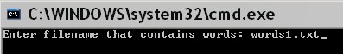

The setFileName method of WordGame is invoked next and uses the above filename as entered by the user as its input parameter.

The main next generates a random number between 0 and 1148 inclusively.

The main uses this randomly generated number as input to the setWord method of the WordGame class. The setWord method performs the following steps:

- Opens the filename containing all the words
- Uses the randomly generated number to determine how many lines to read from the file.
- Reads the word on this line
- Sets the private data field word of the WordGame class

The draw method is invoked next. This method draws a set of white rectangles (32x32) in the Graphics Window as shown below:

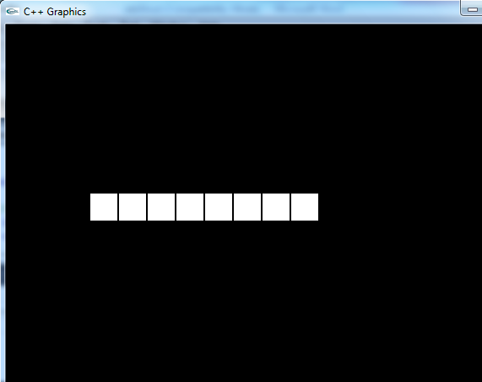

(100,200)

The number of rectangles is equivalent to the number of characters comprising the randomly selected word. Each white rectangle represents a letter of the randomly selected word. For this example, the randomly generated number is 879, and the number of characters for the word on this corresponding line in words1.txt is 8.

The above screen with the white rectangles is displayed for a total of 2 seconds.

The play method is next invoked in main. The play method performs the following steps:

- Displays the initial hint to the user. The initial hint consists of :
  - The 1st letter of the word
  - All vowels of the word are also displayed

The Graphics Window now appears as shown below:
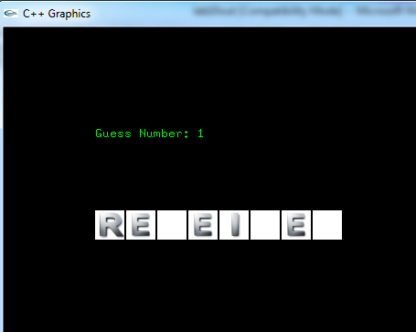

(100,120)

The console also prompts for the user to enter the word (1^{st)} guess based on this initial hint:

Suppose the user believes the word is received. This is entered as shown below:

This is an incorrect guess. A hint (i.e., additional letter) is next revealed to the user. All subsequent letters are revealed one at a time (after each incorrect guess) based on the following rules:

- The leftmost letter that is currently hidden is revealed first. For this example this letter would be 3rd from the left.
- The rightmost letter that is currently hidden is then revealed for the 2nd hint. For this example this letter would be the rightmost letter in the word.
- The letter that is revealed after this alternates between the leftmost letter/rightmost letter for each subsequent incorrect guess.

The next hint for this example is displayed as shown below:
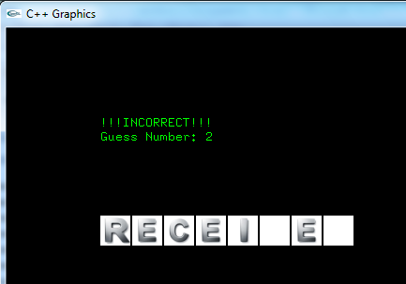

Note that the “C” has been revealed, the Guess Number incremented, and the console now prompting for the next guess is shown below:
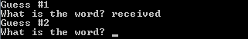
Suppose the user guesses the word to be receiver. The user would enter this guess as shown below:
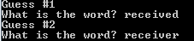
This is again an incorrect guess. The rightmost hidden character is next revealed in the Graphics Window as shown below:
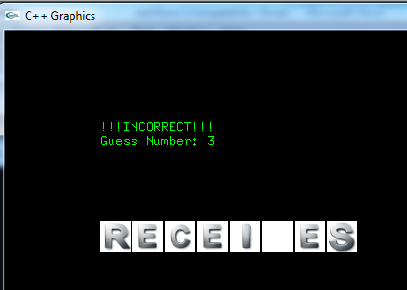
Note that the “S” is revealed, the number of guesses incremented, and the console window now appears as shown below:
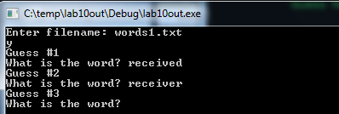
There is only one more guess allowed in this game. The user will now enter the word “receives” as shown below:
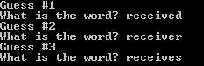
This is correct. The Graphics Window is now updated indicating the Correct Answer has been entered.
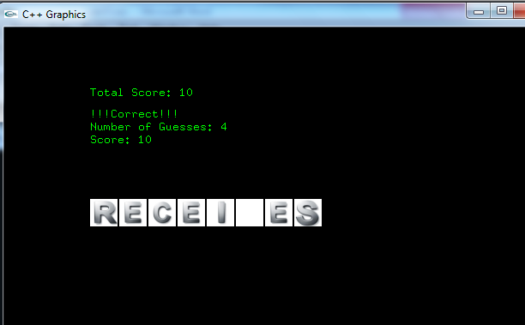
The score is computed based on the following rule:
Total score for all games

Score for most recent game

10 points for each letter still hidden when the correct guess was made.

For this example, there was only one hidden letter, so the total score was only 10. The console now allows the user to play again as shown below:
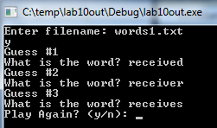
Entering n stops the game, while entering y allows the user to play again. Suppose the user enters y. The following is now displayed for 2 seconds in the Graphics Window:
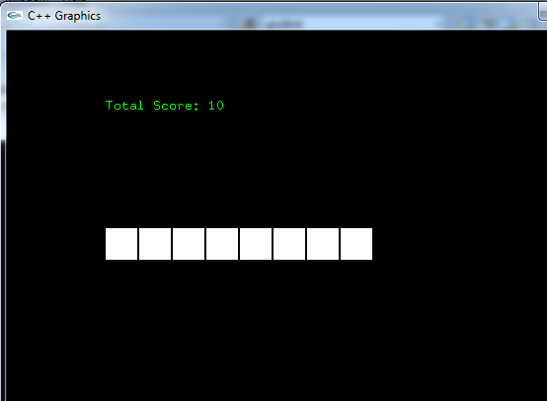
After which the initial hint consisting of the 1st letter and all vowels are displayed:
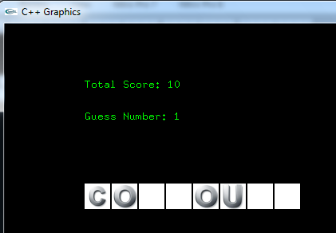
Suppose the user continues to enter guesses incorrectly after each additional hint (i.e., letter) is revealed. Upon the last hint, the Graphics Window appears as follows:
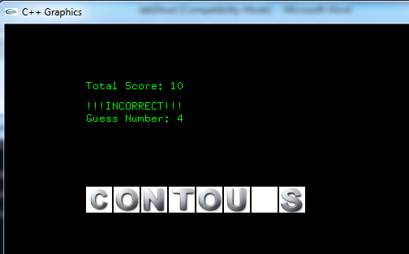
The console window for this example appears as follows and the user once again enters an incorrect guess:

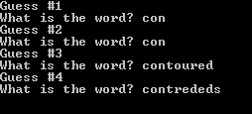
Upon entering the last possible guess results in an incorrect answer and the following in the Graphics Window is thus displayed:
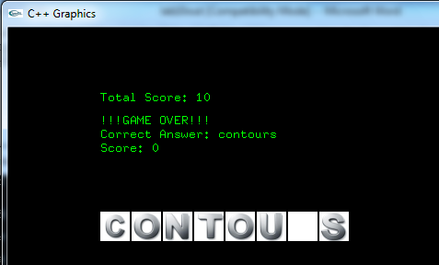
The user is then prompted to repeat the program again.

Your main.should performs the following steps:

1. Declare WordGame object

2.Prompt the user for the file name containing the words to be processed.

3. Invoke setFileName method that sets the fileName private data field.

4. Generate random number between 0 and 1148 inclusively.

5. Invoke setWord method that selects a random word from the file and sets the private data field word.

5. Invoke the draw method that displays the initial set of white rectangles – one for each letter in the word.

6. Invoke the play method that allows the user to play the game by guessing what the word is. An initial hint consisting of the 1st letter and all vowels is revealed. After each incorrect guess an additional letter is revealed – alternating from leftmost to rightmost as shown above on pages 4 thru 10. The score for guessing the specific word is computed and displayed in the Graphics Window along with all informational messages.

7. The accumulated score from all games is displayed in the Graphics Window. The user is allowed to repeat the program as many times as desired.

Data Field Description

string fileName;
The name of the file containing the words used by the game. For our lab, it will be words1.txt.

string word;
The randomly selected word from the file containing the word. Set by the

void setWord(int rand_no);

method.

Methods Description

WordGame();
Default Constructor. Sets datafields to NULL.

string getFileName();
Getter for fileName field.

void setFileName(string fn);
Setter for fileName field.

void setWord(int rand_no);
Setter for word data field. This method performs the following steps.

1. Opens a file associated with the fileName data field for reading (input)
2. Tests the file stream to assure it is opened correctly
3. Reads one word at a time from the file
4. Accumulates a counter for the number of words in the file
5. Stops reading once the counter is equal to input parameter rand_no
6. Assigns the word data field to randomly selected word via deep copy.

string getWord();
Getter for the word data field.

void draw();
Draws the initial blank rectangles as shown on page 3 for 2 seconds.

int play();
Allows the user to play the WordGame based on the rules/scenarios outlined on pages 3 thru 10. The user plays the games by performing the following steps:

1. The player guesses the word by entering his guess in the console.

2. An initial hint of the 1st letter and all vowels are revealed to the player

3. An additional letter is revealed each time the player incorrectly guesses the word The revealed letter alternates between the leftmost hidden letter and the rightmost hidden letter..

4. The maximum allowed guesses is equal to the number of initial hidden characters – this is the number of hidden characters after the 1st letter and all vowels have been revealed.

5. The player wins if he correctly guesses the word.

6. The player receives a score of 10 for each hidden character at the time he correctly guesses the word.

7. The player receives a score of 0 if he incorrectly guesses the word.

8. The method returns the score

What you Submit

Submit all .h and .cpp files (you can zip up) via Blackboard.
.

