Big-Data Systems and Intelligence Analytics - CSYE 7245 - 01

**作业要用到exploratory Data analytics.**

**-Anscombe’s quartet:**

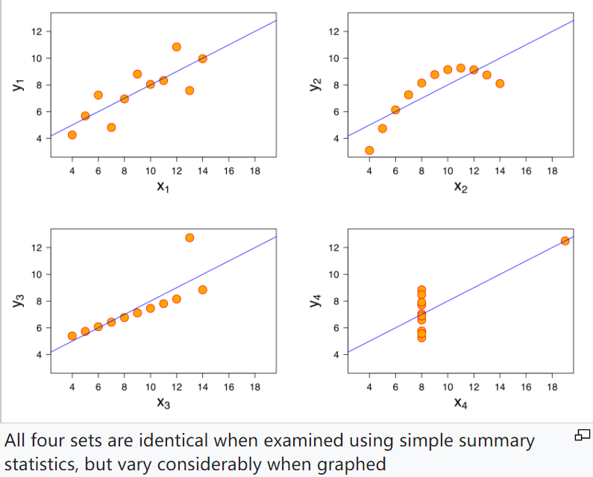

The quartet is still often used to illustrate the importance of looking at a set of data graphically before starting to analyze according to a particular type of relationship, and the inadequacy of basic statistic properties for describing realistic datasets.

**-Difference between AI & Machine Learning & Deep learning?**

A: While ML is often described as a sub-discipline of AI, it’s better to think of it as the current state-of-the-art – it’s the field of AI which today is showing the most promise at providing tools that industry and society can use to drive change. ML takes some of the core ideas of AI and focuses them on solving real-world problems with neural networks designed to mimic our own decision-making.

Deep Learning focuses even more narrowly on a subset of ML tools and techniques, and applies them to solving just about any problem which requires “thought” – human or artificial.