Udemy-Data science

1. Create Virtual environment:

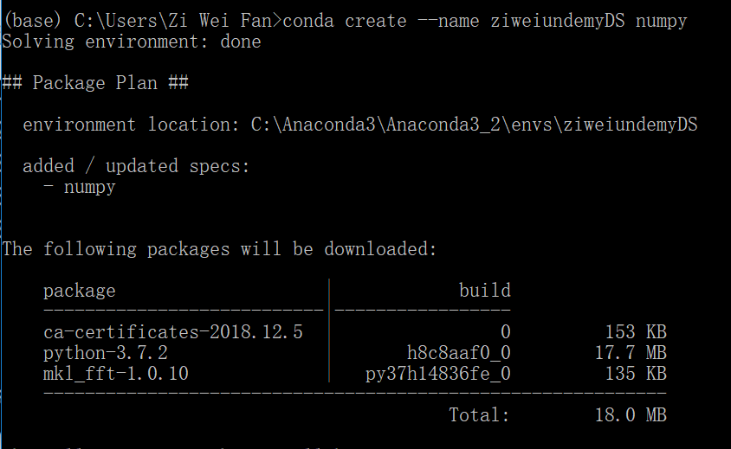

1. Activate virtual environment:

* Active [spaceName]

1. Install some packages:

(if there is no more packages demanded, it will show:

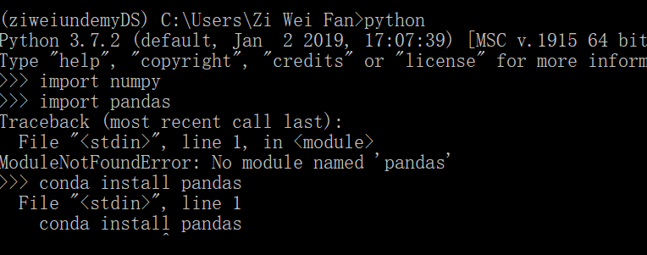

So we have to install it by quitting from python:

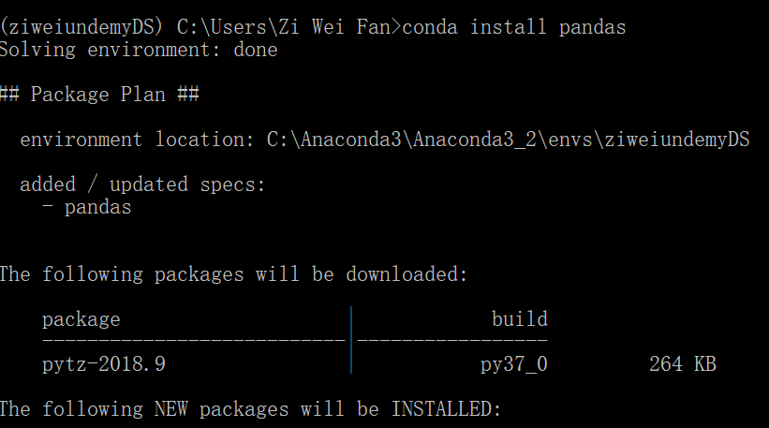

1. Deactivate environment:

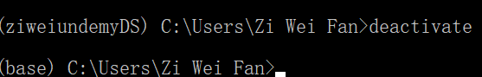

1. View all the virtual environments:

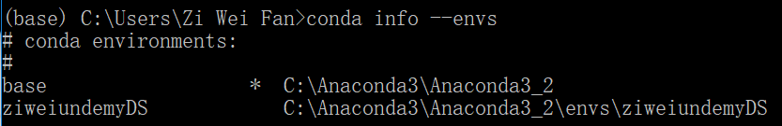

Install numpy:

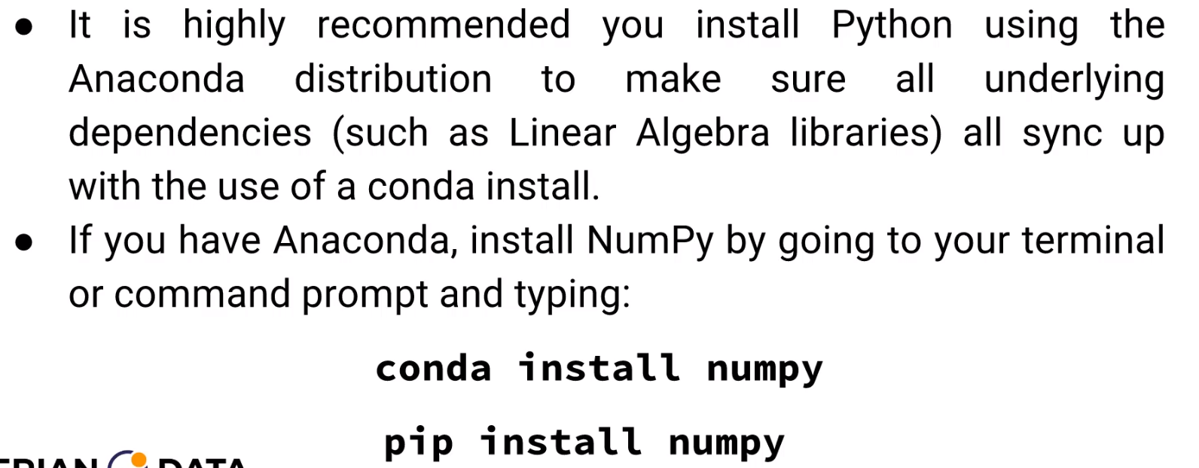

Introduce Numpy:

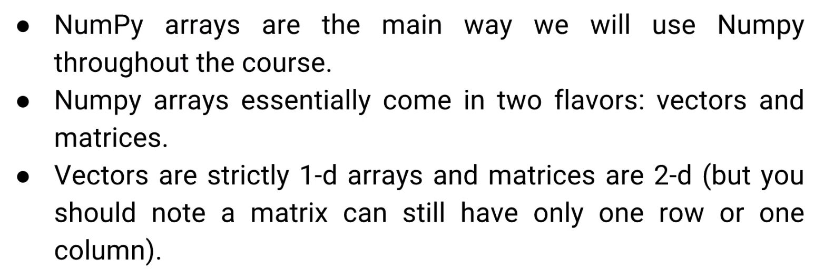

Pandas:

