Django installation <https://www.codingforentrepreneurs.com/blog/install-python-django-on-windows/>

Step 1: Install virtualenv:

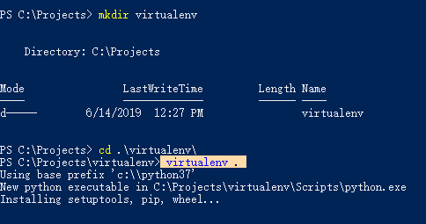

Step2: Activate env:

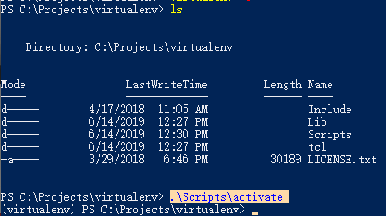

Step3: Select folder to be the project folder.

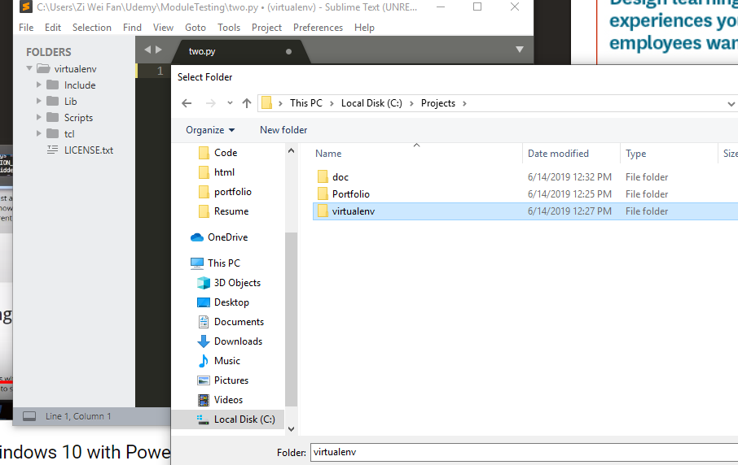

Step4:



Step 5: Run the django server:

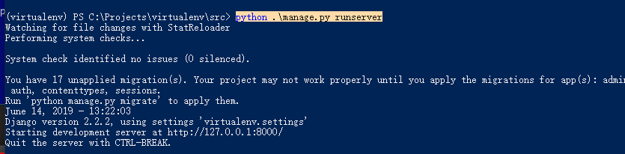

Step 6: Open project in sublime:

Project> Add a folder to project.

Step7: Path, code like this.

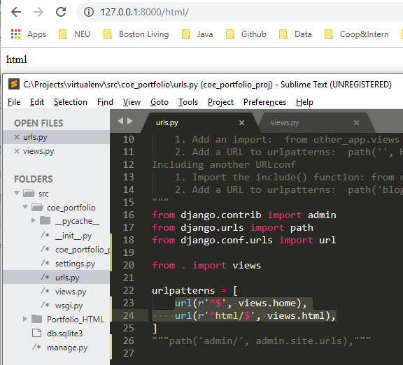

Step8: Run.

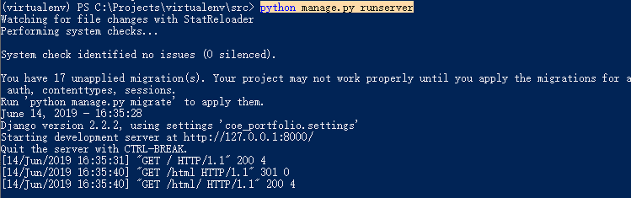

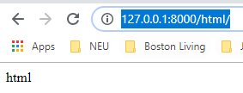 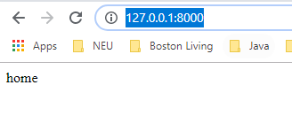

Co-work:

