1. Concept & Stages:

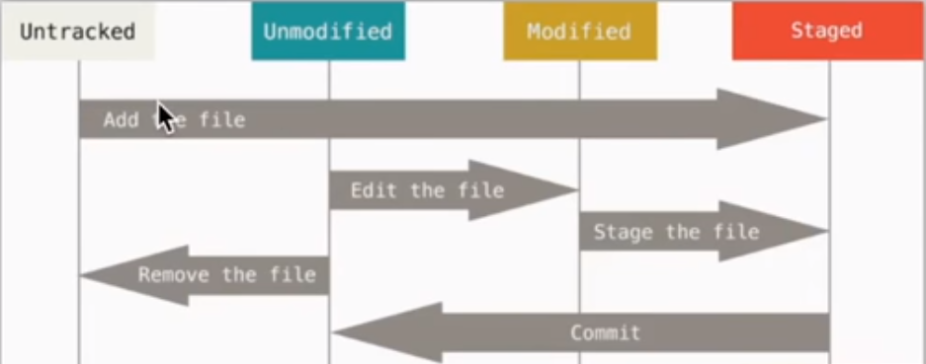

1. Commands used to commit remotely:

git add README.md

git commit -m "first commit"

git remote add origin https://github.com/ziweifan177/myNoteOfGit.git

git push -u origin master

1. **Setup Git bash & commands to check:**

Step1: Run git bash:

Step2: configure the author name & email and check the result:

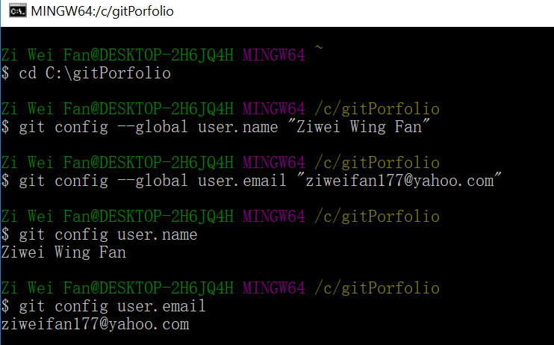

Step3: initialize a whole new repository under the directory with a hidden folder named ‘XXX.git’:

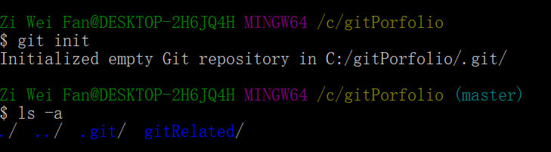

Step4: create a new file in it: by ‘touch XXX.XXX’



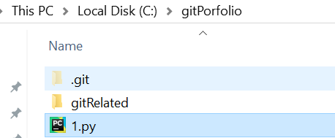

Step5: Check the status of the file:

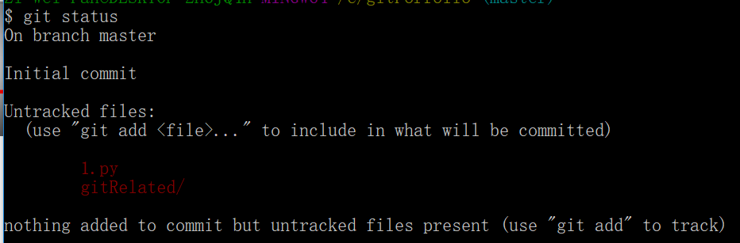

Step 6: add this file for committing, and check the latest status:

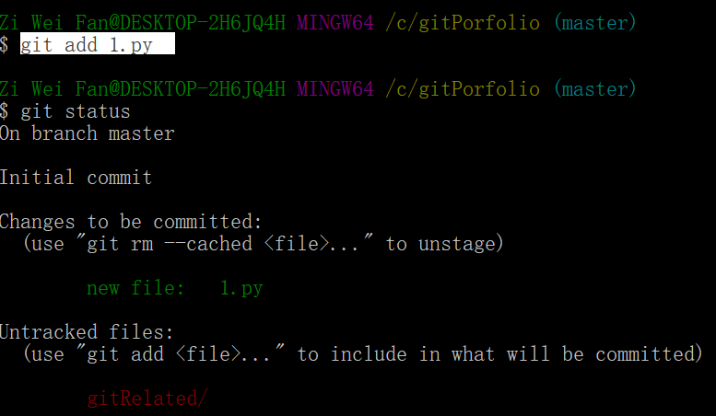

Step 7: commit file:

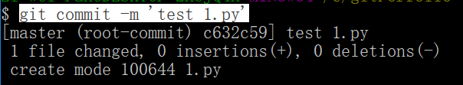

Step 8: modify testing: modify the file and check the status:

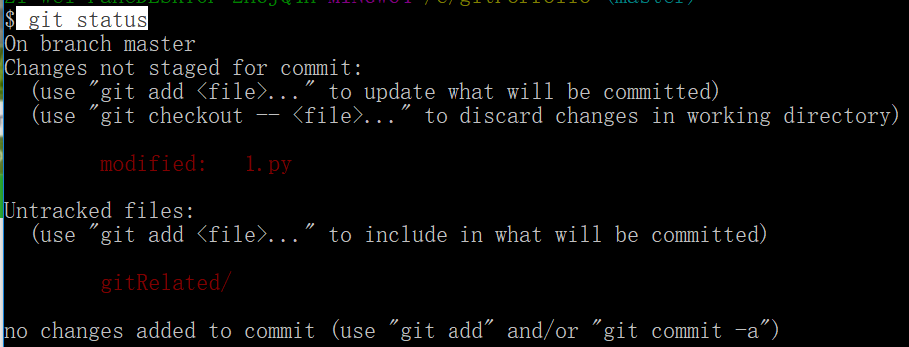

Step 9: Re-add and re-commit the file and check the history log of modification:

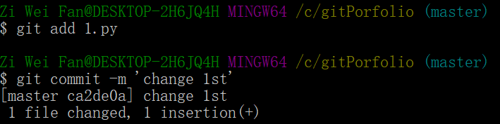

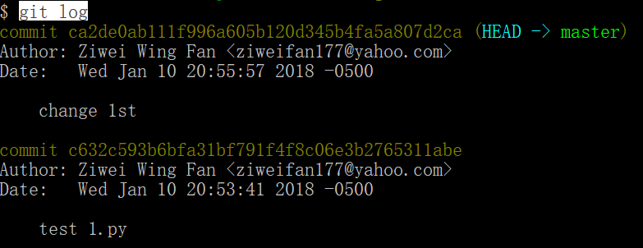

Step 10: check the detail of modification:

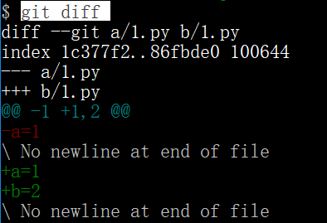

Step 11: Add all modifications of all files with ‘.’:



Step 12: Check the difference between current version and last committed:

