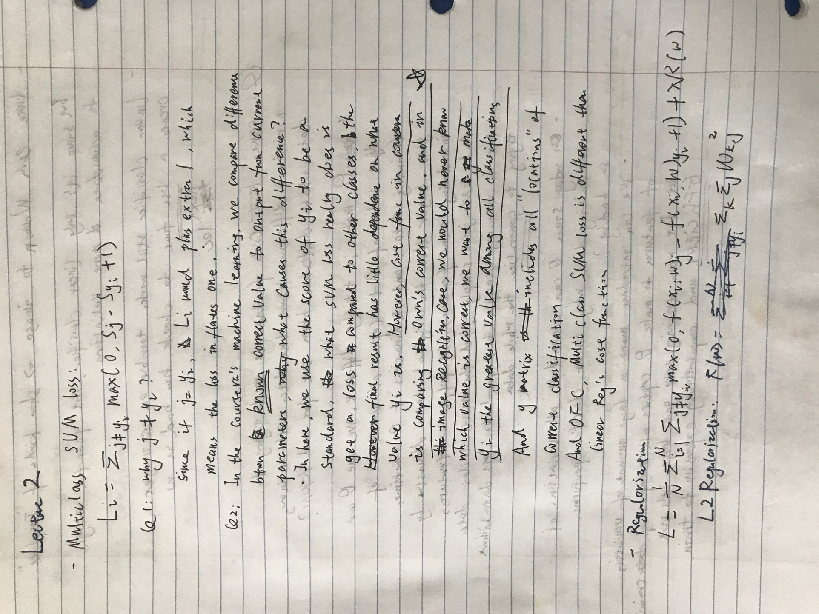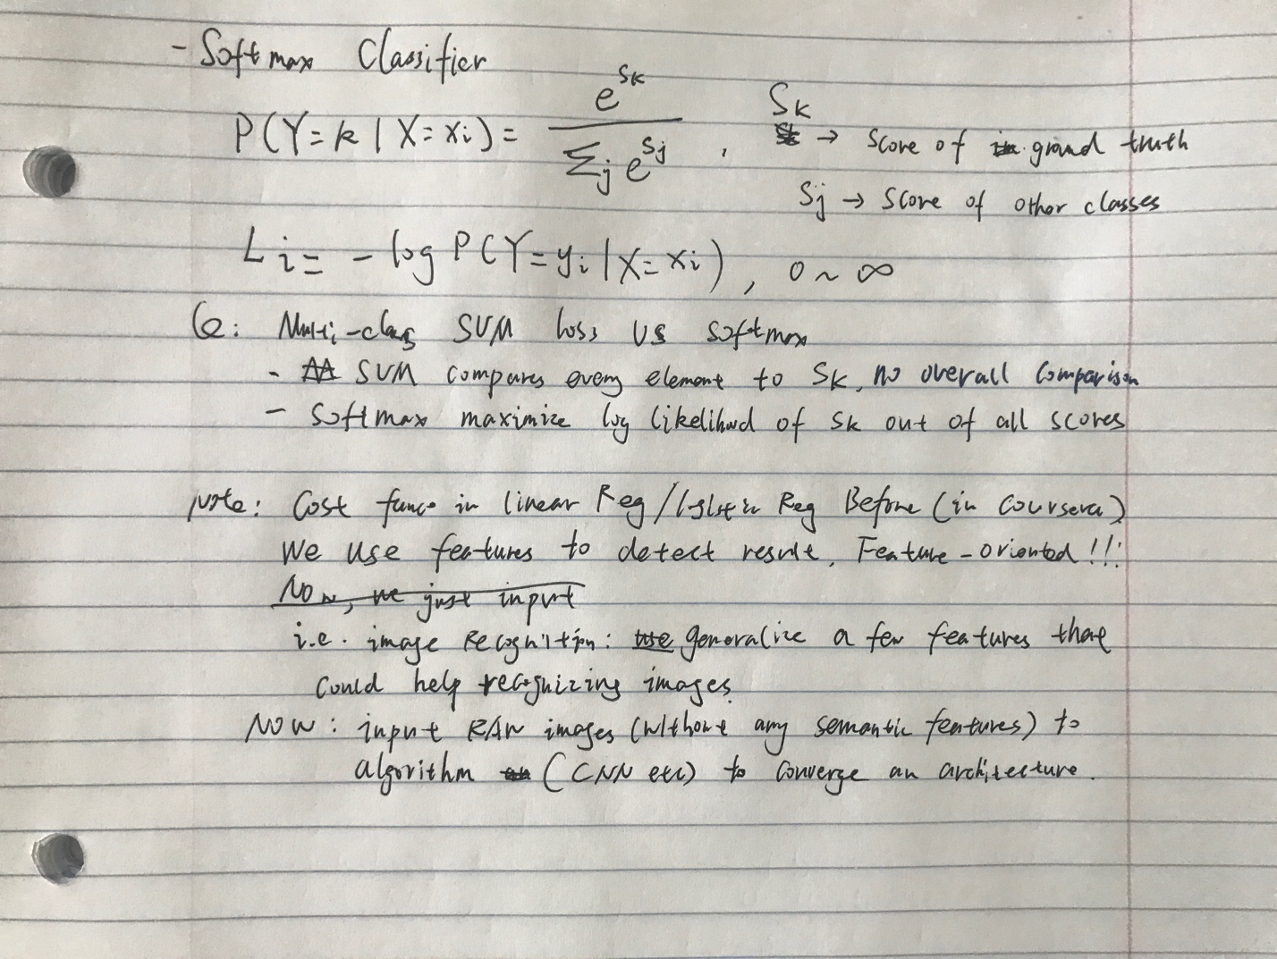

Note from website

In summary, the SVM loss function wants the score of the correct class yi to be larger than the incorrect class scores by at least by Δ (delta). If this is not the case, we will accumulate loss.