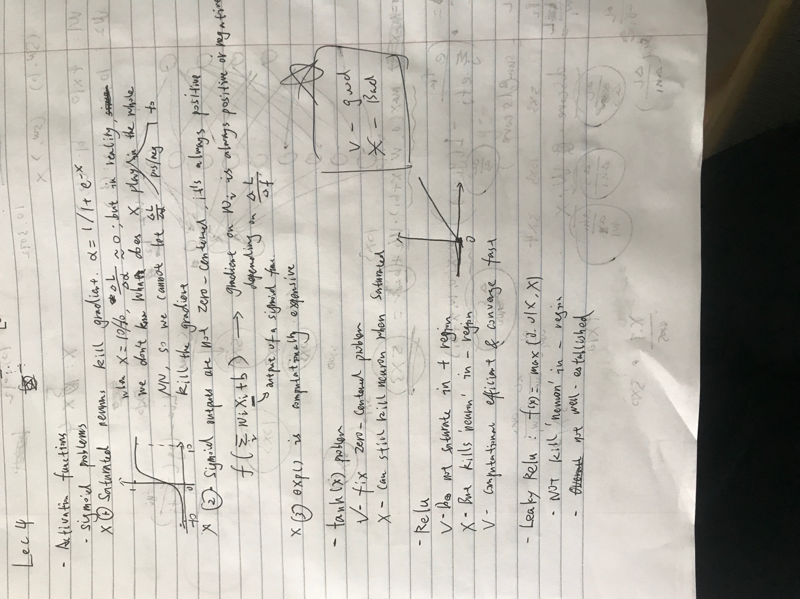

If the dense regions of  X$ are different in the source and the target domains, the optimal model for the source domain will no longer be optimal for the target domain.

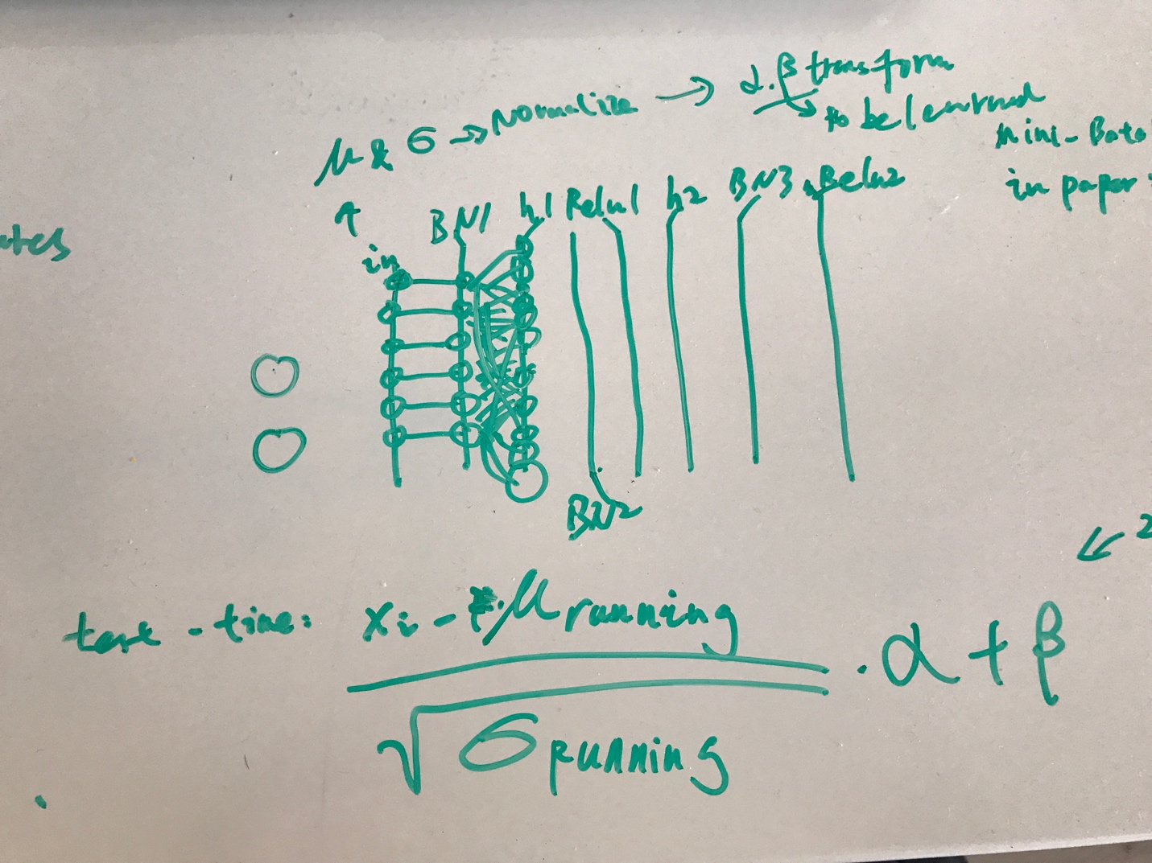

BATCH Normalization Back propagation

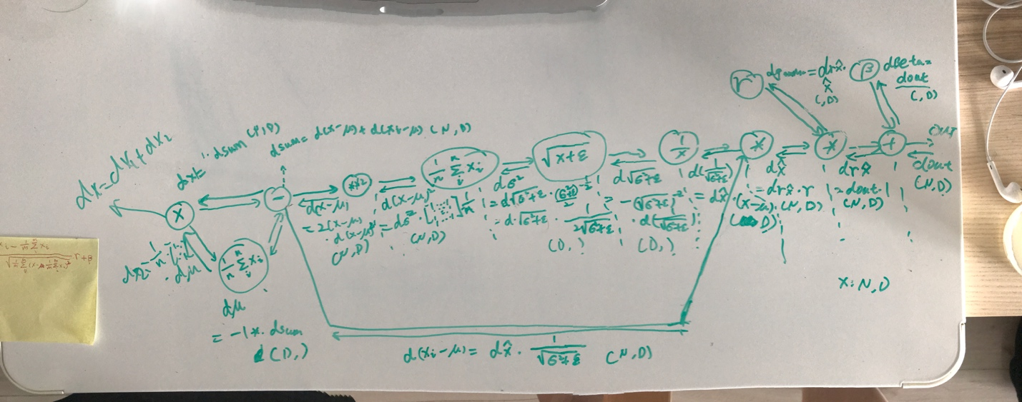

Simplified back prop

<http://cthorey.github.io./backpropagation/>