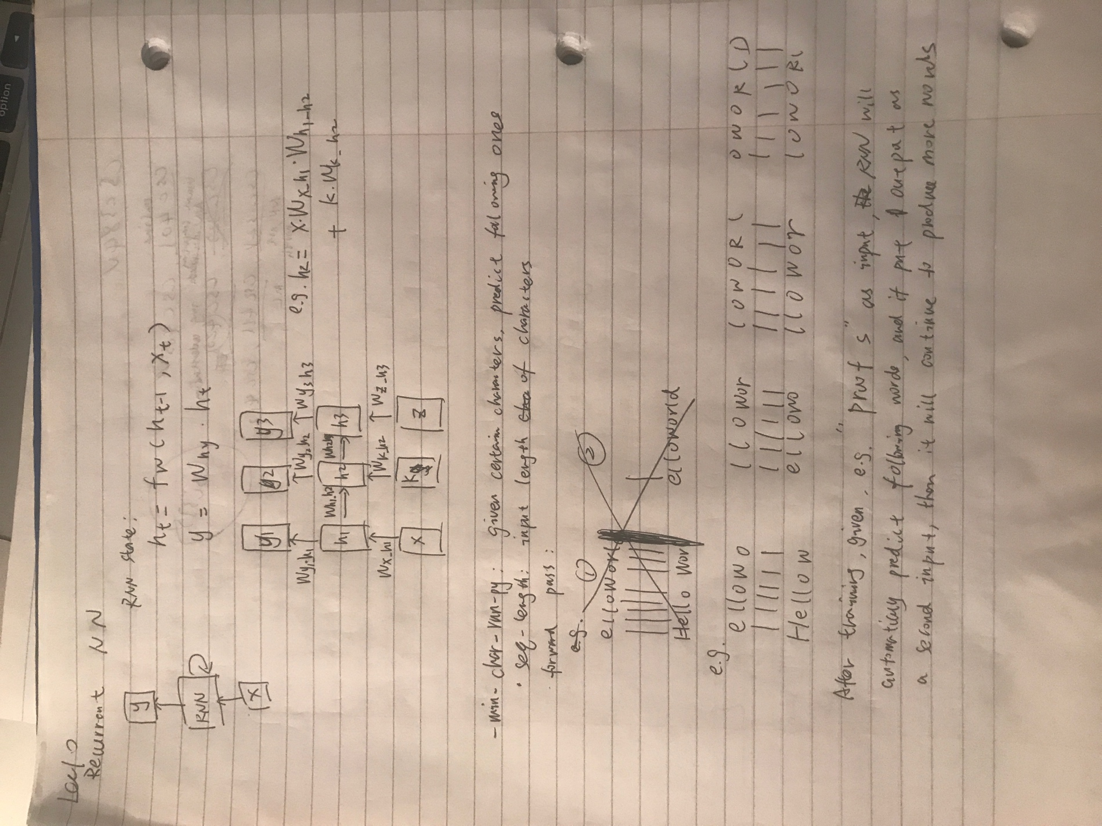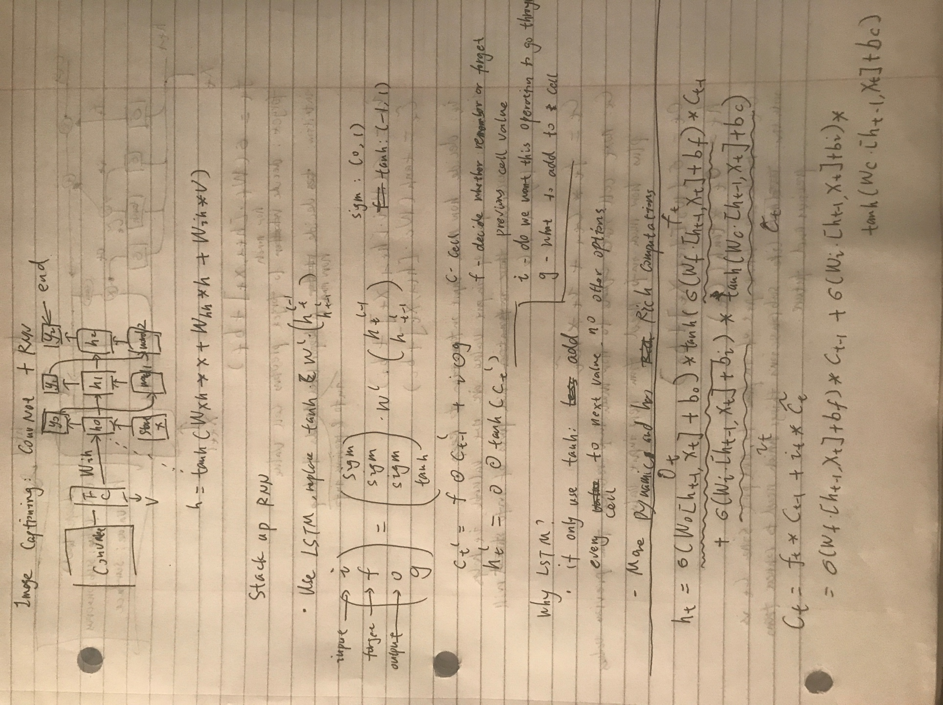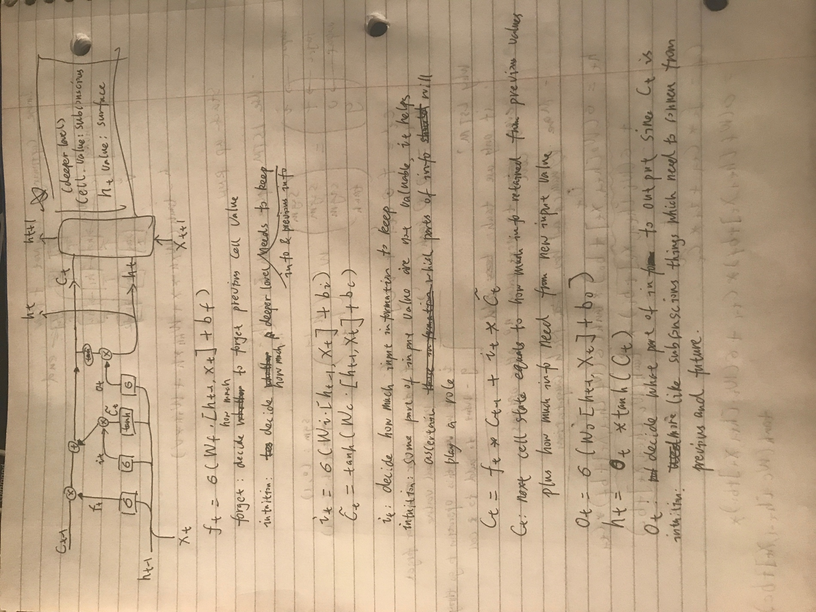

Notes:

The first picture has an error which is the weights of RNN should always be the same one, no Wh1h2 etc anymore just one Whh or Wxh or wyh.