Readme

Step 1: Clone the project from Github using git clone command to your computer (Figure 1). Repository link: <https://github.com/zixiw/SOC-Fall-2015-Team5-Lead-Zixi-Wei>

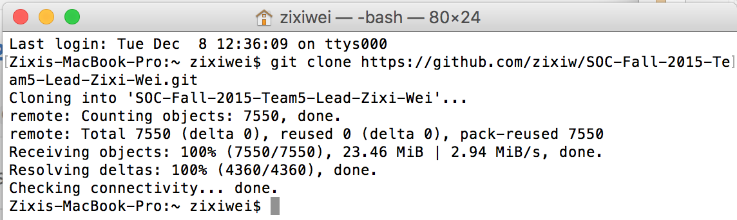

Figure 1

Step 2: Install IntelliJ IDEA Ultimate Edition, you can use your student account to get the free edition (Figure 2). Download link: <https://www.jetbrains.com/idea/buy/#discounts>

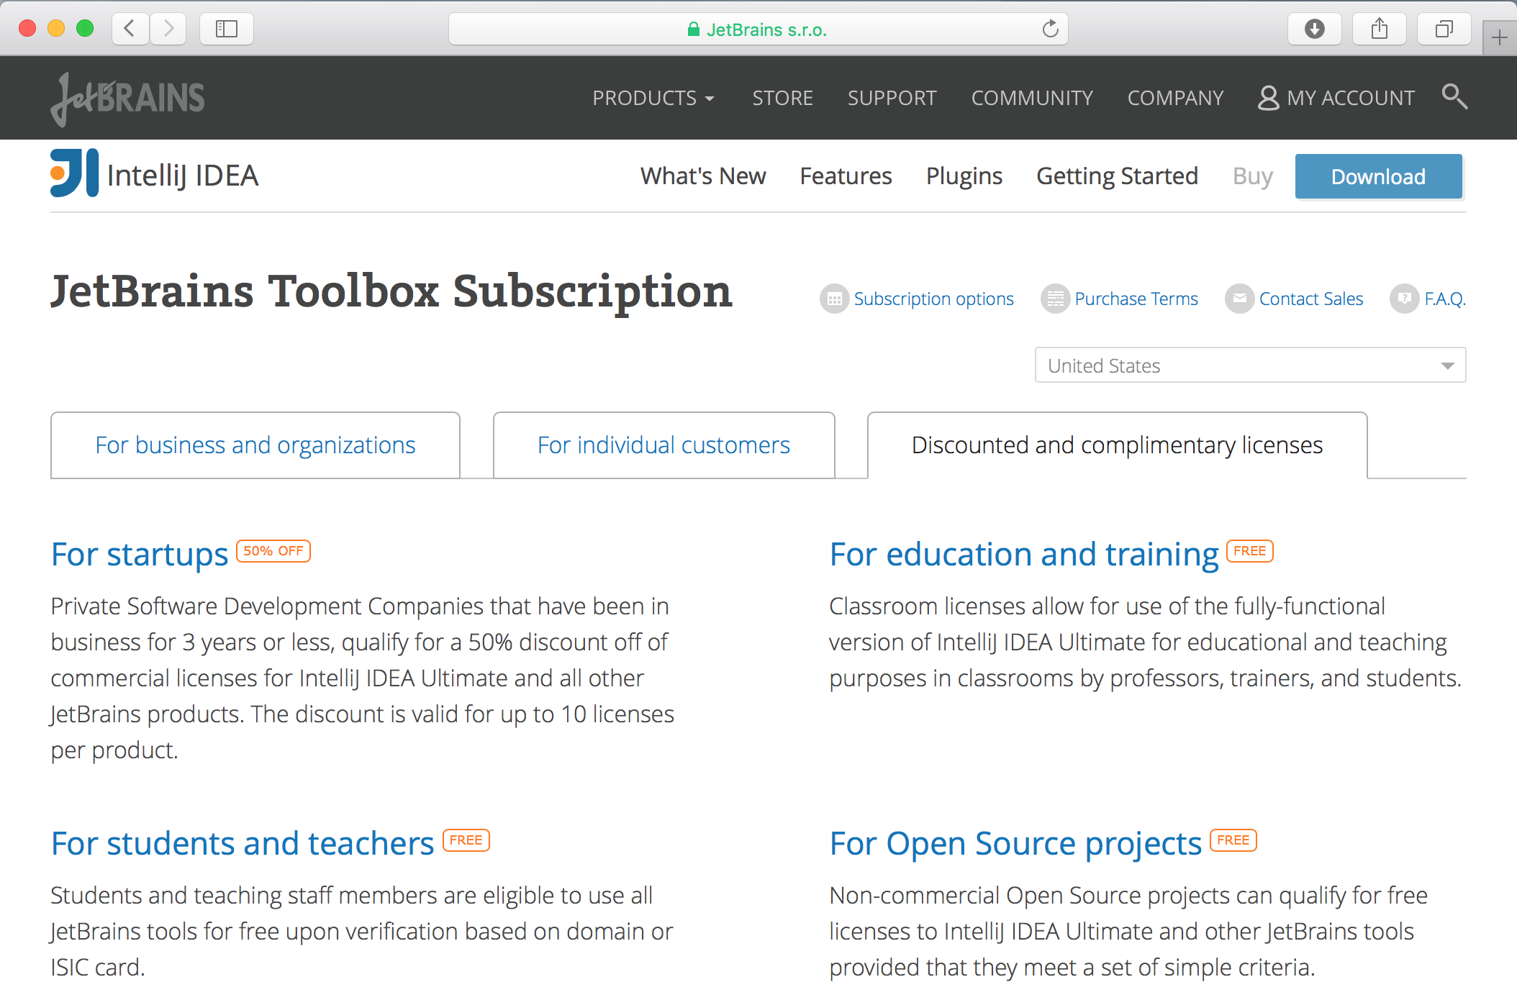

Figure 2

Step 3: Import ApacheCMDA-Backend to IntelliJ. Open IntelliJ, select Import Project, browse to the ApacheCMDA-Backend directory under the SOC-Fall-2015-Team5-Lead-Zixi-Wei folder, click OK (Figure 3)

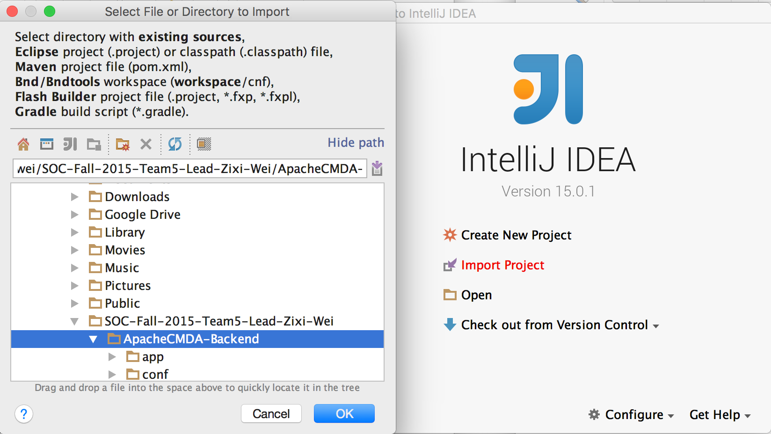

Figure 3

Make sure you Import project from external model of SBT (Figure 4)

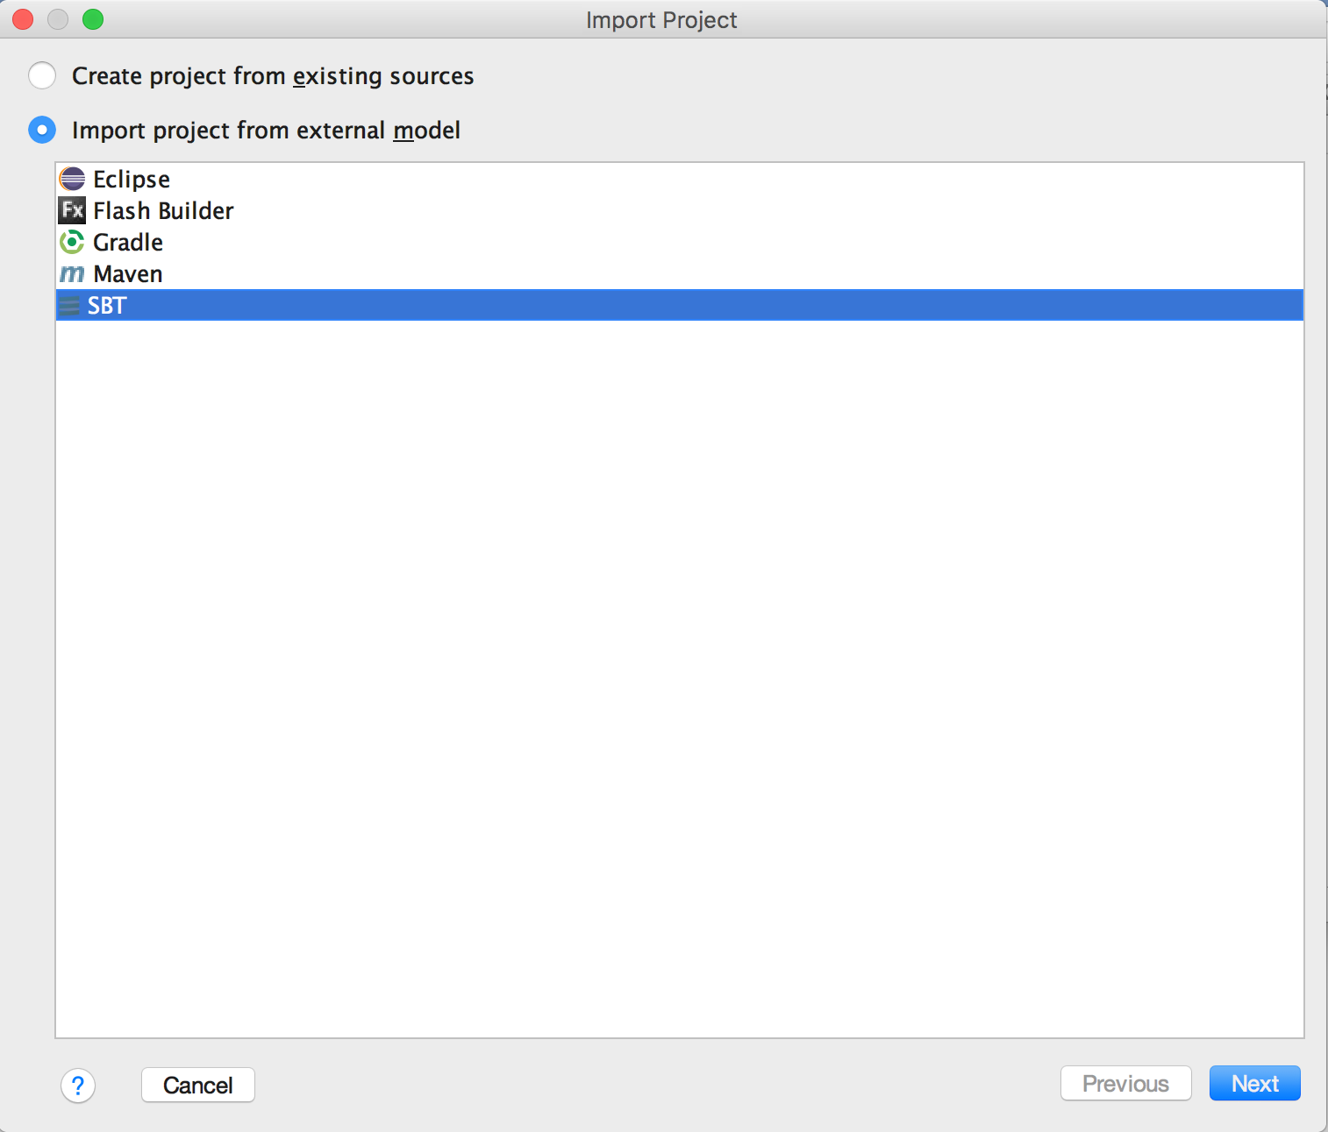

Figure 4

Click Next, check “Use auto-import”, “Download sources and docs” and “Download SBT sources and docs” (Figure 5), then click Finish.

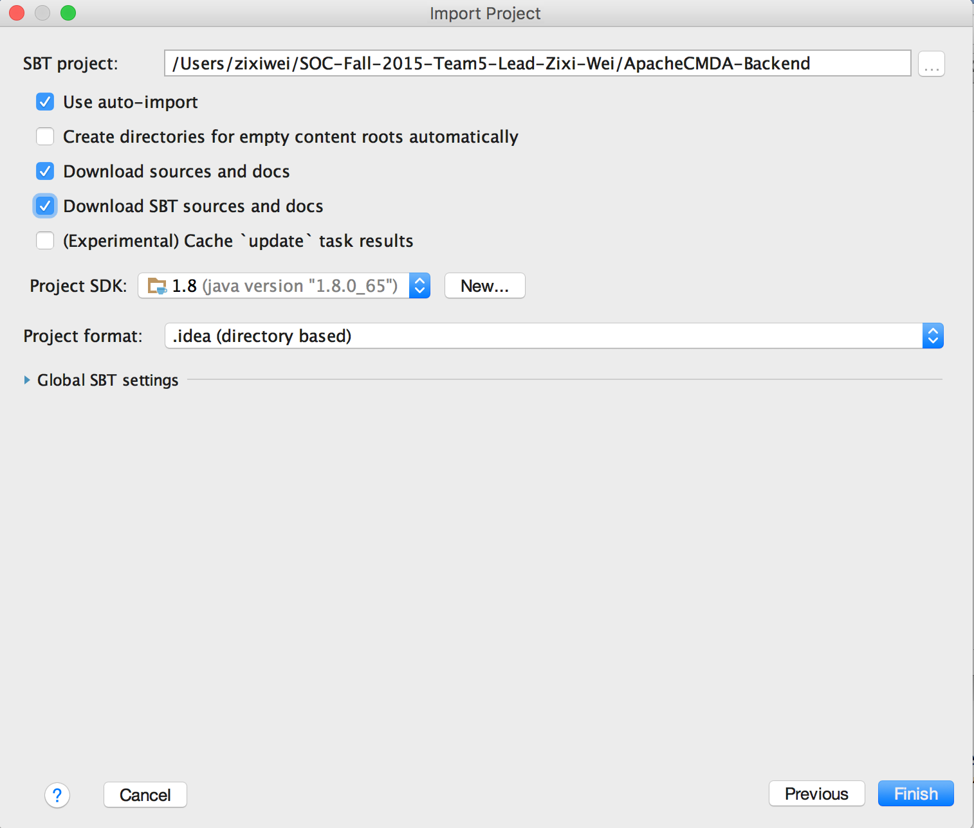

Figure 5

Click OK (Figure 6)

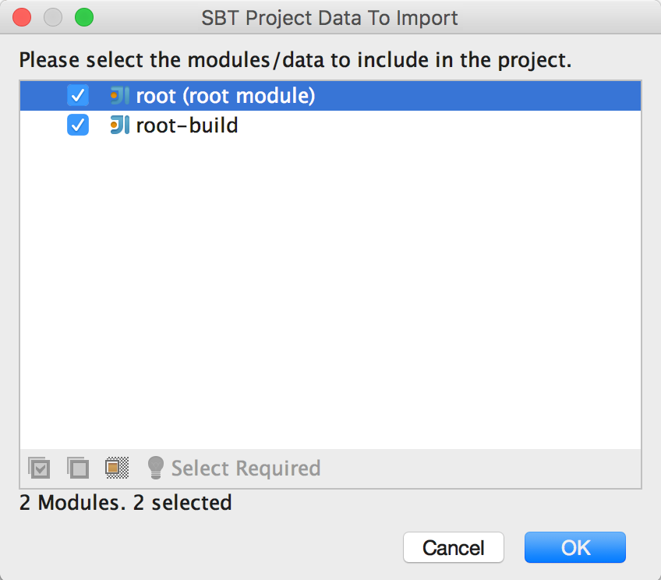

Figure 6

Click Configure to configure JPA framework (Figure 7), click OK (Figure 8)

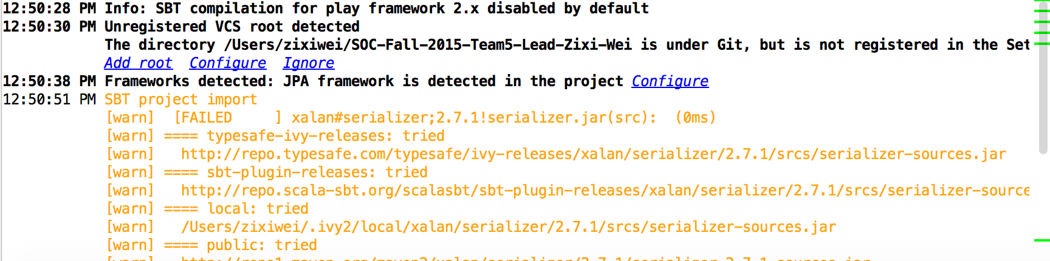

Figure 7

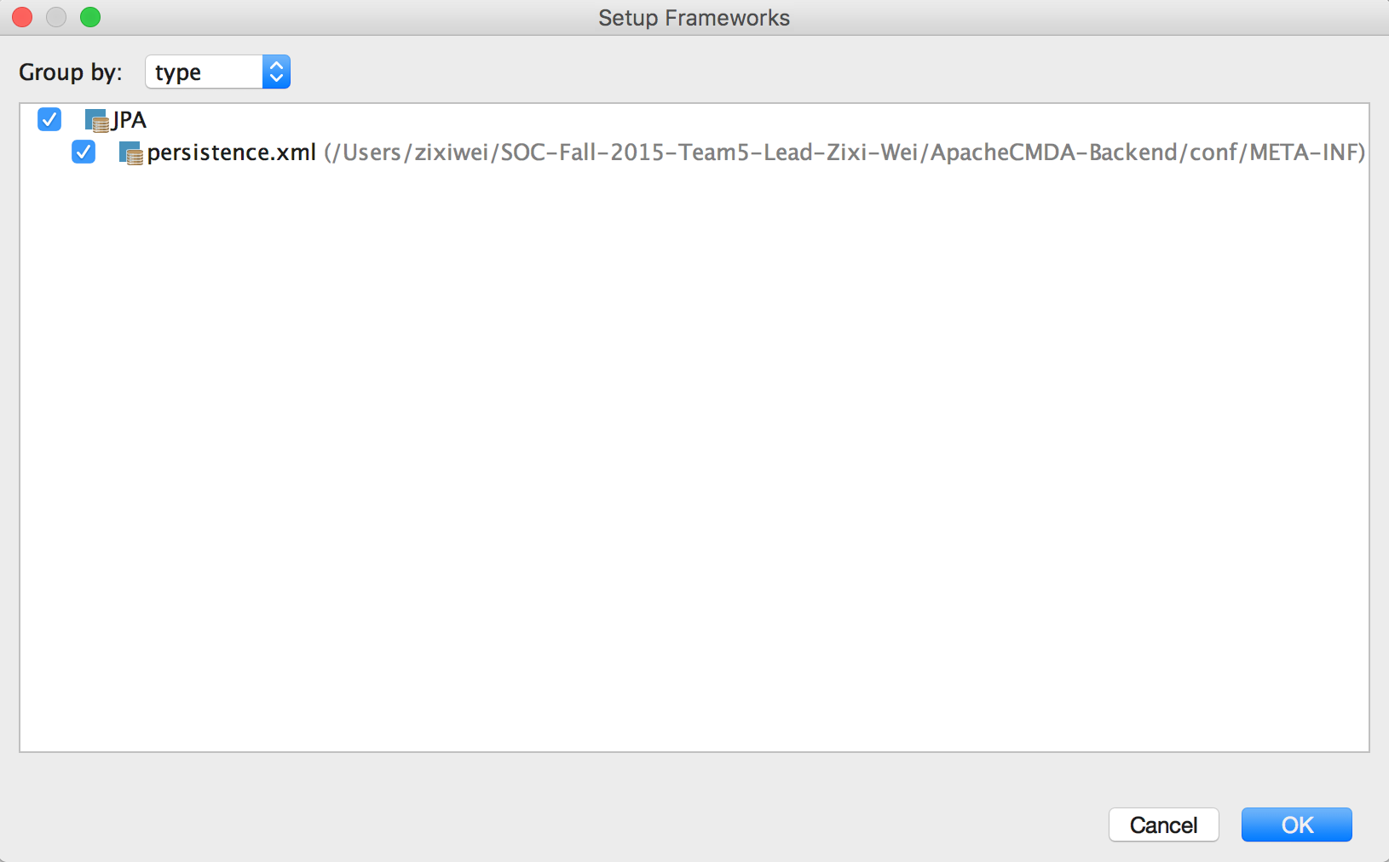

Figure 8

Under IntelliJIDEA menu, choose “Preferences”, choose Play2 under the Languages & Frameworks, check “Use Play 2 complier for this project” (Figure 9), then click OK. The project now is successfully imported.

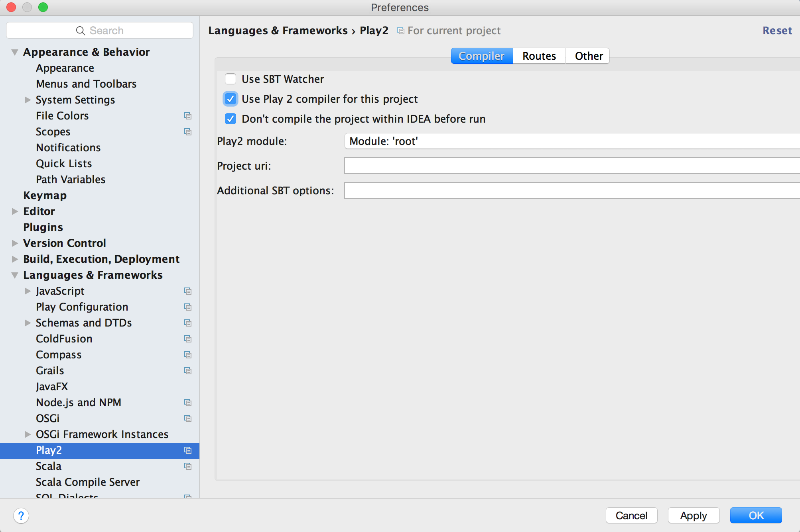

Figure 9

Step 4: Setup Docker environment according to the Docker’s official guide: <http://docs.docker.com/mac/step_one/>

Step 5: Open Docker quick start terminal, run docker pull cmusvsc/apachecmda:1.0, to pull the image from Docker Hub, then use docker images command to check whether the image is pulled successfully (Figure 10).

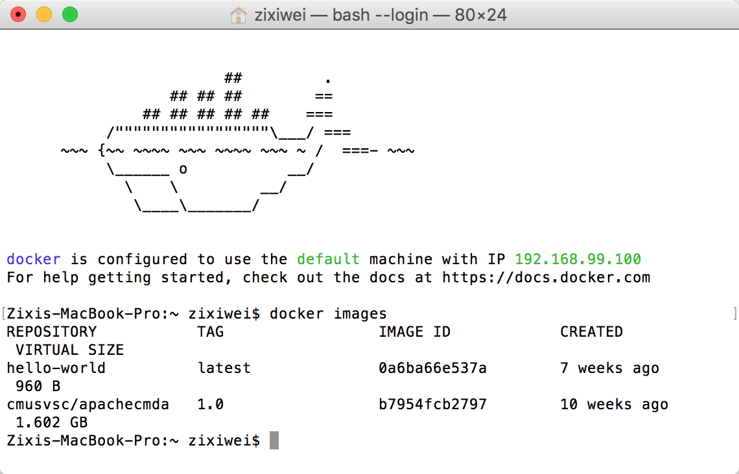

Figure 10

Step 6: Mount your local directory to the /home/SOC-Fall-2015 directory inside the container (Figure 11):

docker run -it -p 9234:9000 -v /Users/zixiwei/SOC-Fall-2015-Team5-Lead-Zixi-Wei:/home/SOC-Fall-2015 cmusvsc/apachecmda:1.0

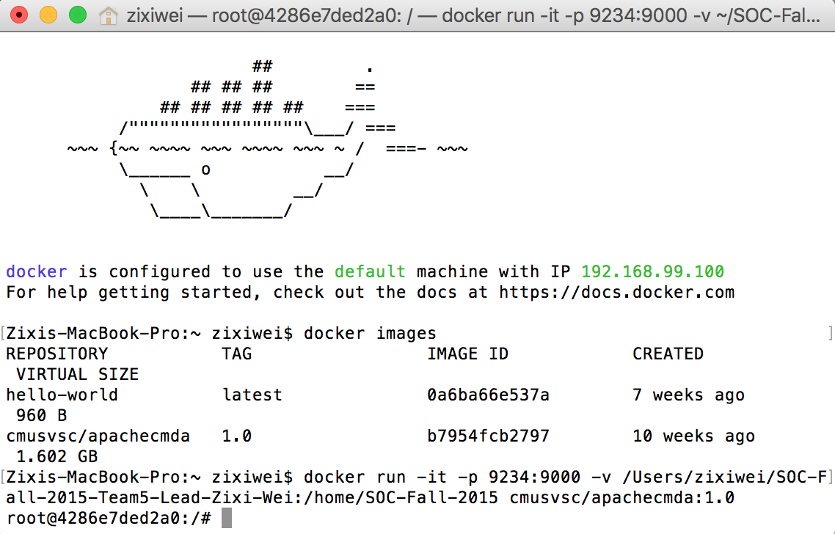

Figure 11

Step 7: Start MySQL service using “service mysql start” (Figure 12)

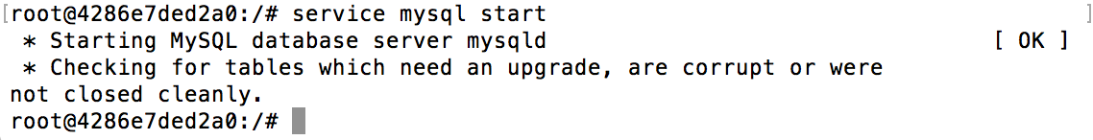

Figure 12

Step 8: Start the backend. Cd into the ApacheCMDA-Backend directory, start the backend by using “./activator run”, now the backend has started (Figure 13)

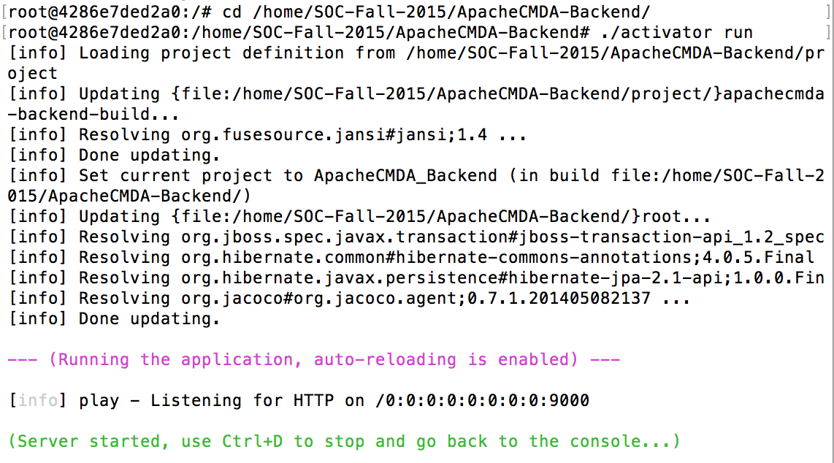

Figure 13

Step 9: Try the first POST. Open the routes file under the conf folder in ApacheCMDA-Backend in IntelliJ, you will find a list of routes that you can use to communicate with the backend. Please only use the routes below the # Newly Added comment. (Figure 14)

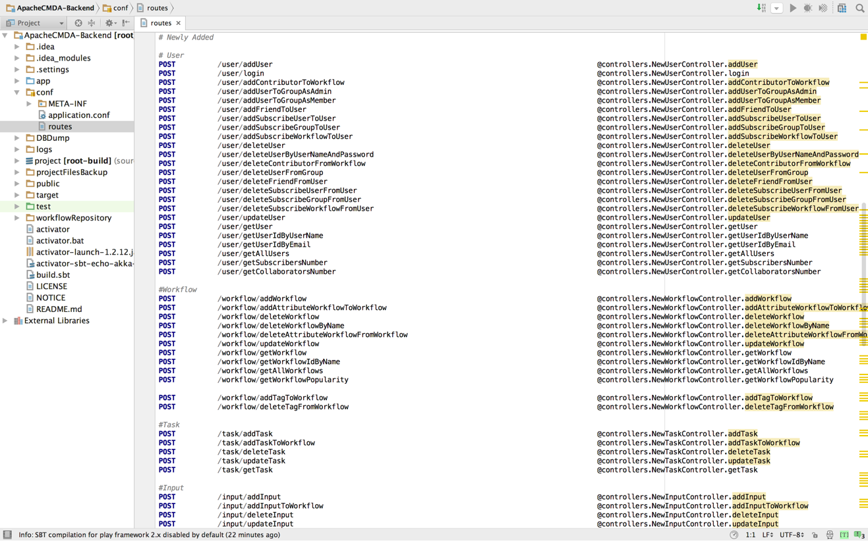

Figure 14

For detailed usage, please refer to the API of the Appendix (Figure 15)

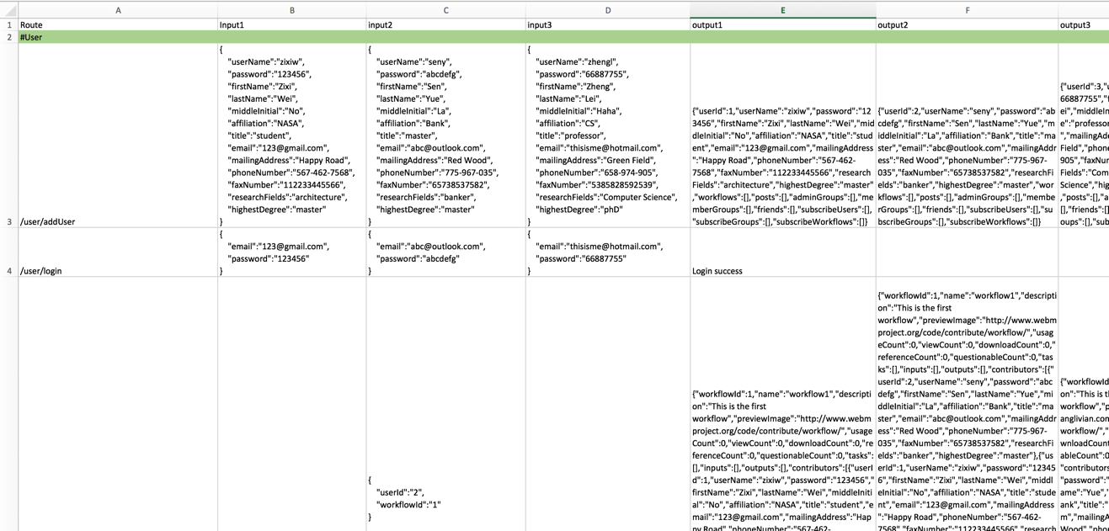

Figure 15

Now let’s register a user. Open Postman, choose POST, type in the url: <http://localhost:9234/user/addUser>

Open the Body menu, choose raw and set the input as JSON(application/json), paste the following JSON data to the input blank:

{

"userName":"zixiw",

"password":"123456",

"firstName":"Zixi",

"lastName":"Wei",

"middleInitial":"No",

"affiliation":"NASA",

"title":"student",

"email":"123@gmail.com",

"mailingAddress":"Happy Road",

"phoneNumber":"567-462-7568",

"faxNumber":"112233445566",

"researchFields":"architecture",

"highestDegree":"master"

}

Then click Send, after a few while, you will get a message to tell you that user added success. (Figure 16), Figure 17 is the output on the Docker terminal.

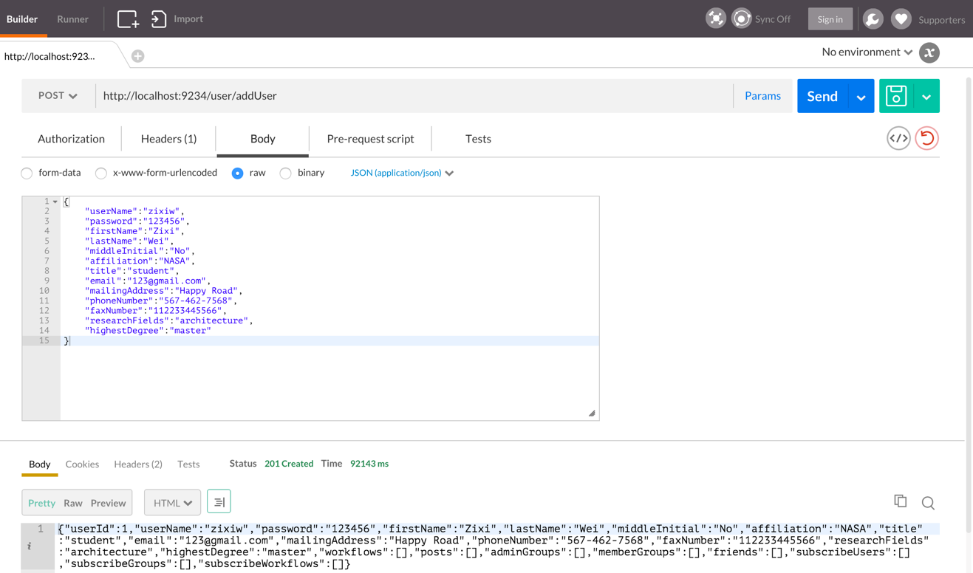

Figure 16

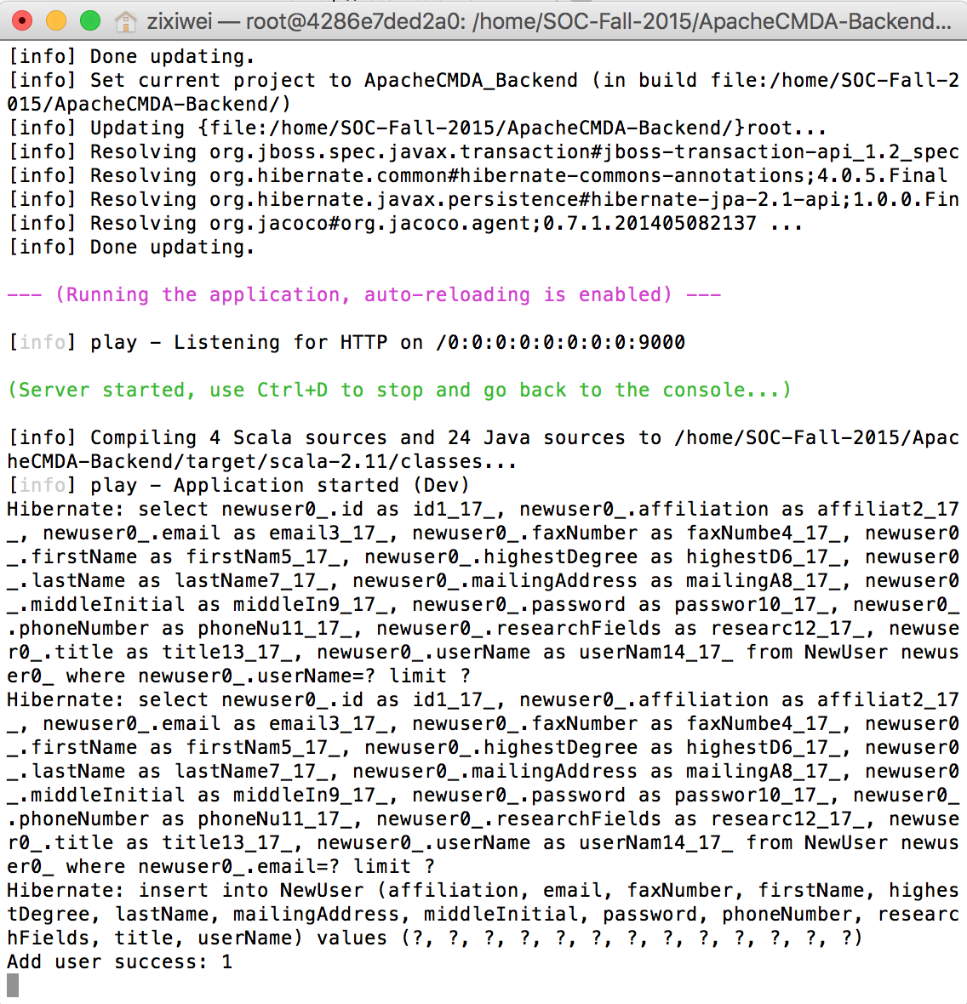

Figure 17