You can add a user account by calling the /user/addUser API, and add the raw data of JSON format as following:

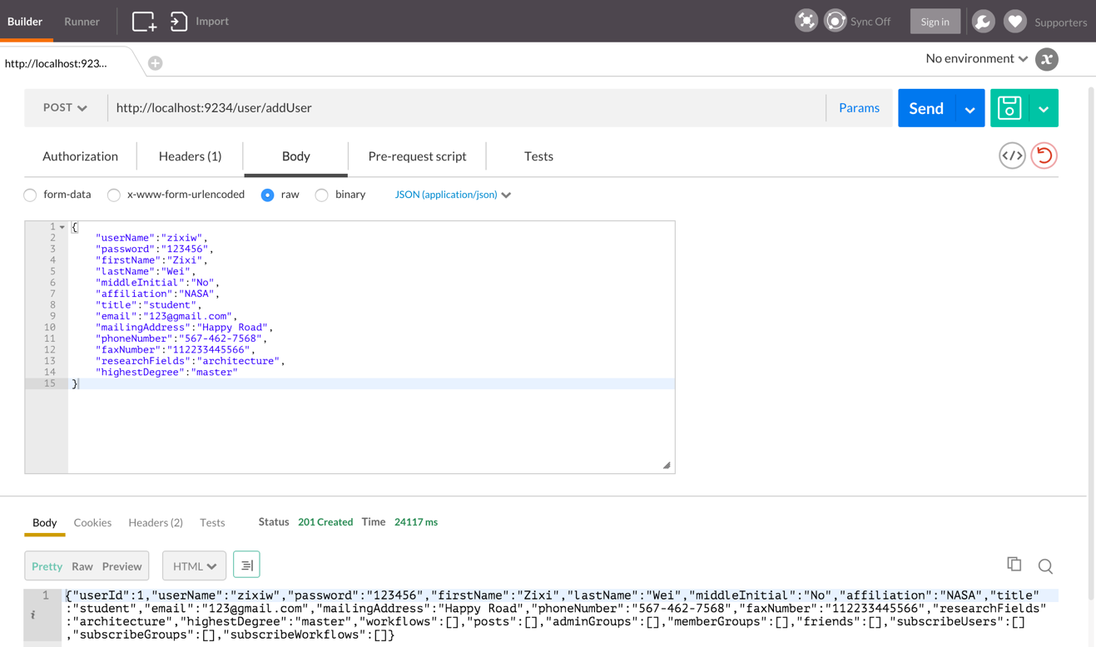

Then you are able to login with the username and password as you defined in the JSON file.