Download and Installation

Step 1: Clone the project from Github using git clone command to your computer (Figure 1). Repository link: <https://github.com/zixiw/SOC-Fall-2015-Team5-Lead-Zixi-Wei>

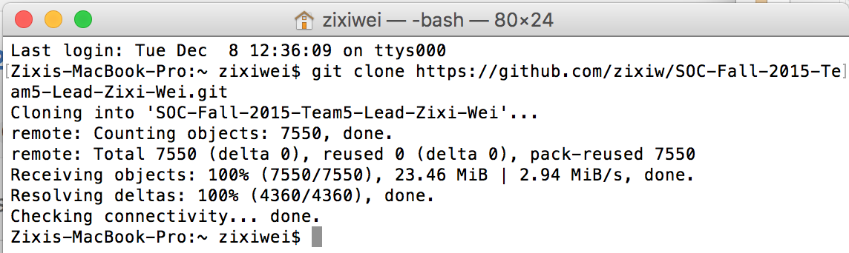

Figure

Step 2: Install IntelliJ IDEA Ultimate Edition, you can use your student account to get the free edition (Figure 2). Download link: <https://www.jetbrains.com/idea/buy/#discounts>

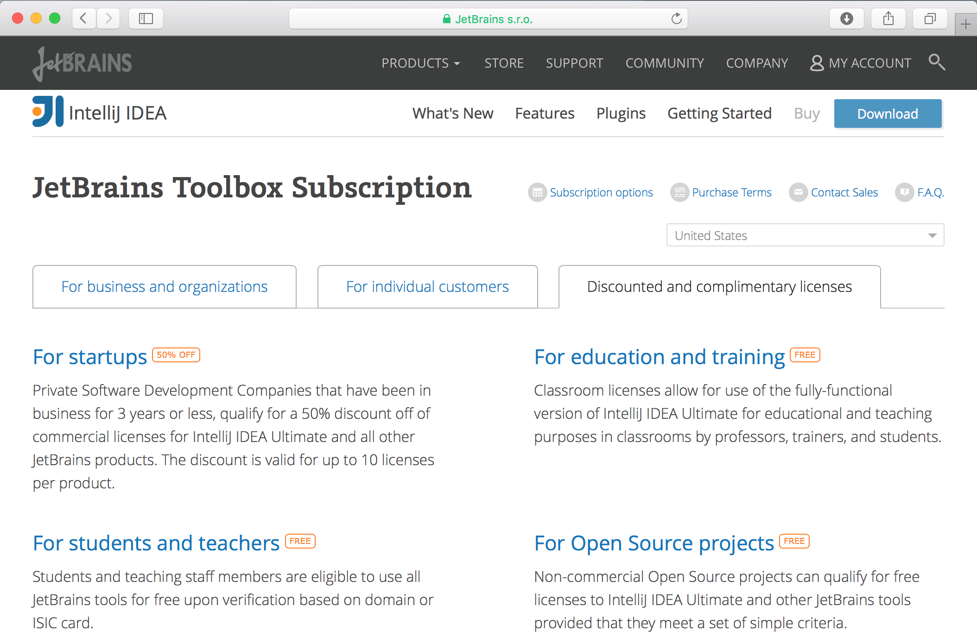

Figure

Step 3: Import ApacheCMDA-Backend to IntelliJ. Open IntelliJ, select Import Project, browse to the ApacheCMDA-Backend directory under the SOC-Fall-2015-Team5-Lead-Zixi-Wei folder, click OK (Figure 3)

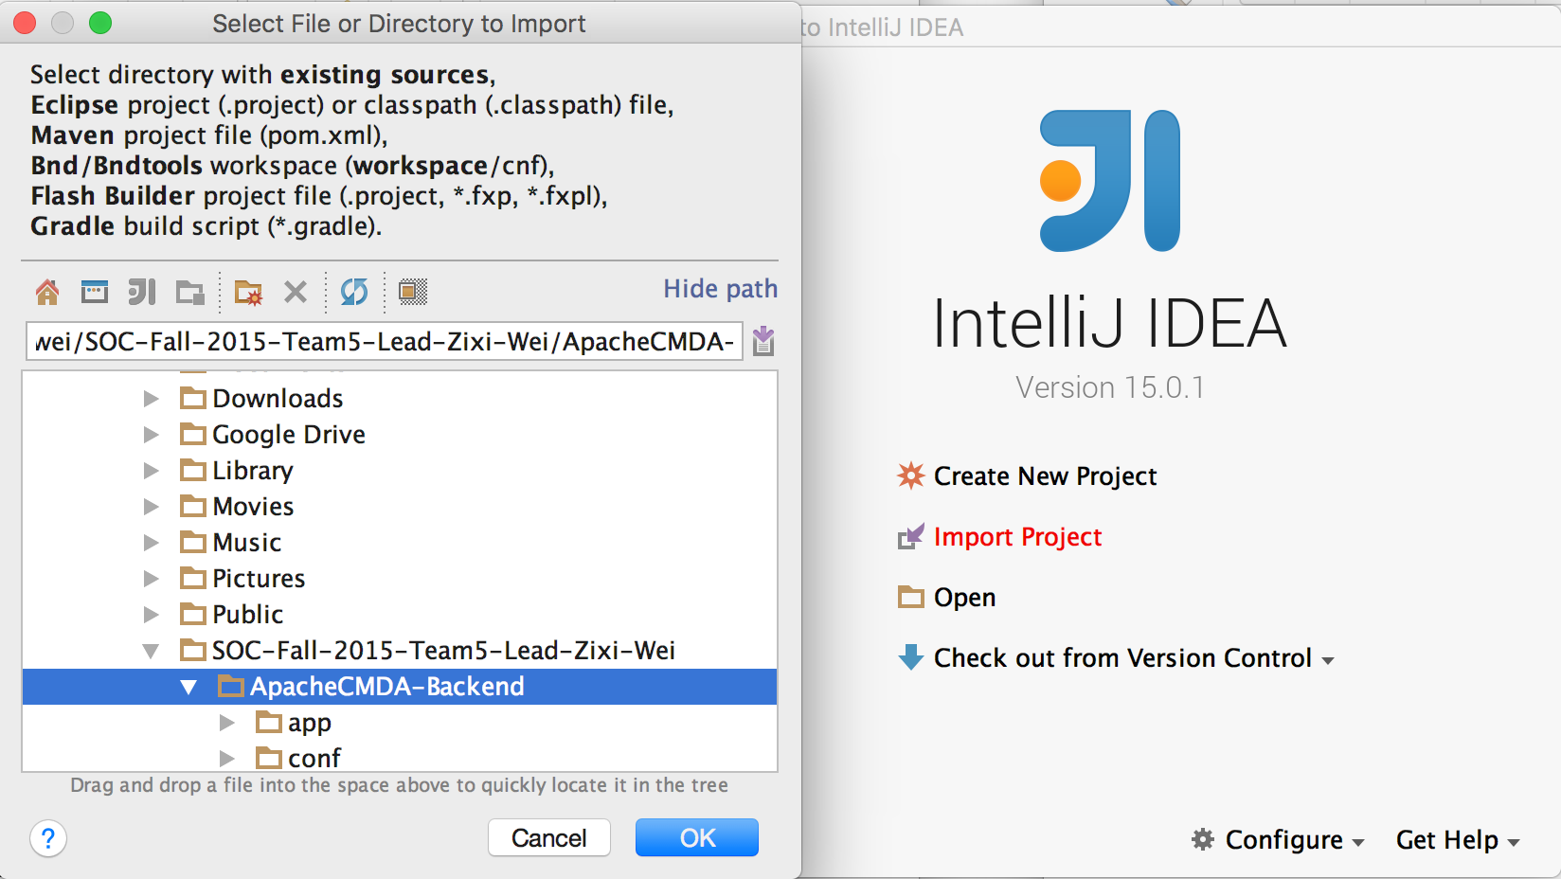

Figure

Make sure you Import project from external model of SBT (Figure 4)

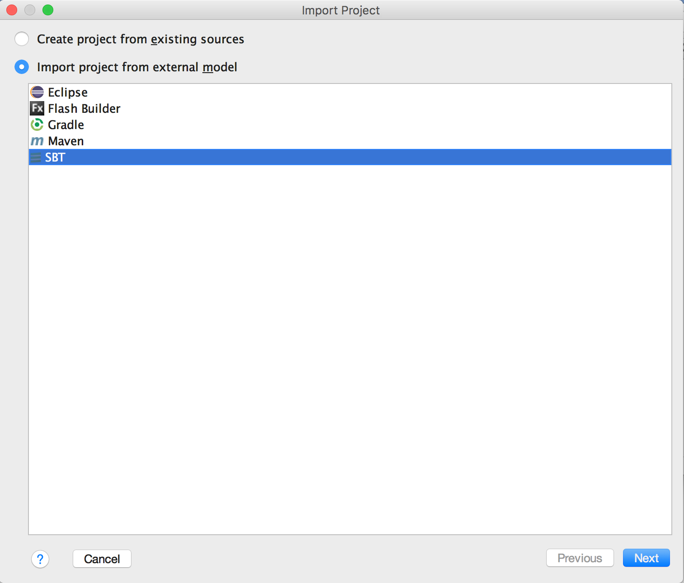

Figure

Click Next, check “Use auto-import”, “Download sources and docs” and “Download SBT sources and docs” (Figure 5), then click Finish.

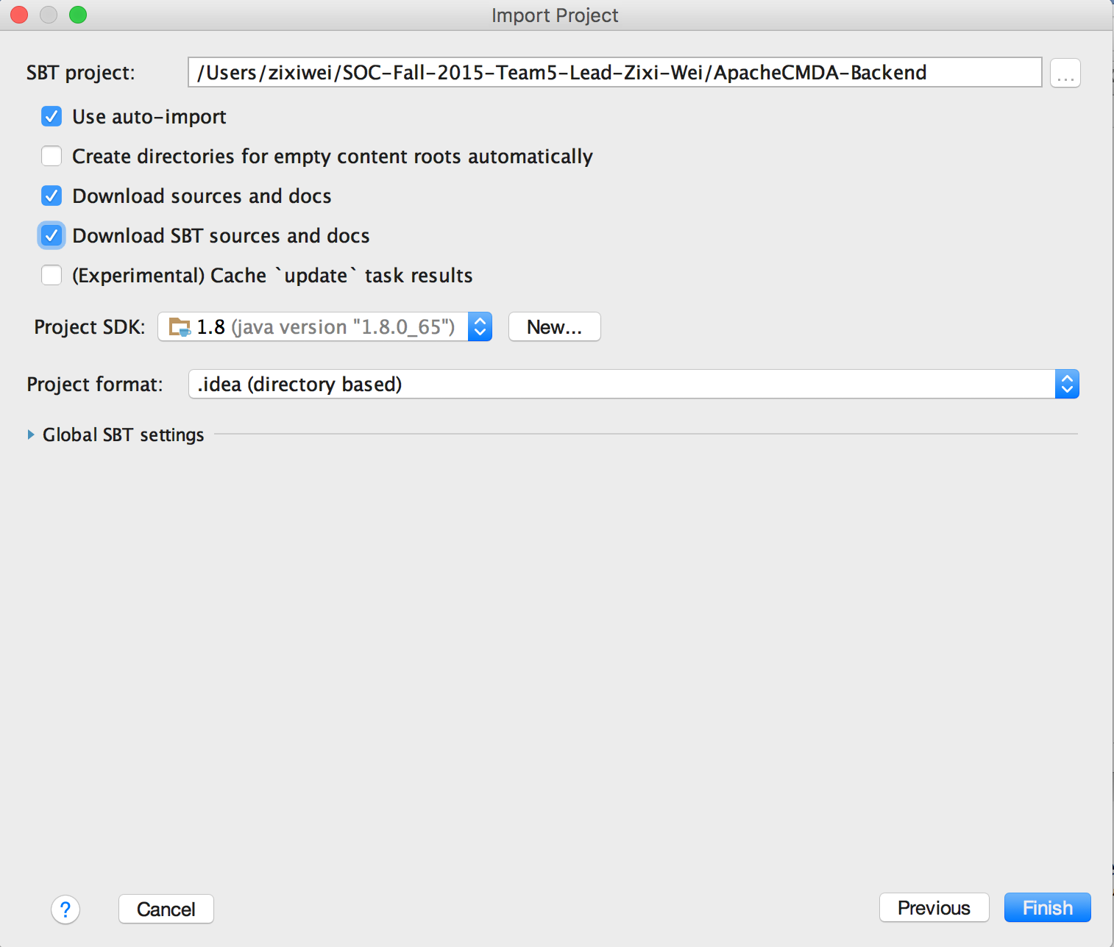

Figure

Click OK (Figure 6)

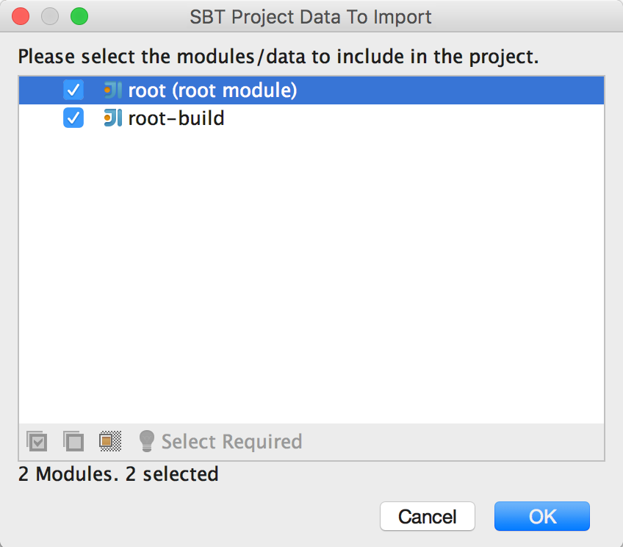

Figure

Click Configure to configure JPA framework (Figure 7), click OK (Figure 8)

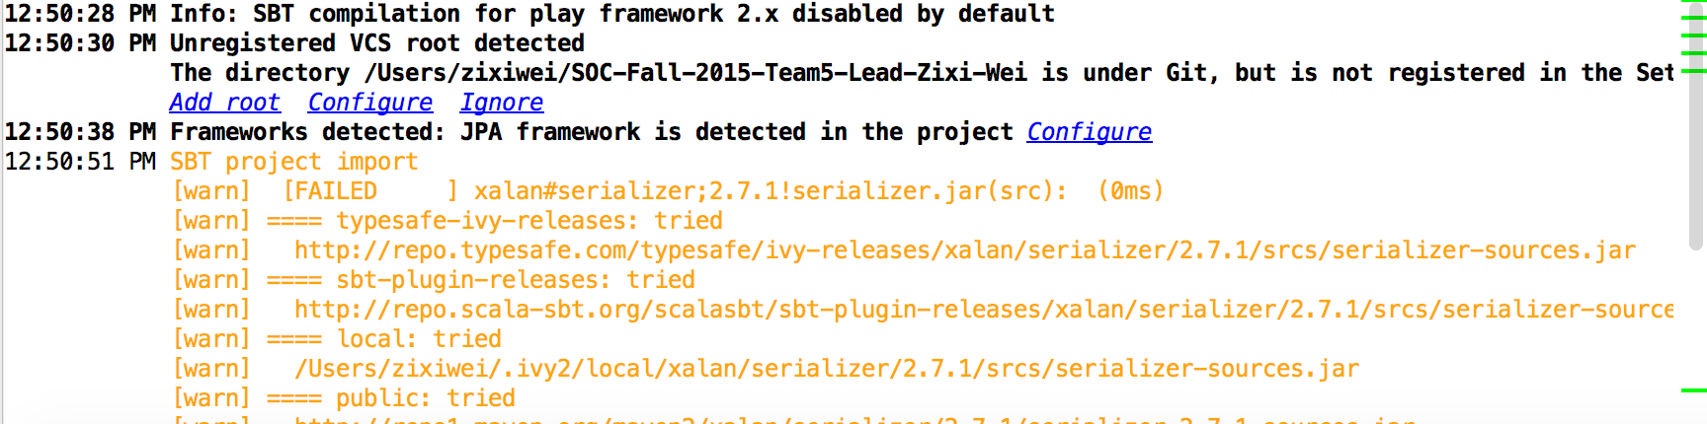

Figure

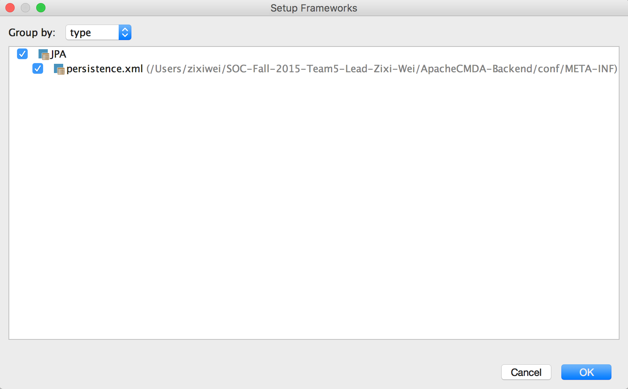

Figure

Under IntelliJIDEA menu, choose “Preferences”, choose Play2 under the Languages & Frameworks, check “Use Play 2 complier for this project” (Figure 9), then click OK. The project now is successfully imported.

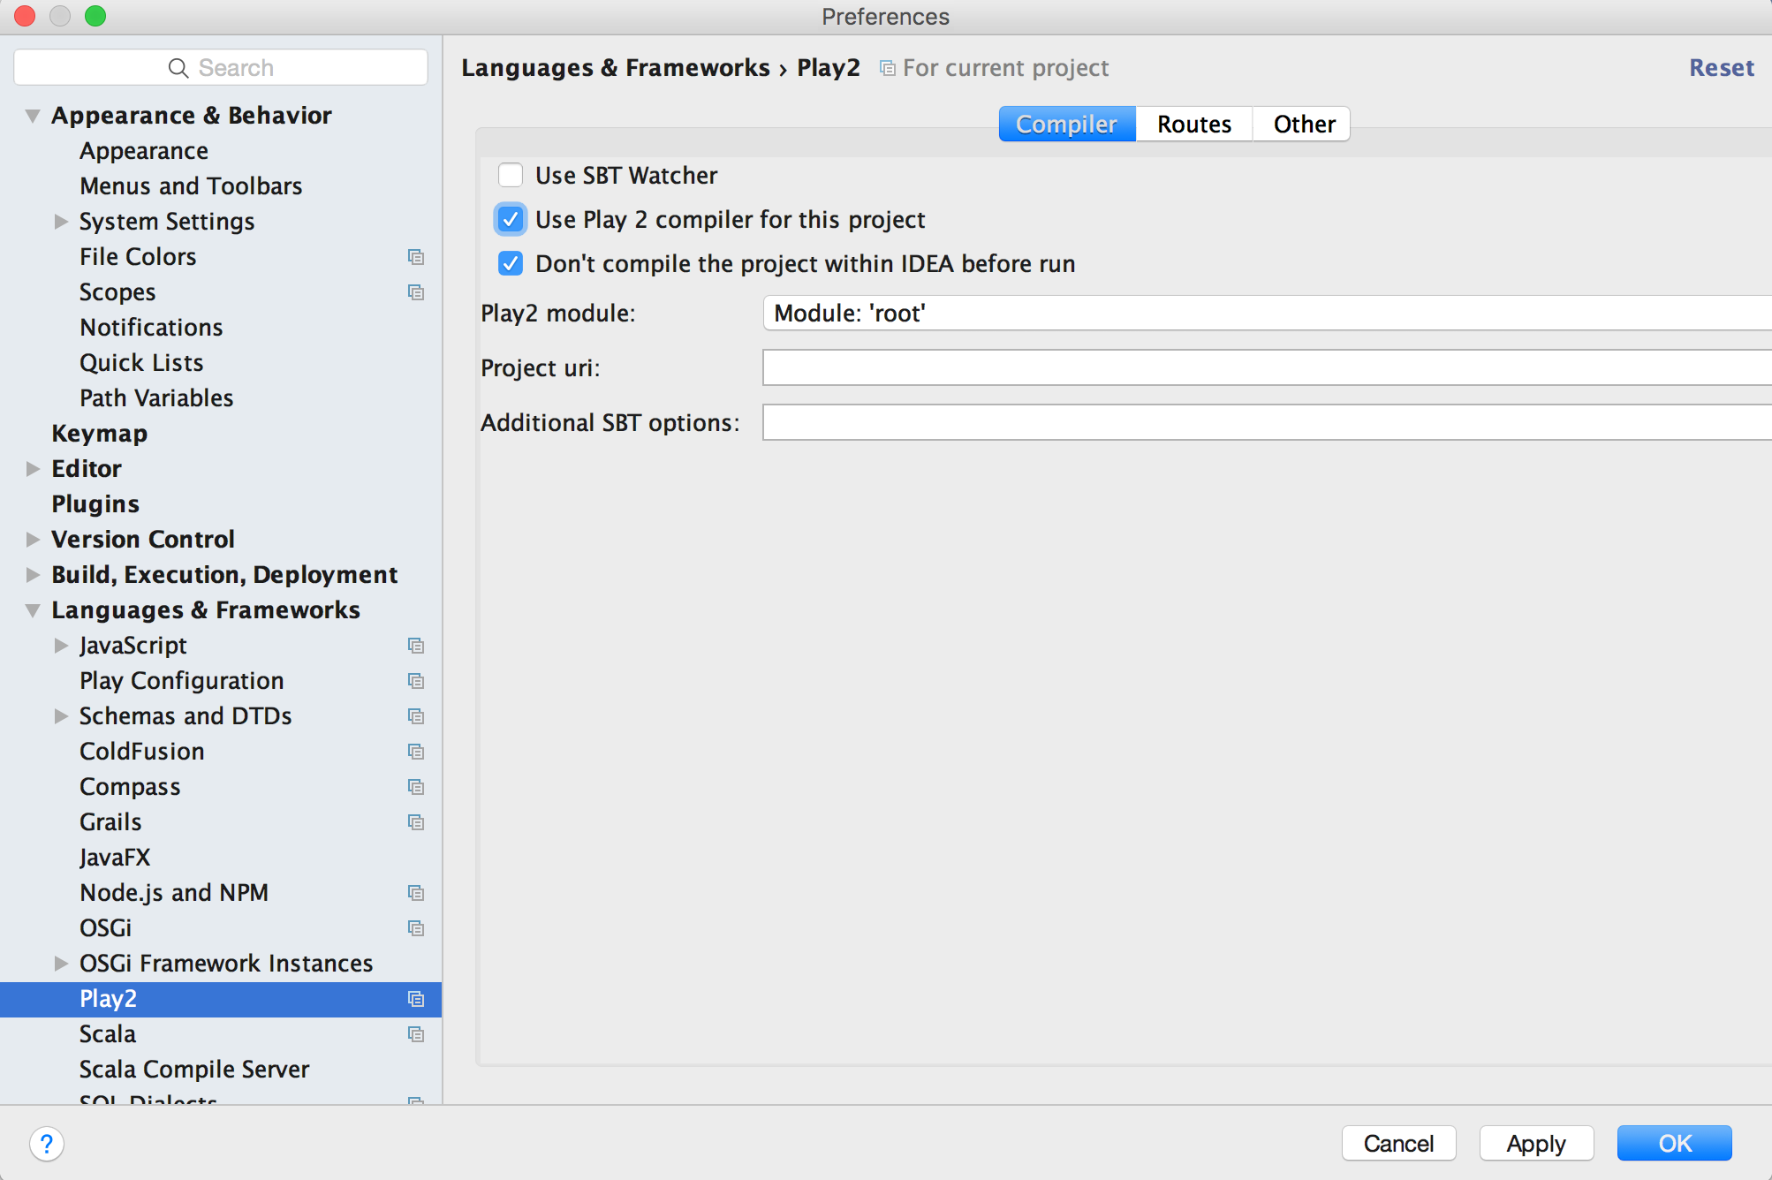

Figure

Step 4: Setup Docker environment according to the Docker’s official guide: <http://docs.docker.com/mac/step_one/>

Step 5: Open Docker quick start terminal, run docker pull cmusvsc/apachecmda:1.0, to pull the image from Docker Hub, then use docker images command to check whether the image is pulled successfully (Figure 10).

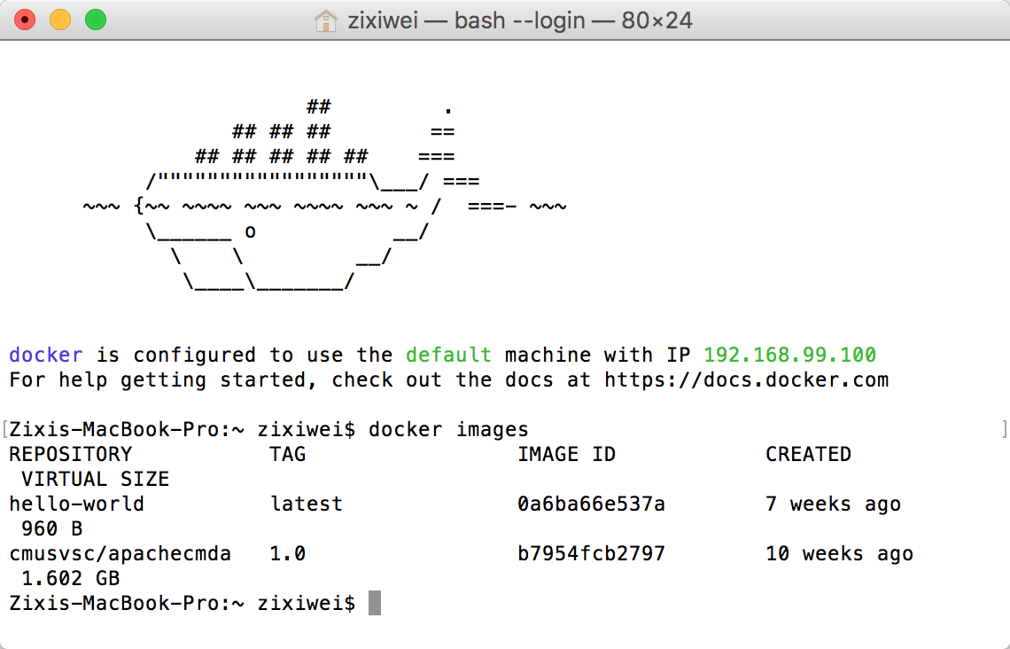

Figure

Step 6: Mount your local directory to the /home/SOC-Fall-2015 directory inside the container (Figure 11):

docker run -it -p 9234:9000 -v /Users/zixiwei/SOC-Fall-2015-Team5-Lead-Zixi-Wei:/home/SOC-Fall-2015 cmusvsc/apachecmda:1.0

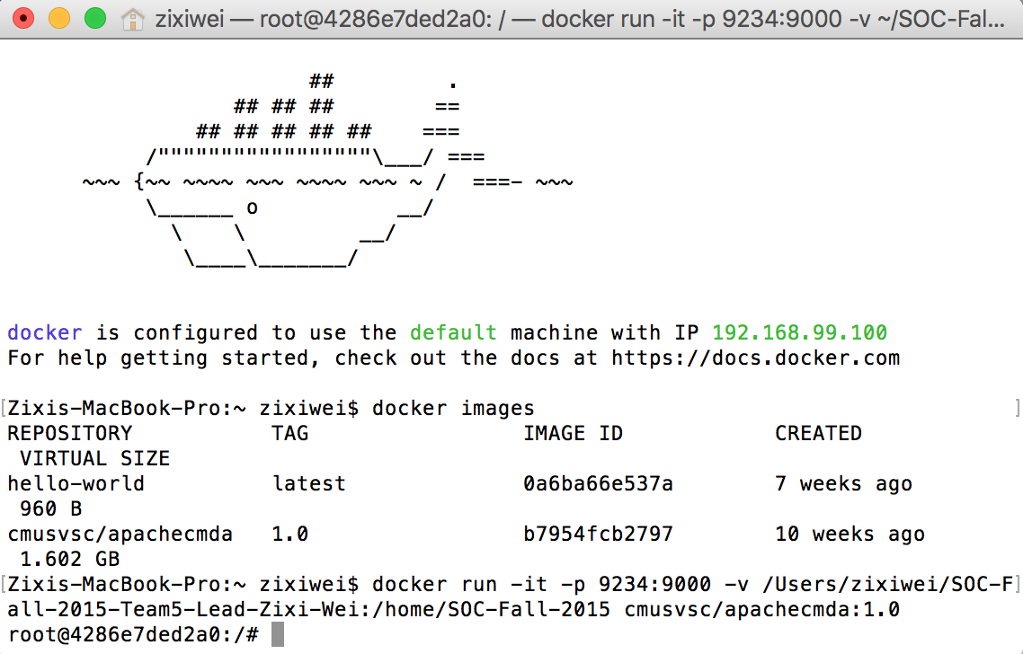

Figure

Step 7: Start MySQL service using “service mysql start” (Figure 12)

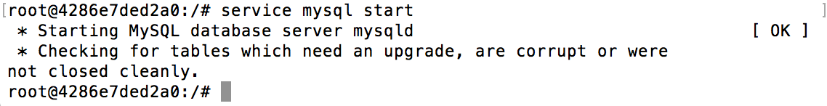

Figure

Step 8: Start the backend. Cd into the ApacheCMDA-Backend directory, start the backend by using “./activator run”, now the backend has started (Figure 13)

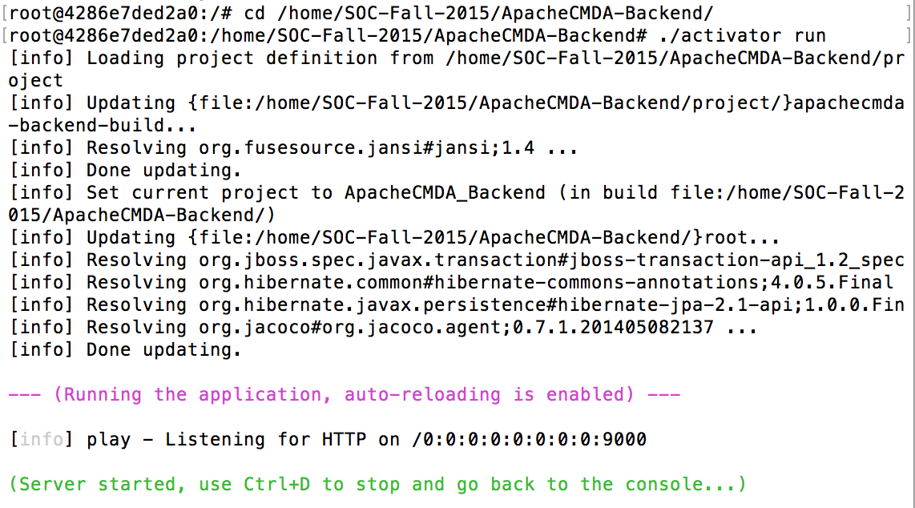

Figure

Step 9: Try the first POST. Open the routes file under the conf folder in ApacheCMDA-Backend in IntelliJ, you will find a list of routes that you can use to communicate with the backend. Please only use the routes below the # Newly Added comment. (Figure 14)

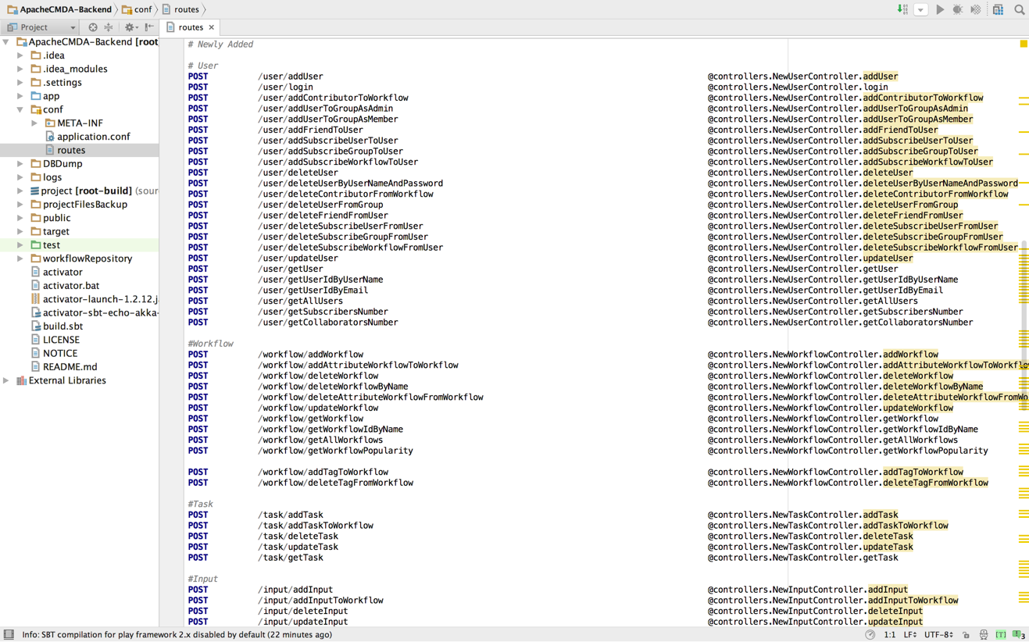

Figure

For detailed usage, please refer to the API of the Appendix (Figure 15)

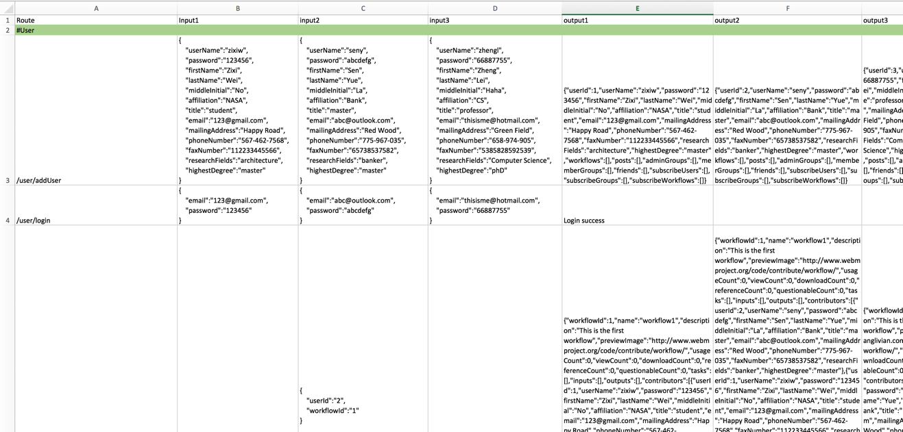

Figure

Now let’s register a user. Open Postman, choose POST, type in the url: <http://localhost:9234/user/addUser>

Open the Body menu, choose raw and set the input as JSON(application/json), paste the following JSON data to the input blank:

{

"userName":"zixiw",

"password":"123456",

"firstName":"Zixi",

"lastName":"Wei",

"middleInitial":"No",

"affiliation":"NASA",

"title":"student",

"email":"123@gmail.com",

"mailingAddress":"Happy Road",

"phoneNumber":"567-462-7568",

"faxNumber":"112233445566",

"researchFields":"architecture",

"highestDegree":"master"

}

Then click Send, after a few while, you will get a message to tell you that user added success. (Figure 16), Figure 17 is the output on the Docker terminal.

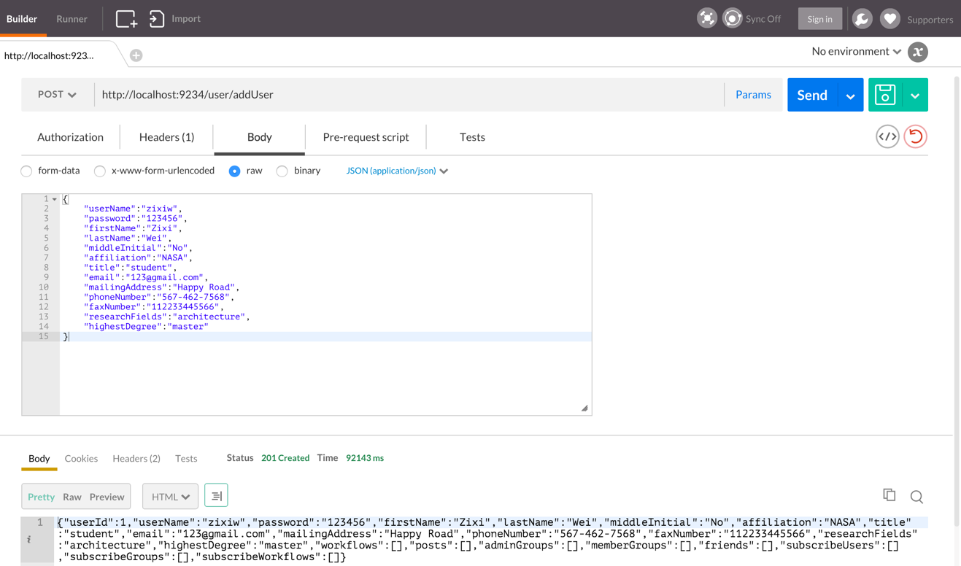

Figure

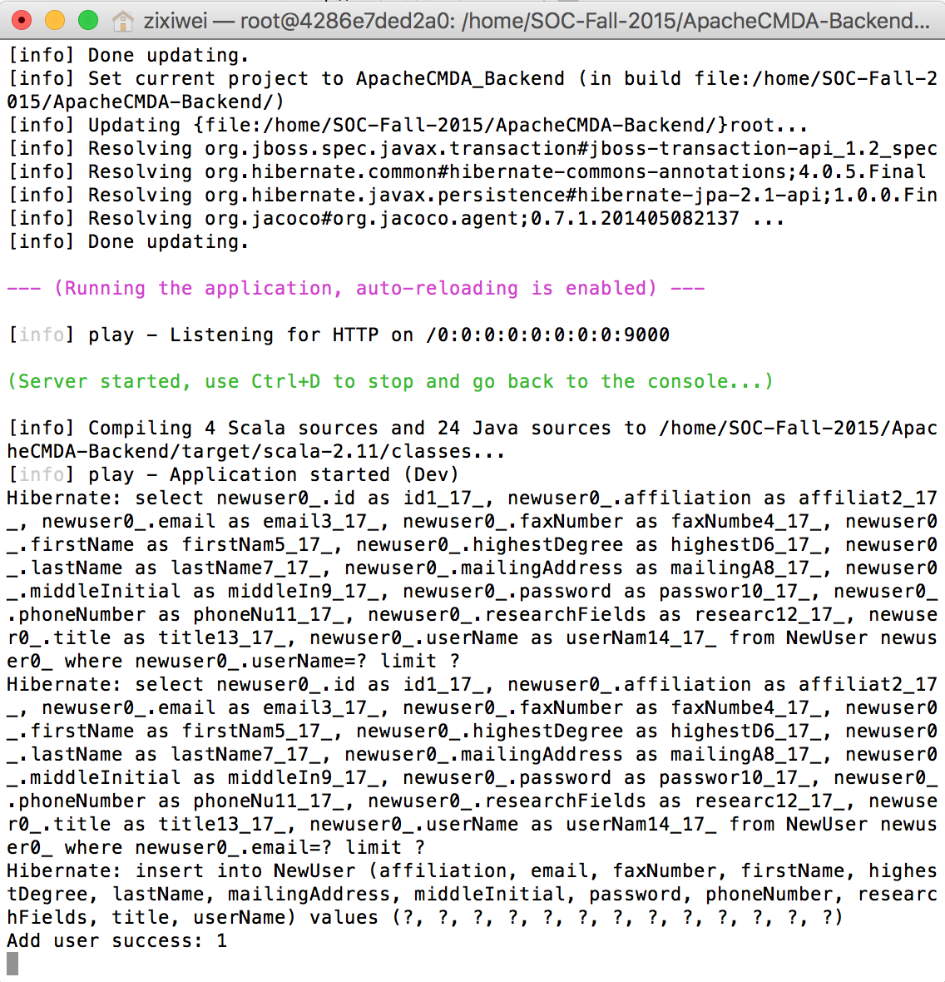

Figure