**COMSATS University Islamabad (CUI)**

**Lab Terminal**

**Submitted to: Sir Bilal Bukhari**

**Submitted By: Ziyad Amjad**

**Reg No: FA21-BCS-057**

**Course: Topics in Computer Science**

**Date: 3 jan, 2025**

# Q1: Sequence Diagram

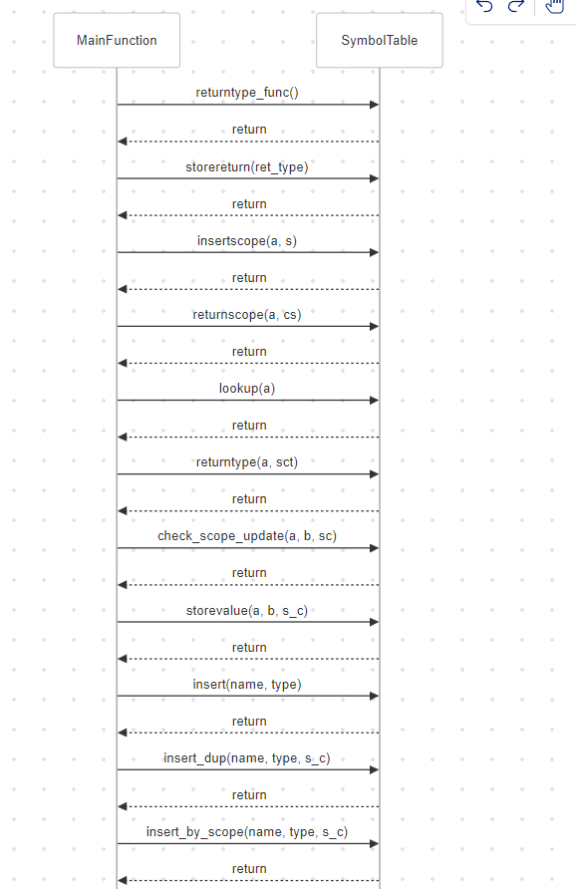

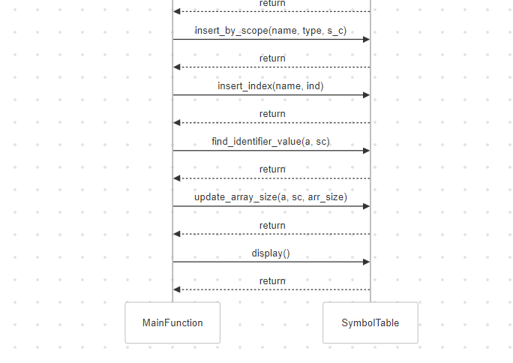

# Q2: Core functions:

### Insert Function

The insert function adds new identifiers to the symbol table or updates the type of existing ones:

1. **Check Existence:** Uses lookup to see if the identifier already exists.
2. **Add New Identifier:** If not found, it adds the identifier with its type, assigns a serial number, and sets storage.
3. **Update Existing Identifier:** If found, it increments the token number and updates the type.

### Check Scope Update Function

The check_scope_update function updates the value of an identifier based on its scope:

1. **Find Most Recent Scope:** Searches the symbol table to find the most recent scope of the identifier.
2. **Update Value:** Converts the value from a string to a float (or int if the type is INT) and updates the symbol table with the new value.

These functions are essential for maintaining and updating the symbol table with accurate identifier information.