Business Template

Online super store’s sales
Logo / Image

Contents
1 Business Description 3
1.1 Business background 3
1.2 Problems because of poor data management 3
1.3 Benefits from implementing a Data Warehouse 3
1.4 DATASETS DESCRIPTION 3
1.5 GRAIN / DIM / FACT 4
2 Business Layer 3NF 4
3 Business Layer Dimensional Model 4
4 Logical Scheme 4
5 Data Flow 4
6 Fact Table Partitioning Strategy 4

Business Description

Business background
An online retail company serving commercial and individual customers across various regions of the United States. The company offers a wide range of products including furniture, office supplies, and technology. Sales are conducted through both cash and card payment methods, with products shipped to customers via different shipping modes.

Problems because of poor data management
The absence of a structured data management approach leads to several critical issues:

Scattered data sources: Sales data is split across two separate files (cash and card), making consolidated analysis difficult.
Redundant data: Customer and product information is repeated in every sales row, leading to inconsistencies and storage waste.
Mixed concerns: Operational data (sales transactions) and descriptive data (customer, product details) are stored together, making analysis complex.
Inconsistent structure: Cash and card datasets have different columns (e.g., Returned only exists in card sales), making integration challenging.
No historical tracking: There is no mechanism to track changes in customer or product information over time.

Benefits from implementing a Data Warehouse
Implementing a Data Warehouse provides the following key benefits:
- Faster and easier analysis: Consolidated, structured data enables quick and accurate reporting instead of manually searching through multiple files.
- Data security and access control: Each team accesses only the data relevant to their role. For example, the sales team does not need to see customer addresses unnecessarily.
- Improved decision making: Historical data enables trend analysis, demand forecasting, and data-driven decisions.
- Employee performance tracking: Sales and profit data per employee makes it easier to evaluate performance and calculate bonuses.
- Data consistency: A single source of truth eliminates contradictions between different data sources.

DATASETS DESCRIPTION

Dataset 1 — Cash Sales (SRC_CASH_SALES)
This dataset records sales transactions made via cash payment. Each row represents a single sales transaction and includes the following information:
Column Name | Description
Payment_ID | Unique identifier for each payment transaction
Order_ID | Unique identifier for each order
Order_Date | The date when the order was placed
Ship_Date | The date when the order was shipped
Ship_Mode | The shipping method used (e.g., Standard Class, First Class, Same Day)
Customer_ID | Unique identifier for each customer
Customer_Name | Full name of the customer
Segment | Customer segment (Consumer, Corporate, Home Office)
Country | Country where the order was delivered
City | City where the order was delivered
State | State where the order was delivered
Postal_Code | Postal code of the delivery address
Region | Geographic region of the delivery address
Product_ID | Unique identifier for each product
Category | Main product category (Furniture, Office Supplies, Technology)
Sub_Category | Sub-classification of the product within its category
Product_Name | Full name of the product
Sales | Total sales amount for the transaction
Quantity | Number of units sold
Discount | Discount applied to the transaction
Profit | Profit generated from the transaction
Employee_Name | Full name of the employee who processed the sale
Employee_ID | Unique identifier for each employee
Payment_Type | Payment method used (Cash)

Dataset 2 — Card Sales (SRC_CARD_SALES)
This dataset records sales transactions made via card payment. It contains the same columns as the Cash Sales dataset with one additional column:
Column Name | Description
Returned | Indicates whether the order was returned (Yes/No)

Differences Between Datasets
 | Cash Sales | Card Sales
Payment method | Cash only | Card only
Returned column | Not available | Available (Yes/No)
Structure | 24 columns | 25 columns
Both datasets together represent the complete sales activity of the company across all payment methods.

GRAIN / DIM / FACT

Dimensional Design Process

Business process
Analysis of retail sales transactions to understand customer purchasing behavior, product and category performance, employee sales efficiency, regional and geographical sales patterns, shipping preferences, and payment method distribution across cash and card transactions.

Grain
The grain of the FCT_SALES fact table is one row per individual sales transaction. Each row represents a single product sold to a customer on a specific date, via a specific payment method and shipping mode. This is a transaction grain — the most atomic level of detail available in the dataset.

Dimensions
• DIM_CUSTOMER
• DIM_LOCATION
• DIM_PRODUCT
• DIM_EMPLOYEE
• DIM_DATE
• DIM_PAYMENT
• DIM_SHIP_MODE
• DIM_RETURNED

Facts
The FCT_SALES fact table contains the following numeric measures:
Fact | Description | Type
Sales | Total sales amount for the transaction | Additive
Quantity | Number of units sold | Additive
Discount | Discount rate applied to the transaction | Non-Additive
Profit | Profit generated from the transaction | Additive

Table descriptions:

FCT_SALES

Column Name Description Data Type
customer_sk FK → DIM_CUSTOMER INT
location_sk FK → DIM_LOCATION INT
product_sk FK → DIM_PRODUCT INT
employee_sk FK → DIM_EMPLOYEE INT
order_date_sk FK → DIM_DATE INT
ship_date_sk FK → DIM_DATE INT
payment_sk FK → DIM_PAYMENT INT
ship_mode_sk FK → DIM_SHIP_MODE INT
returned_sk FK → DIM_RETURNED INT
order_id Degenerate Dimension VARCHAR
payment_id Degenerate Dimension VARCHAR
sales Total sales amount DECIMAL
quantity Number of units sold INT
discount Discount rate DECIMAL
profit Profit amount DECIMAL

DIM_CUSTOMER
Column Name | Description | Data Type
customer_sk | Surrogate key | INT
customer_id | Source customer ID | VARCHAR
customer_name | Full name of customer | VARCHAR
segment | Customer segment | VARCHAR

DIM_LOCATION
Column Name | Description | Data Type
location_sk | Surrogate key | INT
country | Country name | VARCHAR
city | City name | VARCHAR
state | State name | VARCHAR
postal_code | Postal code | VARCHAR
region | Geographic region | VARCHAR

DIM_PRODUCT
Column Name | Description | Data Type
product_sk | Surrogate key | INT
product_id | Source product ID | VARCHAR
category | Main product category | VARCHAR
sub_category | Sub-category | VARCHAR
product_name | Full name of product | VARCHAR

DIM_EMPLOYEE
Column Name | Description | Data Type
employee_sk | Surrogate key | INT
employee_id | Source employee ID | VARCHAR
employee_name | Full name of employee | VARCHAR

DIM_DATE
Column Name | Description | Data Type
date_sk | Surrogate key | INT
date | Full date | DATE
day_of_week | Day number in week | INT
day_name | Name of day | VARCHAR
month | Month number | INT
month_name | Name of month | VARCHAR
quarter | Quarter number | INT
year | Year value | INT
is_weekend | Weekend flag (1/0) | INT

DIM_PAYMENT
Column Name | Description | Data Type
payment_sk | Surrogate key | INT
payment_id | Source payment ID | VARCHAR
payment_type | Payment method | VARCHAR

DIM_SHIP_MODE
Column Name | Description | Data Type
ship_mode_sk | Surrogate key | INT
ship_mode | Shipping method type | VARCHAR

DIM_RETURNED
Column Name | Description | Data Type
returned_sk | Surrogate key | INT
returned | Return status (Yes/No) | VARCHAR

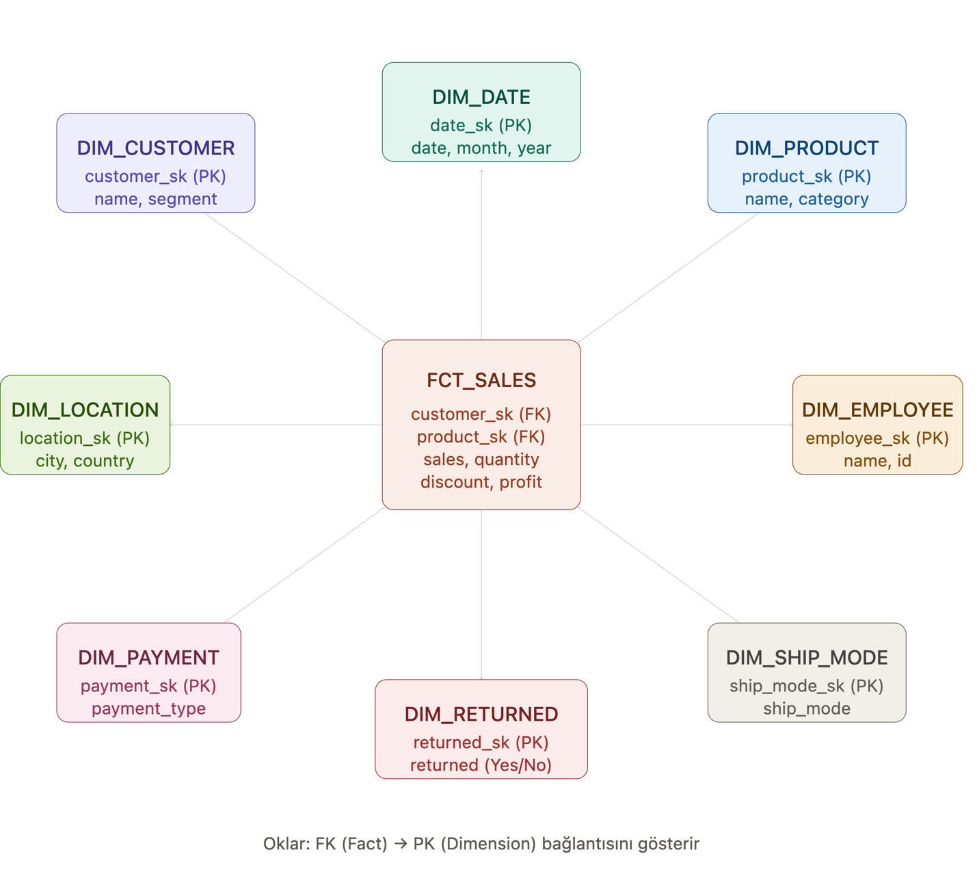

Business Layer 3NF

Business Layer Dimensional Model

Logical Scheme

Data Flow

