Omni Project Specification

Team Omni – North America

# Product Descriptions

There are two primary components that make up Omni: the web site and the web service. The web service provides Omni’s base functionality. The web site serves as a client for the web service.

**Omni Web Site**

The Omni website, located at <http://www.omniproject.org> is the client application for the Omni social network. Built using ASP.NET 2.0 and AJAX, it accesses the XML Omni Web Service in order to provide access to the social network. The web site was designed to give a user experience similar to that of other popular social networks while incorporating Omni’s unique features. One of the primary features is the Language Toolbar. This is the thick horizontal orange bar running across the top of the web site. The features on this bar may be accessed at any time while browsing any part of the site and provide our language learning tools to the user.

**Omni Web Service**

The Omni web service provides all the business logic for the Omni social network. The web service is designed to abstract the functionality of the social network at a very high level in order to make it as easy as possible for developers to use and incorporate into their services. Access to this web service is publicly open, but there are both public and authenticated levels. The public side of the web service provides a large set of the automated language tools and limited access to the database of previously completed translations. Authenticating with the web service provides the user with the full set of social network functionality. The web service takes advantage of other free web services in order to provide automated translation functionality. SQL stored procedures were used for all database access.

# User Scenarios

The following are a collection of use cases that explain how Omni works from a user’s perspective. We will first introduce you to the three fictional characters we will use to demonstrate the Omni social network:

**Alice**: new user to Omni; knows English, wants to learn Chinese

**Bob**: Alice’s friend, already on Omni; knows English, knows enough Chinese

**Charlie**: English and Chinese guru on Omni.

**Scenario: New User**

1. Alice goes to [www.omniproject.org](http://www.omniproject.org) after hearing about it from Bob.
2. Alice registers for an account by filling her name, password, email, and the captcha.
3. Alice logs in with the newly created account.
4. Alice notices the hint to update her profile. She navigates to the “Profile” page and fills in her description, and instant messaging preferences. She also tells Omni more about her interests and that she knows English and wants to learn Chinese.
5. Alice logs out.

**Scenario: Making Friends**

1. Alice logs in and selects “Get Introduced” hoping to meet new friends.
2. Alice selects the language Chinese to get introductions for.
3. Among the list of users, Alice finds Charlie the most interesting due to his Chinese mastery and their common interests. Alice adds Charlie as a friend.
4. Alice goes to her “Friends” page and searches for Bob who told her about Omni. She adds Bob to her friends list as well.
5. From the “Friends” page, Alice selects Charlie to view his profile and to compose a message to him. She writes for the subject “Hi” and for the content “I’m new to Omni. Nice to meet you”. Alice sends her message.
6. From the “Messages” page, Alice can compose a message to Bob by selecting his name in the “Recipient” field. She writes for the subject “Hi Bob” and the content “I’m finally on Omni.” Alice sends her messages and logs off.
7. Charlie logs into Omni and goes to his “Messages” page. He sees a message from Alice who he does not know.
8. He replies to Alice saying “Nice to meet you as well. I’m sure you’ll enjoy Omni”.

**Scenario: Translations**

1. Alice logs in and selects “Request Translation” hoping to learn a bit of Chinese.
2. Alice selects the desired translator as “Global/Anyone”, the source language as English, and the destination language as Chinese. She writes the subject as “I’m so excited!” and content as “I can’t wait to go to Korea.” Alice then sends her request and logs off.
3. Bob logs in for a day of social networking. He hopes to meet some cute girls! Bob wants to start off the day with some light translations to practice his Chinese.
4. Bob goes to the “Perform Translation” page and sees Alice’s translation request.
5. Bob tries to translate it to the best of his knowledge. He doesn’t quite remember how to say Korea in Chinese so he clicks on “Quick Translation”, selects from “English to Chinese” and types in “Korea” in the text box. He then gets the automatic translation to “Korea” and adds that to his translation for Alice.
6. Bob has done the best he can and submits the response. He then logs off.
7. Charlie logs in for a day of translations. He hopes to boost his rating.
8. Charlie sees the translation request from his new friend Alice, and the bad job that Bob did. He decides to help her translate it better.
9. Charlie types in his translation for her message in Chinese.
10. Charlie ranks Bob’s translation to 3 stars because although it’s not perfect, a general speaker would understand the idea of Bob’s message.
11. Charlie logs out.
12. Alice logs in and sees her translation request has been translated; it is in the “Need Approval” section.
13. Alice reads through the translations from Bob and Charlie and believes Charlie’s is better. She gives Charlie a 5 star rating and approves that translation.

**Scenario: Miscellaneous Features**

1. Charlie logs in to see how he is doing with his ranking.
2. Charlie goes to the “Hall Of Fame” page to view the list of top translators by rank. He sees himself first and is proud of himself.
3. Charlie decides to take his skills to the next level.
4. Charlie chooses to navigate Omni completely in Chinese by choosing Chinese from the language dropdown in the top right corner. Now the entire site is in Chinese.

# Software Development Procedures

As the North American team, we faced several unique challenges in terms of our ability to coordinate our ideas and development efforts. When we first started, we had never met each other and lived in 3 different time zones. Our first priority upon getting into contact with each other was developing our idea and figuring out how we would collaborate.

**Communication Medium**

In order to coordinate our ideas and our requirements writing, we used a wiki, a mailing list, and windows live messenger. The mailing list allowed us to have discussions and keep each other updated with all recent changes and events. The wiki allowed for us to all work together on the same set of documents. The wiki held all of our project proposals, information, requirements, and design documents.

**Configuration Management**

We chose to use Subversion for configuration management for the entirety of our development processes. This housed our web site, the web service code, localization resources, tools, and documentation.

# Architecture

The diagram below shows the overall architecture of Omni. The system was divided into three layers: client, business, and data. In the client layer is the web site client that we developed and where any external applications that subscribed to our business logic would reside. The business logic layer is where the structure and functionality of the Omni network is defined. The business logic works with the systems described in the data layer in order to store data and provide services.

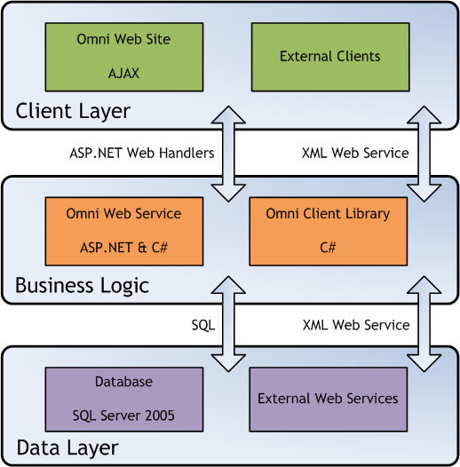

Architecture Diagram

# Technologies Used

**Microsoft ASP.NET 2.0** – Used for the development of the Omni Web Site

**C# & Microsoft .NET 2.0 Framework** – Used for the development of the Omni Web Service

**Microsoft SQL Server 2005** – Provides all the back-end data storage for the Omni Web Service

**Microsoft Visual Studio 2005 –** Used for all development of both the Omni Web Site and the Omni Web Service